**UNIVERSIDAD DE EL SALVADOR**

**CAMPUS CENTRAL**

**DEPARTAMENTO DE IDIOMAS EXTRANJEROS**

  
**UNDERGRADUATE WORK:**

“FACTORS THAT INFLUENCE THE ACADEMIC PERFORMANCE OF STUDENTS MAJORING IN LICENCIATURA EN IDIOMA INGLÉS: OPCIÓN ENSEÑANZA AND IN LICENCIATURA EN LENGUAS MODERNAS ESPECIALIDAD EN FRANCES E INGLES IN THE MAIN CAMPUS OF THE UNIVERSITY OF EL SALVADOR”

**SUBMITTED TO OBTAIN THE DEGREE OF:**

LICENCIADO EN IDIOMA INGLÉS: OPCIÓN ENSEÑANZA

**PRESENTED BY:**

DANIEL ESAÚ GONZÁLEZ ZAVALETA (GZ05011)

KARINA ELIZABETH CABRERA ALVARENGA (CA03005)

JOSÉ MANUEL PALACIOS (PP04001)

**THESIS ADVISOR:**

LICENCIADO JOSÉ ISRAEL OLIVA

**DATE:**

FEBRUARY 04TH, 2013

SAN SALVADOR, EL SALVADOR, CENTROAMÉRICA

**AUTHORITIES FROM THE UNIVERSITY OF EL SALVADOR**

**RECTOR:**

Ingeniero Mario Roberto Nieto Lovo

**ACADEMIC VICE-RECTOR:**

Licenciada Ana María Glover De Alvarado

**ADMINISTRATIVE VICE-RECTOR:**

In Election Process

**GENERAL SECRETARY:**

Doctor Ana Leticia De Amaya

**AUTHORITIES FROM THE SCIENCES AND HUMANITIES FACULTY**

**DEAN:**

Licenciado José Raimundo Calderón Moran

**VICE-DEAN:**

Licenciada Norma Cecilia Blando De Castro

**SECRETARY:**

Licenciado Alfonso Mejia Rosales

**AUTHORITIES FROM THE FOREIGN LANGUAGE DEPARTMENT**

**HEAD OF THE DEPARTMENT:**

Licenciado Ricardo Antonio Gamero

**UNDERGRADUATE DEGREE COORDINATOR:**

Licenciado Ricardo Garay

**ADVISOR:**

Licenciado José Israel Oliva

# ACKNOWLEDGEMENTS

It is a pleasure for me to thank those who helped me make this thesis project possible. Now this journey has come to an end and I would first like to thank God; without his support I do not know what this thesis would have turned into. He was the one who believed in me from the start and helped me overcome any difficult situation.

Other people I also want to express my gratitude to are my colleagues and dear friends Manuel Palacios and Daniel González who have helped me a lot during this project and who have made my day numerous times with their humor and happy mood. Life is not all about work, which you have reminded me about. Thank you!

Special thanks to my thesis supervisor LicenciadoOliva who has taken the time to really read my texts and give me pieces of advice and comments on how to move on and improve and who has helped me to sum up the results of this project.

Last but certainly not least, I want to thank my beloved family, the one who has been closest to my heart during this process. To my wonderful mom, Elizabeth de Cabrera whose love has given me valuable energy for this work. Thank you for all your love and support. I also want to thank my dear sister Marcela Cabrera. She has stood behind me no matter what and encouraged me to stay on the road to finish this thesis as well as my cousins DamarisAlvarenga and Erika Alvarenga who have been by my side during all this time and for all their enduring support. This means a lot to me. To finish I want to thank my aunt, Blanqui de Estevez whose love has given me valuable energy for this work.

**Karina Cabrera**

First and foremost, my utmost gratitude to God almighty for being in charge of giving me the strength, support, and faith needed to bring this project to a great end. Dear Lord, without you I am nothing. All the glory is yours.

I want to express my gratitude to all those who madepossiblethe realization of this project helping me in different areas and giving me the possibility to complete it. I am deeply indebted to my grandmother Francisca de Palacios whose economical and most important spiritual support had enabled me to get to this point.

I want to give my special thanks to my wonderful mother and best friend Norma Palacioswhoseeconomic and astounding and virtuous love fills my life and completes my needs. Thank you Mom for being always taking care of me as if I were still your little baby and for giving me encouragement whenever I was about to give up.

This thesis would not have been possible unless the work and great effort of my thesis colleagues; Daniel González and Karina Cabrera from whom I have learnt a lot. I want to thank them all for their help, patience, interest and valuable hints that enabled me to complete this work.

**José Manuel Palacios**

Above all, to GOD all mighty for giving me life and the knowledge needed to finish my university studies, for letting me accomplish one more goal in life, and for strengthening me every second of every hard moment I went through during my studies.

To my life-mate, Maribel Cruz, because you were always there and encouraged me to take this journey to the end. Thanks for supporting my decisions and for showing me I can attain every goal I set.

Of course I can’t close this life chapter without thanking Gloria de González, my mother. Thank you mom for trusting me, for taking care of me, for loving me, and for enjoying my victories as they were your own.

To my fellow thesis colleagues: Karina Cabrera and Manuel Palacios, for working as hard as this project demanded. You guys made this project lighter. I enjoyed spending long hours with you every time we met.

I also want to thank Licenciado José Israel Oliva, my thesis advisor. Thank you for guiding us through this last big road. I know you had more patience than ever. Without your guidance, we would have certainly been lost.

**Daniel González**

**TABLE OF CONTENTS**

ACKNOWLEDGEMENTS………………………………………………………………………………………………………….i

ABSTRACT……………………………………………………………………………………………………………………..……..vi

INTRODUCTION …………………………………………………………………………………………………………….…….vii

CHAPTER I: 1.0 INTRODUCTION…………………………………………………………………………………….……..1

1.1 STAMENT OF THE PROBLEM……………………………………………………………………….……. 1

1.2RESEARCH QUESTIONS…………………………………………………………………………….…………3

1.2.1 RESEARCH QUESTION ………….……………………………………………………….…..4

1.2.2 SUBSEQUENT QUESTIONS ………………………………………………………..….…..4

1.3 BACKGROUND AND NEED……………………………………………………………………………….…5

1.4 PURPOSE OF THE STUDY …………………………………………………………………………….…….6

1.5 DEFINITIONS……………………………………………………………………………….………………...….7

CHAPTER II: 2.0 LITERATURE REVIEW…………………………………………………………………..............…. 9

2.1 PERSONAL FACTORS INFLUENCING UNIVERSITY STUDENTS’ ACADEMIC PERFORMANCE………….……………………………………………………….………………………………………..…..…8

2.1.1 FAMILY RESPONSIBILITIES ….……………………………………………………….…..…8

2.1.2 WORK RESPONSIBILITIES …………………………………………..………………….…..10

2.2 ACADEMIC FACTORS INFLUENCING UNIVERSITY STUDENTS’ ACADEMIC

PERFORMANCE…………….……………………….…………….……………………………………………………….….…13

2.2.1 STUDY HABITS …………………………………………………………………………………..12

2.2.2 PRIOR KNOWLEDGE ………………..………………………….…………….………………15

CHAPTER III: 3.0 METHODOLOGY………………………………………………………………………………………..16

3.1 METHOD …………………………………………………………………………….…………………………...16

3.1.1 INTERVIEW ………………………………………………………………………………..……..16

3.2 INSTRUMENT ..…………………………………………………….……………………..……………….….. 17

3.3 SAMPLE ……………………………………………….…………………………………………………….…... 17

3.4 DATA COLLECTION PROCEDURES ………………………………………………………………........18

CHAPTER IV: 4.0 RESULTS…………………………………………………………………………………………..…..…...20

4.1 THE SAMPLE……………………………………………………………………………………………........….20

4.2 THE GRADE CLASSES ……………………………………………………………………………………..…..21

4.3 SAMPLE AND WORK RESPONSIBILITIES ……………………………………………………………..22

4.4 SAMPLE AND FAMILY RESPONSIBILITIES ……………………………………………………………23

4.5 PERSONAL FACTORS INFLUENCING UNIVERSITY STUDENTS’ ACADEMIC

PERFORMANCE ………………………………………………..…………………………………………….……………….….25

4.5.1 WORK RESPONSIBILITIES …………………………………………………………………...25

4.5.2 FAMILY RESPONSIBILITIES ………………………………………………………………….27

4.6 ACADEMIC FACTORS INFLUENCING UNIVERSITY STUDENTS’ ACADEMIC

PERFORMANCE …………………………………………………………………………………………………..………….….28

4.6.1 PREVIOUS KNOWLEDGE ………………………………………………………………….…29

4.6.2 STUDY HABITS ……………………………………………………………………………….….29

CHAPTER V: 5.0 DISCUSSION..……………………………………………………………………….………….……...…32

5.1 PERSONAL FACTORS INFLUENCING UNIVERSITY STUDENTS’ ACADEMIC

PERFORMANCE ……………………………………………………………………………………………………………….…..32

5.1.1 SUBSEQUENT QUESTION 1 ……………………………………………………….………..32

5.2 ACADEMIC FACTORS INFLUENCING UNIVERSITY STUDENTS’ ACADEMIC

PERFORMANCE………………………………………………………………………………………………………….….…….33

5.2.1 SUBSEQUENT QUESTION 2 …………………………………………………….…………..33

REFERENCES ………………………………………………………………………………………………………………….…….35

APPENDIXES ……………………………………………………………………………………………………..………………...38

APPENDIX A………………………………………………………………………………………………………..…………….….38

APPENDIX B………………………………………………………………………………………………………………………….39

APPENDIX C……………………………………………………………………………………………………….……………..….41

# ABSTRACT

The principal aim of this study is to describe the factors that influence the academic performance of third-year students majoring in Licenciatura en IdiomaInglésOpciónEnseñanza (LIIOE) and also in Licenciatura en LenguasModernas Especialidad en Frances e Ingles (LLM) in Semester II-2012. Researchers planned to carry out this project because they realized that there are students who work and study at the same time, have family responsibilities and do not have any background of the two languages involved. So, this study intends to find out if these students’ personal profiles might lead them either to academic success or to failure.

This study aimsat understanding the relationship between academic performance and personal and academic factors of students studying the two target majors. Researchers used a Semi-structured Interview so that the participants could provide both personal and academic information that relate to their academic performance. The use of a Checklist was implemented to enrich the information provided by the 27 participants taken into account. Besides, at the end of this project, the researchers answered the research questions in a hundred percent. After analyzing the data, the results of the study indicated that the factor that influences the academic performance of students studying Licenciatura en IdiomaInglésOpciónEnseñanza (LIIOE) and also in Licenciatura en Lenguas Modernas Especialidad en Frances e Ingles (LLM) in The University of El Salvador in Semester II-2012 is study habits.

# INTRODUCTION

This report presents data about the research study “Factors that influence the academic performance of students majoring in Licenciatura en IdiomaInglésOpciónEnseñanza (LIIOE) and in Licenciatura en Lenguas Modernas Especialidad en Frances e Ingles (LLM) in the Main Campus of the University of El Salvador in Semester II-2012”

The researchers have divided this research work into five chapters. Chapter I states the problem being investigated, in this chapter the researchers show the background and need which is the reason why this research is worthy to be carried out and the purpose of it, readers will find the research question in this chapter. Chapter II presents the literature review which is basically the information gathered from different sources in relation to the topic being researched in this study. In this chapter readers can identify the different factors that may influence high or low academic performance

Chapter III contains the methods used in this research project and the type of research; in this case it is a quantitative research study. The sample and the instrument used are also exposed in this chapter, but the most important part which is the way in which the data were collected. Chapter IV is basically the information gathered after administering the instrument. In this section of the study, readers are going to see all the information provided by the sample population and some graphs and tables that are helpful to easily understand the information presented.

Chapter V presents the discussion on the results obtained through the whole process of the recollection of data. The most remarkable data are presented in this chapter by answering the research questions.

# CHAPTER I: 1.0 INTRODUCTION

A commonly accepted principle of economics is that, over a reasonable range of output, a positive and strong link should exist between input and output. Likewise, in El Salvador academic environment, it is just fair to think of the existence of that positive link between effort and performance. Nevertheless, it is quite disconcerting to find different pieces of literature stating mixed results with regard to the relationship between effort and academic performance. Frisbee (1994), Pappalardo (1996), and Christian (1993) find a positive and significant relationship; in contrast, Kember (1995), Gómez (2004) find little to no relationship between the variables. In fact, Aries (2006) establishes that contrary to popular belief, factors such as: time spent studying and ability, sometimes do not have direct influence in optimum academic performance. But the really important thing is that all of these contrasting arguments contribute to a more relevant establishment of the actual factors that build the ideal academic performance equation, so that students and teachers might predict academic success or failure depending on particular and individual academic and personal conditions.

# 1.1 STATEMENT OF THE PROBLEM

Through time, it has been questioned why some university students succeed in their academic performance while others fail. No investigations have been run to finally determine specific university students’ characteristics that might predict academic performance success or failure. In El Salvador, although the lowest university academic failure rate is represented by the humanities fields with only the 18.4% (Marín, 2004); there is still a variety of factors that need to be studied in order to know what is influencing these students’ academic performance.

Failure versus success in university students in El Salvador has been controversial because there is no common factor that can tell the main reason why students fail at a university level. This research intends to find the combination of factors that interfere in the academic performance of third- year students majoring in Licenciatura en Idioma Inglés Opción Enseñanza and in Licenciatura en Lenguas Modernas Especialidad en Frances e Ingles at the Main Campus of the University of El Salvador in Semester II-2012 and to clearly explain how these combinations of factors might affect or help students in their academic performance.

The Language Department of the University of El Salvador hosts two academic fields that are tightly connected. Thefirstfieldis Licenciatura en Idioma Inglés Opción Enseñanza (LIIOE). This first field prepares professional professors to teach English as a Second Language (ESL). The second field known as Licenciatura en Lenguas Modernas Especialidad en Frances e Ingles (LLM) is more focused on developing language skills so that students can listen, speak, read and write in English and in French. Students of both majors need to have particular skills to succeed in their academic performance. But combined with these particular skills, there must be some other variables to complete the academic performance success and failure equations. ­

To put this in perspective, there might be one student who is married, has children and a full-time job, but has a strong English and French background. The first three characteristics might make one assume that this students would relatively have lower academic performance compared to a student who, apparently, has more time to dedicate to his or her studies. Popular belief indicates that academic performance success is influenced by more time dedicated to the studies and less time dedicated to leisure activities and the likes. However, there is no reason to assume this is what is happening with third-year students majoring in Licenciatura en Idioma Inglés Opción Enseñanza and in Licenciatura en Lenguas Modernas Especialidad en Frances e Ingles. It is more likely for third-year students to have more extra-curricular responsibilities and some other sources of academic pressure and stress; therefore, it is important to categorize these factors and label the target participant so that the results might establish relevant information to find the ideal student’ academic profile.

Many students think that they fail just because they do not read or practice hard enough; however, the actual why goes beyond that thought because university students in this country have to deal with personal responsibilities such as family and work. There is a large amount of students who already have a family, children, and jobs, so they have limited time for their academic tasks. These students have to find the way to properly devote the time for each of their activities.

There are also some other factors that can lead a student to failure; for instance, lack of prior knowledge in regard to the field they study and also the way they prepare for academic assessment and exams that is known as study habits (SH). When students decide to study Licenciatura en Idioma Inglés Opción Enseñanza or Licenciatura en Lenguas Modernas Especialidad en Frances e Ingles some of them do not have any background of the languages taught in the majors. This fact is thought to make the English and French languages learning process difficult for students lacking prior knowledge. In spite of all these thoughts, the findings of this research study concretely demonstrated the reality of the target students’ academic performance.

# 1.2RESEARCH QUESTIONS

In this section of the project, the researchers present the main question that guided the investigation. Moreover, there are two subsequent questions that derive from the main question. These research questions are the cornerstone of the project since the answers that the researchers got helped to better understand the factors that influence the target students’ academic performance.

# 1.2.1 Research Question:

What factors influence the Academic Performance of third year students studying the majors of Licenciatura en IdiomaInglésOpciónEnseñanza and Licenciatura en Lenguas Modernas Especialidad en Frances e Ingles in Semester II-2012 in the Main Campus of the University of El Salvador?

## 1.2.2Subsequent Questions:

1. What personal factors influence the Academic Performance of third year students studying the majors of Licenciatura en IdiomaInglésOpciónEnseñanza and Licenciatura en Lenguas Modernas Especialidad en Frances e Ingles in Semester II-2012 in the Main Campus of the University of El Salvador?
2. What academic factors influence the Academic Performance of third year students studying the majors of Licenciatura en IdiomaInglésOpciónEnseñanza andLicenciatura en Lenguas Modernas Especialidad en Frances e Ingles in Semester II-2012 in the Main Campus of University of El Salvador?

# 1.3 BACKGROUND AND NEED

The university academic performance failure and the drop outs rates are the most worrisome events for all the entities involved, the students, the institutions, the communities, and the companies looking for professionals to recruit. There is a solid need to define the equation for academic performance failure and success so that students and institutions can have a reliable overview of the actual university students’ academic development and academic performance success opportunity based on specific and individual academic and personal profiles. Though this research study is focused on third-year students majoring in Licenciatura en Idioma Inglés Opción Enseñanza and in Licenciatura en Lenguas Modernas Especialidad en Frances e Ingles in the University of El Salvador, the results and definition of the ideal academic profiles might help university students from the various academic fields to make the correct decision when choosing their major. It is a great tool to have the academic performance success and failure profiles defined to let students know what they can expect after considering their own and particular academic and personal profile.

This study also helps the teachers because they can predict students’ academic performance success or failure according to these students’ particular profiles. In this research study, the inclusion of internal and external factors influencing the academic performance of third-year students majoring in Licenciatura en Idioma Inglés Opción Enseñanza and in Licenciatura en Lenguas Modernas Especialidad en Frances e Ingles in the University of El Salvador significantly contributed to the core of the study. The results of this research study might lay the foundations for future studies to build the ideal university student’s academic profile so that university academic performance failure rates decrease.

# 1.4 PURPOSE OF THE STUDY

The purpose of this study is to find out the factors that influence the academic performance of students studying the majors Licenciatura en Idioma Inglés Opción Enseñanza and Licenciatura en Lenguas Modernas Especialidad en Frances e Ingles in the Main Campus of the University of El Salvador in Semester II-2012 so that teachers and students might predict academic performance.

Through the completion of this study, the researchers describe the individual factors that influence these students’ academic performance because that description might provide valuable insights on why some students fail while others succeed in their academic responsibilities. The understanding of this phenomenonmight help the target students be aware of what they can expect based on their particular academic and personal profiles.

Knowing these expectations might encourage students to look for alternative ways to achieve academic performance success. Teachers also benefited because the results might direct efforts to other directions meaning other teaching strategies that could work better according to specific students’ academic and personal profiles and needs. Of course, not only students studying Licenciatura en Idioma Inglés Opción Enseñanza and Licenciatura en Lenguas Modernas Especialidad en Frances e Ingles in the Main Campus of the University of El Salvador during Semester II-2012 directly benefited from the results the investigation provides. Students studying these majors in subsequent terms will have broader views to project their academic expectations.

# 1.5 DEFINITIONS

In this section, all the key words used in the project are presented. It is important to be familiar with all these terms since they are going to be used in several passages from this research study. This section for definitions is important because it can be used as a guide to understand the results better.

1. *Academic Performance*: In educational institutions, success is measured by academic performance, or how well a student meets standards set out by local government and the institution itself. As career competition grows ever fiercer in the working world, the importance of students doing well in school has caught the attention of parents, legislators and government education departments alike. (, J., & O’Brien, P. (2011). *The Greenwood Dictionary of Education.* (2nd ed.) California: Cremona Drive.)
2. *Cumulative Point Average*: The cumulative grade point average is composed of the total number of credit hours that students have accumulated throughout their collegiate career. Each class the student enrolls in is assigned a specific number of hours, usually between one through six hours. In addition, the final grades assigned after completing the course are given grade values which help to determine the overall grade point average. (Wallace, S., (2009). Dictionary of Education. (3rd ed.) Oxford: Oxford University Press.)
3. *Family Responsibility*: Family responsibility encompasses more than working mothers or fathers caring for children; it also includes any worker caring for another family member. (Johnson, G., (2000). *The Backwell Dictionary of Sociology.* (2nd ed.) Boston, Massachusetts: Balckwell Publisher Inc.)
4. *Grade Pont Average*: a measure of a student's academic achievement at a college or university; calculated by dividing the total number of grade points received by the total number attempted. (Wallace, S., (2009). Dictionary of Education. (3rd ed.) Oxford: Oxford University Press.)
5. *Prior Language Knowledge*: Information mastered and maintained from previous experiences, whether from earlier classroom lessons or from life experience. Prior knowledge is a key component of schema-based theories of learning languages. (Wallace, S., (2009). Dictionary of Education. (3rd ed.) Oxford: Oxford University Press.)
6. *Study Habits*: buying out a dedicated scheduled and un-interrupted time to apply oneself to the task of learning. (Wallace, S., (2009). Dictionary of Education. (3rd ed.) Oxford: Oxford University Press.)
7. *Work Responsibility*: Work responsibility refers to duties that people in certain positions should claim. This can refer to both laborious and social tasks. Recognizing and fulfilling one’s work responsibility is generally regarded as an essential part of a strong work ethic. (Johnson, G., (2000). *The Backwell Dictionary of Sociology.* (2nd ed.) Boston, Massachusetts: Balckwell Publisher Inc.)

# CHAPTER II: 2.0 LITERATURE REVIEW

While some research studies suggest that the only strong variable affecting college students’ academic performance is time devoted to study, there is a tone of many other factors that are tightly involved in this process. Several academic and non-academic factors might influence academic performance at any educative level. Through the analysis of many research studies, it can be said that measuring university students’ academic performance can be very challenging since academic performance is the product of personal and academic factors.

# 2.1 PERSONAL FACTORS INFLUENCING UNIVERSITY STUDENTS’ ACADEMIC PERFORMANCE

## 2.1.1 FAMILY RESPONSIBILITIES

Students tend to drop off their studies when they have their own family and children to care for(Womble, 2004). Womble also states that whenever these students want to go back to college, they are challenged and the fact that they have a family and they are older than the regular students may contribute to a relatively lower Grade Point Average (GPA). Womblesays these students regularly get help from the university since those universities have childcare services, a service thatis not available in El Salvador. Students in El Salvador would tell a different story if the Government provided this kind of service. Many students from our country would benefit from such a resource.

“College students have many obstacles to overcome in order to achieve their optimal academic performance” (Womble, 2004). It takes a lot more than just studying to achieve a successful college career. Different stressors such as time management, financial problems, sleep deprivation, social activities, and for some students even having children, can all pose their own threat to a student’s academic performance.

The way that academic performance is measured is through the ordinal scale of Grade Point Average (GPA). A student’s GPA determines many things such as class rank and entrance to graduate school. Much research has been done looking at the correlation of many stress factors that college students’ experience and the effects of stress on their GPA. A name given to such stress factors by Hatcher and Prus (1991) referred to these stress factors as academic situational constraints. Their study took into account a variety of factors that can diminish a student’s academic performance, Factors such as fraternity and sorority activities, job responsibilities, or having a boyfriend or girlfriend taking away from valuable time. One extraneous variable that was taken into account was that at most universities students involved in activities such as fraternities or sororities, and also athletics, must maintain an acceptable GPA to participate. This factor by itself could attribute to these students GPA’s being higher than the average college student.

This study did not take into account the fact that some students have to deal with family responsibilities. Today more and more people are deciding to return to college after being out in the work force. Coming back to college puts high demands on older people, who sometimes have family already. This factor of having a family could itself contribute to a lower GPA, but one study looked at this factor of family and found the contrary. What helped these students was the support they found within the University, support such as childcare services, and also courses in how to hone superior studying skills, Hammer, Grigsby, & Woods, (1998). One extraneous factor in the study of family and school demands was that most of the students surveyed were only part-time students and therefore not a representative sample of the general college population.

Students who have children to take care for can often find themselves being held out of class for reasons like their children being ill or not having the proper child care readily available. Grades, motivation and prior GPA can also be reasons for class attendance (Devadoss& Foltz, 1996). With attendance having a major influence on academic performance, even to the point of some professors using it as a requirement to pass a course, it is a great indicator of a student’s overall GPA. One major prediction of class attendance is a student’s GPA prior to enrolling in the class. Students who have done better in previous classes are likely to attend classes more frequently.

Other factors in class attendance include the level of courses the student is taking. On average, Junior and Senior level courses have a higher attendance record than freshman and sophomore courses (Devadoss& Foltz, 1996). One finding that is contradictory to that of other studies is that students who work and are financially independent are more likely to attend classes and take their education more seriously. This may be due to the fact that paying for their education themselves makes them value their college studies more than students who do not pay for their studies themselves.

## 2.1.2 WORK RESPONSIBILITIES

Much has been written about the consequences of working for pay while in school, such as stress, time spent on homework, academic achievement, absenteeism and the risk of dropping out. Most studies claim that employment starts having a negative effect at 15 to 20 hours per week. Some researchers have called for a public debate on the regulation of paid work hours for students, while others argue that such a solution may encourage students to abandon their studies in order to become financially self-sufficient (Franke, 2003).

According to McInnis and Hartley (2002), students work to provide the basic necessities of life and support themselves, to get experience for post-graduation employment, for reasons of independence, to supplement youth allowance, to support a lifestyle, or a combination of these. Whatever the primary reason, however, there are other strong imperatives for students enrolled full-time to work, especially younger students. Employers expect that graduates can provide evidence of consistent paid work experience; economic and social pressures increasingly encourage combining study and work at all ages.

It can be speculated that because of students’ age and experience, some mature age students have the types of first jobs that are likely to pay reasonably well. They are also more likely to have family responsibilities that preclude the taking of a second job. In addition, commencing mature aged students in general have a greater sense of purpose and commitment to study than those who went directly from school to university, hence they are perhaps less likely to jeopardize their study by taking on two jobs.

McInnis and Hartley (2002) suggest ways in which travelling time had an impact. Respondents had to make decisions about whether it was worthwhile to go to university between shifts or whether the time was better spent going home to study. They also faced decisions about whether to spend more time on public transport in getting to work or to buy a car. For some, car travel was the only way, or sometimes the only safe way, to travel to and from work which meant pressure to earn more in order to maintain a car.

The correlation between hours worked in a week and GPA seems obvious. The more time spent at work, the less time a student spends studying. Having to hold down a job and still be a college student is a constant source of stress (Calderon, Hey, &Seabert, 2001). Also, mentally juggling the two roles of workplace and college student can itself be stressful. Finding the time to work a full or part time job and take it as seriously, and also maintain focus on academic studies can be perceived as stressful. Being exhausted from working the night before can cause a poor attendance record and also give a student less time to study, resulting in a poor academic performance.

# 2.2 ACADEMIC FACTORS INFLUENCING UNIVERSITY STUDENTS’ ACADEMIC PERFORMANCE

## 2.2.1 STUDY HABITS

According Palm (2008), it is recommendable that student’s study should have at least three hours out of class for every hour spent in class. She also said that a student must have a special place to study with plenty of room to work. And students should not be cramped. She presupposes that study time would go better if a learner takes a few minutes at the start to straighten things up. A desk and straight-backed chair is usually best. “Don't get too comfortable--a bed is a place to sleep, not to study” as what Palm said. A student must have everything close at hand (book, pencils, paper, coffee, dictionary, computer, calculator, tape recorder, etc.) before starting to study. Students are not suggested to spend on time jumping up and down to get things.

Palmalso suggests that distracting noise should be minimized. However, there are some people who need music or certain other sounds while studying, and some others like silence. In this case, a learner must find what works for him or her. Culprits are family and friends. Consider a "do not disturb" sign and turning on your answering machine is the way also to have better study habits.

Pogue (2000) did a research project to determine why students fail in their studies. What he found to be true in that study habits survey was that more than 30 years ago still rings true today--students fail because they do not know how to study .The best advice he can give is to develop sound study skills. He said that a student should make sure that, first, he or she has a good study environment, a good desk, a sturdy chair, good light, comfortable room temperature and a quiet atmosphere. That means he or she should eliminate all external and internal distractions. Second, get a good overview of the assignment before starting the work. Know what skills, facts and ideas that are expected to master and the ground that are expected to cover. Start with most difficult subject first, while the mind is freshest and most receptive.

Professors in the developing countries said that the undergraduate students should be fully equipped with high level of analytical skills, the capacity for critical reasoning, self-reflection and conceptual grasp and ability to learn autonomously and exercise flexibility of mind (Simmons, 2003). Study habits are said to be improving because of the advent and wide use of the Internet, hypertext, and multimedia resources which greatly affects the Study Habits (Liu, 2005). Karim and Hassan (2006) also note the exponential growth of digital information, which changes the way students perceive studying and with printed materials that are to be use in facilitating study. Liu (2005) and Ramirez (2003) report that students print material from the Internet in order to study and read later on. Igun (2005) also found that 85% of Latin American university students study from materials downloaded from the Internet.

## 2.2.2 PRIOR KNOWLEDGE

There is also another factor that may hinder academic performance in students. This is the Prior knowledge they may have in their major. There are few studies on this, but the information found shows that whenever the students brings something from their prior knowledge to the class they are more likely to learn new things in an easier way (Skourtou, 2005).Activation of prior knowledge is always useful in order to integrate new input in exiting cognitive schemata, making thus the learning process more efficient.

Skourtou (2005) also says that prior knowledge shown in class makes the students background visible for the teacher and they benefit from this since they can see the areas of opportunity that the students may have. Activation of prior knowledge makes the cultural background visible something that first of all enables teachers to realize the potential students bring with them to school, build upon it and also organize the necessary contextual support in order to secure maximum cognitive engagements of the students.

# CHAPTER III: 3.0METHODOLOGY

This study is aimed at finding out the factors that influence the academic performance of students majoring inLicenciatura en IdiomaInglésOpciónEnseñanza (LIIOE) and in Licenciatura en Lenguas Modernas Especialidad en Frances e Ingles (LLM)in the Main Campus of the University of El Salvador in Semester II-2012, so the researchers might construct statistical models in the attempt to understand why some of these students have better academic performance than the rest. The research team used the quantitative research method which helped them process data efficiently to state relevant results. The use of the quantitative research method individualized the various possible scenarios so that the investigators establish significant relationships between the students’ personal and academic profiles and their actual academic performance.

This research is an experimental project that aims to understand the relationship between academic performance and personal and academic factors of students studying Licenciatura en IdiomaInglésOpciónEnseñanza and Licenciatura en Lenguas Modernas Especialidad en Frances e Ingles in the Main Campus of the University of El Salvador in Semester II-2012. The understanding of these relationships led the study to formulate specific students’ characteristics that build the ideal academic performance.

# 3.1 METHOD

## 3.1.1 INTERVIEW

The interview was the most suitable method to gather data for finding out the factors that influence the academic performance of students studying Licenciatura en Idioma Inglés Opción Enseñanza and Licenciatura en Lenguas Modernas Especialidad en Frances e Ingles in the Main Campus of the University of El Salvador in Semester II-2012. The interview is a research method that can provide more information than expected since it becomes more of a conversation than mere direct questions.

# 3.2 INSTRUMENT

To collect the necessary and valid data in order to understand the phenomenon stated in this study, the following instrument was elaborated and administrated:

Semi-structured Interview (Appendix B): To continue with the study, the researchers used an oral interview to get reliable information about the phenomenon being studied. This interview helped the team get broad personal and academic information from the participants. This instrument was designed in a way the participants could provide both personal and academic information that relate to their academic performance.

Because it is important that the participants feel confident to provide reliable information, the researchers designed a check-list (Appendix C) to collect the information provided and avoid recording the interviews or taking notes while making the questions. This check-list was elaborated just by taking the semi-structured interview and adding the most possible answers based on the factors studied.

# 3.3SAMPLE

This research study focuses the attention on third year students taking Licenciatura en Idioma Inglés Opción Enseñanza and Licenciatura en Lenguas Modernas Especialidad en Frances e Ingles in the Main Campus of the University of El Salvador in Semester II-2012. Both LIIOE like LLM have four subjects (Appendix A). For carrying out this study the research team took into account the eight subjects there are in the two majors. The estimated number of students per subject is 30 making a total estimated of 240 students. The sample consisted of 27 students that were submitted to an oral semi-structured interview. Gender and age were not important at the time of selecting the sample because the sampling students were randomly selected in the university just by taking into account students majoring in LIIOE and also in LLM in semester II -2012. Researchers took into consideration the students from the 4 subjects taken in both majors.

# 3.4 DATA COLLECTION PROCEDURES

Since this project is aimed at finding out the factors that influence the academic performance of third-year students majoring in Licenciatura en IdiomaInglésOpción Enseñanza (LIIOE) and also inLicenciatura en Lenguas Modernas Especialidad en Frances e Ingles (LLM) in the Main Campus of the University in Semester II-2012, the three investigators administered two oral interviews to different students from Licenciatura en IdiomaInglésOpciónEnseñanza who were takingLectura y Conversasión en Inglés, Fonología y Morfología, LiteraturaInglesa I and Didactica en Inglés, and also students from Licenciatura en Lenguas Modernas Especialidad en Frances e Ingles who were taking FoneticaFrancesa, Ortografía y EstilísticaFrancesa, Lectura y Conversacion en InglésI and Didactica del IdiomaFrancés/RelacionesPúblicas.

After the researchers investigated the target student’s schedule to know when and where to find them, each of them randomly approached two students from each of the eight subjects to get the needed information to analyze the data. At this stage, the researchers created the appropriate environment to collect data. This means that the researchers did great effort to make students feel comfortable to gain their trust. In this way, the information gather was as reliable as possible.

The researchers used a semi-structured interview for students to talk about the conditions that were influencing their academicperformance. This semi-structured interview was administered once only. This kind of interview is important to make the data collection process more comprehensible for each participant so that the researchers can gather data related to the research questions in the participants’ own words.

The interview was administered by two of the investigators. While one of the investigators asked the questions creating a normal conversation, the other researcher was filling the check-list based on the answer the participant was providing. This helped the research team save some time in the data collection procedure. It also helped the participants feel more confident to give information. This process lasted four days so that the researchers could focus two days on each major.

# CHAPTER IV: 4.0RESULTS

This chapter presents the description of the data gathered. Here, the researchers deepened into the different factors that influence the academic performance of third year students studying Licenciatura en IdiomaInglésOpciónEnseñanza and Licenciatura en Lenguas Modernas Especialidad en Frances e Ingles in the Main Campus of the University of El Salvador in Semester II-2012. Graphs and tables are offered to have a visual helper so that the understanding of the phenomenon studied is given as clear as possible.

The very first section of the data gathering provides general ideas of the actual scenario according to number of participants taken into account, and a quantifiable expression of the main factors that are involved. This section includes both academic and personal factors that might influence the academic performance of the target students.

# 4.1 THE SAMPLE

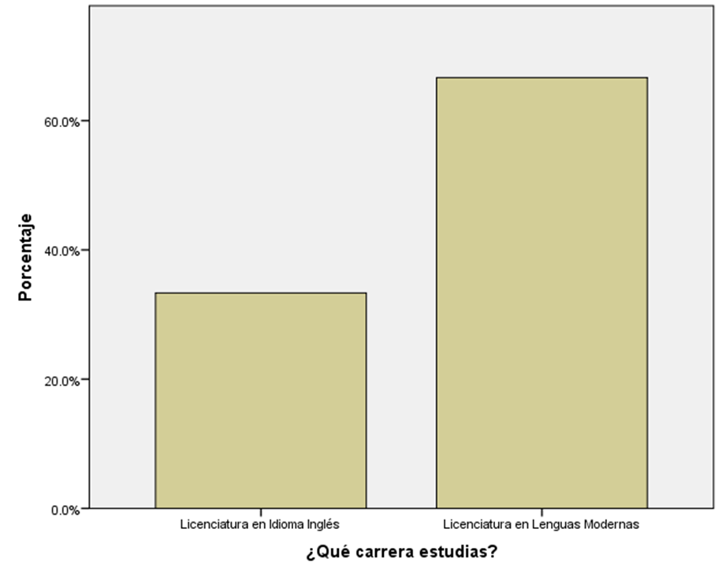

Figure I-A

There were 27 students taken into account to run this study. At first, the research team thought of including more participants; nonetheless, it was not possible due to unwillingness to participate. Data evidence there were fewer people taking Licenciatura en IdiomaInglésOpciónEnseñanza. There is a 37% of the overall target population concentrated in LIIOE; therefore, there is a smaller sample taken from this major. It is interesting to find out there are more people interested in getting skillful in managing two languages at an advanced level ,as they are instructed in Licenciatura en Lenguas Modernas Especialidad en Frances e Ingles, than those interested in teaching English.

# 4.2 THE GRADE CLASSES

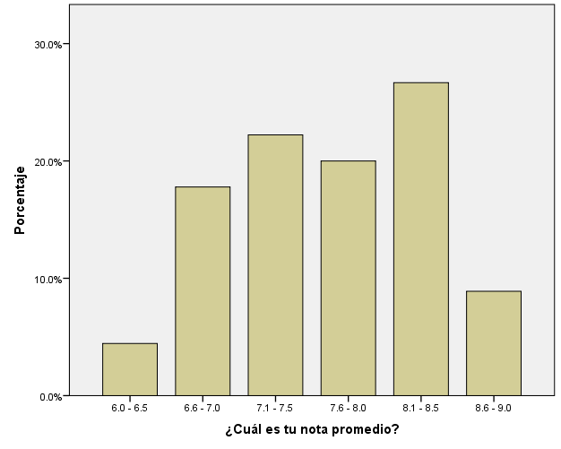

Figure I-B

The researchers hope the reader is as excited as they were when realizing the majority of the target students have an outstanding grade point average (GPA) between 8.1 and 8.5. The average grade was evaluated in a class categorization of 0.5 point frequency, coming from 6.0 to 9.0 and above. So, see that over a 30% of these students have exceptional grades, while the minority happens to belong to the 6.0-6.5 class referred as the lowest and most worrisome spot for this study. It is important to mention that these data are general statistical ideas of the whole population so they do not represent one specific major.

# 4.3 SAMPLE AND WORK RESPONSIBILITIES

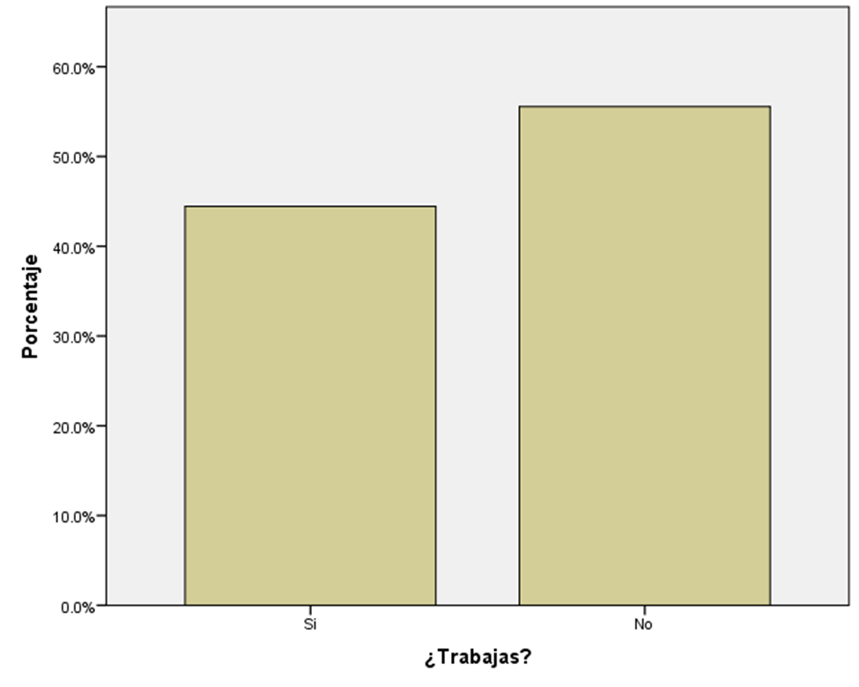

Figure I-C

An important 44% of the participants has work responsibilities. Even if it is not the majority of them, and they have different levels of job responsibilities depending on the kind of job they do, the description was built up to give special attention to those students who, apparently, are more time-engaged than the rest. Popular thinking would assume that this 44% has a relatively lower academic performance than that of the other 56%, but that will be established in further reading. Up to now, the important fact is that there are more of these people who do not have any kind of job responsibilities.

# 4.4 SAMPLE AND FAMILY RESPONSIBILITIES

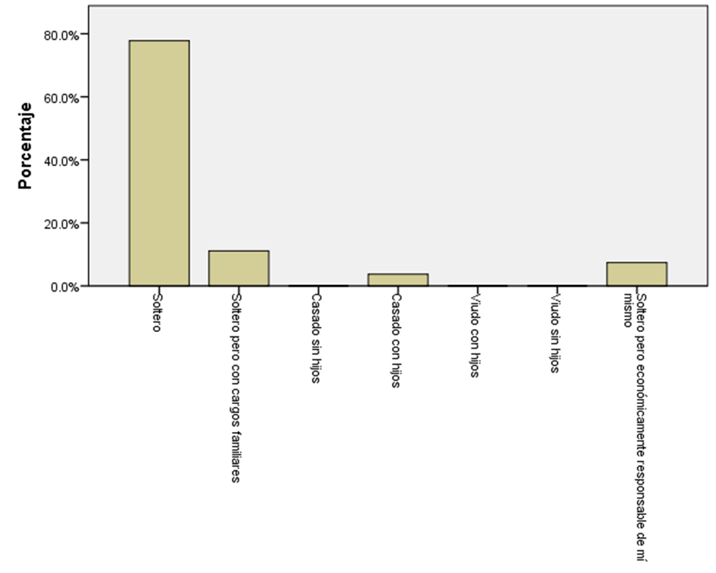

Figure I-D

This graph reveals that the common third year student taking either Licenciatura en Idioma Inglés Opción Enseñanza or Licenciatura en Lenguas Modernas Especialidad en Frances e Ingles is free of family responsibilities. This isolated factor should predict academic success in contrast to those students who have their own family already. An expected 78% is single and does not have any kind of economical obligation to their families. The 20% is evenly divided between those students who are single but have certain family responsibilities and those who are single but are economically responsible for themselves. Finally, there is a small 2% represented by those students who are married and have children to care for.

After clarifying the factors involved in this study, it is time to concentrate more on comparative data. The investigators put together some significant graphs and tables to start reflecting directly on the academic situation of third year students taking Licenciatura en Idioma Inglés Opción Enseñanza and Licenciatura en Lenguas Modernas Especialidad en Frances e Ingles in the Main Campus of the University of El Salvador in Semester II-2012. This section of the description of data is designed to keep track of the two factors involved, academic and personal factors that might influence the third year students’ academic performance. At the same time, these two categories are ramified into more specific sub-categories: for instance, personal factors that might influence the participants’ academic performance are work responsibilities and/or family responsibilities.

# 4.5 PERSONAL FACTORS INFLUENCING UNIVERSITY STUDENTS’ ACADEMIC PERFORMANCE

## 4.5.1 WORK RESPONSIBILITIES

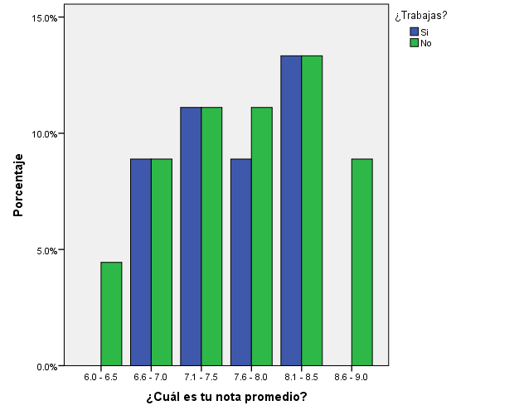

Figure II-A

Amazingly, this finding gave the researchers a complete out-of-expectation contribution. Contrary to what common sense indicates, both, students who have work responsibilities and students who do not have this kind of responsibility, are completely capable of doing really great in their grades. Yet, it is necessary to point out that students who have job responsibilities have GPA’s from 6.5 up to 9.0 and above; unlikely, students who do not have job responsibilities might get lower grades. It is too early to create assumptions to state why these students are getting lower grades if they are thought to have more free time to devote to their studies.

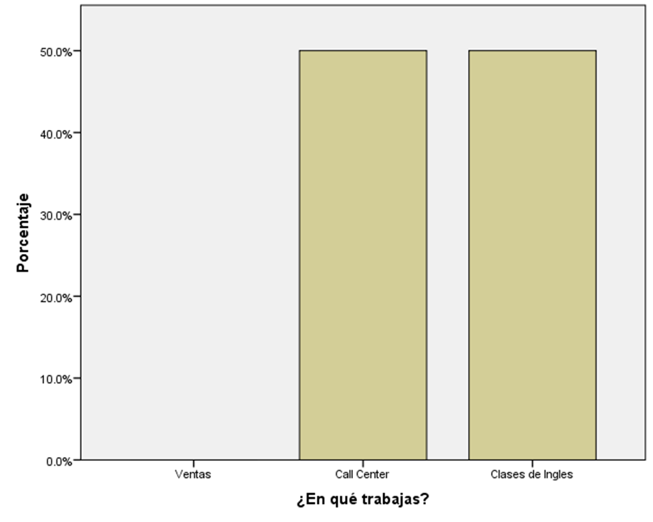

Figure II-B

Out of the 44% of student who work (See Figure I-C), the 50% works in a call center and the other 50% works as English teachers. This statistic manifests that the 100% of the target students who work, look for jobs that have something to do with their studies. This somehow helps these students to be always thinking of their academic compromises and also provides them with extra-curricular practice to improve their academic performance.

## 4.5.2 FAMILY RESPONSIBILITIES

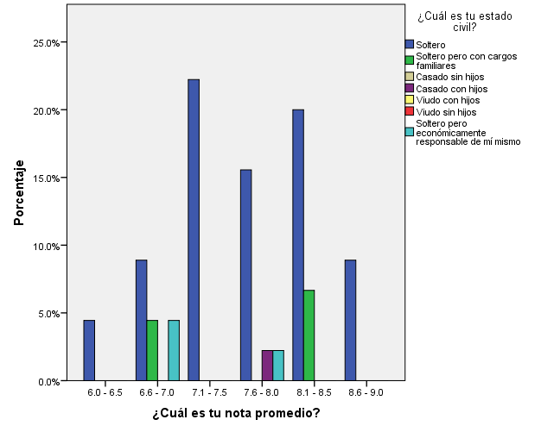

Figure II-C

Once again, data have shown people cannot judge a book by its cover! Earlier in this study, it was stated that a big 78% of the target students is single and does not have any kind of family responsibilities, besides studying (See Graph I-D). Single students can be seen in every grade class. As a matter of fact, the lowest grade class, from 6.0 to 6.5, is awarded to students who do not have any family responsibilities. Who would have guessed students that have more free time to do academic tasks are getting failing grades! It seems students who are married and have their own children take their studies more seriously and manage their time better, resulting in better grades and consequently better academic performance. Now, it is even clearer that it does not matter how many personal responsibilities a student has, he or she can do well in his or her academic performance. But there is one more block to pile in this section before building concrete description.

# 4.6 ACADEMIC FACTORS INFLUENCING UNIVERSITY STUDENTS’ ACADEMIC PERFORMANCE

## 4.6.1 PREVIOUS KNOWLEDGE

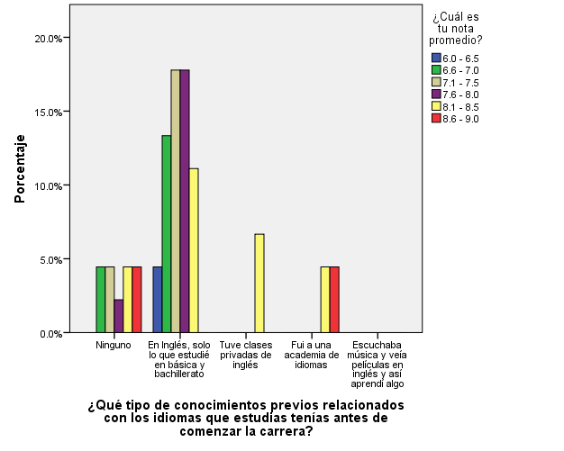

Figure II-D

Look how important it is for the sake of academic performance that students taking Licenciatura en Idioma Inglés Opción Enseñanza and Licenciatura en Lenguas Modernas Especialidad en Frances e Ingles have certain prior knowledge of the languages they will have to deal with in their whole major. All of the students who either had private lessons or went to a language academy before starting their major have grades from 8.1 to 9.0 and above. On the other hand, there is a 15% of students whose GPA is from 6.0 to 6.5. This percentage is split into those students who do not have any kind of prior knowledge of the languages, and those who started the university with the mere high school basic knowledge. However, there are some exceptional participants who started the major without any previous knowledge but have GPA’s between 8.1 and 9.0.

## 4.6.2 STUDY HABITS

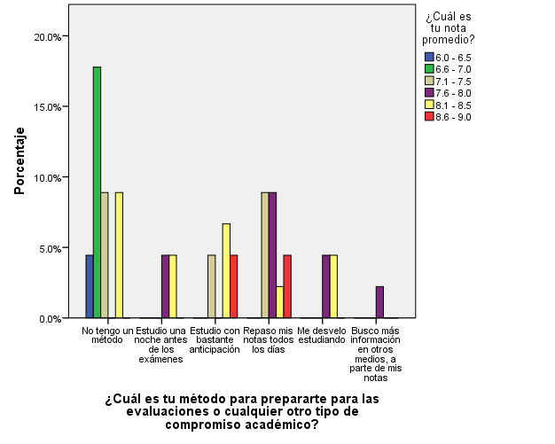

Figure II-E

This graph presents the results for one of the most important factors which is “study habits”. Comparing the study habits of third year students majoring in Licenciatura en Idioma Inglés Opción Enseñanza and in Licenciatura en Lenguas Modernas Especialidad en Frances e Ingles against their GPA`s, there can be seen more variation in the grade classes. The target students do not have a specific method to study. The researchers found significant relationship between study habits and academic performance. For example, through this graph, it can be proven that students who do not have a designed way of studying get the lowest grades considered for this investigation. This class represents the 15% of the population who do not have a specific study method and get grades from 6.0 to 7.0. The following table is presented to have a wider view of some other relevant points in regards to students’ study habits.



Figure II-F

The point of sharing this table is to state clear findings on the influence of study habits on the target students’ academic performance. To break this table into key pieces, it is a good idea to address the results starting from the grade class students belong to, and to describe what the students’ study method is to obtain such grades.

Referring to the first two grade classes from 6.0 to 7.0, the majority of these students do not really use any kind of study method to prepare themselves to cope with their academic demands. Considering the grade class from 7.1 to 8.0, it can be seen that most of these students either check their notes every day or look for extra information about the topics they are studying to reinforce their understanding. Finally, taking a look at the grade class from 8.1 to 9.0 and above, there are two basic things these students do. Some of them study for their exams and the other academic tasks weeks in advance, and some others check their notes every day so that they can clarify doubts and keep their new knowledge activated. For these students, getting outstanding grades is a matter of keeping reading and practicing every day.

# CHAPTER V: 5.0DISCUSSION

At the end of the present study, the researchers can say that the results obtained along its development were satisfactory since the research questions could be answered. The researchers found out the main factors that influence the academic performance of third year students majoring in Licenciatura en Idioma Inglés Opción Enseñanza and also in Licenciatura en Lenguas Modernas Especialidad en Frances e Ingles in the main Campus of the University of El Salvador in Semester II-202. Thus, the research teampresents what the personal and academic factors that influence these students’ academic performance are.

# 5.1 PERSONAL FACTORS INFLUENCING UNIVERSITY STUDENTS’ ACADEMIC PERFORMANCE

## 5.1.1 SUBSEQUENT QUESTION 1

What personal factors influence the Academic Performance of third year students studying the majors of Licenciatura en IdiomaInglésOpciónEnseñanza andLicenciatura en Lenguas Modernas Especialidad en Frances e Ingles in Semester II-2012 in the Main Campus of the University of El Salvador?

Contrary to common thinking, personal factors such as work responsibilities and family responsibilities do not have negative influence over the academic performance of third year students majoring in Licenciatura en Idioma Inglés Opción Enseñanza and in Licenciatura en Lenguas Modernas Especialidad en Frances e Ingles in the Main Campus of the University of El Salvador in Semester II-2012. In fact, the majority of people who deal with at least one of these two factors have better academic performance than that of students who have more free time to devote to their studies.

The discovery of students that are job-responsible and have outstanding academic performance led the researchers to conclude that work responsibilities might not become barriers to achieve successful academic performance. Furthermore, getting a job that somehow relates to the target students’ studies helps them to improve their academic performance. The experience and extra practice these students get while working become great tools that positively influence their academic performance. The 33% of the students who work has GPA’s between 8.1 and 8.5. The other two thirds get grades between 6.5 and 8.0. What is important to understand here is that none of these students get failing grades.

Being married, having children or certain other family responsibilities does not necessarily mean that the academic performance of the target participants is negatively influenced. Students who have more family responsibilities tend to be more engaged to their studies. It appears this factor makes students organize their time better and worry more about their academic performance. Even if the ideal marital status for third year students majoring Licenciatura en Idioma Inglés Opción Enseñanza and in Licenciatura en Lenguas Modernas Especialidad en Frances e Ingles is to be single, so they can prioritize their studies, those who already have family responsibilities can do really well if they are good time managers.

# 5.2 ACADEMIC FACTORS INFLUENCING UNIVERSITY STUDENTS’ ACADEMIC PERFORMANCE

## 5.2.1 SUBSEQUENT QUESTION 2

What academic factors influence the Academic Performance of third year students studying the majors of Licenciatura en IdiomaInglésOpciónEnseñanza andLicenciatura en Lenguas Modernas Especialidad en Frances e Ingles in Semester II-2012 in the Main Campus of University of El Salvador?

Having a solid background and previous knowledge of at least one of the two target languages of the majors studied, has great impact in the academic performance of the students. Students who either had private lessons or went to a language academy to learn English are more likely to get really good grades. As shown in Figure II-D, if students have good High school language background, they can also do really good in these two target majors.

The most important factor that determines the academic performance of the target students is “study habits”. Students need to have a method to study for their academic tasks so that they can do better in their academic performance. It is clear now that the more students organize the way they prepare themselves for assessment and other evaluations, the better the grades they get. Procrastination or simply not studying hard enough has negative influence over the students` academic performance. Figure II-E shows the need to create sections in each course to teach students how to prepare for their academic demands.

# REFERENCES

Abenga, E. S. B., &Mutsotso, S. N. (2010). *Study Methods for Improving Quality Learning and Performance in Higher Education.*(Vol. 5, pp. 808-813).Academic Journals. Retrieved from [http://www.academicjournals.org/err/PDF/Pdf 2010/Dec/Mutsotso and Abenga.pdf](http://www.academicjournals.org/err/PDF/Pdf%202010/Dec/Mutsotso%20and%20Abenga.pdf)

August , D. (2003). *Supporting the Development of English Literacy in English Language Learners.*Baltimore, Maryland: The Johns Hopkins University. Retrieved from <http://www.csos.jhu.edu/crespar/techReports/report61.pdf>

Bachman, L., (2008). *Recommendations for Assessing English Language Learners: English Language Proficiency Measures and Accommodation Uses.* Los Angeles, California: National Center for Research on Evaluation, Standards, and Student Testing. Retrieved from <http://www.cse.ucla.edu/products/reports/r737.pdf>

Brazil, N., Oregón, I., Perry, M., & Williams, T. (2007).*Similar English Learner Students, Different Results: Why do some schools do better?.*Montain View, California: EdSource. Retrieved from <http://www.edsource.org/assets/files/SimElresbriefcomplete.pdf>

Castaño, E., Gallón, S., Gómez, K., & Vásquez, J. (2006).*Análisis de los Factores Asociados a la Deserción y Graduación Estudiantil Universitaria.* (65 ed., pp. 9-36). Medellin, Colombia: Universidad de Antioquia-Lecturas de Economía. Retrieved from <http://www.scielo.org.co/pdf/le/n65/n65a1.pdf>

Franke, S. (2003). *Studying and Working: The Busy Lives of Students with Paid Employment.*Canada: CANADIAN SOCIAL TRENDS. Retrieved from: <http://www.statcan.gc.ca/pub/11-008-x/2002004/article/6499-eng.pdf>

Garbanzo, G. M. (2007). *Factores Asociados al Rendimiento Académico en Estudiantes*

*Universitarios, Una Reflexión Desde la Calidad de la Educación Superior Pública.* (Vol. 31, pp. 43-63). Costa Rica: Universidad de Costa Rica. Retrievedfrom:<http://redalyc.uaemex.mx/pdf/440/44031103.pdf>

Gortner, A. K., &Zulauf, C. R. (1999). *Use of Time and Academic Performance of College Students: Does Studying Matter?*. Ohio: Retrieved from: <http://ageconsearch.umn.edu/bitstream/21547/1/sp99zu01.pdf>

Hartley, R., & McInnis, C. (2002). *Managing Study and Work: The Impact of Full-Time Study and Paid Work on the Undergraduate Experience in Australian Universities.* (pp. 1-80). Oceania Australia: Australia. Department of Education, Science and Training. Evaluations and Investigations Programme (EIP).

Ismail, N. A., & Othman, A. (2006). *Comparing University Academic Performances of Hsc Students at the Three Art-Based Faculties.* (pp. 668-675). Malaysia: International Education Journal.

Lending, D., &Kruck, S. E. (2003). *Predicting Academic Performance in an Introductory College-Level in Course.* (2 ed., Vol. 21, pp. 01-15). Virginia: Information Technology, Learning, and Performance Journal. Retrieved from <http://www.osra.org/itlpj/krucklendingfall2003.pdf>

Marin, J. R. (2004). *Tasas de Éxito y Fracaso Académico Universitario: Identificación y Análisis de Variables Psicoeducativas Relacionadas en una Muestra de Estudiantes Españoles*. (pp. 17-42). España: Universidad Miguel Hernández de Elche. Retrievedfrom<http://www.orienta.org.mx/docencia/Docs/Sesion-7-8/Rodríguez.pdf>

Miller, P. W., & Win, R. (2005). *The Effects of Individual and School Factors on University Students’ Academic Performance.* (1 ed., Vol. 38, pp. 1-18). Crawley, Western Australia: Curin University. Preston Print Inc.

Mosalve, A. M., Tolosa, I., Torres, M. R., & Urrea, M. C. (2009). *Hábitos de Estudio Vs. Fracaso Académico.* (Vol. 33). Costa Rica: Retrievedfrom<http://redalyc.uaemex.mx/src/inicio/ArtPdfRed.jsp?iCve=44012058002>

Nyamubi, G. J. (2003). *The Influence of Motivation on Secondary School Students’ Performance in the English Language.*(Vol. 5, pp. 89-110). Tanzania: University of Tanzania. Norpage Editorial

# APPENDIXES

**APPENDIX A**

**Pensum**

|  |  |  |  |
| --- | --- | --- | --- |
| **LICENCIATURA EN IDIOMA INGLÉS** | | **PRERREQUISITO** | |
| DII314 | Didáctica del Idioma Ingles III | Obligatoria | Didáctica del Idioma Ingles II |
| FYM114 | Fonología y Morfología Inglesa | Obligatoria | Introducción a la Lingüística |
| LCI114 | Lectura y Conversación en Ingles I | Obligatoria | Ingles Avanzado Intensivo II |
| LTE114 | Literatura I | Obligatoria | Composición Inglesa II |

**Pensum**

|  |  |  |  |
| --- | --- | --- | --- |
| **Licenciatura en Lenguas Modernas** | | **Prerrequisito** | |
| FFR114 | Fonética Francesa | Obligatoria | Francés Avanzado |
| LCI114 | Lectura y Conversación en Ingles I | Obligatoria | Ingles Avanzado Intensivo II |
| OEF114 | Ortografía y Estilística Francesa | Obligatoria | Gramática Francesa II |
| DIF114 | Didáctica del Idioma Francés | Electiva | Expresión Oral en Francés |
| RPB114 | Relaciones Públicas | Electiva | Expresión Oral en Francés |

**APPENDIX B**

**UNIVERSIDAD DE EL SALVADOR**

**CAMPUS CENTRAL**

**DEPARTAMENTO DE IDIOMAS EXTRANJEROS**

**ENTREVISTA A ESTUDIANTES DE TERCER AÑO DE LAS CARRERAS DE LIECENCIATURA EN IDIOMA INGLÉS OPCIÓN ENSEÑANZA Y LENGUAS MODERNAS EN LA UNIVERSIDAD DE EL SALVADOR CAMPUS CENTRAL DURANTE EL CICLO II-2012**

**DESCRIPCIÓN:** La entrevista está diseñada para obtener datos de aspectos de carácter familiar, académicos y laborales de los participantes.

**OBJETIVO:** Esta entrevista busca obtener información de las cargas personales y académicas de los estudiantes de tercer año de las carreras LIIOE y LM en la Universidad de El Salvador en el ciclo II-2012 para ver la influencia de estos factores en el desempeño académico de los participantes.

**INDICACIONES:** Entablar una conversación con el participante para obtener respuesta completes y confiables que se refieran a los compromisos académicos y personales de los participantes.

**Factores académicos**

**Conocimiento previo/Vocación**

1. ¿Qué carrera estudias?
2. Menciona algunas cosas que te motivaron a estudiar esta carrera:
3. ¿Qué tipo de conocimientos previos relacionados con los idiomas que estudias tenías antes de comenzar la carrera?
4. ¿Cuantas materias llevas?
5. ¿A cuál de las materias que estas cursando le dedicas más tiempo?
6. ¿Por qué le dedicas más tiempo a esa materia?
7. ¿Cuál es tu método para prepararte para las evaluaciones o cualquier otro tipo de compromiso académico?
8. ¿Entre las materias que has cursado hasta ahora en toda la carrera, cuales son las que más se te dificultaron?
9. ¿Entre las materias que has cursado hasta ahora en toda la carrera, cuáles son las que más se te facilitaron?

**Factores Personales**

**Responsabilidades Laborales**

1. ¿Trabajas?
2. ¿En qué trabajas?
3. ¿Cuál es tu horario de trabajo?
4. ¿Por qué trabajas?

**Responsabilidades Familiares**

1. ¿Cuál es tu estado civil?
2. ¿Cuántas personas dependen económicamente de ti?

**Factores académicos**

**Record de notas**

1. ¿Cuál es tu nota promedio?

**APPENDIX C**

**UNIVERSIDAD DE EL SALVADOR**

**CAMPUS CENTRAL**

**DEPARTAMENTO DE IDIOMAS EXTRANJEROS**

**ENTREVISTA A ESTUDIANTES DE TERCER AÑO DE LAS CARRERAS DE LIECENCIATURA EN IDIOMA INGLÉS OPCIÓN ENSEÑANZA Y LENGUAS MODERNAS EN LA UNIVERSIDAD DE EL SALVADOR CAMPUS CENTRAL DURANTE EL CICLO II-2012**

Factores académicos

Conocimiento previo/Vocación

1. ¿Quécarreraestudias?

Licenciatura en Idioma Inglés

Licenciatura en Lenguas Modernas

1. Menciona algunas cosas que te motivaron a estudiar esta carrera:

Quiero ser profesor de lenguas

Quiero viajar y usar los idiomas

Pienso que es una Carrera fácil

Me aconsejaron estudiar esta carrera

Ya tenía conocimientos previos de uno de los idiomas

Creo que hay más oportunidades de trabajo al saber idiomas

Otras, especifíque _____________________________________

1. ¿Qué tipo de conocimientos previos relacionados con los idiomas que estudias tenías antes de comenzar la carrera?

Ninguno

En Inglés, solo lo que estudié en básica y bachillerato

Tuve clases privadas de inglés

Fui a una academia de idiomas

Escuchaba música y veía películas en inglés y así aprendí algo

Otros, especifique___________________________________________

1. ¿Cuantas materias llevas?

1

2

3

4

5

1. ¿A cuál de las materias que estas cursando le dedicas más tiempo?

Fonética Francesa

Ortografía y Estilística Francesa

Didáctica del idioma Francés

Relaciones Públicas

Lectura y Conversación en Ingles

Didáctica del Idioma Inglés

Práctica Docente V

1. ¿Por qué le dedicas más tiempo a esa materia?

Porque es más compleja

Porque el profesor es más exigente

Porque me gusta

Otras, especifique_______________________________________________________

Habitas de Estudio

1. ¿Cuál es tu método para prepararte para las evaluaciones o cualquier otro tipo de compromiso académico?

No tengo un método

Estudio una noche antes de los exámenes

Estudio con bastante anticipación

Repaso mis notas todos los días

Me desvelo estudiando

Busco más información en otros medios, a parte de mis notas

Otros, especifique ____________________________________________________________________________________________________________________________________________________________________

1. ¿Entre las materias que has cursado hasta ahora en toda la carrera, cuales son las que más se te dificultaron?

_____________________________________________________________________________

1. ¿Entre las materias que has cursado hasta ahora en toda la carrera, cuáles son las que más se te facilitaron?

_____________________________________________________________________________

Factores Personales

Responsabilidades Laborales

1. ¿Trabajas?

Si

No

1. ¿En qué trabajas?

Ventas

Call Center

Clases de Ingles

v

Otros, especifique _____________________________________________________________

1. ¿Cuál es tu horario de trabajo?

Tiempo completo

Medio tiempo

Solo fines de semana

Por horas

En mi casa cuando tengo tiempo

1. ¿Por qué trabajas?

Para ayudar a mi familia

Para darme mis estudios

Para mantener a mi familia

Por satisfacción personal

Para ganar experiencia

Otras, especifique ___________________________________________________________

Responsabilidades Familiares

1. ¿Cuál es tu estado civil?

Soltero

Soltero pero con cargos familiares

Casado sin hijos

Casado con hijos

Viudo con hijos

Viudo sin hijos

Soltero pero económicamente responsable de mí mismo

1. ¿Cuántas personas dependen económicamente de ti?

Ninguna

Una

Dos

Tres

Más, especifique_____________________

1. ¿Cuál es tu nota promedio?

__________________________________________________________________________