UNIVERSITY OF EL SALVADOR
SCHOOL OF ARTS AND SCIENCES

FOREIGN LANGUAGE DEPARTMENT


UNDERGRADUATE RESEARCH:
eNGLISH SYLLABUS PROPOSALS IN THE SERVICE AREA FOR ARTS AND BIOLOGY SCHOOLS

IN ORDER TO OBTAIN THE DEGREE OF:
LICENCIATURA EN IDIOMA INGLÉS OPCIÓN ENSEÑANZA

PRESENTED BY:
GUSTAVO ADOLFO FUNES RIVERA FR05007
ADA ESTELI MENDOZA VILLALOBOS MV02010
ANA SILVIA ORELLANA DE CRUZ OL02001
ROXANA MARISOL PÉREZ RAMÍREZ PR04033

ADVISOR:
MTI PEDRO ANTONIO SALAZAR MURCIA
San salvador, el salvador, central america, octoBER 2012.
AUTHORITIES OF THE UNIVERSITY OF EL SALVADOR

ING. MARIO ROBERTO NIETO LOVO
RECTOR

MTRA. ANA MARIA GLOWER DE ALVARADO
ACADEMIC VICE RECTOR

IN PROCESS TO BE ELECTED
ADMISTRATIVE VICE RECTOR

DRA. ANA LETICIA ZAVALETA DE AMAYA
SECRETARY GENERAL

AUTHORITIES OF SCHOOL OF ARTS AND SCIENCES

LIC. JOSE RAYMUNDO CALDERON MORAN
DEAN

MTRA. NORMA CECILIA BLANDON DE CASTRO
VICE-DEAN

MTRO. ALFONSO MEJÍA ROSALES
SECRETARY

AUTHORITIES OF THE FOREIGN LANGUAGE DEPARTMENT

MTRO. JOSE RICARDO GAMERO ORTIZ
HEAD OF THE DEPARTMENT

RICARDO GARAY SALINAS, M Ed.
GENERAL COORDINATOR OF
THE DEGREE PROCESSES

MTI PEDRO ANTONIO SALAZAR MURCIA

ADVISOR

CONTENTS

Contents | Page
Introduction……………………………………………………………………… | iii
CHAPTER 1: THE PROBLEM
- Statement of the Problem…………………………………..………… | 4
- Formulation of the Problem………………………………..………… | 9
- Objectives………………………………………………….………….. | 10
- Rationale for the Study……………………………………..….……… | 11
- Limitations …………………………………………………..…………. | 12
CHAPTER 2: theoretical framework
2.1. Research Background ………………………………………………. | 13
2.2. Theoretical basis …………….……………………….………………. | 16
2.3. Definitions…………………………………………………………….. | 18
CHAPTER 3: methodology
3.1. Study...................……………………………………….…………….. | 25
3.2. Method…………..……………………………………….…………….. | 26
CHAPTER 4: RESULTS AND ANALYSIS OF RESULTS
4.1. Sampling……………..………………………………………………… | 29
4.2. Instruments……………………………………………………………. | 30
4.3. Data Analysis and findings …………………………………………. | 31
CHAPTER 5: MANAGING ASPECTS  5.1 Resources…………………………………………………………………….  5.2 Budget…………………………..…………………………………………….  5.3 Chronogram………………………………………………………………… | 53  55  56
6. CONCLUSIONS…………………………………………………………………. | 57
7. recommendations………………………………………………………….  8. BIBLIOGRAPHY………….………………………………………………………  9. ATTACHMENTS……………………………………………………….…………  9.1 diagnosis  9.2 syllabus proposal for biology major  9.3 syllabus proposal for art major  9.4 analysis of syllabi | 59  62  64

INTRODUCTION
The main purpose of this project is to propose a new syllabus proposal for the English Service Area in the majors of Arts and Biology by identifying the main students’ needs according to each academic profile during the second term 2011 of the “Licenciaturas en Artes Plásticas y Biología de la Universidad de El Salvador”
This research project was possible with the coordination of both, the research team and tutor advisor. The research team just worked coordinately with the Professor M.T.I. Pedro Antonio Salazar Murcia who was the research team`s advisor in this investigation.
The research team took into consideration the analysis of syllabi from 2006 to 2011 of the English Service Area; also, the biology and arts students, the authorities of “Facultad de Ciencias Naturales” and “Escuela de Artes” interviews, for proposing a new syllabus for both majors.
Summing up, it is important to make a deep and conscientious study of the real students’ necessities and apply them into the syllabus design; that is why the significance of this project.

ENGLISH PROPOSAL FOR A SYLLABUS IN ARTS AND BIOLOGY SCHOOLS RESPECTIVELY
1. THE PROBLEM
  - STATEMENT OF THE PROBLEM
The University of El Salvador offers different majors whose syllabi focus on developing students’ skills. These plans are addressed to forming a professional profile that has to deal with the majors they have chosen. Among the subjects of each study plan, English subject is a requirement to get a degree as an integral professional.
The Foreign Language Department is part of the School of Arts and Science, which began with the objective of teaching English courses to different schools such as Ciencias Naturales, Medicina, Química y Farmacia. This English service unit was established in 1960, which used to be a section called Areas Comunes (Common Areas).Therefore; students of all majors studied the same English courses because that was mandatory for fulfilling their curriculum. (Escobar, Guillermo, 2004) with the purpose of teaching students enrolled just to read comprehensive reading in English even if they learned nothing about the other skills. There was just a single syllabus for all majors in that time which was not covering the students’ real necessities.

The “FACULTAD DE CIENCIAS NATURALES” was created on Sep 5, 1992 and the Department of Biology was changed to Biology School, with the purpose of helping the biodiversity of different ecosystem in El Salvador. The students of these major have to take 35 subjects and among those are two English courses which are taught during the first year of the major, and it is divided into English I in the first semester and English II in the second one, both subjects are mandatory for Biology students.
Another school of the University of El Salvador is Arts and Science which offers “LICENCIATURA EN ARTES PLASTICAS” with sub-specializations in “Pintura, Escultura, Cerámica and Diseño Gráfico”. Students start the first three years of this major by taking thirty common subjects, but in the fourth and fifth years they have only courses on their specialization they have already chosen at the beginning of their major. In the last year of the major, students have two optional courses divided in the first and second semester, which is “Lengua Extranjera”, they are free to choose whatever language they like, it can be English, French or German, but the one taught is English, because is the language used worldwide to communicate but the problem is that these can be taken at any time the student decides to take it due to the flexibility of the study plan; this is because the courses are not a prerequisite, so students have the final resolution of which language area they want to learn and when.
As a concern for this study, English II aims up to comprehensive reading for both schools, and students are given basic notions about English grammar and general vocabulary. Both courses last 16 weeks for both schools and according to the course description, students are supposed to developing basic abilities regarding to English language, that help them to deal with daily situations. Therefore, students are expected to developing the four English macro skills.
The syllabus design does not fulfill current and real students’ needs. Both programs have not been revised since 10 years ago, according to the analysis on the syllabi and as required in the following law:

LEY DE EDUCACION SUPERIOR
DECRETO No. 468
LA UNIVERSIDAD DE EL SALVADOR,
CAPÍTULO III
DE LA INTEGRACIÓN, ESTRUCTURA ORGÁNICA Y GOBIERNO DE LA UNIVERSIDAD DE EL SALVADOR
Sección Cuarta.
Del Consejo Superior Universitario

Art. 22. - Dentro de sus funciones administrativa, docente, técnica y disciplinaria, el Consejo Superior Universitario tendrá las siguientes atribuciones y deberes:
g) Establecer normas generales para la elaboración de los planes de estudio de las distintas Facultades;
h) Aprobar, revisar y reajustar planes y programas de estudio, ciclos de estudios profesionales o de perfeccionamiento y especialización, la organización de cursos y secciones paralelas, así como de las carreras con salidas laterales y el funcionamiento de cátedras libres; por iniciativa propia o a propuestas de las Juntas Directivas de Facultades.
Atribuciones y deberes del Vicerrector Académico

Art. 27. -El Vicerrector Académico sustituirá al Rector en los casos establecidos legalmente y previo acuerdo del Consejo Superior Universitario. Sin perjuicio de lo anterior, deberá cumplir las atribuciones y deberes siguientes:

- Coordinar y supervisar las funciones académicas, en conjunto con las autoridades de las Facultades;
- Analizar y supervisar el desarrollo de los planes de estudio de la Universidad con el propósito de que sean adecuados a las necesidades de la sociedad

Both syllabi lack an analysis of the real students´ needs and the teachers of these courses as observed the contents as designed in the syllabus, most of their classes are only addressed to grammar patterns and most of the students do not understand what they listen to since class is spoken in English.
According to both syllabi descriptions, the English courses must develop on students enrolled a basic knowledge about comprehensive reading, but the only thing they receive is a basic notion about grammar. As in the 70´s, and the 80´s, at present, students of both majors have not been well addressed to their real necessities. Students have been given grammar structure that is really low and it does not fit what they really need, and does not help them get a high English development on their necessities.
In the Foreign Language Department the English taught for the service area is mostly covered by free- lance teachers which worsens the situation due to there are not well designed teaching techniques that help students to improve what they need, this is a great evidence that the University is lacking sufficient budget and knowledgeable teacher staff to fulfill its need. Henceforth, the problems concerning to the management of the English groups in the different majors have become an increasing problem for the several schools in the University of El Salvador, and the low budget given for the Departments is not enough, that is why the schools hire teachers with low cost and avoiding great sum of money monthly. On the other hand, the teachers in charge of these courses emphasize mostly on grammar structures of the language rather than technical one.
English Service Area has been having problems with the syllabi design since its very beginning, because of the lack of evaluation of the specialization of the academic fields and students´ needs. It is essential to identify the academic needs of each major before designing the English syllabus; it is clear that without a well-designed syllabus plan to fulfill students´ real needs oriented to their fields will be hard; for this reason it raises a question as follows:
  - How do the contents of the current English Syllabi applied to Service Area fit Arts and Biology students’ needs at the University of El Salvador?

  - OBJECTIVES

- General objective:

To propose a new English syllabus for Service Area adjusted to the Bachelor degree in Arts and Biology profile respectively.

- Specific objectives:

To diagnose the English service area contents syllabi in the school of Arts and Biology.

To modify the current English syllabus of the Arts and Biology major based on students’ needs.

1.4 RATIONALE
The English language is useful to study contents from different fields worldwide because English is necessary to get different perspectives and wide angles of knowledge. Nowadays, the working areas are very competitive and the better prepared a person is the greater opportunities can be opened to them.
The University of El Salvador offers majors in various fields. Some of these majors have English course as a requirement and some of them as an option. In the University of El Salvador, there are some majors that have in their study plan one or two English courses as a plus or as a choice, such as Biology and Arts majors.
This research is aimed at finding the real necessities that the schools of Biology and Arts have in the English Area given by Language Department of the University of El Salvador, since these students have different necessities related to their major; in order to satisfy their needs.
The current research pretends to present a new English syllabus proposal for Arts and Biology school in order to fulfill students’ necessities. Besides that, the investigation will contribute to the improvement of the English Service Area in the Language Department.

1.5 LIMITATION

During the development of the present research some of the limitations that could be mentioned are:

- Lack of access to old syllabi related to English Service Area

- Difficulties to find the information related to syllabus from other universities.

- Lack of bibliographical information related to the research topic.

- Its scope will get up to proposing new syllabi for both major: Arts and Biology schools.

2. THEORETICAL FRAMEWORK
2.1 RESEARCH BACKGROUND
The Foreign Language Department was born as an academy in order to give service in the English area to the other schools of the University of El Salvador. In 1956 the Foreign Language Department was certified as a Department and began with the administration of the major in Technician in Translation in English and Spanish which lasted 12 years. In 1973, the Consejo Superior Universitario approved the study plan for Profesorado en Educación Media para la enseñanza del Idioma Inglés and Licenciatura en Idioma Inglés, the ones that were certified in 1977 and modified in 1993. (Memoria histórica M.T.I Pedro Antonio Salazar Murcia, 2012) According to Lic. Nicolas Ayala, the English Service Area was somehow an interchange between Foreign Language Department and the other school in which English was being taught. This service was offered first to Science of Nature, Medicine, Chemistry and Pharmacy and Engineering.
The Foreign Language Department was in charge of teaching English courses to different majors during the 70’s and 80’s. However, the agreement between, the Foreign Language Department with the other schools has been changing constantly for different reasons; thus the dissolution of the cooperation with the schools and the Foreign Language Department has made that the exchanging of teachers stopped; an evident example of this is the decision of the Department of Education to hire his own teacher staff.
Every university major is composed of different subjects that are guided by a syllabus, within its information there are several topics applied to a specific learning area. This important document has to be the first information that a student must have about each course. Students need to know what a syllabus contains, how important the information is for students, and the purpose of a syllabus and why students must have it.
As an introduction of this word, Syllabus from Latin means “List”, but from Greek is “Parchment label” or “Table of content”. In 1656 the word syllabus was used as a reference of “Table of Content”, According to Oxford English Dictionary.
Syllabus is an outline or a document in which professors show how to talk about that subject or course and how to develop it. Syllabus is a summary about every course, also a paper addressed to students, which is made by the professor in charge of that subject, “Your Syllabus is the single most important document you offer your students”, (professor Michael Shafer). So, each professor is responsible to facilitate the syllabus to each student, “We presume that every college professor realizes the necessity of preparing a syllabus for each course taught, what is meant by a SYLLABUS”, (Jay Parkes and Mary B. Harris)
According to Jay Parkes and Mary B. Harris there are three main purposes of a syllabus: “the syllabus as a contract, the syllabus as a permanent record and the syllabus as a learning tool”. firstly, the syllabus as a contract, it states that the syllabus is an agreement between the teachers towards the students, where the teacher establishes what is expected during the semester and to guide both by delineating responsibilities of students and professors. Secondly, “the syllabus as permanent record”, this one is a record of what was taught in a course. This one provides detailed of what is going to be covered, what the students are expected to do, the results and performance are assessed. The syllabi are quite useful to evaluate for both the learners and instructor and also the entire program. Thirdly, “the syllabus as a learning tool” in this document, students learn by their own by looking for bibliographical resources from the syllabus, and they are able to discuss, analyze the contents that are stated in it.

2.2 THEORETICAL BASIS
Nowadays, learning English language has become an important necessity for studying and working. Arts students have to learn English just for special purposes; in this case their learning has to be focused on learning how to interpret comprehensive reading related to their major. They need to understand and develop vocabulary that helps them to solidify areas such as: critical thinking, class participation, extensive and intensive reading, etc.
At the moment of designing an English syllabus some features have to be taken into account, such as, the real necessities of students that have to be analyzed carefully, because the contents have to fulfill what students really need. According to Robbinson (1991) there are some important differences that have to list when doing a plan, first the designed program has to follow the ESP line which means English for specific purposes, which is goal-directed. It means students are not learning the English language for the sake of it, but because they need to use it by doing this students´ learning is going to be better and faster.
In the planning and execution of a syllabus applied to the English Service Courses some elements must be taken into account such as: the administrative personnel where the student is enrolled, teachers assigned to this course and also students of this course in order to select which contents are going to be worked during the class period of a particular learning area. By doing these, students will be capable of using English to critically analyze topics related to their fields.
In recent years, “Pat Cross has been advocating the use of what she calls: Classroom research” which means getting teachers involved in the formal study of teaching and learning. This means searching before choosing which contents are going to be included on a syllabus design. Here syllabus planners must list the content areas of the field, also has to specify the skills and knowledge needed by students.
According to Karl Krahnke, content means: “what is taught in the single aspect of syllabus design. Content is only one element of some actual teaching”. Content concerns involve both subject matter and linguistic. When beginning the content planning a question arises over here: What does interpret content mean? Conceptualizing or interpreting is a multifaceted process which involves: Thinking about what you want your students to learn in the course, also their needs, and the purpose of the course, deciding about what to include and emphasize and what to drop. (Graves Kathleen, Designing Language Course. A guide for teachers, 2000, Page. 37-38)

2.3 DEFINITIONS
Types of syllabi:
According to (Karl Kranhke) there are six types of syllabi in which the contents are based on and the university professors use them to guide themselves in the development of their courses. In addition, the syllabus design for a given course, some professors combine more than one which is usually dominated while the other syllabus content may be combined. Therefore, the characteristics and generalities are described as follows: (1) the structural syllabus is a collection of forms and structures usually grammatically. (2) The notional syllabus is the one whose contents are performed when the language is used, for instance, when apologizing or requesting things among others. Another we can mention is (3) the situational syllabus which the content teaching is a collection of real and imaginary situations in which language occurs or is used. (4) The skill-based syllabus emphasizes mostly in specific skills or competences independently the situation or stetting in which language use can occur. Moreover, other in which is addressed to carry out activities or complex tasks in order to develop a second language ability is (5) the Task-based syllabus and the last but not the least in importance is (6) the content-based- syllabus where the main purpose is to teach some contents with the target language (English) that students are learning, as an example of this one is when the teacher explains a topic like the difference between the mammal and the birds using the English as a mean of communication to transmit the instructions. Syllabus choice will depend on the characteristic of the course and the teacher and students’ need and purpose.
Structural Syllabus: when we describe the structural syllabus we mention that it emphasizes mostly in grammar or the part of the speech, (nouns, verbs, adjectives, adverbs, conjunctions and so forth), used in the oral and written language.
- Language is a system which consists of a set of grammatical rules; learning language means learning these rules and then applying them to practical language use.
- The syllabus input is selected and graded according to grammatical notions of simplicity and complexity. These syllabi introduce one item at a time and require mastery of that item before moving on to the next.
- This type of syllabus maintains that it is easier for students to learn a language if they are exposed to one part of the grammatical system at a time.
A notional/ functional syllabus: this syllabus looks for the use of the language in a specific situation where the language is needed to provide or request information, and this one has been associated with what has been called with communicative language teaching. For example, when a person goes to a restaurant and he has to order the menu and he has the need to select his food and the waiter gives him options and takes his order and so on. The students need to use the language taught to fulfill the function of asking and ordering. Besides that, the notional/ functional syllabus is characterized by two ways. First, notion or category of meaning which is characterized by the interaction between meaning and grammatical forms such as time, duration, quantity, agent, instrument, place and many others. Second, the language use or the language form is put, for example, we can mention agreement, greeting, approval, prediction, requesting direction, apologizing and others.
Situational syllabus: this one emphasizes when the speakers are placed in specific real or imaginary setting the goal, the language structures are organized to express different interactions (functions) that are possible for different effects. These functions might be expressing sympathy, disagreement, or concern. Therefore, the fundamental principle for the organization of the contents is situation, instead of grammar items, although which will also appear in the syllabus. One positive aspect of the situational syllabus is that can lead more directly than others to learners to communicate in specific setting, and the situation in language learning provide social and cultural information about the language. However, one negative aspect is that the students can lack creativity and depend on pre-learned routines or pattern of language use rather than their own knowledge to face a new situation.
Skill-based syllabus: Skills are abilities that people must be able to do to be competent enough in a language, instead of independent of the situation or context in which the language use can occur. In this syllabus, the content of the language teaching involves a collection of particular skills that may play a role in using language. Although situational syllabuses combine functions together into specific settings of language use, skill-based syllabi merge linguistic competencies (pronunciation, vocabulary, grammar, and discourse) together into generalized types of behavior, such as listening to spoken language for the main idea, writing well-formed paragraphs, delivering effective lectures, and so forth.
The Task-based syllabus: A task-based syllabus supports using tasks and activities to encourage learners to utilize the language communicatively so as to achieve a purpose. The most important point is that tasks must be relevant to the real world language needs of the learner. The content of the teaching is a series of tasks that students want or need to perform with the aid of the language they are learning; tasks combine language and other skills in specific contexts of language use. One of the positive aspects, we can mention that is very suitable for learners of all ages and background and it can be effective in out of class activities in social or academic. On the other hand, the negative characteristics we can mention that the teacher must be creative concerning the settings to be used and the time they need to spend for such a task, it means that the teacher must not have the traditional role; he needs to give more in creativity and resources. The material that the teacher uses it has to be beyond of what we are accustomed to see in a language classroom (textbook, CD and others), and also the evaluation of task-based learning can be difficult.
A content-based syllabus: This syllabus is intended to designing a type of instruction in which the crucial goal is to teach specific information and content using the language that the learners are also learning. Although the subject matter is of primary and vital importance, language learning occurs with the content learning. The learners are at the same time language students and learners of whatever content and information is being taught. As compared with the task-based approach of language teaching that is connected with communicative and cognitive processes, content-based language teaching deals with information. This syllabus can be exemplified by assuming a chemistry class in which chemistry is taught in the language the learners need or want to learn, possibly with linguistic adjustment to make the chemistry more understandable. The positive characteristics of the content-based syllabus are that the students learn subject matter and language simultaneously and also the language is learned in context of its use, so that the language learning becomes more significant.

Today in the working field, English language is essential for different purposes since English has become an international language around the world; for that reason many people is interested in taking English courses, but is it a communicative learning what they need or for specific purpose? There are different reasons that people have for learning English, as Wilcox mentions ”everyone wants to know English for a variety of reasons(for prestige, even for the sake or snobbery as well as for enhancement of personality and its utilization value in education and in securing employment and promotion in one’s profession”. (Wilcox Peterson, Pat, ESP in practice p.42)
People desire to learn English language in order to develop it and apply, in their working field, so they can get better job opportunities and increase their budgets.
In recent years, English language has had an important role in Education. In most universities and majors exist the English subject but in many of these, English is taught in a communicative way. Teacher has to ask themselves what English learners need to know in order to adapt that knowledge to their professional development. It is very important to take into account lots of points of view as subject teachers, the institution, English language teachers give an input to show the skills needed for learners to succeed in any academic situation. The institution provides the academic environment and the facilities in which students and teachers have a good teaching-learning process. The teacher of English view in order to feedback and enrich the syllabus and give important suggestions and learners point of view, they express their needs and wants in order to have motivating and interesting class, it is most valuable, because they are who directly receive the benefit. The main objective of ESP is to enable the learners to handle science lectures and laboratory, but also practice reference skill.

3. METHODOLOGY
3.1 STUDY
Observation has been the starting point in order to find out the problem, as a team, the group has decided to observe two English II classes taught in Biology and Arts Major, those observations have the objective to identify problems with syllabus deficiency and if the syllabi are oriented to students’ needs and major’s profile.
Based on the information, researchers have decided to do some class observations to the English Service Classes of Biology School and Arts School, to write a letter addressed to the teachers in charge of this subject. The use of the class observation is to analyze how the contents are designed. This period lasts three weeks, during this time researchers realize that teachers do not instruct according to the syllabus description and in use. Therefore, the problem begins here, there is not a sequence on topics; also it is not addressed to fulfill student´s needs. As teachers, they have to select a good guide to develop on the students an adequate attitude towards English learning. Researchers decided to develop these observations with the purpose to get a diagnosis, which is the starting point to suggest a new syllabus proposal.

3.2 METHOD
With the purpose of getting more information, researchers made open interviews, where the interviewees express the situation according to their point of view of the studied problem. Firstly, this technique was applied to Lic. Xenia Maria Pérez Oliva, who is the Head of the Arts Department, she was the first interviewee, where she exposed what students from Art School were expecting to know at the end of the major in order to get more opportunities in the working world. Secondly, the researchers interviewed Engineer Martin Guerra, who is the Dean of “Facultad de Ciencias Naturales” of the University of El Salvador. Thirdly, another interview was addressed to Lic. Rodolfo Menjivar, the head of Biology school, and finally the last interview was applied to Lic. Miguel Carranza, who is in charge of English Service Area that Foreign Language Department, gives and this way they were interviewed to have a better comprehension of the real situation.
Researchers also interviewed ten students from Arts major that had already taken English II during the second semester of 2011; since the group had around thirty students, the team research decided to take a sample of thirty three percent, which means one third of the population. Also, the objective was to find out what kind of topics Art’s students prefer when they take English course. In the same way, students from Biology School were interviewed and researchers took a sample of one third from the group, which was around thirty enrolled students, in order to search the contents appropriate for their needs and related to the career’s profile.
Based on all the information, researchers presented a diagnosis in order to propose different syllabi to overcome the observed problem. This diagnose included the reasons of research and the proposal for Arts School
At the moment of developing a research, a deep analysis needs to be conducted to decide which kind of level research is going to be adapted to. The main purpose of this project was to propose a different syllabus for Arts and Biology students. Researchers decided to develop this research through an explorative research, due to there were no prior investigations, researchers decided to choose this research because the selected area that is not well known by many people, but it is an important field in which all the people in charge have to observe the teaching- learning process and improve the weakness points.
Researchers want to establish priorities for future projects by proposing different syllabi that fulfill participant´s needs. An exploratory research does not try to explain the problem; on the contrary, it is done with the purpose of collecting, identifying and describing general backgrounds regarding to the observed problem. According to Jany Lozano (2011), this kind of research presents “the findings of problems that need to be deeply examined in future projects”. The main purpose of this is to give facts about topics that have not been enough studied before. Generally, this kind of research gives the basis to subsequent investigations.
The exploratory studies serve as a tool to get familiar with phenomenon or problems unknown, and help us to get information in order to develop an investigation on the observed field. That is why researchers decided to follow this line, due to the current problem has not been studied before, so as it has been mentioned before, the present project is the basis for a future investigation. This kind of research determines tendencies for next investigations, and most of the time are quiet flexible in its methodology. (Hernandez et al. Research Methodology. Pp 8, 2011)
Researchers had gotten information from all the parts involved in this problem, this means the data was obtained since the very beginning of where the problem occurred, so this problem was defined as a field research. Moreover, this investigation followed a qualitative design because we as researchers wanted to describe the problem and at the same time to propose alternative syllabi for each school.

4. RESULTS AND ANALYSIS OF RESULTS
4.1 SAMPLING
PROCEDURE
In order to develop this research, two groups of English Service subject were observed and interviewed. One was from Arts school which had 30 students and the other was from Biology school where there were 78 participants.
The selected sampling to obtain the data was at random in the English course where the researcher team interviewed a class of 30 students in the Arts School at the University of El Salvador in the year 2011. The schedule of this class was from 12:00 m. to 1:00 p.m. on Tuesdays and Thursdays. Besides that, the same kind of sampling was used to find out what topics the students really needed to learn for the coming courses.
All the interviews applied to students were structured because the questions followed a sequence previously established. On the other hand, the interviews applied to head of Biology Department, Arts School and the Natural Science’s Dean were semi-structured interview because at the time when they were interviewed new questions emerged and they answered spontaneously.

4.2 INSTRUMENTS
The instrument and techniques, used for gathering information were the following:
- The direct observation
- The structured interview
- The semi-structured interview
Processing techniques
The data analysis was based on the results gathered from students and teachers interviewed, in order to identify which were the contents they wanted to see in future courses.
Researchers perform a structured interview to 10 students from Biology School and another interview to 10 students of Arts school. From the first group 6 were male and 5 were female, there ages were on a range of 21 to 29 years old, and for second group 6 were female and 4 were male, the age range was the same as Biology students. As has been mentioned before they were chosen at random.
Firstly researchers interviewed students from Biology; they asked them which topics they wanted to see in the coming English Service courses. The first question was the following:

4.3 Data analysis and Findings
Biology major:
- What kind of contents do you want to see in the first unit of your English Service course?
Summarize:
UNIDAD 1 : botánica estructura y función de las plantas | Porcentajes
floración de las plantas de semillas | 15.00%
la estructura y función de las plantas | 10.00%
flores, frutos y semillas | 25.00%
tallos y raíces | 25.00%
variedad en el mundo de las plantas | 25.00%
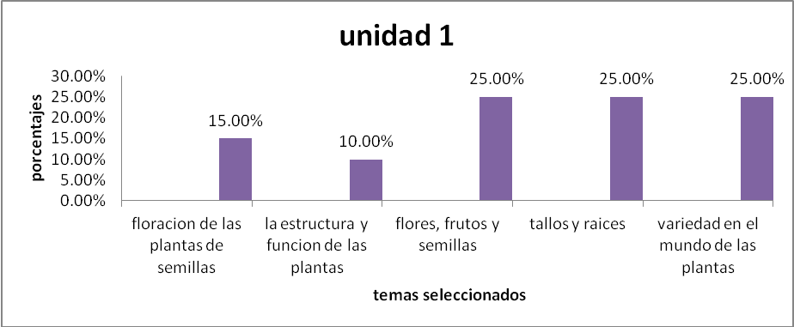

Analysis:
The results shows that most of students are interested on topics related to plants and fruits, also they told researchers that these topics have not been taught in any English class they received. This is a big matter due to students need to be exposed to real topics that must be related to the field they are studying.
- Do you know something regarding to Botany, if not which topics regarding to this area would you like to see?
Summarize:
Unidad 2
anatomía humana y fisiológica
teoría creacionista | 5.00%
huesos y músculos | 5.00%
el sistema nervioso | 50.00%
nutrición y digestión | 20.00%
circulación y respiración | 10.00%
sistemas integumentarios, endocrino y excretorio | 10.00%

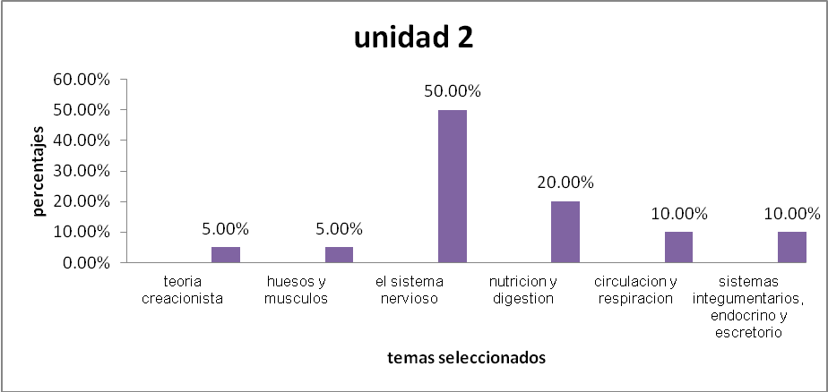
Analysis:
According to the results students are most interested in getting knowledge about nervous system and nutricion and digestion, while the rest are interested on other topics that are related to human anatomy. Researchers compare these topics with the ones they saw at the moment of observing this class are really away from students´ needs.
- Which kind of topics would you like to see in English Service course regarding to Life Sciences and Philosophy?
Summarize:
UNIDAD 3: ciencias de la vida, Metodología y Filosofía
historia natural e investigación científica | 40.00%
evolución un retiro de la ciencia | 10.00%
introducción a la ecología | 50.00%

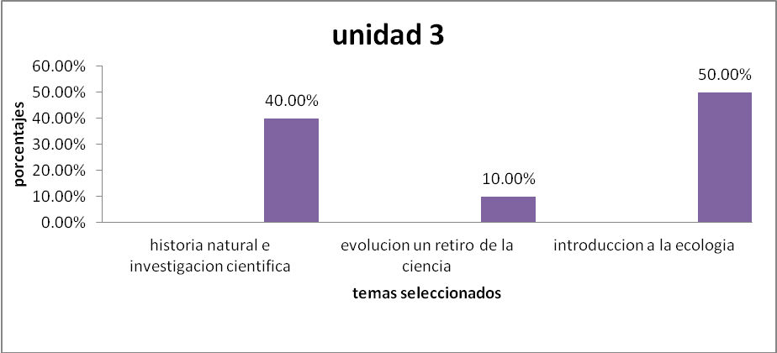

Analysis:
Based on the information above most of the students show the necessity to receive information regarding to Ecology and Scientific Research and natural history, so these topics should be offered in future courses in order to create on students a different perspective of what they need.

- Do you have information about Zoology, if not which are the related topics you would like to see?
Summarize:
UNIDAD 4: Variedad y diseño en el mundo animal (Zoología)
los mamíferos | 50.00%
las aves | 5.00%
reptiles y anfibios | 5.00%
Peces | 10.00%
artrópodos; invertebrados con pies articulados | 20.00%
variedad en el mundo de los invertebrados | 10.00%

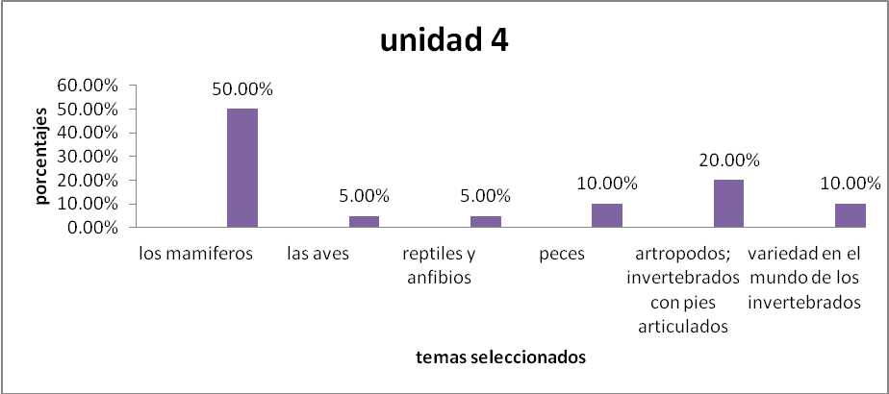

Analysis:
Most of the interviewed students show a big interest on topics related to mammals and invertebrates, also based on this information there is a big necessity to make a change on the current contents they are receiving.
- Which contents would you like to see regarding to your field?
Summarize:

UNIDAD 5
La Biología y la Biología molecular | 20.00%
La complejidad de las cosas vivientes | 20.00%
Citología: El diseño y la función de la célula | 20.00%
Herencia: La continuidad de la vida | 20.00%
ADN: La regulación de la vida | 20.00%

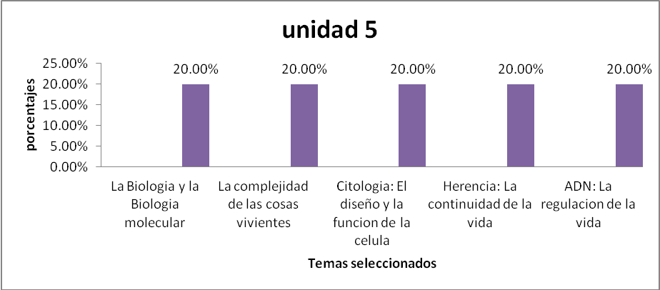

Analysis:
According to the gotten results all students that were interviewed show a big interest on all topics regarding to their study field. This information shows that they are expecting to be really involved in all information about Biology.

Art Major:
- What do you know about Arts?
Summarize:
Unidad 1: | porcentajes
¿Qué es Arte? | 49.00%
Vocabulario Básico de Arte | 51.00%

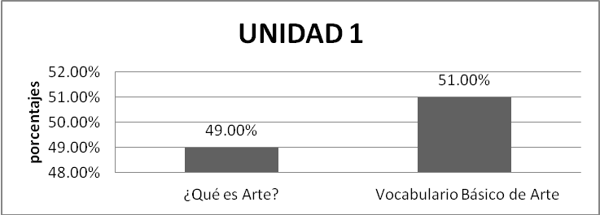

Analysis:
Based on the information above, most of the students are interested on getting knowledge about vocabulary regarding to Arts. Going behind, these topics were not develop at the moment researchers did the Class Observation, so is needed to go deep through this parts in order to get students involved on the major they have chosen.

- What do you know about the beginnings of Arts field?

Summarize:
Unidad 2: | Porcentajes
Arte y Artista en la edad media | 25.00%
El Arte y el Artista en el Renacimiento | 25.00%
El Arte y el Artista en el campo académico | 50.00%

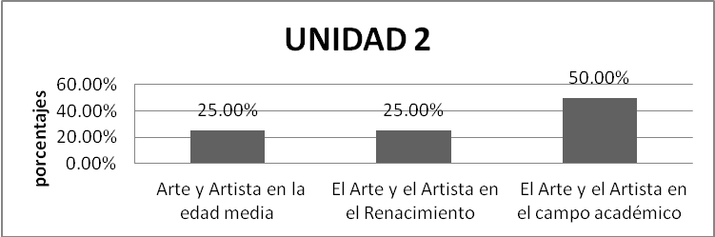

Analysis:
Most of the students are interested in information regarding to their academic field, the results would not be the best if they are not exposed to what they are looking for. This point needs to be studied in order to succeed on this major,

- What information do you have regarding to the different fields that Art have?

Summarize:
UNIDAD 3: | Porcentajes
Las Raíces de Modernismo | 20.00%
El Arte Y Artista en la actualidad | 40.00%
Arte es Forma y Contenido | 40.00%

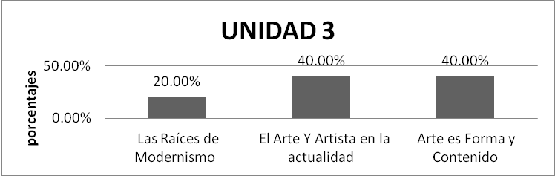
Analysis:
Students are highly interested on learning topics about how they want to be seen in the current times, this is really important due to most students have to be inducted to the real life events that have relationship with their learning area, this exposure helps them to lead their attitudes toward their major.
Based on all information gotten from students´ interview, a change on current syllabi needs to be deeply analized, in order to cover students real needs. Researchers argue that, current Art syllabi applied to English Service Subject requires to be quiet study in order to propose a different perspective, so students can be more interested by doing this the learning results are going to be completely different.
Teachers interview:
Researchers did the following semi-structured interview to Lic. Martin Guerra, with the purpose to know which were his expectations regarding to English Service Area:
Decano: Martin Guerra
- ¿Cuál es su punto de vista con respecto al área de Inglés de servicio?
Están contemplados solo dos de inglés cursos biología y química y dos cursos más instrumentales para tener un dominio de gramática con énfasis de hacer pequeñas traducciones y habilitar la lectura porque parece estar muy limitado y fortalecer la competencia lingüística, también tener la capacidad de comunicarse y leer textos científicos. Anteriormente existían dos cursos de inglés técnicos pero era para conocer estructuras (gramática con vocabulario técnico), para producir textos de química, física y matemática pero desapareció. Hoy en día es indispensable desarrolla la habilidad de comunicarse en una manera básica.
¿Viene extranjeros de intercambio? Vienen profesores extranjeros la mayoría de ellos son bilingües pero el carecer de la habilidad lingüística durante la carrera limita la interacción.
Con respecto a los libros, ¿qué avances traen en el idioma inglés? Indudablemente de todo es conocido que el idioma Inglés es el idioma universal para comunicarse en congresos, en revistas y material escrito.
No hay una estrategia definida depende mucho del maestro y no hay una manera de obligar al estudiante si no dependerá mucho del estudiante por si sabe que lo más importante de ese tema está en inglés deben leer, pero al no tener el dominio del idioma se crea una barrera de rechazo al manejarlo, se crea una barrera pero el factor que domina es el poco dominio y también que los estudiantes no quieren hacer un esfuerzo adicional. Por eso el inglés que se da no es suficiente y hay muchas materias técnicas que no dan lugar para dar 5 horas semanales,
¿Cuántas horas de Ingles tiene los estudiantes? Cuatro horas semanales.
Analysis:
According to engineer Martin Guerra, a big change should be done in order to get students deeply involved on their chosen field. Why? Due the current opportunities students have to be well-prepared on their field, this is because nowadays there are several requirements that are linked to this language. Engineer Martin argues that the current schedule is not enough; he said that, this aspect should be analyzed in order to propose a different one.
- ¿Cuál es el perfil académico que los estudiantes de Biología deben de obtener al finalizar su carrera?
Allí es donde entra el uso del inglés porque los estudiantes para usar técnicas novedosas para genéticas, taxonomía, muchos de las cosas están en Ingles y los estudiantes puede decidir entre temas que ellos quieren investigar toman una revista o un libro de inglés y estudian ese tema más o menos se pueden traducir.
Analysis:
Based on this answer, most students have to be exposed to an environment in which the English language need to be well develop according to the area in which is being used. If students need to read or translate any related material to their major, they have to know how to do it.
- ¿Que pensaría Ud. si se abriesen mas cursos de Inglés?
Si, seria necesario pues el tiempo no es adecuado, además debería ser como requisito que el alumno apruebe y domine por lo menos 420 puntos en el TOEFL para poder graduarse así como lo hacen universidades de otros países que ellos tienen como opción o aprueban la tesis o aprueban el idioma Inglés para poder graduarse como la Universidad Autónoma Metropolitana de México, eso les permitía también poder ingresar a un postgrado solo con la acreditación de el Idioma Inglés. Eso lo conocí allá por el año 1992. Obligaban al estudiante de entrada a tomar un segundo Idioma que a la vez les daba estos beneficios.
Analysis:
It is clear that the period that students are exposed to English Courses is not enough for creating on them an adequate background; more courses need to be addressed to them in order to help students to be more knowledgeable on this subject. An only course does not create on English service students a great level of vocabulary that they can use on real life situations.
- Según su experiencia ¿cual sería la solución al problema planteado?
Flexibilizar y poner como requisito el dominio de inglés para poder graduarse y no habría necesidad de trabajo de graduación.
CENIUES ya no da abasto, la facultad debería de crear otra academia de idiomas que de abasto a las exigencias diarias de los estudiantes que quieren aprender.
Acá hemos pensado en crear una importancia en los estudiantes para crear un programa de inglés que incluya información básica para el área de Bilogía y hacer que el alumno se comprometa consigo mismo para obtener excelentes resultados.
Crear estrategias que conecten las verdaderas necesidades de los estudiantes en las que las facultades se involucren para alcanzar el objetivo.
Analysis:
Administrative staff should analyze a little bit the current activities used to train English students in order to create a different stage in which participants can be really engaged with what they are looking for.
- ¿Poseen maestros contratados para el área de Inglés de servicio?
No de lo que tengo entendido, se ha hecho con servicio social, y antes que naciera CENIUES si se hacía con maestros del departamento, pero ahora se hace con estudiantes del servicio social, y eso no es malo pero deberían de tener un asesor que los evalué y les de tutorías sobre la enseñanza de Inglés, para que el modelo didáctico sea el adecuado a la disciplina desarrollada.
Enseñarle al estudiante del servicio social, técnicas que capten la atención del estudiante inscrito en la materia.
Analysis:
Once again administrative personnel should prepare in somehow all the teachers responsible for teaching English Service courses, it is not bad to have students from social service but it should be appropriate teach them techniques that help to catch students attention.
- ¿Temas adecuados o no la carrera?
Actualmente los temas son pobres y no satisfacen el área aplicada, pues básicamente se les enseña gramática y vocabulario, pero deberían de ser enfocados al área y ahora están más separados de lo que realmente necesitan, debería de haber programa especifico, pues los programas no se cambian eso se mantiene, y se le deja libre al maestro que él decida que enseñar, el único énfasis que se tiene es que le enseñe al estudiante a traducir de una manera textual, que le ayude a capturar literalmente lo que ellos están recibiendo. En los exámenes ellos salen muy mal eso es muestra que hay fallas y se necesita crear estrategias que aborden de una manera objetiva.

Analysis:
The current topics that students are receiving are not adequate to their fiel, students are getting low grades due to the lack of strategies used to teach them, this point need to be carefully analyzed in order to propose an objective solution.
Jefa del Departamento de Artes: Lic. Xenia Pérez Oliva
Artes
- ¿Como evalúa el área de inglés en este departamento?

Existe la necesidad de mejorar los siguientes puntos:
- Habilidades para leer y comprender texto,
- Habilidades comprender textos
- Solo leer no es suficiente
- Necesitamos un ingles mas productivo

Analysis:
A deep analysis need to be conducted through Arts syllabi, due to the current teaching parameters are not enough to create on Art´s student a different perspective of what they need to learn.

- ¿Existe un maestro asignado a esta material por parte de la Escuela de Artes?
No actualmente trabajamos con maestros asignados por el Departamento de Idiomas Extranjeros, dependemos de ellos, generalmente son maestros contratados por horas clases. Solicitamos al jefe del departamento para que nos manden a la persona indicada
Analysis:
Arts School does not have a specified teacher for English Service class, they depend on who does the boss of Language and Foreign Department decides to send them. They should have a second propose too in order to evaluate how is going to be attending students´ need.

- ¿Cual es el perfil profesional que el estudiante de Artes debe cumplir al final de su carrera?
Perfil profesional, el alumno debe estar capacitado para resolver problemas con mucha creatividad apegados al contexto donde se encuentran ellos desarrollando la actividad, por ello el Inglés es realmente importante pues el estudiante debe tener técnicas que le ayuden a solventar situaciones donde se requiera su intervención.

Analysis:
In order to develop a competent professional profile, Arts student need to be taught with techniques and methods that help them to deal with situations that will need their analysis in order to propose appropriate solutions.

- ¿Cuales temas considera Ud importantes para que los estudiantes se involucren en la carrera elegida?

Áreas de estudio:
- Arte contemporáneo
- Manifestación cultural
- Habilidades técnicas

Analysis:
All topics that an Arts syllabus needs to be addressed to what participants need, this can help them to be more engaged with their own goals.

- ¿Cuantos cursos considera Ud. necesarios para esta material?
Deberían de ser por lo menos tres cursos de ingles intensivos para que el alumno construya más su lado laboral.

Analysis:
The current courses are not enough; more hours should be applied in order to build on students a wide professional space.

Coordinador del Área de Inglés de servicio: Lic. Miguel Carranza:
- ¿Desde qué fecha esta Ud. encargado de el área de Inglés de Servicio?
Pues he sido asignado en el segundo ciclo de el año 2012.
- ¿El programa de estudio para esta materia es nuevo o se esta trabajando con un diseño anterior?
Pues esta el clásico desde hace varios años, pero creo de unos tiempos atrás estos chicos han mezclado en Inglés comunicativo con el Inglés para propósitos específicos enfocado a la enseñanza a la lectura y es así como lo están trabajando, Inglés comunicativo mezclado con técnicas de lectura, antes solo eran técnicas de lectura.
- ¿En que se basan para hacer o diseñar un programa?
Me han comentado los que están actualmente que por ejemplo la Jefa de Artes quería que los estudiantes de Artes aprendan un Inglés comunicativo, en sociales quieren el Inglés como lectura solamente, y así se han escuchado opiniones de los jefes y alumnos para crear un ambiente apropiado, la experiencia de los profesores y alguna asesoría que uno les pueda dar, en este caso lo que yo he hecho es revisarles y es donde he visto que han modificado para hacerlo un poco comunicativo,
- ¿Los contenidos están apegados al área en la que se están desarrollando?
No se exactamente el porcentaje de acercamiento que ellos puedan tener con respecto a los temas que imparten pues como se darán cuenta ellos no son maestros de Bilogía sino de Inglés, así que ellos solo generalizan

- ¿A que carreras se les brinda este servicio?
Antropología, Sociología, Historia, Psicología, Educación, Bilogía y Artes.
En el caso de educación fue desligado de nuestro departamento y ahora ellos están contratando maestros por su parte, pero en realidad el maestro tiene libertad de cátedra y ellos lo pueden diseñar como mejor les parezca, no existe ninguna regulación en ese lado

- ¿Hay una previa revisión de los programas por parte de los jefes?
Los jefes no se meten en este punto allí se le deja al profesor nada mas y también el coordinador no es fijo se cambia constantemente todos son licenciados, no son personas inexpertas, en realidad cada departamento debe canalizar que es lo que el estudiante realmente necesita,
- ¿Qué aspectos deberían de tomarse para diseñar un programa de estudio?
- Saber que es lo que necesitan los estudiantes
- Consultar a profesores del departamento o ex graduados
- Revisar que el material sea adecuado al área que ellos estudian.
- Consultar libros recientes como el Reading Power que es uno de los clásicos.
Analyzing all the questions above, there are many empty spaces on syllabi design, due to there is a lack of revision on which topics students will receive, also not all professors are following an structured syllabus to teach students, since they are allowed to teach students what they think is the best. Researchers argue that, professors, students enrolled, head of departments and tutors should meet in order to establish a line and a sequence on which topics will help students to be more engaged on what they are learning.
According to researchers’ class observation on Arts class, students did not receive any topic regarding to their field, this is a problem, why? Because, in future activities in which students should use the English language they will not be able to applied what they receive in class, due to contents were not the ones they needed.
Jefe del Departamento de Biología: Lic. Rodolfo Menjivar

Desempeño del curso de Inglés en Biología.
El jefe no conoce sobre el desarrollo de los contenidos ya que el no sabe sobre el programa de la materia. El explica que el inglés que se desarrolla en la carrera es específicamente para desarrollar técnicas de lectura.
El inglés que pide la escuela es Técnico.

Contenidos Importantes.
Lo que le interesa al Lic Menjivar es que los estudiantes sepan comprender lecturas relacionadas a su carrera, no necesitan un inglés comunicativo.

Material
La aplicación de diverso material para la comprensión es muy variada hoy en día ya que con la tecnología del internet la información está más al alcance de los estudiantes. En años pasados los estudiantes investigaban sobre algún tema en ingles y luego tenían que exponerlo según su análisis y comprensión de la lectura.
Muchas veces la terminología es muy compleja, entonces se debe poseer una buena herramienta como es un buen diccionario técnico.

Tiempo
Para el Lic Menjivar es importante conocer anticipadamente sobre el programa adecuado antes de iniciar clases. Con respecto al número de horas que se imparte inglés, a él le parece bien que se diera 5 horas clase por semana, aunque esto depende de las U.V. que cada materia posee.

Aplicación del idioma al campo laboral
No utilizan libros de texto para el desarrollo de otras materias que el departamento imparte, sino que usan artículos ya que en el se utilizan varias palabras claves como abreviaturas y bien técnicas, propias de ese campo.
En nuestro departamento es solo un inglés el que se imparte y se cursa en el ciclo sexto aunque alumnos de primer año la pueden cursar ya que no posee ningún pre requisito, aunque yo considero que eso no es apropiado pero como el sistema les permite hacerlo. Ellos deberían tomarla cuando les corresponde.

5. MANAGING ASPECTS
5.1 RESOURCES
During the development of this Project, researchers need funds to accomplish each part of this research, one of the aspects that is required to facilitate the investigation is the Human Resources, they are form by:
Tutor: M.T.I Pedro Antonio Salazar Murcia
Responsible of the English Area: M.A. Miguel Carranza
Secretary of the Foreign Language Department: Mónica Hernández
Professors of the Foreign Language Department: Lic. Grace Gómez,
Lic. Ricardo Cabrera and Lic. Nicolas Ayala
Dean of Facultad de Ciencia Naturales and Math school: Ing. Martin Guerra
Head of Biology Department: Lic. Rodolfo Menjivar
Head of Arts School: Lic. Xenia Pérez Oliva.

At the same time researches need Material and Equipment for their investigation as they are presented in the chart below:

MATERIAL | EQUIPMENT
Paper  Books  Photocopies  Notebooks  Brochures  Ink  Prints  Folder  Internet | Cell phone  Computer (Desktop, Laptop)  Printer  USB

5.2 BUDGET
Also researchers have invested Money and time on the project, following there is a summary for each member about the investment:
Gustavo Funes
MONEY | TIME
$776 | 500 Hours

Ada Estelí Mendoza
MONEY | TIME
$1044 | 500 Hours

Ana Silvia Orellana
MONEY | TIME
$776 | 500 Hours

Roxana Marisol Pérez Ramirez
MONEY | TIME
$1208 | 500 Hours

TOTAL
MONEY | TIME
$3804 | 2000 Hours

5.3 CHRONOGRAM
ACTIVITIES |  | NOVEMBER |  |  |  | DECEMBER |  |  |  | JANUARY |  |  |  | FEBRUARY
1 | Tutor’s meeting
2 | Class’ Observation
3 | Proposal
4 | Group meeting
5 | Search bibliography
6
7
ACTIVITIES |  | MARCH |  |  |  | APRIL |  |  |  | MAY |  |  |  | JUNE
1 | Bibliography analysis
2 | First draft
3 | Tutor´s meeting
4 | Group meeting
5 | First draft corrected
6 | Tutor´s meeting
7 | Second draft
8 | Syllabi analysis
ACTIVITIES |  | JULY |  |  |  | AUGUST |  |  |  | SEPTEMBER
1 | Tutor´s meeting
2 | Group meeting
3 | Third draft
4 | Tutor´s meeting
5 | Group meeting
6 | Final draft
7 | Tutor´s meeting
8 | Last Draft
9 | Thesis Complete
6. CONCLUSIONS
According to the results obtained from class observations, teachers/ students interviews and syllabi analysis, as well as own experience as foreign learners all applied syllabi have to cover students necessities but previous the teacher in charge has to investigate what participants really need, that is mean the contents have to fit with student professional profile.
Based on the research question: “How do the contents of the current English Syllabi applied to Service Area fit Art students’ needs at the University of El Salvador during the second semester of 2011?”, the researcher team establishes that, the syllabus applied to English Service course in Art major have to be deeply studied and revised at least every semester in order to be updated with the current reality.

All professors need to analyze carefully what their students want to learn, in order to have a learning environment in which participants can easily perform, reinforce and develop what they are learning. By doing this, all parts involved in the learning process are going to get the better results.

Students need to be listened in order that their learning can be more significant and also to help them to develop in a better way their own abilities, by taking interest to the contents and the class performance, going in this way student will become a competent professional in the modern world.

According to the findings, the University authorities have to be interested on syllabi design and take them involved for monitoring all related activities to syllabi development, in order to get better syllabi arrangement, this will help to professor performance, also help them to facilitate their job at the moment of planning an English class.

As a manner of conclusion, the research team recognized that there are several weaknesses in the English Service Area, mainly on syllabi design, due to, as was mention before, nobody is taking care of this important part, and according to University laws, and students necessities, this must be carefully analyzed, and all the people involved have to reflect on this problem. Even though, this is an optional subject, teachers and authorities have to take the merely importance on this area, in order to satisfy students´ goals and needs.

Finally, the researchers have done this investigation with the idea to place the basis for future projects, also to take it into consideration the recommendations that are presented on this work.
7. RECOMMENDATIONS
Considering all the syllabus’ characteristics and students’ needs to have a significant learning in their major profile and the obstacles that students may find which interfere in the Students’ development, the research team suggests the following recommendations to develop a syllabus that fulfills Arts and Biology students’ profile with real academic and working needs:
- The Foreign Language Department should verify that teachers have updated contents with the current tendency of the students’ needs regarding to academic field.

- The syllabi should be revised every certain time as it is demanded by the Organic Law of the University of El Salvador in the article 22, in the fourth section of the “Consejo Superior Universitario” which states about the attributions and duties.

- The Foreign Language Department should work on designing Syllabus according to the students’ needs in their academic and working profile, in order to develop competences to incorporate them to obtain a job opportunity.

- There should be a research aiming at evaluating and proposing a previous course prior to the Technical English.

- The Foreign Language Department should ask the authorities of Arts and Biology Schools to provide teachers with material such as books, magazines, and other important resources necessary to develop students’ knowledge in Art and Biology field.

- The Foreign Language Department should specialize or train specific professors to be in charge of the English Area, so that the students acquire the best instructions as possible.

- The Arts School should include more English courses in its study plan, so that the students improve their skills in the language in order to obtain an international scholarship and job opportunities.

- The Foreign Language Department should request students from the other schools that need English services a minimum of Basic English level to attend the English Courses.

- The Foreign Language Department should have more academic relationship with the schools in which the English Service is provided, in order to interchange and give relevant information that helps to develop the educational activities in the courses.

8. BIBLIOGRAPHY
Arias, Fidias G. (1999). El Proyecto de Investigación (3ra Edición). Caracas: Venezuela.

http://actflproficiencyguidelines2012.org

Parkes Jay and Harris. Mary B. (2001). The purpose of a syllabus. University of New Mexico: Albuquerque.

Far, Mohammad Mohseni. M.A., (2001). An overview of syllabi in English Language Teaching. Shahid Chamran University, Iran.

Kranhnke, Karl. (1987). Approaches to syllabus design for Foreign Language Teaching. Englewood Cliffs, New Jersey.

Ley Orgánica de la Universidad de El Salvador, (199). Tomo No. 343, número 96, dado en el Salón Azul del Palacio Legislativo: San Salvador, El Salvador.

Peterson, Pat Wilcox, (1986). ESP in Practice, Models and Challenges for Teachers, English Language Programs Division Bureau of Educational and Cultural Affairs. United States Information Agency: Washington, D.C.

Graves, Kathleen, (2000). Designing Language Courses: A Guide for Teachers. Boston, MA, USA.

Brown, Douglas H, (2001). Teaching by principles an Interactive Approach to Language Pedagogy. (2nd Edition). San Francisco State University.

Davies, Paul, with Pearse, Erick, (200). Succes in English Teaching. Oxford Handbooks for Language Teachers. Oxford University Press.

9. ATTACHMENTS

