UNIVERSITY OF EL SALVADOR
SCHOOL OF ARTS AND SCIENCES
FOREIGN LANGUAGES DEPARTMENT

UNDERGRADUATE RESEARCH

PROBLEMS THAT THE STUDENTS OF TERCER CICLO FACE IN THE LARGE ENGLISH CLASS AT CENTRO ESCOLAR “RAFAEL ALVAREZ LALINDE” IN SANTA ANA CITY

PRESENTED BY:

NORMA LIZETH CHAVEZ CHAVEZ CC02108
TERESA DE JESUS HERNANDEZ MENDOZA HM01026
GERARDO ALBERTO JUAREZ CONTRERAS JC03004

IN ORDER TO OBTAIN THE DEGREE OF:
LICENCIATURA EN IDIOMA INGLES OPCION ENSEÑANZA

ADVISOR:
RICARDO GARAY SALINAS, M Ed.

San Salvador, El Salvador, Central América, September 27, 2012

AUTHORITIES OF THE UNIVERSITY OF EL SALVADOR

ING. MARIO ROBERTO NIETO LOVO
RECTOR

MTRA. ANA MARIA GLOWER DE ALVARADO
ACADEMIC VICE RECTOR

IN PROCESS TO BE ELECTED
ADMISTRATIVE VICE RECTOR

DRA. ANA LETICIA ZAVALETA DE AMAYA
SECRETARY GENERAL

AUTHORITIES OF SCHOOL OF ARTS AND SCIENCE

LIC. JOSE RAYMUNDO CALDERON MORAN
DEAN

MTRA. NORMA CECILIA BLANDON DE CASTRO
VICE-DEAN

MTRO. ALFONSO MEJIA ROSALES
SECRETARY

AUTHORITIES OF THE FOREIGN LANGUAGE DEPARTMENT

MTRO. RICARDO ANTONIO GAMERO
HEAD OF THE DEPARTMENT

RICARDO GARAY SALINAS, M Ed.
ADVISOR AND GENERAL COORDINATOR OF
THE DEGREE PROCESSES

ACKNOWLEDGMENTS

TO GOD ALMIGHTY

TO MY MOTHER

TO MY FATHER

TO MY SISTERS AND BROTHERS

TO MY CO-WORKERS

Thanks Lord for giving me the wisdom, strength, and faith to achieve this goal, for blessing my life. “Trust in the Lord with all your heart, and lean not on your own understanding” Proverbs 3:5

God bless you, mother, for your unconditional love, patience, and comprehension to me. Thanks for your prayers, advices and for being there when I need you.

For the support, concern, and love during all this years. God bless you!

For the confidence, help, and affection that you give me

Thank you for your friendship and support. For let me share this experience with you. Thanks a lot!

NORMA LIZETH CHAVEZ CHAVEZ
ACKNOWLEDGMENTS
With especial dedication to:

GOD

TO MY PARENTS

TO MY SISTER

TO MY TEACHERS

TO MY FRIENDS

TO MY CLASSMATES AND FRIENDS

For giving the strength to deal with any kind of situation in my life

Rosa Estela de Hernández and Oscar Armando Hernández, for being there for me at any time, for their support, unconditional love, and for all their effort to help me in everything they could
Elda Beatriz Hernández Mendoza, for giving me joy and believing in me.

For their contribution to my professional development

Julia Margarita Chilin Paniagua and Oscar Oswaldo Zepeda Vargas, for their dedication to help me whenever I needed, for their support and encouragement that inspired me to never give up

Norma Chávez and Gerardo Juarez, for their friendship, enthusiasm, support, and dedication in the development of this work

TERESA DE JESUS HERNANDEZ MENDOZA
ACKNOWLEDGMENTS

TO MY GOD AND SAVIOR

TO MY BELOVED PARENTS

TO MY BELOVED “TIA PATY”

TO MY AUNTS AND RELATIVES

TO MY TEACHER LIZ AND DAUGHTERS

My love, devotion, and worship are yours. For your unending love, for being more than a friend to me, and for everything you have done for me; for Jesus Christ, my Savior, I surrender this major at your feet “…Worthy are you, our Lord and God, to receive glory and honor and power, for you created all things, and by your will they existed and were created.” Revelation 4, 11

I love you so much. Words cannot express how thankful am I for your unconditional love, support, and patience “…good and perfect gift is from above, coming down from the Father of the heavenly lights, who does not change like shifting” James 1, 17

For being like a second Mother, not only for me, but for nearly all my cousins; thank you for your great love and support “then I will bless her, and she shall be a mother of nations” Genesis 17, 15b

Dear “Tia Conchy and Tia Margara” my other aunts, uncles, cousins, grandparents and friends. Thank you for your love and support. “…and in multitude of counselors there is safety..” Proverbs 24, 6b
For your friendship and for being such an inspiration to take this major “she speaks with wisdom, and faithful instruction is on her tongue” Proverbs 31, 26b
TO BEATRIZ HENRIQUEZ

TO TEACHER GLOWER

TO MY PASTORS AND THE CHURCH

For your great support, company, and the special moments, you are so special “…thank you for being such a friend to me, Oh I pray a friend for life…” Flyleaf – Broken Wings; “…a friend loves at all times, and a brother is born for a time of adversity.” Proverbs 17, 17

For giving me warmth welcomes to my new place of study “Blessed is the man who finds wisdom, the man who gains understanding” Proverbs 3, 13

For all the prayers, the friendship, and the special moments “For in him all things were created: things in heaven and on earth, visible and invisible, whether thrones or powers or rulers or authorities; all things have been created through him and for him.” Colossians 1, 16

TO THE RESEARCH TEAM

For being a blessing for me, I really enjoyed working with you both girls. Norma Chavez and Teresa Hernandez this moment is ours. “In all labor there is profit” Proverbs 14, 23a

GERARDO ALBERTO JUAREZ CONTRERAS
ACKNOWLEDGMENTS

TO OUR ADVISOR

We owe special thanks to our advisor Ricardo Garay Salinas for his unconditional support during the elaboration of this project. He provided us valuable assistance, guidance, and advices to the successful completion of this work.

TO THE AUTHORITIES OF CENTRO ESCOLAR “RAFAEL ALVAREZ LALINDE” IN SANTA ANA CITY
For letting our research team to enter to their school to carry out this investigation, providing their valuable trust in us in this important research project, and as well for having given us the necessary support without any hesitation.

INDEX

INTRODUCTION xi
ABSTRACT xiii
CHAPTER I
STATEMENT OF THE PROBLEM
1.1 DESCRIPTION OF THE PROBLEM 1
1.2 OBJECTIVES 4
1.3 JUSTIFICATION 5
CHAPTER II
STATE OF ART 7
CHAPTER III
METHODOLOGICAL DESIGN
3.1 TYPE OF PARADIGM AND TYPE OF RESEARCH 15
3.2 DESCRIPTION OF THE POPULATION AND THE SAMPLE 16
3.3 FORMULATION OF THE OBJECTIVES 17
3.4 FORMULATION OF THE STATE OF ART 17
3.5 DATA GATHERING TECHNIQUES AND INSTRUMENTS 17

3.6 ELABORATION OF THE INSTRUMENTS 19
3.7 PROCESS TO VALIDATE INSTRUMENTS 19
3.8 PROCESS TO BUILT RAPPORT WITH THE STUDENTS………………………20
3.9 DESCRIPTION OF THE DATA GATHERING TECHNIQUES PROCESS .21
3.10 PROCESS TO ANALYZE AND INTERPRET DATA 22
3.11 VISUALIZATION OF THE INVESTIGATION 23
CHAPTER IV
DATA ANALYSIS AND INTERPRETATION
4.1 DISCUSSION OF THE RESULTS 24
CHAPTER V
CONCLUSIONS AND RECOMMENDATIONS
CONCLUSIONS 37
RECOMMENDATIONS 42

BIBLIOGRAPHICAL REFERENCES 45
ANNEXES
ANNEX A 49
ANNEX B 50
ANNEX C 51

ANNEX D 54
ANNEX E 67
ANNEX F 77
ANNEX G 83
ANNEX H 84
ANNEX I 85
ANNEX J 86
ANNEX K 129
ANNEX L 130
ANNEX M 132

INTRODUCTION

With the increasing population, the number of students’ enrollment to school is growing much faster than the number of schools does. Overcrowded classrooms present a problem not only to teachers but also to students. The public school buildings in El Salvador are small. The classrooms often do not have enough materials to support all the students who are attending and the classes are overpopulated.
This document comprises all the information about the undergraduate research work “Problems that the Students of Tercer Ciclo face in the Large English Class at Centro Escolar Rafael Alvarez Lalinde in Santa Ana City”. The study describes how problems of discomfort, control, individual attention, evaluation, and learning effectiveness take place in the large English class with the students from 7th to 9th grade at Centro Escolar Rafael Alvarez Lalinde in Santa Ana city.
This research contains five chapters: Chapter I that consists of the description of the problem, the objectives, and the justification. In this chapter are found the strong reasons why this project is relevant. Chapter II is composed of the state of art, where is presented the theory that functions as reference material for the investigation. Chapter III encompasses the type of paradigm and type of research the researchers used to execute the study; the description of the population and sample; formulation of the objectives; creation of the state of art, data gathering techniques and instruments; validation; the process to build rapport with the students taken as sample; description of the data gathering techniques process; process to analyze and interpret data; and the visualization of the investigation. Chapter IV presents the analysis and interpretation of data through the application of the instruments to the students of Tercer Ciclo at Centro Escolar Rafael Alvarez Lalinde and the use of the software Nvivo 8. Finally, the chapter V includes the conclusions the teamwork drew after the discussion of the results, and the recommendations.

ABSTRACT
The main purpose of this research project was to understand how problems of discomfort, control, individual attention, evaluation, and learning effectiveness take place in the large English class with the students from 7th to 9th grade at Centro Escolar Rafael Alvarez Lalinde in Santa Ana city.
Thus, the investigation was aimed at answering the question: How do problems of discomfort, control, individual attention, evaluation, and learning effectiveness take place in the large English class with students from 7th to 9th grade at Centro Escolar Rafael Alvarez Lalinde in Santa Ana city?
This was a qualitative research study because it was used to gain insight into people's attitudes, behaviors, concerns, meanings, and culture. Besides, it includes a description of the main problems found in the large English class. The Ethnography and Photography methods were used in this research because ethnography is focused on describing a culture or way of life in the participants’ points of view and photography enriches it by taking into account recording equipment. The unit under study was 18 out of 84 students from 7th to 9th grade at Centro Escolar Rafael Alvarez Lalinde in Santa Ana city. Subsequently, it was found out that the problems of discomfort, control, individual attention, and evaluation affect in great manner students and teachers in large classes since they are obstacles for learning effectiveness. Even though the students’ lack of interest seemed to be a main factor here, the other problems mentioned above only contribute to make the situation worst. Therefore, some recommendations are included to be taken into account in order to minimize the effect of the problems.

CHAPTER I
STATEMENT OF THE PROBLEM

1.1 DESCRIPTION OF THE PROBLEM
Large classes in many developing countries are an unavoidable fact of life and will remain so for many years to come, just as in the previous centuries they were a typical feature of the education systems of industrialized countries (Valérien, 1991). Thus, class size is an ongoing issue in education and it is continually expanding. For this reason, researchers and educators have argued that large classes can have negative effects on students achievement as Leahy (2006) has stated that it consists of a decrease in student achievement of those in larger classes and an increase in student achievement of those in smaller classes.
In El Salvador, the issue of having large classes in public school is very common since the population growth has increased abruptly in the last decades (Tobar, Hernandez, & Alvarenga, 2005). Thus, population growth has become one of the main reasons why Salvadoran public schools have large classes making the teachers’ job harder to develop. In the Education System of El Salvador, English teaching has been taught since long time ago in Tercer Ciclo (7th, 8th, and 9th grades) taking into account that students are in a propitious age to learn easily a new language (Tobar, Hernandez, & Alvarenga, 2005). However, according to some English educators, this process should be developed in the best conditions.
In public schools of El Salvador, it is very common for teachers from 1st to 9th grade to find classes with more than 25 students. In addition, according to Roni Reynaldo Alvarez, principal of Centro Escolar Rafael Alvarez Lalinde in Santa Ana City, the enrollment of students has increased significantly since the last three years. This year, for instance, the institution had an increase of students willing to study due to some benefits they have been given by the government. Unfortunately, student overpopulation is one of the most important hindrances that can affect the teaching-learning process. In addition, the classrooms size is a factor since they are very small for the amount of students they can hold. The number of students in Centro Escolar Rafael Alvarez Lalinde exceeds the number established by experts in teaching a foreign language. According to Murphy (1998), a small class contains 13-17 students while a large class contains 22-25 students. This factor makes it hard for the teachers to control students and guide their learning. Therefore, students at Centro Escolar Rafael Alvarez Lalinde face a series of problems that a large class may have.
Students in large classes report the highest degree of dissatisfaction on course-evaluation questions relating to the quality of student instructor and student-student interaction (Feldman, 1984; Carbone & Greenberg, 1998) quoted by Cuseo Joe (n.d.). At Centro Escolar Rafael Lalinde, the students faced this problem because there were 34 students in the seventh grade, 25 in the eighth grade, and 25 in the ninth grade, in the classrooms with capacity for 17 students. This situation was difficult because as it was observed in the institution, the teacher could not move around the classroom to monitor the entire class. The students at the back made noise and distracted the rest of the class. Because of the big amount of students, not all of them could participate in class; moreover, some other students were reluctant to participate because they felt ashamed to make mistakes in front of their classmates, especially girls since there are more boys than girls in all the classrooms of Tercer Ciclo of the school mentioned above. Hayes (1997) summarized the problems with teaching in large classes as follows: discomfort, lack of control, individual attention, evaluation, and learning effectiveness. Moreover, through spontaneous talks, the researchers found out relevant information to support this situation. Though there were some students that have no major problems when being exposed to this kind of situation, the rest faced any issue in such environment. For example, a student said, “No me gusta participar en la clase de ingIés porque me da pena” (I do not like to participate in class because I feel embarrassed). Other student expressed, “No me gusta que la seño de ingIés me haga repetir una palabra o una oración en voz alta porque no puedo inglés” (I do not like when the teacher asks me to repeat a word or a sentence aloud because I cannot speak English”). This was related to fear to perform in front of a large group of classmates. Seemingly, most of the students liked the language and considered it important for their future, but they did not feel like learning a big deal. Thus, they expressed that they have found the English subject very difficult. Therefore, an important question arises: How do problems of discomfort, control, individual attention, evaluation, and learning effectiveness take place in the large English class with students from 7th to 9th grade at Centro Escolar Rafael Alvarez Lalinde in Santa Ana city?

1.2 OBJECTIVES
GENERAL OBJECTIVE
- To understand how problems of discomfort, control, individual attention, evaluation, and learning effectiveness take place in the large English class with the students from 7th to 9th grade at Centro Escolar Rafael Alvarez Lalinde in Santa Ana city
SPECIFIC OBJECTIVES:
- To describe how the problem of discomfort in the large English class affects students from 7th to 9th grade at Centro Escolar Rafael Alvarez Lalinde in Santa Ana city
- To illustrate how the problem of control takes place in the large English class with the students from 7th to 9th grade from Centro Escolar Rafael Alvarez Lalinde in Santa Ana city
- To describe how the problem of individual attention affects students from 7th to 9th grade in the large English class at Centro Escolar Rafael Alvarez Lalinde in Santa Ana city
- To illustrate how the problem of evaluation takes place in the large English class with students from 7th to 9th grade at Centro Escolar Rafael Alvarez Lalinde in Santa Ana city
- To describe how the problem of learning effectiveness occurs in the large English class with students from 7th to 9th grade at Centro Escolar Rafael Alvarez Lalinde in Santa Ana city
1.3 JUSTIFICATION
Most teachers agree that teaching a small group of students is easier, more enjoyable, and less time consuming than teaching a large group. Unfortunately, due to budgets, space, or lack of teachers, many ESL schools only offer large classes. Besides, education researchers suspect that class size reduction in the early grades helps students to achieve because there is a greater opportunity for individual interaction between student and teacher in a small class (Greatschools, 2012). Therefore, this research was aimed to explain how the problems of discomfort, control, individual attention, evaluation, and learning effectiveness affected students in the large English class at Centro Escolar Rafael Alvarez Lalinde in Santa Ana city since the school presented the case of overpopulation.
Since it is very common to find large classes in public schools in El Salvador, the researchers considered that it was relevant to carry out an investigation on this area. Besides, there were not too many studies in this country about the topic, so the investigators considered that to accomplish a project like this could help to improve the students’ performance even with an increased number of students. But first, it was important to determine what the problems were to see how they affected the students, so the most convenient options could be provided to deal with the situation. The investigators decided to make the investigation at Centro Escolar Rafael Alvarez Lalinde because this school met the requirements to develop this research about the problems of large English classes essentially in 7th, 8th, and 9th grade. Moreover, the Principal and the rest of the teachers of the institution welcomed the idea of carrying out the study on their school because they are concerned about the problems, and they expected with this study to find out better ways to deal with the issue.
Previous observations and spontaneous talks showed that many students faced problems when being in the large English class. The students hardly moved inside a small classroom with more than twenty-five people. With so many students packed into one classroom, the teacher was not able to have one-on-one time with the students that needed help. With the classroom overcrowded, the teacher hardly ever saw what was happening with all the students. It was very difficult for the teacher to keep an eye on say 25 plus students when also trying to teach; besides, some shy students or more introverted students felt inhibited to freely ask questions or make comments when the group was large. This affected the students' development, confidence and understanding of the subject. Researchers believe that smaller class sizes increase student achievement. Thus, it is critical that class size and its effects be investigated (Leahy, 2006). Therefore, the inspiration to make this research was to help students to have a better learning environment, to guide teachers overcome the issue of overpopulation at public schools. Even though it was not possible to eliminate these problems completely, conditions were created to diminish them.

CHAPTER II
STATE OF ART

A child's experience in an elementary school classroom serves as the foundation for the rest of his educational career. However, many elementary school students must learn in overcrowded, large classes; the growth of large classrooms in the developing world is tied to two interrelated trends: global initiatives for universal education and rapid population growth. These are a result of a web of factors that make large classrooms an enduring feature of the developing world. Thus, rapid population growth is the foundation upon which discussions of school overcrowding rest. In the four decades between 1959 and 1999 the world’s population doubled. Therefore, there is a need to deal with situation searching for ways to increase student success (Benhow, H, Mizrachi, A, Oliver, D, & Said-Moshira, L, 2007) quoted by GreatSchools staff (2008).
As explained by O'Brien (2011), the large classes are overwhelming teachers, for example, one 24-year veteran said: “I’ve won awards. I am a champion teacher. … This is the first time I’ve felt inadequate.” Thus, the author continues by saying that these classes also upset students. One high school senior pointed out that class sizes are so large that classrooms do not have enough seats. Some students have to stand or go into the hallway. It makes them feel unimportant. So, the biggest problem is that kids aren’t getting the education they deserve and teachers struggle to keep up with basic work.
As stated by GreatSchools Staff (2008), many studies have shown an increase in student achievement, fewer discipline problems and improvement in teacher morale and retention as a result of class size reduction. But many researchers question whether the costs outweigh the benefits. Enlargement of class size may seem to be the only solution to deal with the shortage in personnel and material resources. However, large classes result in many problems associated with the teaching and learning of English. These problems are the following:
Discomfort
Discomfort is defined by audioenglish.net as the state of being tense and feeling pain or an uncomfortable feeling of mental painfulness and distress. This factor is a big problem in the large English class. Hayes (1996) has found that many teachers are worried by the physical constraints imposed by large numbers in confined classrooms. They feel unable to promote student interaction, since there is no room to move about. Some teachers also feel that teaching in large classes is physically very weary. The students cannot move easily and some students do not do the activities. Teachers must speak very loud and make them sore throat. There is not enough room (space) to do the activities. Large size of class makes teachers very frustrated and tired and they feel hopeless to manage the class successfully (Hayes, 1996). As stated by GreatSchools Staff (2008), it has been found that when the class size is small, students are more likely to achieve because there is a greater opportunity for a good interaction since there is little distraction and noise, so they can feel more comfortable. On the other hand, teachers are less likely to feel overwhelmed and more likely to provide a supportive environment. As a result, the small class reduces the distractions in the room and gives the teacher more time to devote to each child.
Lake, William (2011) expresses that “when teaching a large class, it is important to remember that you might be pushed for space. You might not be able to arrange the classroom how you usually do or how you would like.” Ensure that the students are as comfortable as possible to help them to stay interested in any class activities. If possible, arrange the students into groups.
Control
Henry Fayol (1949) defined Control as an undertaking that consists of seeing that everything is being carried out in accordance with the plan which has been adopted, the orders which have been given, and the principles which have been laid down. Its object is to point out mistakes in order that they may be rectified and prevented from recurring. These principles are founded in effective teaching theories and classroom management to support the teaching-learning process at any environment it is carried out. Kennedy and Kennedy (1996) stated that it is difficult to control what happens when the number of group passes a certain number. In these words is accurately described the reality of education in developing countries, especially, in public schools, in which day by day, teachers need to face and overcome the difficulties lack of control may bring. Teachers are often worried by the discipline aspects of large classes. They feel they are unable to control what is happening and that the classes become too noisy (Hayes, 1997). The issue of control in class is strongly related with discipline, and the larger the class, the less control the teacher can have; in addition, Hess (2001) has admitted that teachers feel the loss of authority; they often feel that with a large number of students in a class it is more difficult to maintain discipline. Nevertheless, good organization helps to promote good control, as It helps students to know what is expected of them and to get on task quickly and efficiently. Also, setting up routines early in the term helps the class to operate more smoothly.
Individual Attention
Blatchford (2003) showed the importance teachers attach to individual attention as the basis for effective teaching and how this suffered in larger classes and that in small classes pupils were more likely to be the focus of a teacher’s attention. Conversely, in a large class there is more chance that a pupil would be in an ‘audience’ mode, that is, listening to the teacher address all pupils equally or another pupil. Small classes therefore seem to allow more individual attention, while in large classes students are more likely to be one of the crowd.
Education researchers suspect that class size reduction in the early grades helps students to achieve because there is a greater opportunity for individual interaction between student and teacher in a small class. Teachers generally have better morale in a small class, too, and are less likely to feel overwhelmed by having a variety of students with different backgrounds and achievement levels. One researcher, Frederick Mosteller notes "Reducing the size of classes in the early grades reduces the distractions in the room and gives the teacher more time to devote to each child" (GreatSchools Staff, 2008).
GreatSchools Staff (2008) considers that smaller classes allow teachers to devote more time to instruction and less to classroom management; smaller classes are popular with teachers unions and administrators. Many studies have shown an increase in student achievement, fewer discipline problems and improvement in teacher morale and retention as a result of class size reduction.
According to OSSTF/FEESO (Ontario Secondary School Teachers´ Federation n. d.), large class sizes mean less individual attention for students, both in class and after hours because of the higher preparation and marking load for teachers with large classes. With less individual attention, students can become frustrated and more behavioral problems can arise in class, which makes it harder for all the students to learn.
Class size affects the quality of the classroom environment. In a small class, there are more opportunities to adapt learning programmers to the needs of individuals. Chances are good that the climate is friendlier and or conductive to learning. Class size affects pupils’ attitude, either as a function of better performance or contributing to it. In smaller classes, pupils have more interest in learning. Perhaps, there is little distraction (Ahmad Azhar, Mahamood, 2004).
Evaluation
To evaluate is to assess or appraise. Evaluation is the process of examining a subject and rating is based on its important features (Kiefer, 2012). As investigated by the Deakin University (2010), in a large class there are a number of issues associated with evaluation. For example, the difficulty to return work promptly to ensure the feedback is optimized. The need to manage large numbers of assessment pieces, and deal with occurrences of plagiarism and cheating, can also create particular problems. Although all of these issues can occur in any teaching and learning situation, they are generally magnified when dealing with large classes. The CSHE (Center for the Study of Higher Education) (2012) has identified five challenges when it comes to evaluate or assess: The first one is avoiding assessment that encourages shallow learning so less demanding assessment may significantly diminish the quality of learning in higher education. The second one is providing high quality, individual feedback, so it is common for students to receive little direct feedback. The third one is fairly assessing a diverse mix of students, so it is necessary from the students to undertake a foundation unit to develop necessary academic/study skills and/or skills to successfully undertake assessment tasks. The fourth one is managing the volume of marking and coordinating the staff involved in marking; this requires developing student skills and understanding related to the assessment requirements prior to their undertaking assessment tasks. Finally, the fifth challenge is minimizing plagiarism; one reason students may deliberately cheat in a large class is because they may feel somewhat anonymous and “lost in the crowd” and are less likely to be caught.
Learning Effectiveness
All teachers want their students to learn English. They are worried if they do not know who is learning what.
“I am not sure that my students get what I have taught exactly. It is difficult to control the students and I do not know what they have learnt because there are a lot of students. Some maybe understand but some maybe not understand and the teacher does not know what.”
Thus, with more children in the class there will be more potential for distraction and more possibility of being off task. Conversely, in small classes there will be more opportunity to engage children and keep them on task (Rowe, 1995) quoted by Blatchford, Bassett and Brown. According to Science for all Americans on line (1989, 1990), Effective learning often requires more than just making multiple connections of new ideas to old ones; it sometimes requires that people restructure their thinking radically. That is, to incorporate some new idea, learners must change the connections among the things they already know, or even discard some long-held beliefs about the world. The alternatives to the necessary restructuring are to distort the new information to fit their old ideas or to reject the new information entirely. Students come to school with their own ideas, some correct and some not, about almost every topic they are likely to encounter. If their intuition and misconceptions are ignored or dismissed out of hand, their original beliefs are likely to win out in the long run, even though they may give the test answers their teachers want. Mere contradiction is not sufficient; students must be encouraged to develop new views by seeing how such views help them make better sense of the world. Researchers have used various techniques to study the effect of class size on the quality of education.
A study that examined the relationship between class size and student performance at Binghamton University revealed that large class sizes adversely affect both student performance and retention (Keil et al. 1996) quoted by Bradley, C and Green, E . In a similar study, Borden and Burton discovered that students in large classes did not perform as well as students in small classes (Borden and Burton 1999) quoted by Bradley, C and Green, E.

CHAPTER III
METHODOLOGICAL DESIGN
This chapter explains in detail the steps that were followed to carry out this research. First, a brief description of the type of research is presented. Second, the descriptions of the population and sample are included. Third, the research techniques and instruments are described in the order they were used. Fourth, the process to validate instruments is presented. Finally, this chapter presents how rapport building, data analysis process, and data analysis and interpretation procedures were carried out.

3.1 TYPE OF PARADIGM AND TYPE OF RESEARCH
Basically, in every investigation, it is necessary to establish a specific method that serves as a foundation to develop methodological procedures in order to think, analyze and create new theories within a context. So, the type of research is qualitative because it was used to gain insight into people's attitudes, behaviors, concerns, meanings, and culture. The Ethnography and Photography methods were used in this research. Ethnography is focused on describing a culture or way of life in the participants’ points of view. It is the job of ethnography to study the hidden inferences of the evidence gotten; In addition, Photography or Filmmaking enriches the Ethnography by taking into account recording equipment where the problem under study occurs.

3.2 DESCRIPTION OF THE POPULATION AND THE SAMPLE
The population was the 84 students from 7th, 8th, and 9th grade of Centro Escolar “Rafael Alvarez Lalinde” in Santa Ana City, the English teacher, the principal, and the principal assistant making a total of 87 participants. There were 34 students in 7th grade, 25 in 8th grade, and 25 in 9th grade. The age of the students was between 13 and 17 years old. The researchers took 18 students out of the 84, six per grade divided in two groups: Three girls and three boys. First, in every grade three groups of students were identified according to some characteristics: The Shy, the students who remain always silent and hardly ever participate; the Participative, the students who like to participate; and the misbehaved, the students with disruptive behavior who talk all the time and interrupt the class. This division was achieved through continuous observations by the teamwork. Second, the researchers decided to interview the students in groups of three members of the same gender (taking into consideration a representative per each group mentioned above). This decision was taken since there were preliminary personal interviews, where students felt inhibited to talk either being alone, or being with another student of the opposite gender. Moreover, the investigators decided to select three participants per interview by making a raffle with balloons (blue for boys and pink for girls) containing a piece of paper indicating the student who was going to be interviewed. The reason why 18 students were chosen was because the research team was not looking for statistics, but a clear description of the problem. Thus, it would be easier to manage the group during the interview and later to process the data.
3.3 FORMULATION OF THE OBJECTIVES
Based on the situation under study, the researchers thought deeply and decided to set as a general objective: To understand how problems of discomfort, control, individual attention, evaluation, and learning effectiveness take place in the large English class with the students from 7th to 9th grade at Centro Escolar Rafael Alvarez Lalinde in Santa Ana City. Regarding the specific objectives, the investigators wanted to describe how each of the problems of large classes occurred. Based on the results of the observations and spontaneous talks, interviews and note taking, the researchers found out that the problem really existed.
3.4 FORMULATION OF THE STATE OF ART
The researcher team supported the theory of the problem with information gotten from various sources of previous studies. The information was mainly gotten from different websites since the team made an exhaustively internet research in many opportunities. Moreover, they visited the central and the English library of the University of El Salvador, and the Universidad Católica de El Salvador (UNICAES) to find the right references and obtain the pertinent information.
3.5 DATA GATHERING TECHNIQUES AND INSTRUMENTS
In order to understand how problems of discomfort, control, individual attention, evaluation, and learning effectiveness take place in the large English class with the students from 7th to 9th grade at Centro Escolar Rafael Alvarez Lalinde in Santa Ana City, two techniques were used: the observation and the interview. Two instruments were designed to collect the data: First, an observation checklist to observe how the variables under study took place in the large English class of “Tercer Ciclo”, which was filled at the end of the observation period (fourteen weeks) through the different notes the researchers wrote down. The time was enough to reach the saturation point since the students got accustomed to the presence of the research team and behaved naturally. Second, a non-structured interview was used to know the participants’ opinions about the problems that involved taking English classes in a large group. After the designing of the tools, their application took place. For conducting the data collection, the following instruments were used:
- A non-structured interview: It was addressed to the principal, the assistant principal, the English teacher, and a sample of the students from 7th to 9th grade of Centro Escolar Rafael Alvarez Lalinde in Santa Ana City with the purpose of knowing their opinions and feelings toward the problems that involved the large English class (See annexes A and B).
- An observation checklist: It was used to observe the students in their environment and how the problems of discomfort, control, individual attention, evaluation, and learning effectiveness took place in the large English class (see annex C).

3.6 ELABORATION OF THE INSTRUMENTS
For carrying out the project, the researchers designed two instruments, an observation checklist that was filled after observing the students from Tercer Ciclo for a long time to get the most representative information and a non-structured interview guide, addressed to the principal, the assistant principal and the teacher in charge of the English subject. In this way, the results were more genuine since they were taken from the main source. The team formulated and designed the observation checklist and interview guide with precise questions that they considered appropriate to gather significant data.
3.7 PROCESS TO VALIDATE INSTRUMENTS
In order to validate the instruments, the investigators took into consideration the assistance to a specialized professor in the field, who suggested changing the structure of some questions to make them more understandable for the students. Therefore, the teamwork decided to simplify the vocabulary of the interview. Once the instrument was modified, the professor checked it once again and recommended to eliminate a couple of unnecessary questions. Thus, the tools could be improved to get relevant data. Besides, the questions were approved by the advisor of the project. The researchers also interviewed the teachers two times in order to get deeper information about the variables under study. Afterwards, the teamwork tested the tool addressed to the students with one individual per each grade who belonged to the population but not to the sample.

3.8 PROCESS TO BUILD UP RAPPORT WITH THE INFORMANTS
Since the researchers did not know the population at the beginning, it was necessary for them to get along with the participants. In order to reach this purpose, first, it was necessary to get in contact with the English teacher. She kindly accepted to cooperate with the group, reason why the research team offered a special support in exchange for the time she would let them observe her English classes. Thus, the investigators agreed that they would be in charge of checking homework assignments, journals, activities and exams of Tercer Ciclo. But this happened after the first month of the observation period because at the beginning the researchers did not want to interfere with their normal and natural routine of the class. This fact was of great help for the investigators because they could have access to the grades and the English notebooks of the students for further analysis (see annexes J, K and L). The investigators also helped the English teacher to monitor the class, provide directions to the students who needed it, and teach during the time she got recovered from a surgery. This allowed the researchers to experience the problems in the large English class by putting themselves in the teacher’s position. Moreover, the English teacher had explained the students since the beginning that the researchers would be observing the classes with an investigation purpose, and that she expected from them a nice attitude toward them. The teamwork approached them kindly to create a positive atmosphere of trust with sensibility toward students’ attitudes and feelings.
The team observed 14 weeks from March 6 to June 15, summing up 30 observations. During the first month, the investigators played a passive role in order to observe the participants in their natural environment. Afterwards, the researchers’ role was active since they took part in the activities, but this did not affect the investigation because the students got accustomed to their presence and continued to behave as they usually did and let the researchers experience and deepen the problematic situation by themselves and get more detail information. On the first week of April, the students had their evaluations called “Trimestrales” and they were completely adapted to the research team that they forgot they were being observed. During the teaching period, the team included new activities to help the students develop the four-macro skills; however, this idea was not welcomed for several of the students because they did not show acceptance to these activities, participated a little, and got disruptive behavior especially in oral activities since they were not accustomed to them. However, the majority of the students engaged in the class with fun activities. Even though it was difficult to catch all the students’ attention, there was an evident improvement.
3.9 DESCRIPTION OF THE DATA GATHERING PROCESS
For conducting the data gathering activity, the researchers established respectful and friendly communication in order to get the most relevant information. Besides, each of the three investigators was in charge of one level (7th, 8th, and 9th) for interviewing. Moreover, the members of the teamwork and participants set the suitable place with the least distraction possible. When administering the tools, the researchers explained their purpose and addressed terms of confidentiality. In addition, the format of the tools was explained to the informants. Also, the participants were allowed to clarify any doubts. Finally, a tape recorder was used to store data in each of the interviews.
3.10 PROCESS TO ANALYZE AND INTERPRET DATA
The researchers used two instruments to analyze all the information collected: An observation checklist and a non-structured interview. In addition, it was used NVivo, which is a qualitative data analysis computer software. This software let collect, organize, and analyze content from the interviews. No doubt, it was of great help in this phase because it allowed the researchers to organize different kind of documents, so they could link together for easy access. The instruments were imported to a new project created in the software. Once all the instruments were in the project, the researchers created the tree nodes, which contain all the variables and indicators under study. After that, the investigators started to code each of the questions and answers of the instruments one by one. Coding is an interpretive process that both organizes the data and provides a means to introduce the interpretations of it. This allowed observing all the information gathered related to each variable and indicator in a detail view. In this way, it was easy to analyze data deeply.

3.11 VISUALIZATION OF THE INVESTIGATION
GENERAL OBJECTIVE | UNIT OF OBSERVATION | VARIABLES | INDICATORS
To understand how problems of discomfort, control, individual attention, evaluation, and learning effectiveness take place in the large English class with the students from 7th to 9th grade at Centro Escolar Rafael Alvarez Lalinde in Santa Ana city | Students from 7th, 8th and 9th grade of Centro Escolar Rafael Alvarez Lalinde | Discomfort  Control  Individual attention  Evaluation  Learning effectiveness | - Physical space - Noise level - Students’ and teacher’ needs (sight, lights, desks, etc.) - Students’/teachers’ mood (anxious, ashamed, bored, relaxed, etc.)  - Discipline - Distractions - Behavior problems  - Student-teacher interaction - Individual assistance  - Giving feedback - Delay to give grades - Monitoring - Cheating  - Chance to participate - Chance to clarify doubts - Chance to get involved in every activity.

CHAPTER IV
DATA ANALYSIS AND INTERPRETATION
The following analysis was based on all the information gathered from the instruments used: A checklist and an interview. The checklist was used to gather information about how the problems of discomfort, control, individual attention, evaluation, and learning effectiveness took place in the large English class with students of Tercer Ciclo from Centro Escolar Rafael Alvarez Lalinde of Santa Ana City. The interview was used to know the participants’ opinions about the problems that involved taking English classes in a large group. Thus, all the information was analyzed according to the variables under study (see annexes D, E, and F).
4.1 DISCUSSION OF RESULTS
To make a precise analysis about the problems of discomfort, control, individual attention, evaluation, and learning effectiveness in the large English class, it was necessary to describe each of them in the way they occurred taking in to account the participants’ point of view as well as the research team’ observation.
As regards to the problem of discomfort, the results showed the following:
Almost all the students agree that there is not enough space in the classroom and that they are so close. Thus, it is difficult to do activities that imply movement or simply to get around. This causes that students feel uncomfortable especially after the break when boys are sweating and the classroom is hot. According to the principal, the principal assistant and the English teacher, the lack of space is a fact that affects both students and teachers because it is not possible to innovate in the sit arrangement and activities. Through the observations, it could be confirmed that problem of physical space existed. The classrooms are very small for the number of students registered in each grade. They were designed for 15 students. The desks are so close that students cannot move easily.
Most of the students agree that in the classroom, it is difficult to listen to the teacher’s instructions due to the high noise level. They talk a lot and interrupt the class over and over again. As the principal, the principal assistance, and the English teacher express, the noise level is high since it is a great number of students and they are so close. Besides, there are interferences outside the classroom such as the time when other students take the meal that the government provides because they stay outside the classroom and interrupt the ones that are in class. As stated by GreatSchools Staff (2008), it has been found that when the class size is small, students are more likely to achieve because there is a greater opportunity for a good interaction since there is little distraction and noise, so they can feel more comfortable. The research team observed that effectively, there is a lot of noise when the teacher is writing on the board, explaining something, or asking the students to work in groups. Sometimes, the teacher has to speak aloud for them to remain silence to explain something or to give directions.
Talking about the students’ and teacher’ needs (sight, lights, desks, etc.), for some students there are not problems regarding this issue because there are enough desks and good lighting. For some others, it is so hot and they need a good ventilation system. Besides, the reflected rays of the sun on the board do not let them see very well. According to the principal and the principal assistant, there is good lighting because there are big windows, however, in some classrooms the electric system fails. On the other hand, the English teacher adds that there is not any glass in the windows, so the dust and the gas smell from the kitchen enter the classroom. The teamwork witnessed all the facts mentioned above. Regarding the desk, every student has or recognizes his/her desk. They do not need to take it from other classrooms since there are enough desks there. Almost all the students are able to see the board, the ones at the sides of the room has difficulty to read because of the reflection of the sunlight on the board, especially from 10:00 a.m. to noon.
Regarding the students’/teachers’ mood (anxious, ashamed, bored, relaxed, etc.), there is a variety of mood among the students as they themselves have expressed. It depends of the personality of each student, but generally they are bored or hyperactive. Just a few of them remain quiet and look engaged in the class. For the principal, the scene is favorable because he has been informed that the English class is dynamic and students like it. For the principal assistant and the English teacher, of course, there are a few students that look attentive, but in general, they lack interest and motivation in the class. Therefore, teachers feel discouraged to bring more activities to the class. For its part, the research team realized that most of the students did not show interest in the class, after some minutes, they started talking and bothering their classmates. At the moment of participating, they felt ashamed especially girls since the others made fun of them. The teacher looked active trying to catch the students’ attention. However, sometimes she seemed annoyed when she lost the control. This is similar to what Hayes (1996) said, large size of class makes teachers very frustrated and tired and they feel hopeless to manage the class successfully.
As regards to the problem of control, the results showed the following:
The majority of students agree that the English teacher takes actions to maintain the order in the classroom by taking off the cell phones being used during the class, leaving students without break when they do not work in class, or by speaking aloud to attract attention. For the rest of the students, she does not apply discipline in a good way because the students are always bothering and at some point, she let them do what they want due to the great amount of them. About this issue the principal says that discipline is not excellent but it is improving year after year. For him, it depends on the ability of the teachers to maintain discipline since they must know how to apply their rules no matter the amount of students they have. The principal assistant recognizes that there is a problem with discipline due to the amount of students since it is harder to control a large group than a small one. This happens because in a large group, students are most likely to talk and get distracted in the crowd. This is related to what Kennedy and Kennedy (1996) stated that it is difficult to control what happens when the number of group passes a certain number. For the English teacher, even though she confesses that it is difficult to work with the groups of students, she also mentions that it is not something out of control. Through the continuous observations, it was found that the English teacher had a lot of problems to maintain discipline in the classroom. Students made noise, threw papers, and used their cell phones all the time. When she is explaining something, students at the back are annoying their classmates and almost all of them get distracted doing something else. Consequently, the teacher spends too much time trying to make them pay attention. GreatSchools Staff (2008) considers that smaller classes allow teachers to devote more time to instruction and less to classroom management.
There are different distractions in the English class. The majority of students recognize that cell phones is the biggest of them since they are texting, playing, or listening to music almost all the time, hiding the device from the teacher. Other distractions include talking with others, looking themselves in the mirrors, and throwing papers. The principal, the principal assistant, and the English teacher agree that there are distractions in the class, especially with cell phones because students are always watchful of them. In addition, the English teacher says that it is a distraction when the children from other groups are practicing sports or taking the meal provided by the government since some remained near eating or talking. The investigators observed the same things disrupting the class. Above all, some students disturb the class by asking silly questions, asking for permissions to go to the bathroom, hiding their classmates’ belongings, or doing homework for a different subject.
According to the students, most agree that there are behavior problems affecting in a great extent. For example, they give nicknames to their classmates, throw papers, use the cell phone, and make fun of the others, and so on. The principal mentions that also there is a problem with courtship since they are sending messages to each other or exchanging notes in small pieces of paper. Another problem he notices is that students pull pranks on their classmates leading them to get into fights. For the principal assistant, the behavior problems include the excessive talk of the students during class, their attention in something different from the class, and the careless aspect when they return from break. The English teacher states that when there is a student showing the bad behavior repeatedly, he or she is called separately from the rest to correct the problem, but if this does not work, the teacher must talk to his or her parents. The investigators found out that there are not serious problems with behavior, but day after day the same issues take place (throwing papers, talking too much, making fun of their classmates, using the mobile, etc.) because when the English teacher wants to carry out an activity that involves participation such drills, dialogues, and dictations, the students take the moment as free time and start misbehaving. Therefore, she has decided to use the grammar translation method to teach, which is more helpful for her to keep students working.
Concerning the problem of individual attention, the results showed the following:
Talking about the student-teacher interaction, the majority of students admit that there is not any problem with the English teacher since she is easygoing and patient. A couple of students state that she gets angry or annoyed once in a while. The authorities coincide with the students saying that there is a good relationship among them. There is an environment of confidentiality and respect. On the contrary, the research team could realize that the interaction did not go beyond the class. The students are limited to ask for instructions they do not listen. Besides, the interaction occurs in the native language only. Hardly ever the teacher uses both languages, but students did not catch any English word.
Individual assistance is another parameter the investigators included to support the variable of individual attention. The opinions of the students vary regarding to this indicator. However, they conclude that there is no individual assistance in the large English class because of the large number of students. Besides, whenever she provides assistance to a certain student, the rest of the class starts messing around, so she has to give explanation to the whole class in general. Likewise, the authorities strongly agree that it is very difficult to provide individual assistance in a large class. They express that it could be possible if they had teacher assistants to support them; this could help students for an effective learning. Even though they are willing to assist each student, the conditions prevent them to do it. All this mentioned above could be probed through the observations since the investigators confirmed that the teacher could not help each student and it would have taken too much time for her to assist the students one by one. Instead, she helped them just when they were in group work. This is similar to what OSSTF/FEESO (Ontario Secondary School Teachers´ Federation n. d.) stated that large class sizes mean less individual attention for students. With less individual attention, students can become frustrated and more behavioral problems can arise in class, which makes it harder for all the students to learn.

As regards to the problem of evaluation, the results were the following:
. Giving feedback was one indicator that supported the evaluation problems that large classes may have. According to the students of Tercer Ciclo, the teacher rarely provides feedback after each lesson. This is not enough for them to clarify their doubts. Also the teacher does not correct what they have in the journals (notebooks in which students do homework). One of the challenges that the CSHE (Center for the Study of Higher Education) (2012) has identified when it comes to evaluate or assess is providing high quality, individual feedback, so it is common for students to receive little direct feedback. However, she sometimes provides error correction in the oral form whenever students face difficulties in pronunciation. On the other hand, the authorities of the school agree that there is feedback on the topics that the majority of students have doubts. The teacher assigns homework, and some other activities called: “Actividades Integradoras” that help to provide feedback to the students. These activities have the purpose of improving their grades when they fail a test. Nevertheless, the research team could observe that the teacher sometimes provided feedback but only in the pronunciation of certain words. It could be seen that there was a gap in the four macro skills especially in the oral and written form for the lack of error correction she provided.
Considering the indicator of delay to give grades, the students express that the teacher gives back the checked homework on time, and they argue that this happens because not all the students hand in their homework assignments on time. They do this gradually because the teacher receives homework after the deadline. Similarly, the authorities state that they do not have major problems in this issue; however, they instead prefer the students do the activities at school because they do not bring their homework on time. The research team could observe that there was no problem for the teacher to give back homework on time since the majority of students hand in their homework two days, three days, and even a week after the scheduled day. Regarding the exams, the teacher has little difficulties. Although she is also teaching literature and she pile up both subjects’ exams from the three grades of Tercer Ciclo, it does not take too long.
Talking about monitoring, some students consider that the teacher monitors them by standing in front of the class. Some others express that the teacher keeps an eye on them while she is checking their homework on the desk. The rest say that she approaches them just when they call her or that she monitors just some groups. On her part, the English teacher says that she can monitor all the students just when she is explaining the lesson or during oral activities, but it is difficult to do it when she carries out activities that require students to write. On the other hand, the principal assistant expresses that he realizes when students are distracted. This means that he can monitor all his students. He said that he focuses his attention on those students and pushes then to work harder. The principal considers that monitoring the students in the classroom depends on the discipline the teacher establishes. He provided the example of some people in charge of a program that the students attend on Wednesdays, who told him that in certain grades it is more evident the control the teacher exerts over his or her students. Through the observation, it was noticed that the teacher cannot monitor all the students since there is not enough space to move among the students. Therefore, she does not know if the students are working on the activity assigned or doing something else in some cases.
Regarding cheating, the majority of the students admit to do it either on the tests or in the homework assignments. In addition, the researchers confirmed that fact through the observation. Some students state that they throw papers with the answers of the test to their classmates. Besides, some of them have the copy under the table. Few of the students consider difficult to cheat on the tests since the teacher is there watching them or since they are too many and some students have to take the test in the hallway. The researchers for their part observed that the students are too close that they can see their classmates’ paper during the exams. In regards to the homework, the students cheat it during the break. The students cheat because they still have problems with basic vocabulary and simple sentences; for instance, the alphabet, numbers, days of the week, and months of the year, the third person singular, among others in both written and oral form. As the principal has observed, the students are so close, however, the presence of the teacher in the classroom does not let students to cheat. Likewise, the principal assistant consider easy for the students to cheat due to the lack of space among them. As stated by The CSHE (Center for the Study of Higher Education) (2012), one reason students may deliberately cheat in a large class is because they may feel somewhat anonymous and “lost in the crowd” and are less likely to be caught. The principal assistant also says that it is the job of the teacher to monitor the group and to look for strategies such as taking out the notebooks and the backpacks or moving the hard working students to avoid cheating. On her part, the English teacher confesses that students cheat on the homework assignments, but not in the exams. She considers that English is a subject difficult to cheat. Besides, she expresses that sometimes the students from Tercer Ciclo are mixed to take the test, something that helps to avoid cheating.
Concerning the problem of learning effectiveness, the results showed the following:
In relation to the chance to participate, all the students except one agree that what happens on this area is that only a few students participate, maybe because they are too many. However, as most of them have stated, they do not participate because they do not like it, because there is a mess in the class, or because they feel ashamed. The principal, on his part, has stated that he has noticed the different activities the teachers prepare for the students to participate either individual or in groups and that it is the teacher´s job to promote the participation. On this area of participation in the classroom, the principal assistant and the English teacher coincide that they must push the students to participate because they do not like to do it and if they do, generally, they are the same people. In addition, the English teacher confesses that mockery is something they have not been able to eradicate and it is a big obstacle that prevents students from participating in the classroom. All of the above was the same gotten from the observations because the students do not participate unless the teacher asks them to do it. Besides, there are not different activities to require that.
Talking about the chance to clarify doubts, the majority of the students agree that the English teacher gives a time for them to ask any question they may have and if this is the case, they ask. However, most of the questions are regarding what they have to do in a certain activity. Some students say they do not ask because everything is clear while others do not do it because they are afraid to be embarrassed by their classmates, because they prefer to ask another student, or because they have not understand anything. As far as the principal knows, the students have the chance to clarify their doubts and if they do not ask, the teachers do it. This is confirmed by the principal assistant and the English teacher, who also say they try to leave everything clear by reviewing some points of the class. Here, something important the English teacher says is that generally the people who ask are the ones that do not pay attention and do not know what to do. The investigators verified all of this. Thus, the students do not clarify their doubts and it is reflected in the exams. The teacher assesses the topic studied in class and they do not know what to do.
Regarding the chance to get involved in the class, the students themselves express that there is no interest in the class. There is too much noise and misbehavior. Students do not like to be involved in the class unless the teacher pushes them to do it or evaluates the activity. Others add that there is a lack of material that prevents them to carry out some activities, for ex, paper or text books. Furthermore, there are not a variety of activities in the class beyond the same process of copying from the board or working in pairs or groups in a written exercise. Despite of this, a couple of students say that it is up to the student to be attentive in the class and participate. For them, there are some students that pay attention in the class and want to learn. Even though the authorities agree that there are opportunities for students to get involved in the class, the English teacher expresses that it is difficult to achieve that because of the lack of interest of the students and because of the great number of them. As stated by Rowe (1995), with more children in the class there will be more potential for distraction, and more possibility of being off task. Conversely, in small classes there will be more opportunity to engage children and keep them on task. For this reason, teachers have to include extra activities to have a response from students that do not work as expected during the regular activities. The research team found similar results; the teacher prepares activities for all the students to participate occasionally. The only way the teacher involves all the students in the class is by having them work in pairs or groups. If she tries to do another kind of activity, she has to take the students out of the classroom. However, there is not enough time. She should take the whole hour doing the activity since there are so many students. Besides, some students refuse to participate because they do not like their classmates make fun on them if they make a mistake, especially girls since there are more boys in the class.

CHAPTER V
CONCLUSIONS AND RECOMMENDATIONS
CONCLUSIONS
After having gathered and analyzed all the information obtained through all the instruments applied to the students, the principal, principal assistant, and the English teacher taking as sample for this study, the researches drew the following main five conclusions:
- The problem of discomfort is closely related to the great number of students. The size of the classrooms and the location are propitious to cause problems of discomfort among the population of 7th, 8th, and 9th grade of Centro Escolar “Rafael Alvarez Lalinde” in Santa Ana city. The capacity of the classrooms is really small in relation to the number of students and the furniture on them. This gives the classrooms an appearance of overcrowded, having students too close one another and the space is reduced for the teacher to move freely and carry out a variety activities that require space. Due to the lack of space, the environment is favorable for students to talk and make noise because of the nearness found. From ten a.m. to noon, the classrooms get hotter and the students at the extreme of the room cannot see what is written on the board because of the rays of the sun reflected on it. In addition, the location of the classrooms make the situation worst, since they are located in a dusty terrain, which is used for giving physics education class, and the noise caused by other students from outside interferes in the class. Moreover, the lack of interest of the students makes the teacher feel discouraged to innovate and improve the class. Thus, the discomfort experienced not only by the students but also by the teachers, affects the teaching-learning process.
- The level of difficulty to control a large class is related to the number of students it may have; the larger the class is, the most difficult to control. Even though classes in 7th, 8th, and 9th grade at Centro Escolar “Rafael Alvarez Lalinde” in Santa Ana City are smaller in relation to other schools in Santa Ana, there are large classes and problems regarding to control take place easily. The first indicator that evidences this is the problem of discipline, especially in 7th and 8th grade. Students in those grades tend to have disruptive behavior constantly at any point of the class, and when the teacher is calling the attention to one group, another group starts bothering, or throwing paper balls. This situation makes the teacher take several minutes of the class to take back the control. Sometimes, some students distract themselves doing other things without misbehaving, for instance, girls put on make-up, or text on their cell phones. These issues of control occur every day. Even though the teacher´s attitude influences students as the principal has stated, it is more difficult when one has to deal with a great number of them as showed in the scene. Therefore, the pace of the class is affected in great manner when the activities are not carried out as planned and most of the time is devoted to deal with the students’ bad behavior.
- Since the English classes are large in the levels of 7th, 8th, and 9th grade in Centro Escolar “Rafael Alvarez Lalinde” in Santa Ana city, it is a fact that the teacher is not able to provide individual attention to all of the students. Instead, she has to explain in general. She only offers individual assistance when one student approaches her to ask what to do in a certain activity. At the end, this affects the students because they cannot receive the necessary feedback according to their specific needs. The interaction is another important factor in the class. In the relation between the students and the teacher, there are no major problems since there are not conflicts or discord. They treat each other with respect. However, the relationship between the students and the teacher is just in the native language, which prevents students to get more familiar with the target language and practice it more. In addition, the interaction among the teacher and the students is limited by the academic area. This does not let the teacher to understand the students and find out what they need: this means getting to know students as individuals as well as a group. For example, the teacher should know each student in terms of their cultural background, intellectual profile, learning strengths and academic potential, as well as their interests outside of school. A strong relationship with students is vital for classroom success, so it is worth spending time and energy to get it right.
- There are critical evaluation issues in the students of 7th, 8th, and 9th grade of Centro Escolar “Rafael Alvarez Lalinde” because the students are not conscious about how important their studies are for their future. Though the teacher provides several evaluations for the students, they do not seem interested in studying beyond what they have in the class. In fact, they do not seem interested in what is taught. They do not bring homework and when they do it, they do it late because they know they have more chances for that. It makes it hard for the teacher to measure their academic achievement. At the end, students have the opportunity to pass the course because of the extra activities assigned and not because of the knowledge they should have. In addition, monitoring is an issue because the great number of students makes difficult to control what they are doing and to make sure they are working. This let students to cheat in the exams, in extra evaluations, and homework assignments easily and interferes in the evaluation process because the teacher does not know they have really learned.
- Learning effectiveness is affected by different factors related to the large number of students. The chance to participate is one of them and it is important for the students to put in practice the theory. However, in this case, the students are pushed to participate since they do not do it; mockery is the main reason why. Students do not like to participate, there is not a variety of activities to do it, and the teacher does not bring new activities to the class because students do not cooperate with her. The chance to participate is related to the fact of getting involved in the class because it is when students are encouraged to be actively engaged. Therefore, it is evident that students are not involved in the class and it is noticed their lack of interest in the subject. Thus, the lack of Learning Effectiveness in the students of Tercer Ciclo in Centro Escolar “Rafael Alvarez Lalinde” in Santa Ana City is in part due to the apathy of the students toward their studies, being more specific in the case of English. Even though they have already studied the topics and the structures even more than once before, the majority of them are not able to reproduce English as it is expected. They have little motivation to enrich their knowledge. Besides, these students focus their attention in distractions that hinder their learning. In addition, they do not study for their tests, and they hardly do their homework and if they do it, they hand it in after the deadline. They do not review the topics they study. They seem satisfied only with the teacher’s explanation and still they have doubts that do not ask and when they do, it is just because they do not pay attention to the instructions and do not know what to do. Even though one of the main reasons seems to be the lack of interest of the students, it has been evident that the large number of students just makes more difficult all the process of learning. It has been discovered that the previous problems described above (discomfort, control, individual attention, evaluation) influences in great manner the teaching-learning process because they are obstacles that become bigger when taking place in a large class. Teaching English as a foreign language has in general the same challenges as any foreign language. In this case of a large class, the problem gets more difficult because it is an ideal that students must be kept busy every moment. Since this cannot happen, they lose their interest in learning since everyone must have something to do almost every moment to keep their attention.

RECOMMENDATIONS
- The principal of Centro Escolar “Rafael Alvarez Lalinde” in Santa Ana should request the MINED (Ministerio de Educación) for funds to improve the conditions of the classrooms (ventilation, teaching materials, warehouse where to keep things that take space in the classroom). Action by the government is necessary to reduce the problematic situation and create an environment of education that pushes students to perform better.

- The authorities of the school should enable the afternoon shift for Tercer Ciclo so that they could split the number of the students in both groups. In this way the number of the students attending class in the morning could be reduced in order to provide a better assistance to each student.

- The principal of the School should look for a specialist in teenagers to provide lectures about study habits to the students of 7th, 8th, and 9th grades with the purpose to improve their academic performance.

- The MINED should allow English assistants to aid the English teacher to have a better control of the class and provide individual attention to the students.

- The English Teacher should have more training opportunities regarding the use of effective teaching strategies such as cooperative learning and group discussion.
- The authorities of the school should build a classroom for the computers they already have, which were donated, in order to have what is called “Aula Virtual” to carry out a series of activities that could improve the students’ academic achievement.

- The students should not be given too much extraordinary time to bring their homework assignments since it makes them lazy. They get accustomed to doing the work after the deadline.

- The instructor should identify spaces outside of the classroom that can be used as activity centers in order to deal with the lack of space in the classroom.

- The English teacher should evaluate the students in the four Language Macro Skills (reading, listening, speaking, and writing). So she has to implement a variety of activities in the form of games or contests and fun. This is especially useful to younger pupils whose attention can be easily distracted if there is nothing interesting for them.

- When developing a lesson plan, the teacher could identify the topic to be taught, learning objectives, teaching methods, classroom arrangement, main activities, resources, and assessment method. Then, to organize the day’s topics in a meaningful sequence in order to enhance smooth flow of thought. A visual display of the topic outline and learning objectives could be prepared to help students visualize the flow of the class and the relationships between the topics covered.

- A cordial relationship between instructor and students inspires students to willingly participate in class. Therefore, the teacher should attempt to know their students’ names and abilities. Thus, it is advisable for the instructor to move around the class while teaching; as this can reduce the physical and social distance between the instructor and students.

BIBLIOGRAPHY
Ahmad Azhar, Mahmood (2004) Management of large size English language teaching classes: A study at high school level in District Abbottabad, Pakistan. National University of Modern Languages, Islamabad. Retrieved from http://prr.hec.gov.pk/thesis/2421.pdf
Audio English.net (n.d.). Retrieved April 22, 2012 from http://www.audioenglish.net/dictionary/discomfort.htm
Blatchford, Peter, Bassett Paul & Brown, Penelope (2004) Teachers’ and pupils’ behavior in large and small classes: A systematic Observation Study of Pupils Aged 10/11 Years. Institute pf Education, University of London Retrieved April 22, 2012 from http://www.classsizeresearch.org.uk/Blatchford.%20Behaviour.%2010-11.pdf
Bradley, Cara & Green, Eric (2011).Teaching Effectively in Large Classes Retrieved April 24, 2012 from http://www2.uregina.ca/ctl/2011/04/25/teaching-effectively-in-large-classes/
Cuseo, Joe (n.d.)) The empirical case against large class size: adverse effects on the teaching, learning, and retention of first year students. Marymount College. Retrieved March 20, 2012 from http://steenbock.library.wisc.edu/instruct/class_support/imd/Week%2013%20Cuseo.pdf
CSHE (Center for the Study of Higher Education) 2012 Responding to the assessment challenges of large classes. Retrieved April 26, 2012 from
http://www.cshe.unimelb.edu.au/assessinglearning/03/large.html
Deakin University (2010) Assessing large classes. Retrieved April 24, 2012 from
http://www.deakin.edu.au/itl/pd/tl-modules/assessment/assess-large-class/index.php

GreatSchools Staff (2008) How important is class size? Retrieved April 25, 2012 from http://www.greatschools.org/find-a-school/defining-your-ideal/174-class-size.gs?page=all
Hayes, D. (1997) Helping teachers to cope with large classes. ELT Journal 51 (2)106-116. Retrieved March 12, 2011 from http://203.72.145.166/ELT/files/51-2-2.pdf
Henri Fayol (1949). General and industrial management. New York: Pitman Publishing. Retrieved April 30, 2012 from http://en.wikipedia.org/wiki/Control_%28management%29
Hess (2001) English class and its associated advantages and disadvantages of strategy. Retrieved April 16, 2012 from http://eng.hi138.com/?i229246_ English_Class_and_its_associated_advantages_and_disadvantages_of_strategy
Kennedy, C. & Kennedy, J., “Teacher Attitudes and change implementation”, System, 24(3), (1996), 104-111

Kiefer, Kate (2012) A definition of evaluation. Retrieved April 30, 2012 from
http://writing.colostate.edu/guides/processes/evaluate/pop2a.cfm
Lake, William (2011). How to teach a large class. Retrieved April 23, 2012 from
http://schools-education.knoji.com/how-to-teach-a-large-class/

Murphy, Dan & Rosenberg, Bella. (1998). Recent research shows major benefits of small class size. American Federation of Teachers, 3, 1-3.
O'Brien, Anne (2011). Large classes can be a large problem. Retrieved from http://www.learningfirst.org/large-classes-can-be-large-problem-0
OSSTF/FEESO Ontario Secondary School Teachers´ Federation. Individual attention. Retrieved April 20, 2012 from http://www.osstf.on.ca/Default.aspx?DN=f3c13350-7a55-4c1a-94d5-ea1bbda4e7a1
Leahy, Sarah (2006). A survey of selected teacher’s opinions to the effects of class size on student achievement among middle school students
Science for all Americans on line (1989, 1990) Effective learning and teaching Retrieved April 29, 2012 from http://www.project2061.org/publications/sfaa/online/chap13.htm
Tobar, Hernández & Alvarenga (2005) Factores que condicionan el aprendizaje del idioma Inglés en estudiantes de Tercer Ciclo de educación básica. Retrieved April 28, 2012 from www.ufg.edu.com
Valérien (1991) unesdoc retrieved April 16, 2012 from unesco.org/images/0008/000880/088046eo.pdf

ANNEXES

UNIVERSIDAD DE EL SALVADOR
FACULTAD DE CIENCIAS Y HUMANIDADES
DEPARTAMENTO DE IDIOMAS

GRADO: _______ FECHA: ________________

ENTREVISTA DIRIGIDA A LOS MAESTROS DE TERCER CICLO DE EDUCACION BASICA DEL CENTRO ESCOLAR RAFAEL ALVAREZ LALINDE

INDICACIÓN: Pregunte y grave las siguientes interrogantes
Objetivo: Conocer la opinión de los maestros con respecto a los problemas que implica recibir clases de inglés en un grupo numeroso.

- ¿Ve algún tipo de situación que cause incomodidad durante las clases con grupos numerosos?

- ¿Cómo ve el factor de la disciplina por parte de los maestros en los grupos numerosos?

- ¿Puede el maestro/a brindar atención individual a los alumnos o enfrenta algún inconveniente?

- ¿Cree que los maestros enfrenta problemas a la hora de evaluar a los alumnos ya sea durante la clase, actividades o exámenes?

- ¿Cree Ud. que en el aula se dan las condiciones necesarias para un aprendizaje efectivo?

UNIVERSIDAD DE EL SALVADOR
FACULTAD DE CIENCIAS Y HUMANIDADES
DEPARTAMENTO DE IDIOMAS

GRADO: FECHA: ________________

ENTREVISTA DIRIGIDA A LOS ESTUDIANTES DE TERCER CICLO DE EDUCACION BASICA DEL CENTRO ESCOLAR RAFAEL ALVAREZ LALINDE

INDICACIÓN: Pregunte y grave las siguientes interrogantes
Objetivo: Conocer la opinión de los estudiantes con respecto a los problemas que implica recibir clases de inglés en un grupo numerosos.

- ¿Ve algún tipo de situación que cause incomodidad durante las clases de inglés por estar en un grupo numeroso?

- ¿Cómo aplica la disciplina maestra en el salón de clases?

- ¿Puede el maestra brindar atención individual a todos los alumnos por igual durante la clase o enfrenta algún inconveniente?

- ¿Cree que la maestra de inglés enfrenta problemas a la hora de evaluar a los a todos ya sea durante la clase, actividades o exámenes?

- ¿Cree Ud. que en el aula se dan las condiciones necesarias para un aprendizaje efectivo?

UNIVERSIDAD DE EL SALVADOR
FACULTAD DE CIENCIAS Y HUMANIDADES
DEPARTAMENTO DE IDIOMAS

OBSERVATION GUIDE
GRADE: DATE: ________________

Objective: to observe the students in their environment and how the problems of discomfort, control, individual attention, evaluation, and learning effectiveness took place in the large English class.
DISCOMFORT
1. - In the classroom, there is enough space, so that, students can move easily to do any kind of activities.
________________________________________________________________________________________________________________________________________________________________________________________________________________________________________________
2. In the English class, what are the students’ mood and teachers’ mood (anxious, ashamed, bored, relaxed, uncomfortable, etc.)?
________________________________________________________________________________________________________________________________________________________________________________________________________________________________________________
3. - The classroom adjusts all the teacher and student’s needs students’ and teachers’ needs (enough desks, sight, lights, board, etc.)
________________________________________________________________________________________________________________________________________________________________________________________________________________________________________________
4. - In the English class, the noise takes over the class.
________________________________________________________________________________________________________________________________________________________________________________________________________________________________________________
CONTROL
5. - In the English class, the teacher is able to control the discipline and behavior problems or any kind of situation that may arise during the class.
________________________________________________________________________________________________________________________________________________________________
6. - In the English class, students get distracted very easily.
________________________________________________________________________________________________________________________________________________________________________________________________________________________________________________
7. – In the English class, it is easy for the teacher to maintain students’ attention and interest.
________________________________________________________________________________________________________________________________________________________________________________________________________________________________________________
INDIVIDUAL ATTENTION
8. - In the English class, the teacher has time to help all the students.
________________________________________________________________________________________________________________________________________________________________________________________________________________________________________________

9. - In the English class, there is a good teacher-student/ student-teacher interaction.
________________________________________________________________________________________________________________________________________________________________________________________________________________________________________________
EVALUATION
10. - In the English class, the teacher monitors all the students without difficulty.
________________________________________________________________________________________________________________________________________________________________________________________________________________________________________________
11. - In the English class, the teacher gives feedback at the right moment.
________________________________________________________________________________________________________________________________________________________________________________________________________________________________________________
12. - In the English class, the teacher is able to hand back evaluations, homework, etc. quickly.
________________________________________________________________________________________________________________________________________________________________________________________________________________________________________________
13. - In the English class, it is easy for the students to cheat.
________________________________________________________________________________________________________________________________________________________________________________________________________________________________________________

LEARNING EFFECTIVENESS
14 - In the English class, all the students have the chance to clarify their doubts.
________________________________________________________________________________________________________________________________________________________________________________________________________________________________________________
15 - In the English class, there are equal chances for the students to participate and practice.
________________________________________________________________________________________________________________________________________________________________________________________________________________________________________________
16. - In the English class, there is equal chance for all the students to get involve in every activity.
________________________________________________________________________________________________________________________________________________________________________________________________________________________________________________

Objective | Variable | Indicator | Informant 1 | Informant 2 | Informant 3 | Informant 4 | Informant 5 | Informant 6
To understand how problems of discomfort, control, individual attention, evaluation, and learning effectiveness take place in the large English class with the students from 7th to 9th grade at Centro Escolar Rafael Alvarez Lalinde in Santa Ana city | Discomfort | Physical space  Noise level  Students’ and teacher’ needs (sight, lights, desks, etc.)  Students’/teachers’ mood (anxious, ashamed, bored, relaxed, etc. | He, he, he molesta que los bichos entran todos sudados después del recreo y estamos muy juntos.  Mucho molestan y se distraen los alumnos porque son muy inquietos y no se oye cuando la seño da indicaciones.  Tenemos bastantes pupitres y luz suficiente en el salón.  Pero cuando la seño nos pregunta casi no participamos porque los varones se burlan de uno. | Si, por que estamos demasiado unidos…muy juntos. Hay poco espacio para hacer actividades.  Lo que la seño dice poco se escucha debido a que mucho hablan (los compañeros).  El salón tiene ventanas grandes y buena ventilación.  Pero cuando la seño nos pregunta casi no participamos porque los varones se burlan de uno. | El reflejo en la pizarra nos molesta porque no se ve.  Cuando trabajamos en pareja se hace mucho ruido.  Todo está bien aparte del reflejo de la pizarra  Sí, se distraen y hay veces que no ponen atención o no hacen las cosas correctas. | Si, muy juntos estamos.  Poco se escucha cuando habla la maestra mucha bulla en el salón.  Por los pupitres no tenemos problemas hay suficientes.  Algunos compañeros se ven aburridos, porque no es tan alegre la clase. | Casi no nos podemos mover para hacer grupos.  Mucho molestan, a veces hacen mucho relajo y no ponen interés en lo que la señorita está diciendo.  Hay suficientes pupitres y ventanas grandes en el salón.  Algunos se ven bien inquietos y otros aburridos. | También estamos muy topados en el grado.  Sí, mucho hablan los compañeros y no dejan oír lo que la seño dice.  La claridad del grado es buena y los pupitres no hacen falta.  Yo la siento divertida la clase, que aprendo más.
 | Control | Discipline  Distractions  Behavior problems | Siento que muy….No los maneja bien porque no les hace nada.  Siempre se distraen, como cuando ella está escribiendo o dictando, ellos se los están tirando. Algunos están mandando mensajes.  Los papeles que se tiran por ejemplo: Los papeles a cada ratito aunque ella dice que no, a cada ratito se los están tirando. | Normal, llama la atención primero y después si no hacen caso quita (los celulares).  Unos se distraen hablando con el de al lado.  Otros molestan tirando papeles. | Yo siento que tampoco la aplica bien….No, ósea… no disciplina a todos porque quizás hay muchos  Algunas niñas se distraen viéndose en los espejos. Los de atrás usan los celulares en clases.  Hacen mucho desorden, con los papeles… los celulares... los apodo. | La disciplina la aplica bien, porque los regaña.  Otros se distraen con los teléfonos o hablando con el de al lado.  Aunque a veces no le hacen caso y siguen molestando. | ahhh, yo siento que como tienen varios alumnos no sé que…. Ella para que los demás no hagan bulla ….no se enojen con ella no les dice nada.  Las distracciones en el grado son los teléfonos y los que hablan mucho.  A veces se dan problemas con los que les gusta tirarse papeles. | Normal, Primero los regaña, después los quita los teléfonos.  Algunos que no traen las cosas que vamos a ocupar para trabajar a cada rato le están pidiendo a uno que se las preste y distraen a los que están trabajando.  Cuando alguien se equivoca le hacen burla.
 | Individual attention | Student-teacher interaction  Individual assistance | La seño es bien contenta con migo, nunca me ha llamado la atención  No, porque como son muchos y también ella no controla toda la clase y como se distraen. | Con la seño no tenemos problemas nos trata bien.  Sí, nos explica rápido una palabra a todos los alumnos y nos dice como se dice correctamente. | Nos llevamos bien con la seño.  .  No, los atiende a todos somos muchos. | La profe es paciente con nosotros y nos explica bien las cosas.  Sí, nos explica como se dice alguna palabra a todos en la clase. | Yo nunca ha tenido problemas con la seño, a mi me gusta el modo de ella.  No, mmm… no creo porque somos bastantes y si le explica a uno los demás comienzan hacer desorden. Entonces la seño lo que hace es explicarnos a todos. | Nos llevamos bien con la seño.  Sí, nos explica a toda la clase lo que no entendemos.
 | Evaluation | Giving feedback  Delay to give grades  Monitoring  Cheating | En el journal solo me califica pero no me pone que es lo que tengo malo.  Para devolverlas tareas no, no se tarda como el siguiente día las da. No se las revisa a todos no porque no la traen  Ella no puede verlos a todos solo a unos grupos.  Ahhh ehhh hay unas que copian en los exámenes o en las tareas porque eso siempre pasa aquí …en los cuadernos o les piden copia a otros. | Pero no nos pone lo que tenemos malo para corregir.  Las tareas las devuelve rápido como pocos la entregan.  Siempre se para adelante para vernos a todos.  No, no se puede copiar porque allí está la seño vigilando. | A veces nos escribe en el journall los errores que tuvimos, pero es raro.  Como ella deja refuerzo, piensan los demás que en el refuerzo la van a traer todos. Se atienen por el tiempo que les da para traerla después. La seño devuelve la tarea el siguiente día.  La seño se para enfrente del salón y de allí nos vigila a todos.  Como en la mesita de abajo se ponen los cuadernos y algunos allí tienen la copia. | Siempre nos dice como pronunciar las palabras difíciles para nosotros.  Como pocos entregamos la tarea la seño la devuelve rápido.  Esta calificando en el escritorio y desde allí nos está viendo si trabajamos.  Se puede copiar pero digamos uno lo hace poco pero a las personas que no les importa el estudio se ponen a copiar. | En la clase la seño nos repite montón de veces las palabras para que veamos cómo se pronuncian.  Le cuesta porque no traen la tarea todos. Pero como los bichos casi no traen la tarea y como la seño les da lo del refuerzo por eso no la traen.  Como no puede pasar entre los pupitres desde el frente nos vigila.  En los exámenes algunos hasta se tiran papeles para pasar la copia. | . En la clase ella nos explica hasta dos veces lo que no entendemos.  No, devuelve rápido las tareas como en dos días.  La seño siempre está viéndonos que no hablemos en los exámenes.  En los exámenes pocos son los que copian.
 | Learning effectiveness | Chance to participate  Chance to clarify doubts  Chance to get involved in every activity | Yo creo que por ser muchos no participamos todos… solo participan unos 10.  Ella nos pide la opinión y si nos ha quedado alguna duda hay que decirle.  Tal vez unos aprenden y los otros no porque a veces ellos no ponen interés y por mucha bulla y mucho desorden hay unos que no .. osea…. No ponen interés en la clase. | Sí, siempre participan los mismos  Cuando tenemos dudas siempre le preguntamos a la maestra.  La seño nos dice que participemos pero ni así les gusta hacerlo | Y son los mimos porque algunos no participan como se equivocan todos son bien burlistos por eso no participan.  Creo que no, también son muchos y no todos logran aprender lo que otros aprenden.  Yo pienso que son muchos y quien pasa aprende y en cambio el otro no presta interés. | Si, a la mayoría no les gusta participar porque nos da pena equivocarnos.  Si tenemos dudas le preguntamos a la maestra.  Pasamos al frente cuando la seño nos dice que va calificar la actividad. | Algunos son penosos para participar por eso a veces nadie quiere participar porque hay muchos compañeros burlistos.  Somos muchos y no todos logran aprender pero a mí me queda claro todo en la clase de ella porque la seño explica lo que cree que no hemos entendido  Ella nos dice a todos que participemos pero a la mayoría no nos gusta.  . | Sí, casi todos participan son pocos los que no les gusta.  Si alguien no entiende las indicaciones le pregunta a la seño.  Casi nunca hace actividades para que todos participemos.
Source: interview addressed to the students from Tercer Ciclo at Centro Escolar Rafael Alvarez Lalinde

Objective | Variable | Indicator | Informant 7 | Informant 8 | Informant 9 | Informant 10 | Informant 11 | Informant 12
To understand how problems of discomfort, control, individual attention, evaluation, and learning effectiveness take place in the large English class with the students from 7th to 9th grade at Centro Escolar Rafael Alvarez Lalinde in Santa Ana city | Discomfort  Control  Individual attention | Physical space  Noise level  Students´ and teacher´s needs(sight, lights, desks, etc)  Students´/teacher´s mood (anxious, ashamed, bored, relaxed, etc)  Discipline  Distractions  Behavior problems  Student/teacher interaction  Individual assistance | El salón es muy pequeño y la cantidad de alumnos que hay es bastante.  Cuesta oír porque siempre están haciendo bulla. Los varones no lo dejan que uno ponga atención.  Los pupitres hay suficientes porque a nadie le toca andar buscando.  En la clase algunos están aburridos, otros si vea poniendo atención.  Ja ja ja! Nos dice así, de que si no hacemos caso nos va a bajar puntos.  También quita los teléfonos cuando están allí ocupándolos en vez de poner atención.  Es por demás, siempre se portan mal.  Como casi no nos puede ayudar por el tiempo porque inglés no los dan solo una o dos veces por semana.  Como somos bastantes no nos puede ayudar así individualmente. | El espacio veo yo que no está bueno porque quedamos muy juntos y somos bastantes.  Los bichos por estar molestando ellos no dejan que uno ponga atención, entonces es difícil escuchar lo que dice la seño cuando da la clase o nos explica lo que hay que hacer en una actividad.  El aula está bien iluminada porque tenemos ventanas grandes.  Cuesta poner atención porque siempre están molestando. Están distrayendo a los demás y no dejan hablar a la seño.  Nos pone a copiar y no nos deja salir a recreo hasta que terminamos.  Si ocupan celulares, entonces ella los quita para que pongan atención.  Si cuesta que todos pongan atención porque son bien molestones y burlistos.  Problemas con la profesora no tengo.  A veces nos deja un trabajo o algo y no lo terminamos porque muy poquito tiempo por eso no nos puede atender por individual. | somos bastantes, quedamos todos juntos así todos incómodos  Ella (maestra) está explicando allí va y la interrumpen, cuando estamos en grupo, así. No se entiende lo que tenemos que hacer, lo que está diciendo porque los tiene que estar callando a cada rato.  Otra cosa que molesta es el reflejo de la pizarra. No veo bien.  Unos aburridos y otros molestando.  Ella dice eso de bajar puntos y de quedarnos trabajando en recreo.  Cuando ve que están mensajeando o con otra cosa allí en vez de estar poniendo atención, ella los regaña o les quita los celulares.  Yo veo que siempre se portan mal.  La seño es bien contenta con nosotros solo a veces que se enoja.  (No se puede) porque somos demasiados pero si nos distingue por nuestros nombres aunque no nos pueda ayudar a todos individualmente. | El espacio es muy chiquito y mucha calor hace.  A veces cuando los compañeros se distraen…Hay problema para escuchar por el alto nivel de bulla de los alumnos que no se pueden quedar callados.  No tengo problemas para ver bien la pizarra ni con los pupitres  El estado de ánimo de los alumnos es hiperactivo.  Primero les dice que se calmen, por dos veces pero a la tercera, toma otras medidas para el alumno.  Los celulares los decomisa y ya cuando vamos a volver a la casa nos lo devuelve.  La conducta no es tan buena que se diga.  La relación con la seño es buena.  (La maestra no puede asistir individualmente) …porque algunos no ponen atención y los que queremos poner atención no dejan que estudie el otro. | El espacio si es pequeño.  Comienzan a veces a hacer desordenes y esto nos incomoda y la maestra pierde el control de la clase. Claro que hay mucha bulla.  Necesitamos ventiladores por el calor.  Los alumnos son inquietos.  Las medidas que toma son sacándolos del aula, y llamando al director y dejándolos sin recreo.  Si ve (la maestra) que mucho están jugando con teléfono, los quita.  Hay problemas de conducta.  Hay buena relación con la seño.  No es suficiente el tiempo de la clase para brindarles la atención a todos porque somos muchos. | El espacio no es suficiente.  Hay desorden más que todo. La gran bulla que hay.  Eso si, que no nos toca buscar pupitres.  Los alumnos no se quedan quietos.  Dejándolos trabajando en recreo (a los alumnos cuando no hacen caso).  Quita los teléfonos cuando se distraen mucho por estar allí mensajeando o haciendo otra cosa con el teléfono, que es lo que más distrae y tirar papeles también.  Varios se portan mal.  Todo bien con la seño hasta que se enoja algo.  Si tiene problemas (maestra) por eso de que somos bastantes no alcanza a atendernos a todos en forma individual.
 | Evaluation | Giving feedback | Cuando nos califica nos pone la nota pero no nos pone lo que tenemos malo. | Yo como no participo pues no me corrige. | Nos corrige los errores porque nos explica lo que no entendemos. | No me fijo lo que tengo malo. No me dice. | Para las actividades nos dice lo que no entendemos. | Nos repite las cosas.
 |  | Delay to give grades  Monitoring  Cheating | Las actividades las revisa rápido porque las devuelve en el mismo día.  Mientras ella esta calificando nos deja a nosotros haciendo algo.  Con eso de copiar no es fácil. | Nos revisa las tareas constantemente para entregar todo rápido.  Nos revisa las cosas hasta que ya terminamos.  Para copiar no es fácil porque a veces saca a unos y deja a otros adentro. | Pues yo veo que rápido entrega las cosas que nos revisa.  Solo se acerca a ver lo que hacemos cuando la llamamos.  Ya en los exámenes si hay unos que copian. | Nos devuelve las cosas que califica rápido.  En una actividad yo le llego a enseñar lo que hago para que me califique.  Para los exámenes no es fácil copiar porque esta otra maestra vigilándonos. | Siempre nos esta revisando las tareas.  No nos llega a ver lo que estamos haciendo.  Copiar en los exámenes no es fácil copiar porque hay quienes dicen quienes están copiando. | El problema tal vez sería que no todos traen los deberes pero ella rápido nos devuelve las actividades. Se pone a calificar en clase.  Casi siempre se queda al frente. No llega a revisar donde estamos.  Durante los exámenes no copiamos pero hay unos que sí.
 | Learning efectiveness | Chance to participate  Chance to clarify doubts  Chance to get involved in every activity | No participan todos en clase porque a algunos no les gusta participar.  En la clase a veces nos quedamos con a duda y a veces no. A veces la seño nos dice algo en inglés y no entendemos. A veces cuando tengo dudas, pregunto.  Al menos los varones mucho relajo y a la seño la cansan y le agotan la paciencia y porqué los bichos están molestando no nos explica las cosas mejor. | A algunos no nos gusta participar.  Si tengo dudas no las pregunto. Me quedo con la duda.  Hay algunos que no ponen atención pero otros que si, los que si quieren aprender. | No todos participan. A veces por eso no participamos porque mucho relajo.  Si tengo dudas pido copia.  Allí depende de si uno pone atención y quiere aprender pero si cuesta por eso de que mucho desorden. | En cuanto a la participación no nos gusta participar a todos.  Pero dudas no tengo. Todo me queda claro.  A veces necesitamos material como cartulina para hacer carteles y no hay. Eso hace que no siempre hagamos lo que se nos pide. | No todos participamos.  La maestra trata de explicar todo bien para que no nos queden dudas. A mi no me quedan dudas.  Tal vez lo del desorden que cuesta mucho poner atención | No participamos todos.  A mí no me quedan dudas.  El control se ve que cuesta con los alumnos para que todos estemos atentos.
Source: interview addressed to the students from Tercer Ciclo at Centro Escolar Rafael Alvarez Lalinde

Objective | Variable | Indicator | Informant 13 | Informant 14 | Informant 15 | Informant 16 | Informant 17 | Informant 18
To understand how problems of discomfort, control, individual attention, evaluation, and learning effectiveness take place in the large English class with the students from 7th to 9th grade at Centro Escolar Rafael Alvarez Lalinde in Santa Ana city | Discomfort | Physical space  Noise level  Students’ and teacher’ needs (sight , lights, desks, etc)  Students´/teacher´s mood (anxious, ashamed, bored, relaxed, etc) | En cuanto al espacio yo lo veo bien.  Algunos compañeros se ponen hablar pero no en voz alta.  Los pupitres están bien y nos alcanzan los que hay.  Veo que a la mayoría le gusta la clase. | El aula es como para 18 pero como somos 25 a veces las actividades no las podemos hacer bien.  Casi no hacemos bulla, la mayoría habla pero en voz baja.  Cuando hace calor porque uno se siente bien sofocado.  Yo veo bien tranquilos a todos en la clase y poniendo atención. | Es que es muy pequeño el grado y como somos veinticinco en el grado, aquí caben unos 20 o 18 más o menos.  Hay poca bulla.  Cuando hace calor a eso de las 10 y el reflejo (reflejo del sol en la pizarra).  Por lo general están todos al “sua”. | Estamos muy cerca y cuesta pasar hasta atrás.  Regular, lo de siempre, la bulla que hacen los bichos a veces.  Desde donde yo estoy se ve bien la pizarra.  Hay algunos compañeros que se ven aburridos en la clase porque no les gusta la materia. | Estamos bien juntos pero no le veo problema.  Bulla es poquita porque casi todos nos portamos bien.  Con los pupitres no hay problemas. Todos tenemos y no nos toca andar buscando. El calor si molesta.  Casi siempre estamos tranquilos solo cuando toca participar se pone uno nervioso. | Si, el espacio no es suficiente para movernos.  Hay quienes están haciendo algo de bulla.  La luz no es problema. Se ve bien. Ni los pupitres.  Y en la clase están entusiasmados con la clase allí.
 | Control | Discipline  Distractions  Behavior problems | Bien, es muy buena.  Algunos se distraen con el teléfono, lo ponen debajo del bolsón para estarlo viendo.  Cuando no está ella (maestra) es lo yuca porque los bichos se ponen a tirar papeles. | Bien, ella trata que todos ponga atención.  Algunos de mis compañeros se distraen con celulares. Y si no hacen caso de guardar el teléfono los quita.  Como todas las demás veces que los descubre (distraídos) les llama la atención. | La aplica bien porque les quita los teléfonos.  Esa es la distracción de muchos, los teléfonos.  Son raros los que andan parados en la clase. | La maestra es bastante accesible pero a su vez es bastante estricta.  Cuando ve que están distraídos con el teléfono se los quita.  Pero no hay muchos problemas de conducta | Lo normal, creo yo, hasta donde ella aguante.  La distracción son los teléfonos que siempre los están ocupando.  La conducta no es muy mala. | Ella nos deja sin recreo cuando no hacemos las tareas.  Ella nos deja sin recreo cuando no hacemos las tareas.  Nos portamos bien.
 | Individual attention | Student/teacher interaction  Individual assistance | La seño es bien cabal con nosotros porque nos explica.  La situación es que cuando uno necesita ayuda ella llega a explicarnos más despacio lo que tiene que hacer. | En el grado con todos nos llevamos bien con ella.  A veces si, a veces no por ser muchos. Así que ella mejor explica las cosas a todo el grado. | Nos llevamos bien con ella.  Creo que nos atiende a todos los que le pedimos ayuda | Es accesible cuando uno le pregunta algo.  Definitivamente no porque somos bastantes. | No tenemos inconvenientes con ella.  No, porque somos muchos | Problemas con ella no hay (con maestra).  No, porque hay 25 alumnos en el aula.
 | Evaluation | Giving feedback  Delay to give grades  Monitoring  Cheating | Nos explica varias veces lo que no hemos entendido.  La tarea la devuelve rápido porque no todos la dan.  Ella siempre está al frente dando la clase.  Si, por que uno puede copiar en sus exámenes bien fácil. | No nos pone que tenemos malo en el journal, no nos corrige.  Las tareas las devuelve bien rápido como en dos días.  Desde la puerta o el escritorio nos vigila para ver si trabajamos.  La mayoría copia en sus exámenes. | Casi no nos corrige como no hablamos (inglés) en la clase.  Se tarda mucho en entregar las actividades, deja otra y no tenemos el cuaderno.  Ella llega a verlo a uno solo si la llamamos.  A la mayoría nos cuesta y va… y uno tiene que copiar para salir bien. | En las actividades integradoras que ella nos pone nos evalúa constantemente.  No se tarda mucho para que nos regrese los deberes.  Allí nos ve lo que vamos haciendo.  En los exámenes solo unos cuantos copian. | No nos pone que tenemos malo en el journal, no nos corrige.  Las tareas las devuelve bien rápido como en dos días.  Desde la puerta o el escritorio nos vigila para ver si trabajamos.  La mayoría copia en sus exámenes. | Le vamos a enseñar lo que terminamos y si no entendemos, nos repite.  Nos deja bastantes deberes y los califica rápido.  Se queda en el escritorio viéndonos.  Cuando son los exámenes pues si se le dificulta vigilarnos a todos porque hay varios que copian.
 | Learning effectiveness | Chance to participate  Chance to clarify doubts  Chance to get involved in every activity | No todos participamos en la clase por pena.  Si tenemos dudas le preguntamos a la seño.  Hace falta algo más como… libros de texto para trabajar con otras actividades | No todos participan en clase.  Si le preguntamos a la seño los demás nos hacen burla y dicen: “ehhh no entendiste”.  Es raro que hagamos actividades siempre trabajamos en pareja o grupo | Algunos se rehúsan a pasar.  Cuando no entiendo nada yo mejor me quedo con la duda, no me gusta preguntar casi porque a veces nos dice, “no entienden ya les expliqué bastantes veces” y hacen burla los demás. Aunque la seño les diga que les va a bajar nota allí se quedan sentados, no les gusta pasar, porque les da pena. | No me gusta pasar.  Hay unos que preguntan pero porque no entienden lo que vamos a hacer.  Lo que hacemos siempre es copiar la clase en el cuaderno. | Si participamos pero porque la seño nos hace pasar.  Si explica las cosas para que no nos queden dudas.  Um casi no hay variedad de actividades | ¡Participación! Yo digo que sí.  Si preguntamos también.  Um no mucho de actividades diferentes para participar pero si estamos atentos.
Source: Interview addressed to the students from Tercer Ciclo at Centro Escolar Rafael Alvarez Lalinde

Objective | Variable | Indicator | Informant 19  (Principal) | Informant 20  (Principal assistant) | Informant 21  (English teacher)
To understand how problems of discomfort, control, individual attention, evaluation, and learning effectiveness take place in the large English class with the students from 7th to 9th grade at Centro Escolar Rafael Alvarez Lalinde in Santa Ana city | Discomfort | Physical space  Noise level  Students´ and teacher´s needs(sight, lights, desks, etc)  Students´/teacher´s mood (anxious, ashamed, bored, etc) | Cuando realmente el espacio es limitado si se da verdad porque cuesta dar una mejor atención y así de manera igual individualizada. Sin embargo por motivos de infraestructura nos toca dar esa cobertura de esa manera verdad pero si, si hay inconveniente. Si, efectivamente se da verdad porque realmente piden que se trabaje de manera grupal verdad y el espacio es limitado. Algunas veces toca sacar pupitres y trabajar afuera.  Todo esto ocasiona ruido que puede interferir los otros salones.  Eh, tenemos buena iluminación en cuanto a que hay ventanas grandes sin embargo sentimos que sí nos afecta verdad porque aparte que tenemos las instalaciones eléctricas están malas. Entonces estamos en proceso de poderlas reparar porque en vista que cuando el clima está mal se oscurece verdad y se necesita de los focos y las instalaciones están fallando. Entonces a pesar que hay buena entrada de claridad no deja de afectar porque no contamos con iluminación eléctrica en buen estado.  Pues, dependiendo del maestro, las dinámicas que les puedan poner pues algunos me han manifestado sentirse satisfechos con la temática que desarrollan los maestros y las dinámicas por que los cipotes en este tiempo son bastante expresivos y las compañeras de tercer ciclo me han llamado para demostrarme cómo es que se trabaja digamos en inglés la seño Nury ha hecho dinámicas las clases y hasta la fecha los cipotes manifiestan satisfacción también. | Si hay dificultad en algunos momentos por los espacios dentro del aula que no están digamos con su espacio pedagógico adecuado verdad, entonces como ustedes ven no se puede innovar con los grupos grandes, por ejemplo no puedo sentarlos en semicírculo. Es más factible sentarlos de la forma tradicional porque los alumnos no caben. Inclusive quise hacer una demostración científica pero por la falta de espacio tuve que hacerlo fuera del aula, pero fuera del aula no ponen atención. El problema de la incomodidad se da en todas las escuelas del país, sean rurales o urbanas. Así que la incomodidad se puede ver reflejada tanto en docente como en el alumnado.  El MINED nos pide en los manuales de evaluación del currículo nacional un mínimo de 35 alumnos. El hecho de tener esa cantidad en un salón, quiérase o no ocasiona  que en algunos momentos los estudiantes se distraigan pues y hablen o hagan ruido. Porque siempre se ve uno que otro alumno inquieto que provoca desorden.  En cuanto a iluminación, nos ponen allí en la ventana un periodo mural y eso nos dificulta y nos quita claridad, luz, por eso en momentos me siento obligado a encender las luces, verdad…tenemos espacios allí que no tenemos toda la claridad necesaria.  Hablando así en forma general eh muchas veces no sé si es debido a que en el hogar no se es fomenta el hábito al estudio, muchas veces los muchachos vienen aquí con cierta apatía, pues, a seguir las indicaciones del maestro y por eso no se les ve la motivación pues para estudiar… ellos no miran un futuro de desarrollo verdad tal vez en el hogar quizás no les inculcan el hábito del estudio que es parte del desarrollo personal para que sean útiles en la sociedad. Todo esto quierase o no lo desmotiva un poco a uno hasta cierto punto. | Si, para comenzar el área de trabajo es bien reducido, no hay mucho espacio para moverse ni hacer algún tipo de actividades, eso en cuanto a infraestructura, en cuanto a los alumnos por el hecho de que están juntos esto propicia a que ellos hablen.  Hay bastante ruido y aparte de eso la interferencia que tenemos alrededor de la escuela porque por el programa de alimentos y todo que no hay un control y cuando sentimos están allí los chicos afuera. Hay que tenerlos ocupados para que ellos no se distraigan, esa es la clave.  Si hay suficiente luz y ventilación pero por el hecho de ser aulas pequeñas siempre se siente mucho calor y tenemos problemas con el polvo por la zona donde están ubicados por que cuando los niños juegan todo el polvo se va para los salones, lo mismo que el olor a gas de las cocineras encargadas de preparar los alimentos en los alumnos esto en las aulas de 8º y 9º grado.  En la clase es normal ver que unos alumnos sean activos y otros no, algunos son callados y otros que les gusta hablar y participar. Por mi parte, al principio me esmeraba en preparar actividades para que al final ellos ni trabajaran y estuvieran allí desinteresados sin ánimos de colaborar entonces me sentí algo decepcionada y ya no me quito la vida con ellos.
 | Control | Discipline  Distractions  Behavior problems | Pues en la manera que se puede sabemos que cada maestro es el que pone su disciplina, verdad. No la considero excelente, pero en estos últimos años hemos ido tratando de mejorar eso que cada maestro domine su disciplina y que en lo menos posible traigan casos de indisciplina a la dirección. Allí depende de ellos verdad el orden y disciplina que impone porque yo estudié en una institución privada y eran 80. Era bien difícil controlar sin embargo habían unos maestros que si ponían disciplina a pesar de que eran 80. Entonces si considero que una parte muy influyente es que el maestro debe de saber dominar ese grupo verdad porque a veces aquí he tenido ocasiones en el turno de la tarde específicamente de que hay maestros que tienen 10 alumnos y no los han podido dominar. Entonces allí puedo ver yo que los maestros son los que tienen que tratar de imponerse.  Es posible si si! se dan algunas distracciones en vista de que están bien cerca se incomodan verdad y siempre hay más de un alumno que esta como molestando al compañero que está muy cerca.  Algunas veces problemas de noviazgos que se mandan mensajes por teléfono y si no se les permite con el teléfono lo hacen con papelitos y se los están pasando luego lo que pasa es que se hacen bromas inadecuadas que lo que casan son pleitos, discordias y lo otro es que se distraen platicando. | Los alumnos se comunican o hablan de muchas maneras debido al poco espacio que los separa y ellos se ingenian como distraerse. Mi grupo de 35 alumnos es más difícil de controlar que un grupo más pequeño y cuando llegan todos es más difícil de controlarlos.  Uno de los problemas que se nos da ahorita es la cuestión de los celulares. Casi todos traen aunque la mayoría son de muy bajos recursos casi todos tienen celular. De repente ellos los sacan solo para verlos, vea! Casi siempre se distraen con esas cuestiones.  Un problema de indisciplina o conducta es la falta de atención de ellos, que están platicando, que están comiendo, que vienen y entran desordenados del recreo, aunque uno se los esté repitiendo y eso quita tiempo en estarlos ordenando y llamándoles la atención, que ese estén arreglando las camisas. | Yo pienso que es variable porque en los tres grados es diferente quizás donde se puede trabajar con más tranquilidad es en noveno grado pero en 7 y en 8 se dan unos problemas de indisciplina pero nada que no se pueda controlar verdad.  Quizás las distracciones que tenemos son los celulares, ellos están pendientes de los celulares y no de la clase, también los espacios de deporte que tienen los niños afuera; cuando nosotros estamos trabajando, los niños de otros grados están en deporte, eso nos distrae, cuando los chicos van a traer los alimentos algunos se quedan afuera comiendo y platicando.  Bueno...lo primero que nosotros hacemos es el llamado de atención eh cuando ya vemos que es constante bueno primero hacemos un llamado de atención general verdad pero cuando vemos que es la misma persona la que esta reincidiendo la llamamos aparte vea. Pero cuando no da resultado mandamos a llamar al padre de familia.
 | Individual attention | Student/teacher interaction  Individual assistance | Este, la relación de la maestra con los alumnos…bueno, bastante aceptable, tienen comunicación por que los maestros saben los problemas de los alumnos generalmente y los vienen a exponer, tienen confianza tanto los alumnos como los padres para manifestarles problemas ya más particulares.  Si, considero que el maestro tendría que doblegar su esfuerzo el maestro porque son muchos y generalmente no se cuenta con auxiliares. Según lo último que hemos estado viendo en algunos países verdad asi se trabaja de manera individual pero se cuenta con más personal y de esa manera se da una mejor atención y mayor rendimiento de los alumnos verdad porque le llaman educación personalizada. | Se trata de tener una buena relación con ellos ya que espero que me respeten también y les doy el ejemplo. Por ejemplo si yo les digo “no coman en clases” yo no como en clase. Yo les doy el ejemplo. Entonces se puede decir que una relación alumno maestro, se mantiene bien, en cuanto no hago las cosas que digo.  Si se presentan inconvenientes porque en grupos numerosos no se brinda atención a todos los alumnos por igual. Esto no permite que haya aprendizaje por que no doy abasto para atender tantos alumnos. Inclusive en países más desarrollados hay grupos pequeños con 2 o 3 maestros atendiéndolos. | En cuanto a la relación con los alumnos yo creo que nosotros mantenemos una buena relación con los muchachos, verdad, hay bastante confianza. Tratamos de llegar hacia ellos cuando ellos nos lo permiten verda, a veces, la comunicación que se da con ellos es bastante efectivas hasta el grado de que nos confían ciertas cosas. En el área académica, tratamos de explicar lo que se nos pide, que traer como tareas se les explica verdad. Pero si por ejemplo alguno no entiende y se acerca a uno pues se le da ese espacio ahora en cuanto lo personal si tratamos de estar cerca de ellos porque sabemos que la mayoría de ellos vienen de hogares bastantes complicados, algunos son hogares desintegrados, muchos viven con padrastros, entonces estamos bastante pendientes de ellos. Como le digo a la medida que nos permiten, porque uno mantiene el respeto hacia ellos.  Casi no, la verdad es que no. Atendemos a los grupos en su mayoría, pero… difícilmente podemos atender a cada alumno de forma personal lo que si hacemos a veces es que si damos atención pero no en la forma que deberían. A veces lo que se hace es que si el alumno no trabajo durante la hora de clase se busca que termine en algún espacio que tenga libre.
 | Evaluation | Giving feedback  Delay to give grades  Monitoring  Cheating | Poco tiempo me queda para visitar los grados pero sin embargo los maestros son consientes y generalmente me vienen a enseñar que es lo que van a reforzar, han tomado conciencia de manera personal por que es el llamado que yo les hago; no esperan que yo visite los grados y en ese sentido ellos me dicen, mire profe, vamos a retroalimentar estos vacíos que han quedado al final de la unidad.  En cuanto a la evaluación se puede salir con los compromisos de notas y tareas media vez ponga la disciplina. Algunas veces tratan de hacerlo lo más pronto por que en el caso de seño Mayra, ella se queda una o dos veces por semana trabajando en actividades verdad, lo mismo las compañeras vea cuando van a FUSALMO, se van turnando y se queda una revisando y se llevan el trabajo para revisarlo en FUSALMO, lo hacen en un tiempo aceptable, no se tardan mucho.  En algunos ocasiones algunos profesores me lo han manifestado por eso le digo depende del maestro o maestra que ponga el orden y la disciplina. Porque cuando el maestro/a pone su orden o disciplina se le facilita porque a mí me consta verdad. Aun me consta cuando van a FUSALMO….ellos mismo me dicen “con Fulano de tal hay un gran orden” “con la Zutana no. Entonces allí puede ver yo que se pueden hacer las cosas aunque sean numerosos.  Algunas veces sí! Yo he visitado los grados y están bien cerca pero quizás vuelvo a lo mismo depende de la maestra/o en el sentido que no se haga la del ojo pacho y he visto que están bien cerca sin embargo por la misma presión de la maestra no les da mucha oportunidad para copiar por la cercanía hacia ellos. | Se les está dando refuerzo constantemente, ya sea en el mismo momento o al siguiente día para refrescarles lo visto en clases.  Devolver las tareas nos toma un día, un par de días nos tardamos en revisarlos para poder darles las tareas ya que no todos la traen a veces la traen por grupos. Para darle los deberes en su tiempo busco espacios para poderles revisar durante la clase mientras trabajan en otras actividades y durante el recreo.  Generalmente si he logrado monitorear a mi grupo, se me hace fácil darme cuenta quienes son los alumnos que se distraen más fácilmente y quienes no, entonces a ellos se les pone más atención ya que uno se da cuenta que a ellos les cuesta más trabajar que les cuesta hacer las cosas que uno les dice ya sea en la pizarra o que copien de algún texto solo que uno tiene que estar constantemente presionándolos por decirlo así para que hagan las cosas ya que son bien distraídos  Sí, porque con un grupo grande hay más facilidad de copiar debido al espacio reducido entre los alumnos. Ellos se las ingenian para hablarse o pasarse la copia. En el grado los docentes están pendientes de que no lo hagan y ocupan sus estrategias como por ejemplo se les quita los cuadernos o se les ubica los bolsones un poquito retirados o que se cambian de lugar a los alumnos que uno considera que son los más aventajados. | Siempre se les da retroalimentación, incluso manejamos porque es una exigencia del ministerio, pero aun cuando no es exigencia del ministerio, nosotros siempre lo hemos hecho, pero si, en las actividades integradoras, en las tareas, en los exámenes, reforzamos y damos oportunidad para que el muchacho aun que las ponderaciones se bajan un poquito para darle un poco de responsabilidad, este, siempre les recibimos las tareas a ellos.  Si la clase cuando es participativa allí los estamos evaluando la participación y si trajo tareas. El problema que se nos da es el tiempo porque cuando uno se pone a calificar en el salón se les pierde la atención y empiezan a generar desorden. En las actividades el problema es que la mayoría no las trae aquí lo que hacemos para poder evaluarles actividades es que hacemos actividades integradoras por lo general dentro del salón y en equipo porque si las dejamos para que las hagan en la casa, la traerán tal vez un 30% de la clase y los demás en están la mañanita compilándola, entonces se les revisa de inmediato. Los exámenes si toma un poquito más de tiempo revisarlos y devolverlos.  Cuando ya estoy dando la clase si se monitorea bien el grupo, pero si por ejemplo hicieron una actividad escrita, es difícil revisarle a todos, así que a veces, lo que hacemos es que revisamos los primeros 10 o los primeros 5 y de ahí comenzamos a corregir, ahora cuando son actividades practicas de diálogos o actividades en las que los muchachos nos vayan a participar si se puede monitorear.  En cuanto a la copia, en las tareas si lo hacen, en los exámenes no por experiencia propia, inglés es una de las áreas en las que no se puede copiar. Pero las tareas el que la trajo siempre les pasan la información, pero en los exámenes, cuando son trimestrales los separamos en diferentes grados.
 | Learning effectiveness | Chance to participate  Chance to clarify doubts  Chance to get involved in every activity | Siempre y cuando la maestra hago lo que se dice en esto días “el rediseño del aula” pienso que de que si se da un aprendizaje efectivo, verdad! Este… esa es la idea, generalmente. Realmente, este… yo me he dado cuenta de algunos trabajos que han dejado para que trabajen de manera individual y grupal  Hasta donde yo tengo conocimiento las señoritas los cuestionan a ellos que tienen que lanzar preguntas, de lo contrario ellas les van a preguntar. Por allí tengo una familiar yo va y ella me cuenta esto. La maestra les dice que después que termine la exposición ellos tienen que lanzar preguntas, si no el expositor las lanza y luego si no lo hace nadie ella les pregunta.  Han tenido exposiciones, me he dado cuenta porque he visto carteles y si han estado en actividades, y yo les pido eso a los maestros que se les den las oportunidades y que deben ser expresivos y que se tienen que desenvolver y yo considero que no se está haciendo un alto nivel pero si en una manera aceptable. | Sí, claro, la participación es igual para todos, ahora bien no todos tienen el ánimo de participar. Uno a veces los obliga a participar vea.  Si, se les da la aclaración media vez ellos expongan en que temas ellos necesitan que se les haga una aclaración de alguna duda y se le trata de retroalimentar en su momento. Hay un grupito que si me preguntan a los demás los obligo a que me pregunten.  De esta forma todos los estudiantes tienen la oportunidad de ser incluidos en las actividades, ya sea participando voluntariamente o obligando lo a que se incluya en la actividad. | Generalmente, siempre son los mismos quienes participan primero porque a estos niveles se maneja aquello de la burla y no hemos podido erradicarlo, si alguien se equivoca se les hace burla a pesar de que uno les ha explicado que equivocarse es algo normal para aprender. Yo les pongo el ejemplo de los norteamericanos cuando vienen al país que hablan un español que, un español malísimo y uno está allí hasta con la boca abierta, pero si es uno el que se equivoca o si es uno de los compañeros pues siempre le hacen burla los demás verdad.  Cuando ellos tienen una duda por lo general preguntan pero en español, y muchas veces pregunta aquel que no presta atención, a veces ya se ha explicado 2 o más veces y siempre pregunta por que no puso atención, en inglés siempre hago repasos y cualquier duda en el camino se va aclarando.  Es muy difícil tener un aprendizaje efectivo debido al número de estudiantes. Pero a veces depende mucho de la actitud o del interés que cada uno de ellos tenga, porque a veces el espacio puede ser reducido y los alumnos pueden estar interesados y a veces podemos tener todas las comodidades y no hay interés. No todos los alumnos se involucran a participar porque los grupos son grandes y en grupos numerosos entonces, es bien difícil verdad, pero lo que hacemos es como rectificar o reforzar las actividades para que en ese momento aquellos que quedaron algo perdiditos puedan ubicarse, eso se hace, para ayudarlos a todos.
Source: Interview addressed to the principal, the principal assistant, and the English teacher from Centro Escolar Rafael Alvarez Lalinde

Objective | Variable | Indicator | Observation 1 | Observation 2 | Observation 3
To understand how problems of discomfort, control, individual attention, evaluation, and learning effectiveness take place in the large English class with the students from 7th to 9th grade at Centro Escolar Rafael Alvarez Lalinde in Santa Ana city | Discomfort | Physical space  Noise level  Students’ and teachers’ needs (enough desks, sight , lights, etc )  Students’/teachers’ mood (anxious, ashamed, bored, relaxed, uncomfortable, etc) | No, the classrooms are very small for the number of students registered in each grade. They were designed for 15 students. The desks are so close that students cannot move easily. Besides, there are other things that use space: lockers, a shelf, the teacher´s desk, and a table. The desks are always arranged in rows because of the lack of space there cannot be another type of sitting arrangement. Because of the space, it is not possible to carry out activities such as games and warm-ups and other activities that require movement.  There is a lot of noise when the teacher is writing on the board, explaining something, or asking the students to work in groups. In other words, all the time.  Students have a desk, so this is not a problem for them. The light reflects on the board so that some students cannot see very well what the teacher writes on the board. There is no problem with light because there are big windows. However, they do not have glass and the dust and rain effect students.  The teacher looked active trying to catch the students’ attention, she showed herself in good mood most of the time, but sometimes she turned uncomfortable and annoyed when she lost the control of the class. The students were distracted during the class, the majority of them didn’t show interest in the class, at all; they felt ashamed at the moment of participating specially in oral activities because the rest make fun of them. Since they are hyperactive, they talk aloud, they throw papers among them, and make bad comments in order to bother their classmates. | No, there is not space to do any kind of activity. The desks are so close that students cannot move easily. There is a locker, a shelf, and other things the teachers use in classes. If the teacher needs to carry out an activity, she does it outside the classroom.  Yes, it does. The students talk too much during the class, especially when they are working in groups or pairs. Sometimes, the teacher has to speak aloud for them to remain silence to explain something or to give directions.  Regardless the desk every students has or recognizes his/her desk. They do not need to take it from other classroom since there are enough desks there. Almost all the students are able to see the board, just the ones at the sides of the room has little difficulty to read because of the reflection of the sunlight on the board  At the beginning of the class, the students look relaxed, but after five minutes, they start talking or standing up. When the teacher does any drill, the students feel ashamed and do not like to participate, especially girls who look embarrassed when they make mistakes and boys make fun at them. | No, the students of 9th grade are not able to move easily because there’s lack of space in their classroom; beside, the desks arrangement is always in rows, the desks are so close that students cannot move easily; in addition, there is a locker, a shelf, and other items that reduce the space even more.  Well, sometimes they do. The students at this level are more mature; they talk but the level of noise is not too high.  In 9th grade classroom, there are enough desks. Though there are two set of large windows in the classroom, students sat in the rows of the extreme hardly see what the teacher writes on the board because the light reflects on it.  The students look passive at the beginning of the class; they seem distracted doing other stuffs without misbehaving. They pay attention carefully to the teacher’s explanation; however, some of them text on their phones, throw pieces of paper, or make up without making too much noise. When the teacher does any drill, the students feel ashamed and do not like to participate, especially girls who look embarrassed when they make mistakes and boys make fun at them.
 | Control | Discipline  Distractions  Behavior problems | They do not take the class seriously. They make noise, throw paper, and use the cell phone in classes. The teacher cannot control the class.  The students get distracted easily. They start doing other things not related to the class such as, send messages on the phone, start talking, send notes, ask for permission for going out, interrupt the flow of the class asking silly questions, hide other classmates´ belongings, write things on the desks. They almost always do to her subject homework during the English class. Despite the teacher asked them to pay attention, she acted the fool whenever she saw any student using the phone, make up.  No, whenever she tries to do an activity that involves participation such as drills, dialogues, and dictations, the students take that moment as a free time and start misbehaving more than the usual. Therefore, the teacher prefers to use grammar translation method to maintain the students working. | It is difficult for the teacher control all the students. When she is explaining the class, some students at the back are disrupting or annoying their classmates. When the teacher is writing on the board, the students are texting or throwing papers. If the teacher realizes that, she call the students ‘attention, but at soon as she turns to the board, the students start doing it again.  Yes , they do. The distractions they have are the cell phones. They use it most of the time in cases. if they are working in pairs or groups just one or two students work and the rest are talking or using the cell phone  She catches the students’ attention just the first 10 minutes of the class. Another way to catch their attention is by asking them to translate a paragraph or to draw something related to the vocabulary they are studying. | In this level it is less complicated for the teacher to control than 7th and 8th grade because the students are grown more mature. That is why these types of situations rarely take place.  Yes, they do. Some of the students text or listen to music most of the time by phone. They often take the English class to work in another subject homework they forgot to do the previous day  She catches the students’ attention almost all the class when she assigns them tasks regarding to Grammar Translation Method. They seem to pay attention and remain silent whenever the teacher gives directions or explanation.
 | Individual attention | Student-teacher interaction  Individual assistance | No, there is not. The teacher just teaches and do not has too much communication with the students beyond the class. In case, there is interaction just in the native language.  The teacher takes too much time trying to catch the students ‘attention, so she cannot monitor every student. She does not provide error correction either in the oral or written form. | She is available for any student that needs help, but the majority of them are ashamed to ask. So, the interaction is not so good.  No, she does not. The teacher has 25 students so it is impossible to help them one by one. She helps all of them just when they are working in groups since she clarifies the students’ doubts in each group. | There is no interaction in the target language, and the only interaction they have is by asking for instructions.  No, she does not. The teacher has 25 students so it is difficult to help them one by one because of the time. She helps all of them just when they are working in groups since she clarifies the students’ doubts she considers they have in general.
 | Evaluation | Giving feedback  Delay to give grades  Monitoring  Cheating | No, the teacher does not carry out oral exercises, so there is no chance to give feedback.  Yes, she does but few students hand in the homework for the schedule day and she uses class time to check them. The other students bring the homework on different days, so she does not pile up homework. However, it is a different thing with the exams since she has to check the ones for the English subject and the ones for literature class (the other subject she teaches)  No, she cannot do that since the she is always at the front of the class. She does not move around the classroom because there is not enough space to do it.  Yes, the majority of the students cheat during the exam since they are so close. There are many students and the teacher is not able to monitor all of them. Despite she realizes they are cheating, she does not call their attention. They do it because they still have problems in basic vocabulary and simple sentences; for instance, the alphabet, numbers, days of the week, and months of the year in both, the third person –s, among others in both written and oral form. | No, she does not give them feedback since she rarely has students repeat sentences or words. the students are writing or drawing on their notebooks most of the time.  She gives the homework assignments back quickly because she checks them during class. Since not all of the class hand in the homework on time, she checks them gradually.  There is not enough space to move among the students, so the teacher cannot monitor all the students work. She can do that just when the students are working in groups or outside the classroom.  Yes, it is. The students are so close that they can see their classmates’ paper during the exams. Some of them cheat the homework assignments also. They do it during the break. | No, she does not give them feedback either oral (for intonation or pronunciation purposes) or written.  She gives the homework assignments back quickly because she checks them during class since not all of the class hand in the homework on time.  There is not enough space to move among the students, so the teacher cannot monitor all the students work. She can do that just when the students are working in groups or outside the classroom.  Yes, it is, and nearly all the class cheats during the exams or during the class doing homework from other subjects.
 | Learning effectiveness | Chance to participate  Chance to clarify doubts  Chance to get involved in every activity. | There is no chance to participate because most of the time the teacher does not make activities that requires participation. Besides, the students do not ask questions in class.  The students do not clarify their doubts and it is reflected in the exams. The teacher asses the topic studied in class and they do not know what to do.  They do not show any interest in participate in the class even though the teacher tries to get them involved in the activities. | No, the students do not participate unless the teacher asks them to do it. When the teacher makes activities that require the students participation, just few of them do it because of they are many and the time is not enough to have them all participate.  Most of the students do not ask questions even though they have. The ones that have doubts approach the teacher to ask her personally.  The teacher makes activities for all the students to participate occasionally; however, there is not enough time. She should take the whole hour doing the activity since there are so many students. Besides, some students refuse to participate because they do not like their classmates make fu on them if they make a mistake. This happens with girls since there are more boys than girls. | Yes, there is, but they do not like to participate when the teacher makes activities that require their participation, and in case they participate, the ones who participate are always the same students.  They have the chance, but they do not take advantage on that.  The only way the teacher involves all the students in the class is by having them work in pairs or groups. If she tries to do another kind of activity has to take the students out of the classroom and some students (especially girls) refuse to participate because the rest of the class makes fun of them.
Source: Observation guide used to observe to the students from Tercer Ciclo at Centro Escolar Rafael Alvarez Lalinde

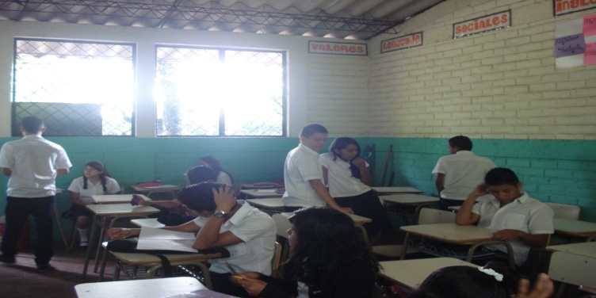

Some minutes after the break, the teacher is not in the classroom yet and the students of 9th grade are chatting around waiting for her.

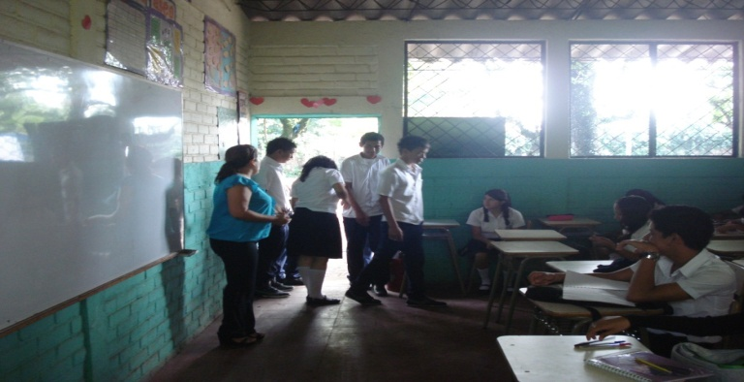

The teacher arrived but the class has not started yet, she is calling the attention of 9th grade students to sit down. The same students stood up.

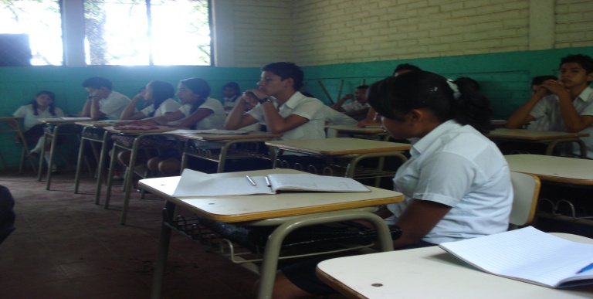
The students of 9th grade are listening to the teacher’s instructions. The girl at the front is texting in her cell phone. The teacher does not call her attention.

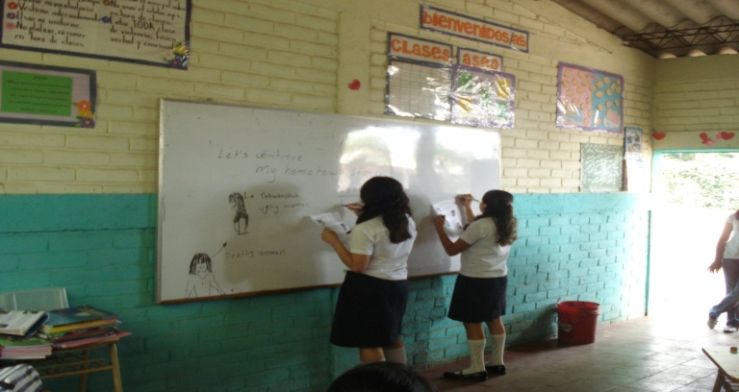

At some point during the class, two Students of 9th grade are working in some written exercises (race sentences) on the board.

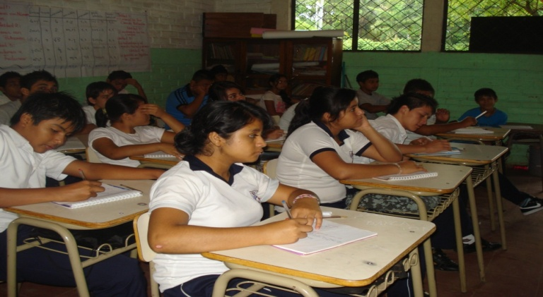
The first five minutes of the class, the students of 8th grade listen to the teacher and copy what she wrote on the board.

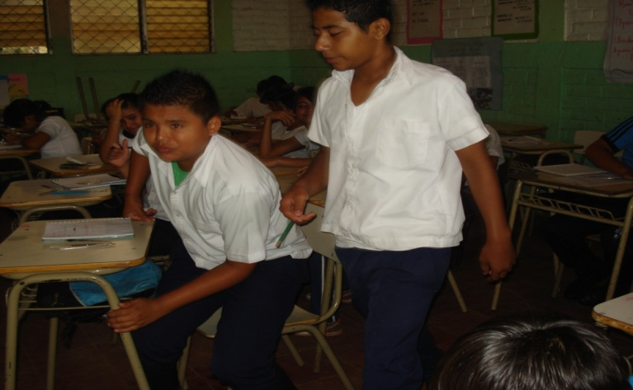

In the course of the class, some students in 8th grade stand up while they should be working on the exercise the teacher explained them. This happened when the teacher left the classroom to talk to the principal.

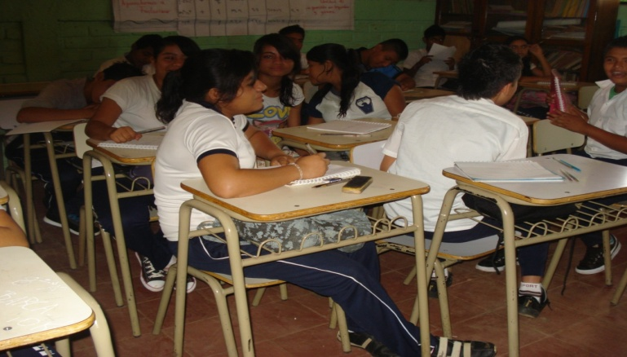

Most of the students are talking during the activity they have to do. They should be writing on their notebooks, but just few of them do it.

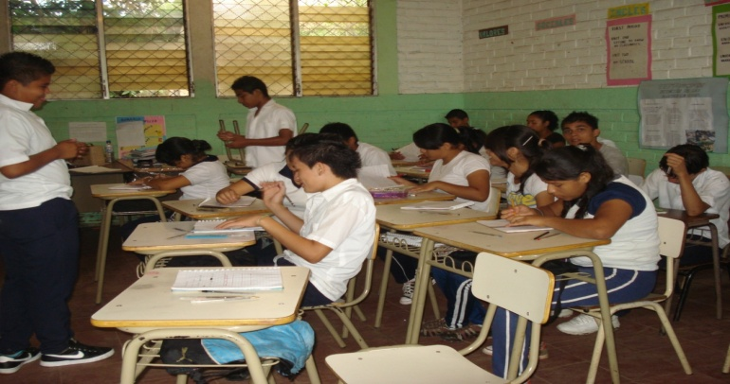

Some minutes before the break, students are impatient and start doing other things not related to the class.

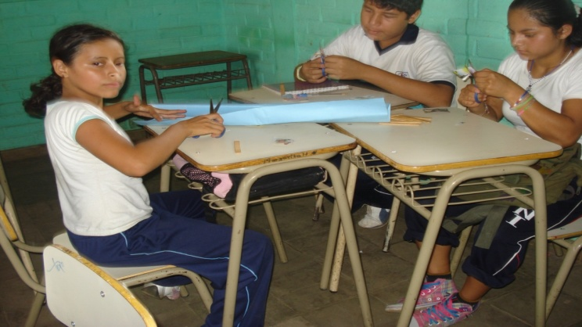
A group of students from 7th grade is working in an activity where they have to form a family using draws, pictures, etc. This is the only group that has the material the teacher asked for in the previous class.

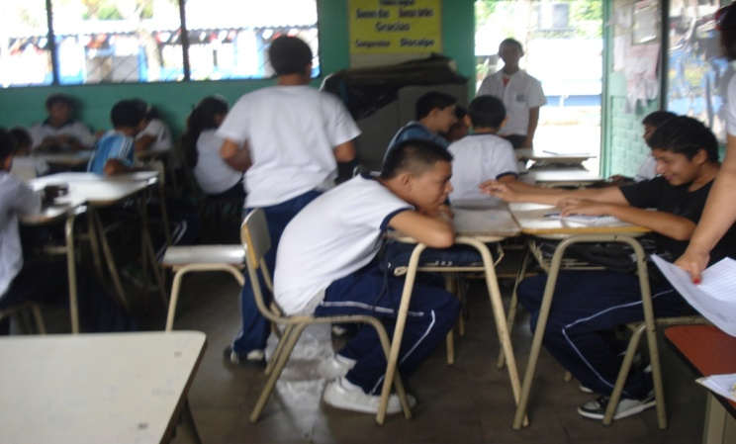

Since the students do not have material to work with, they spend the time talking or doing others things while the teacher is looking for books or magazines to use for the activity.

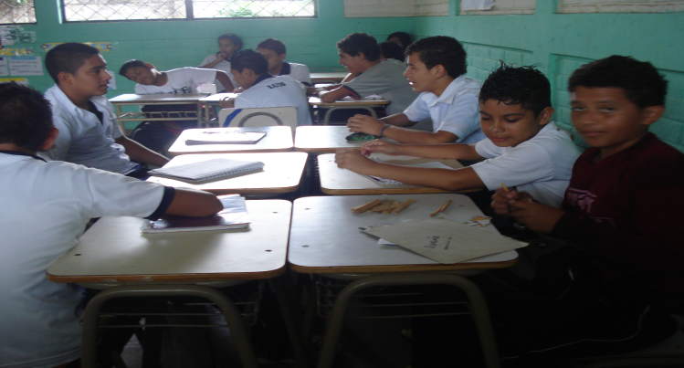
Students wasting time for not bringing the required material.

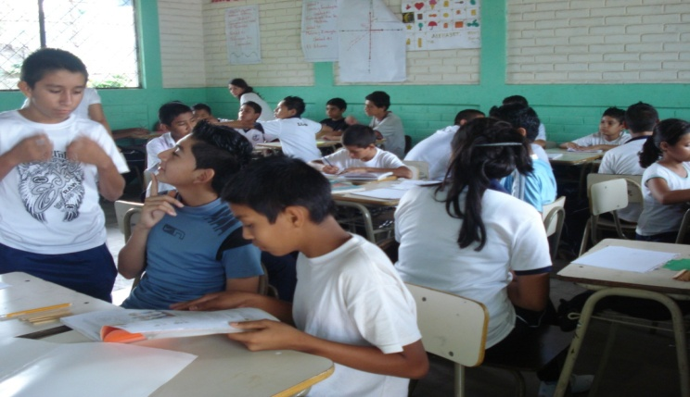

Students prefer to talk rather than work when they are in groups.

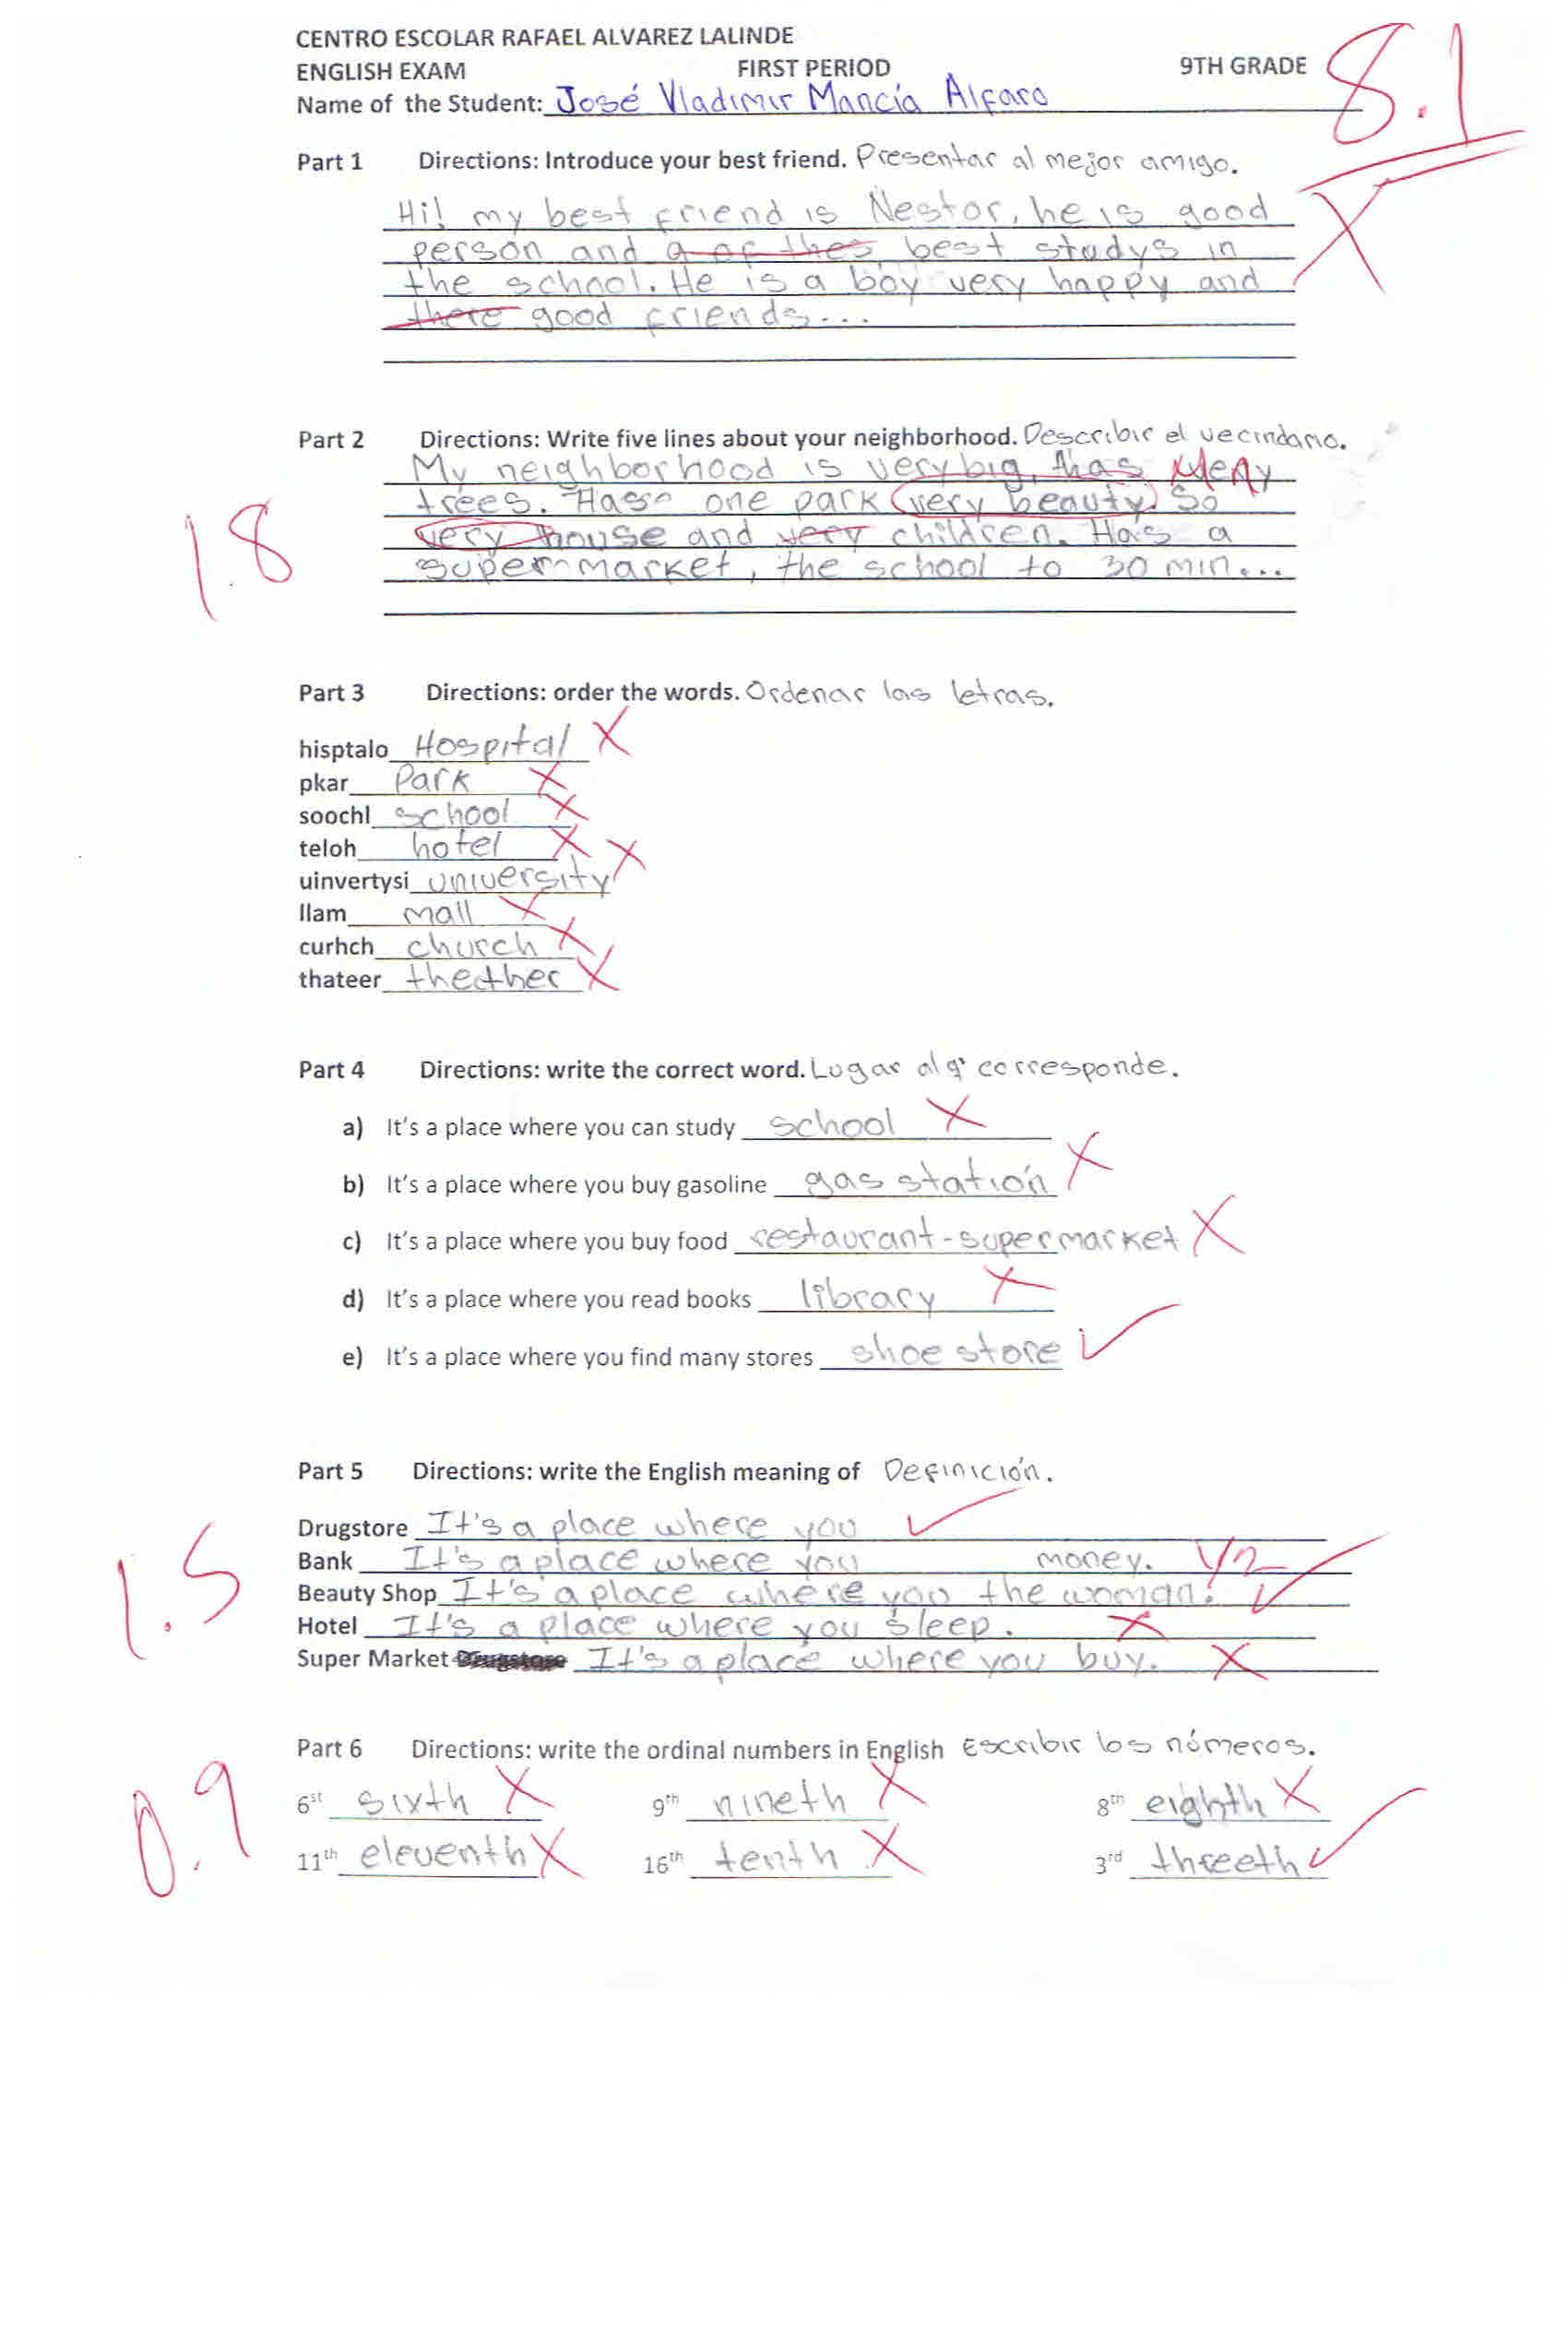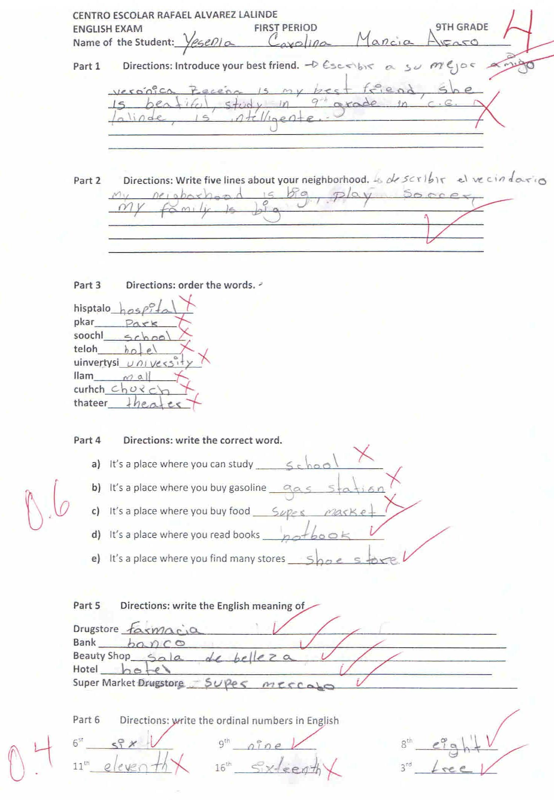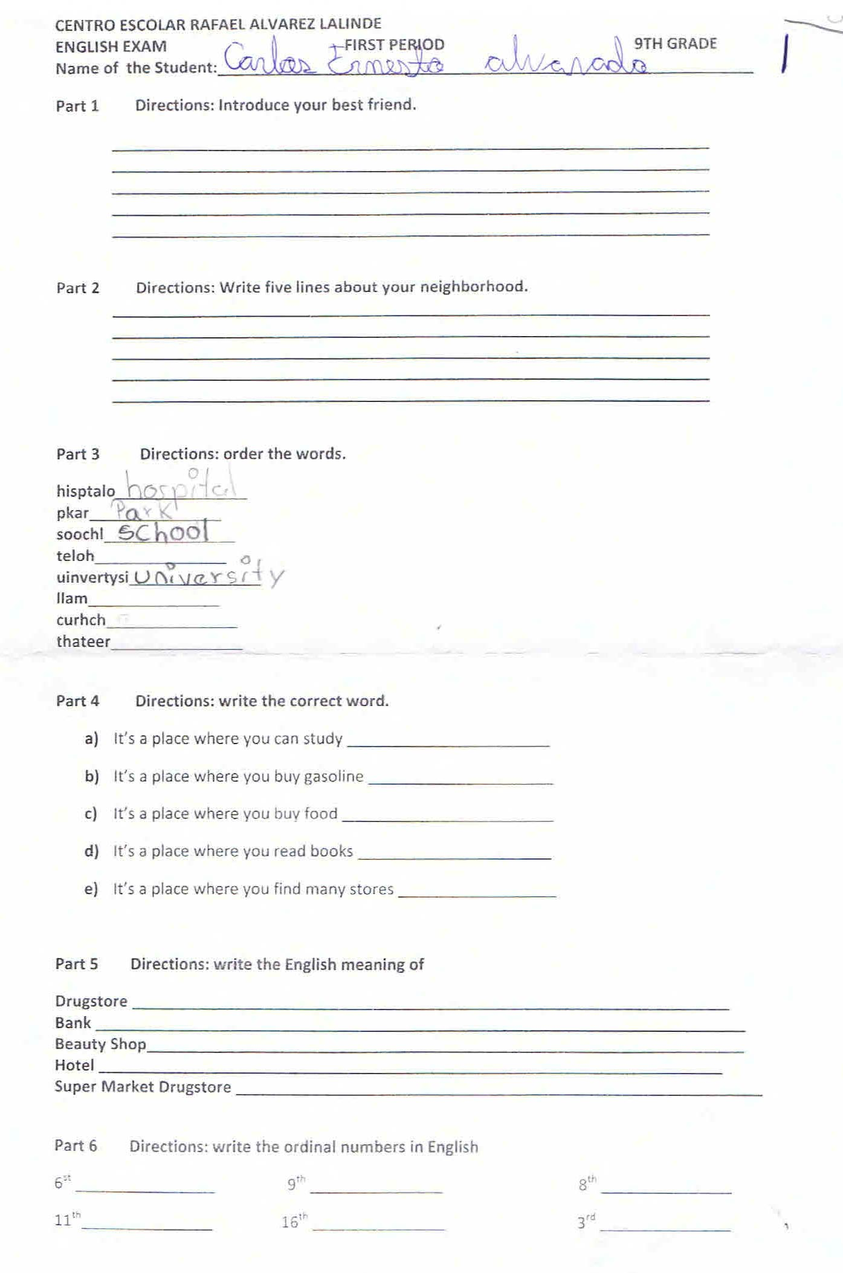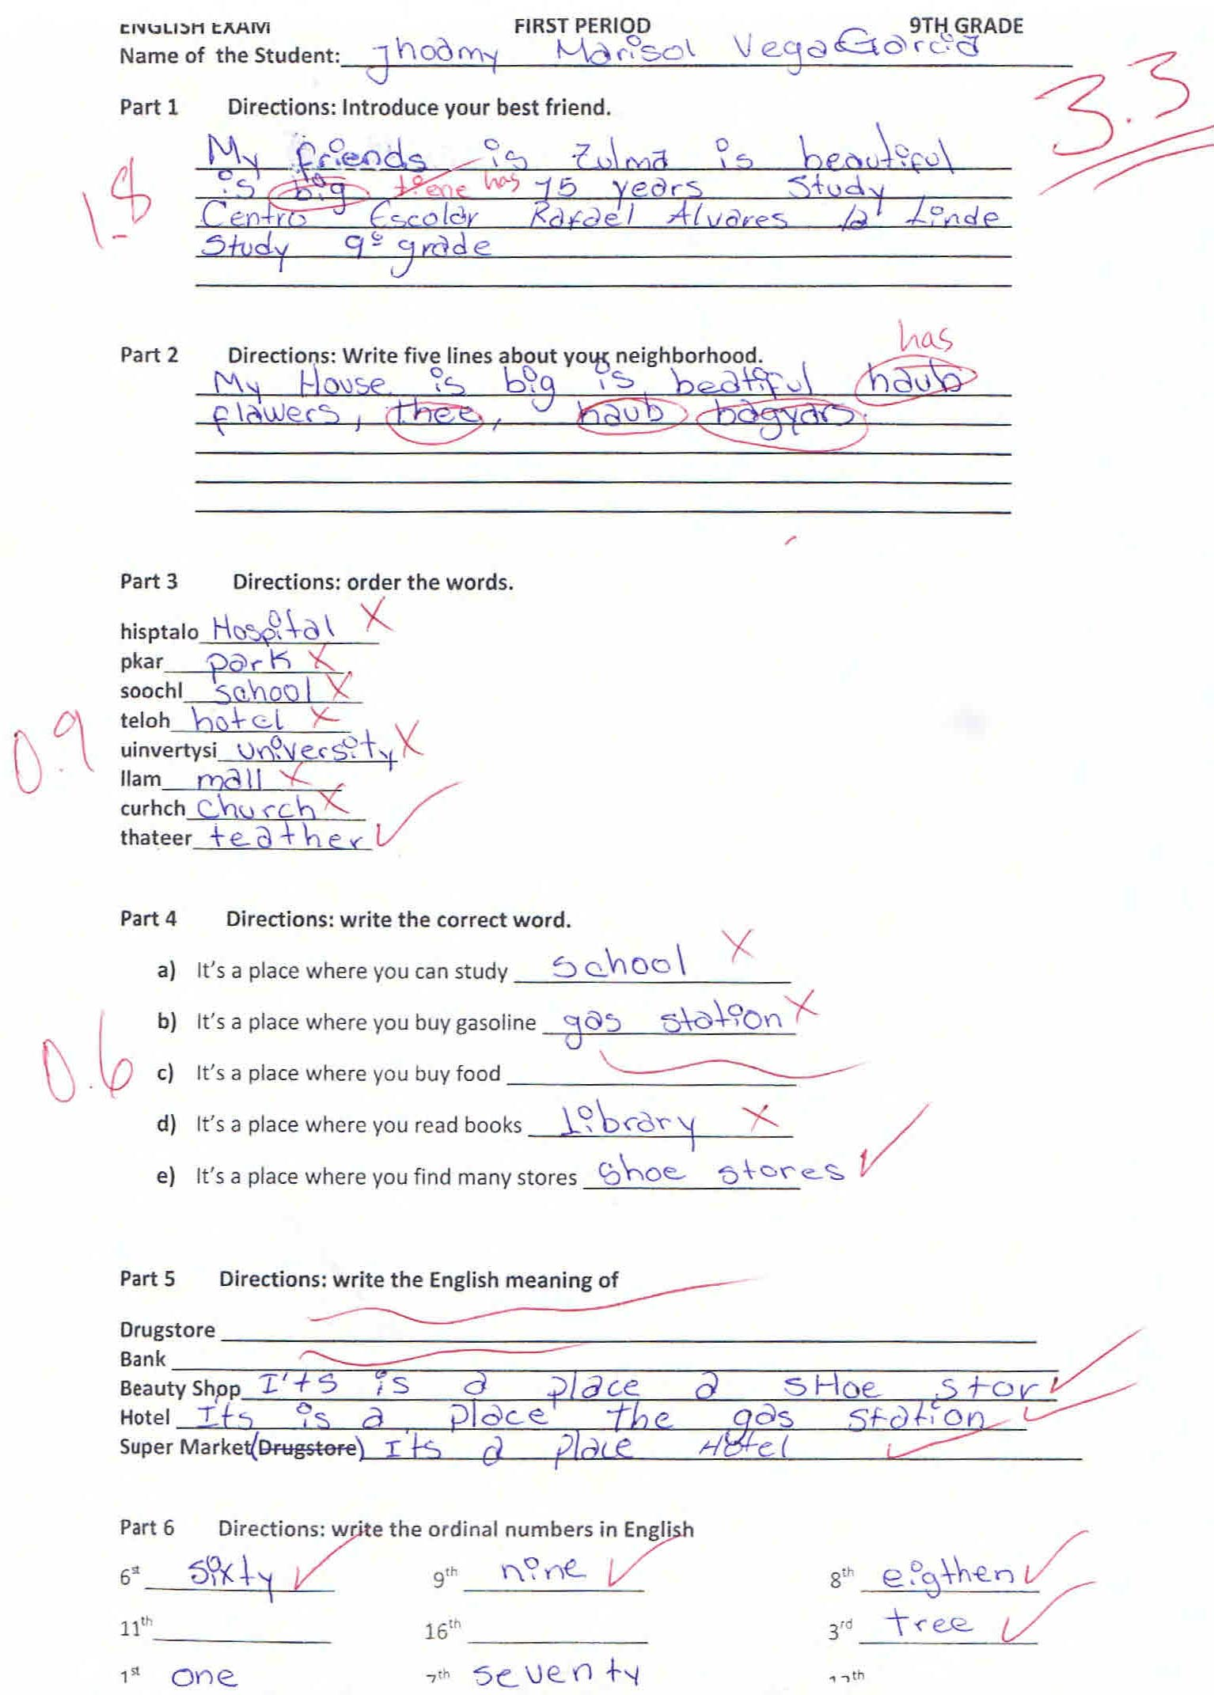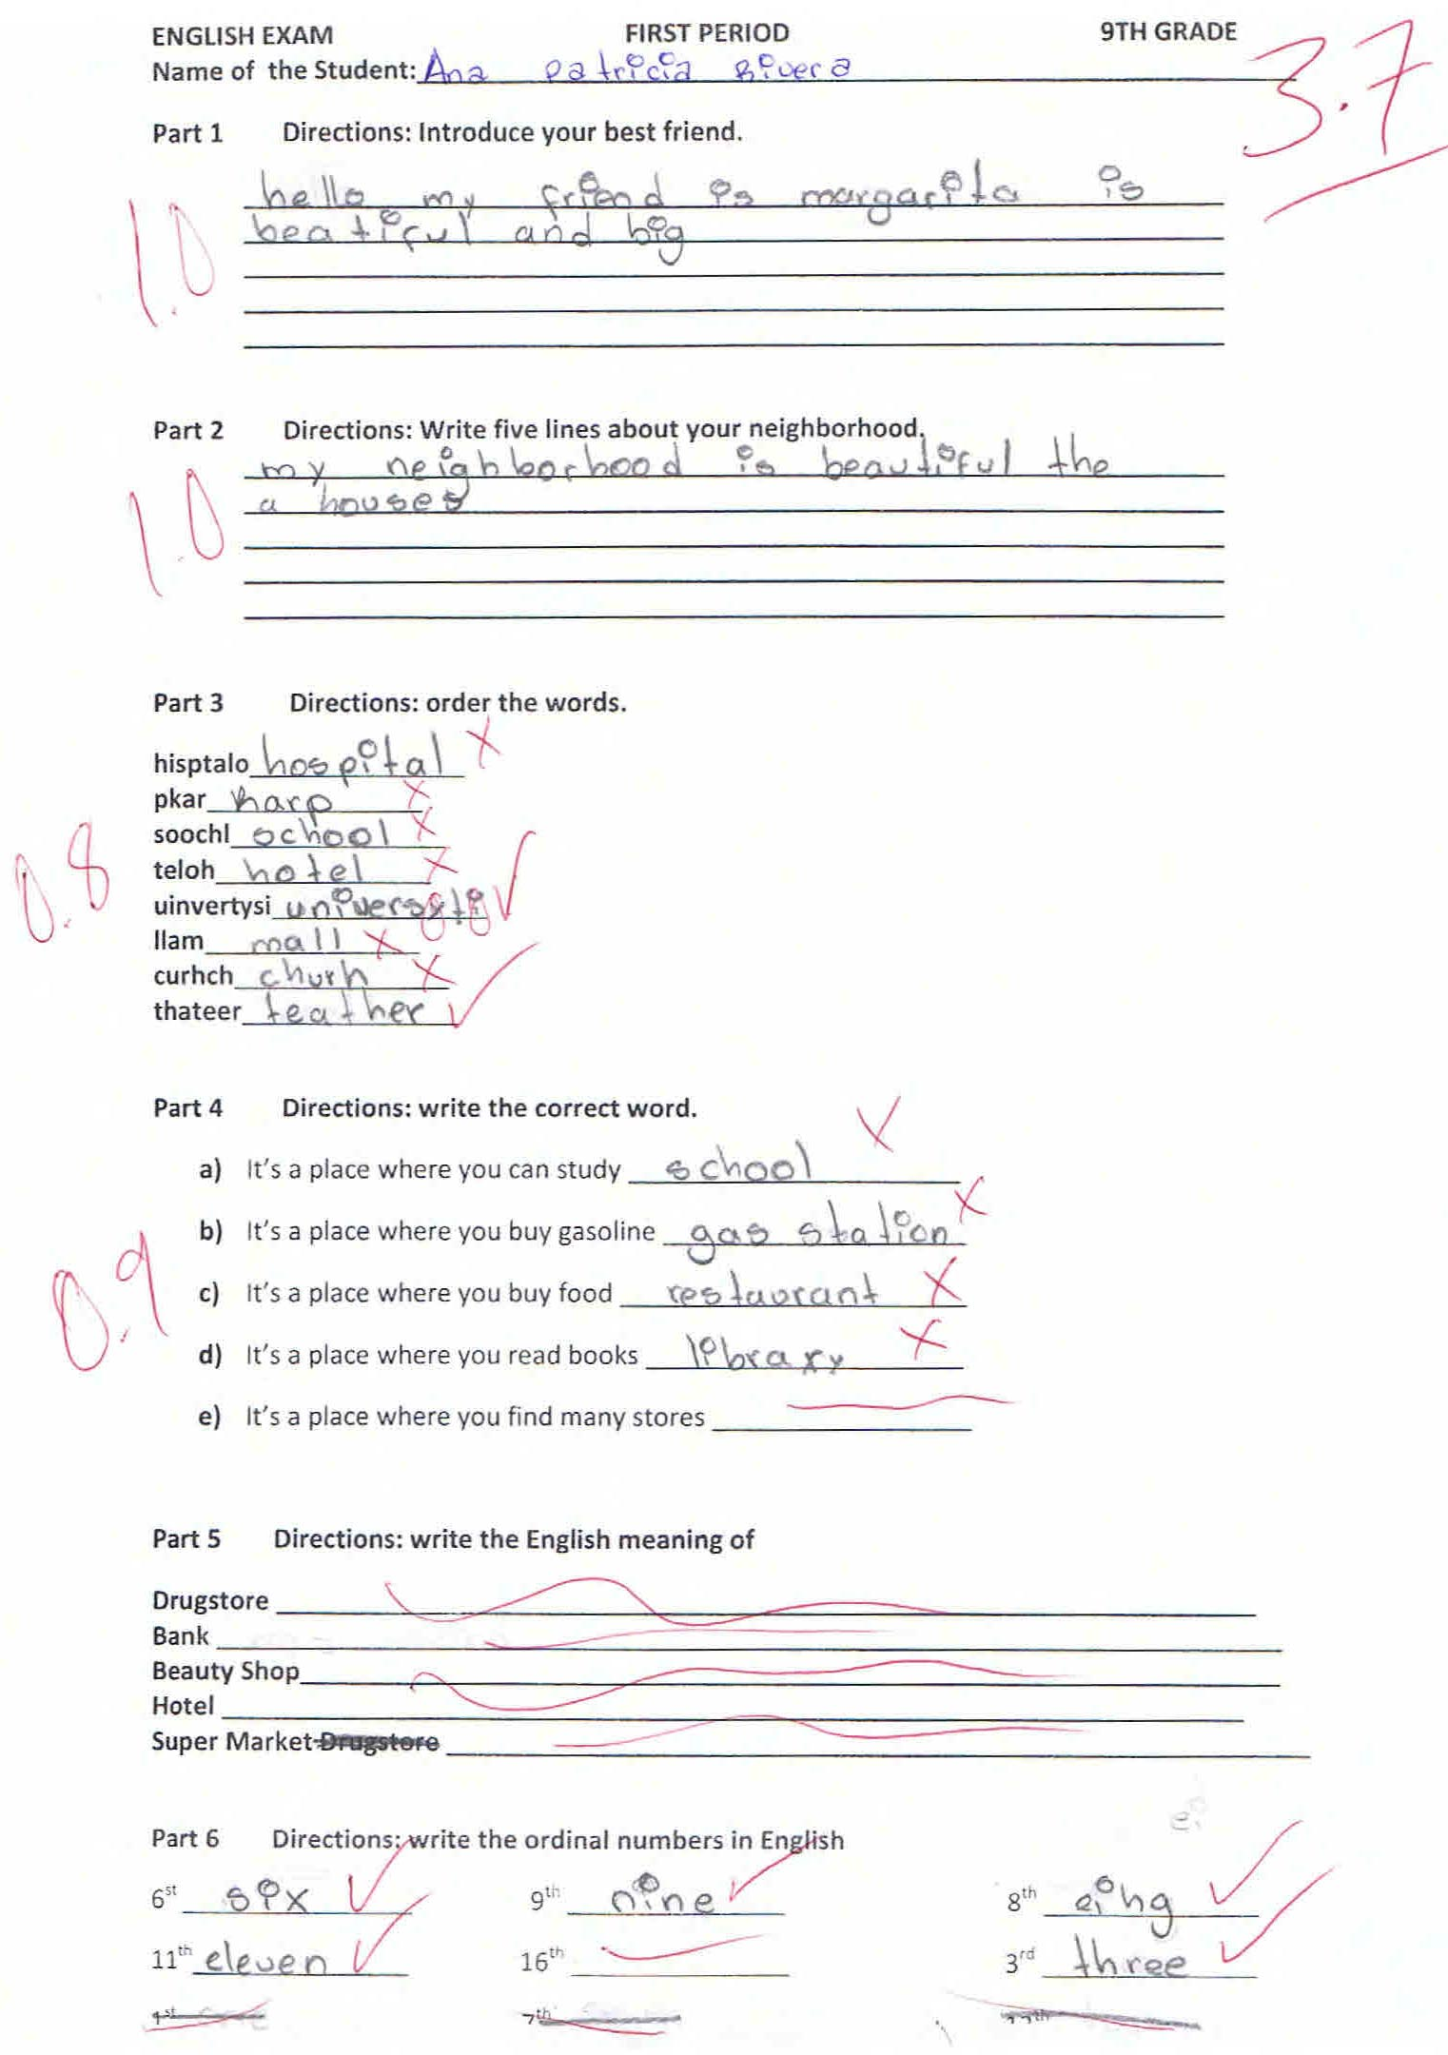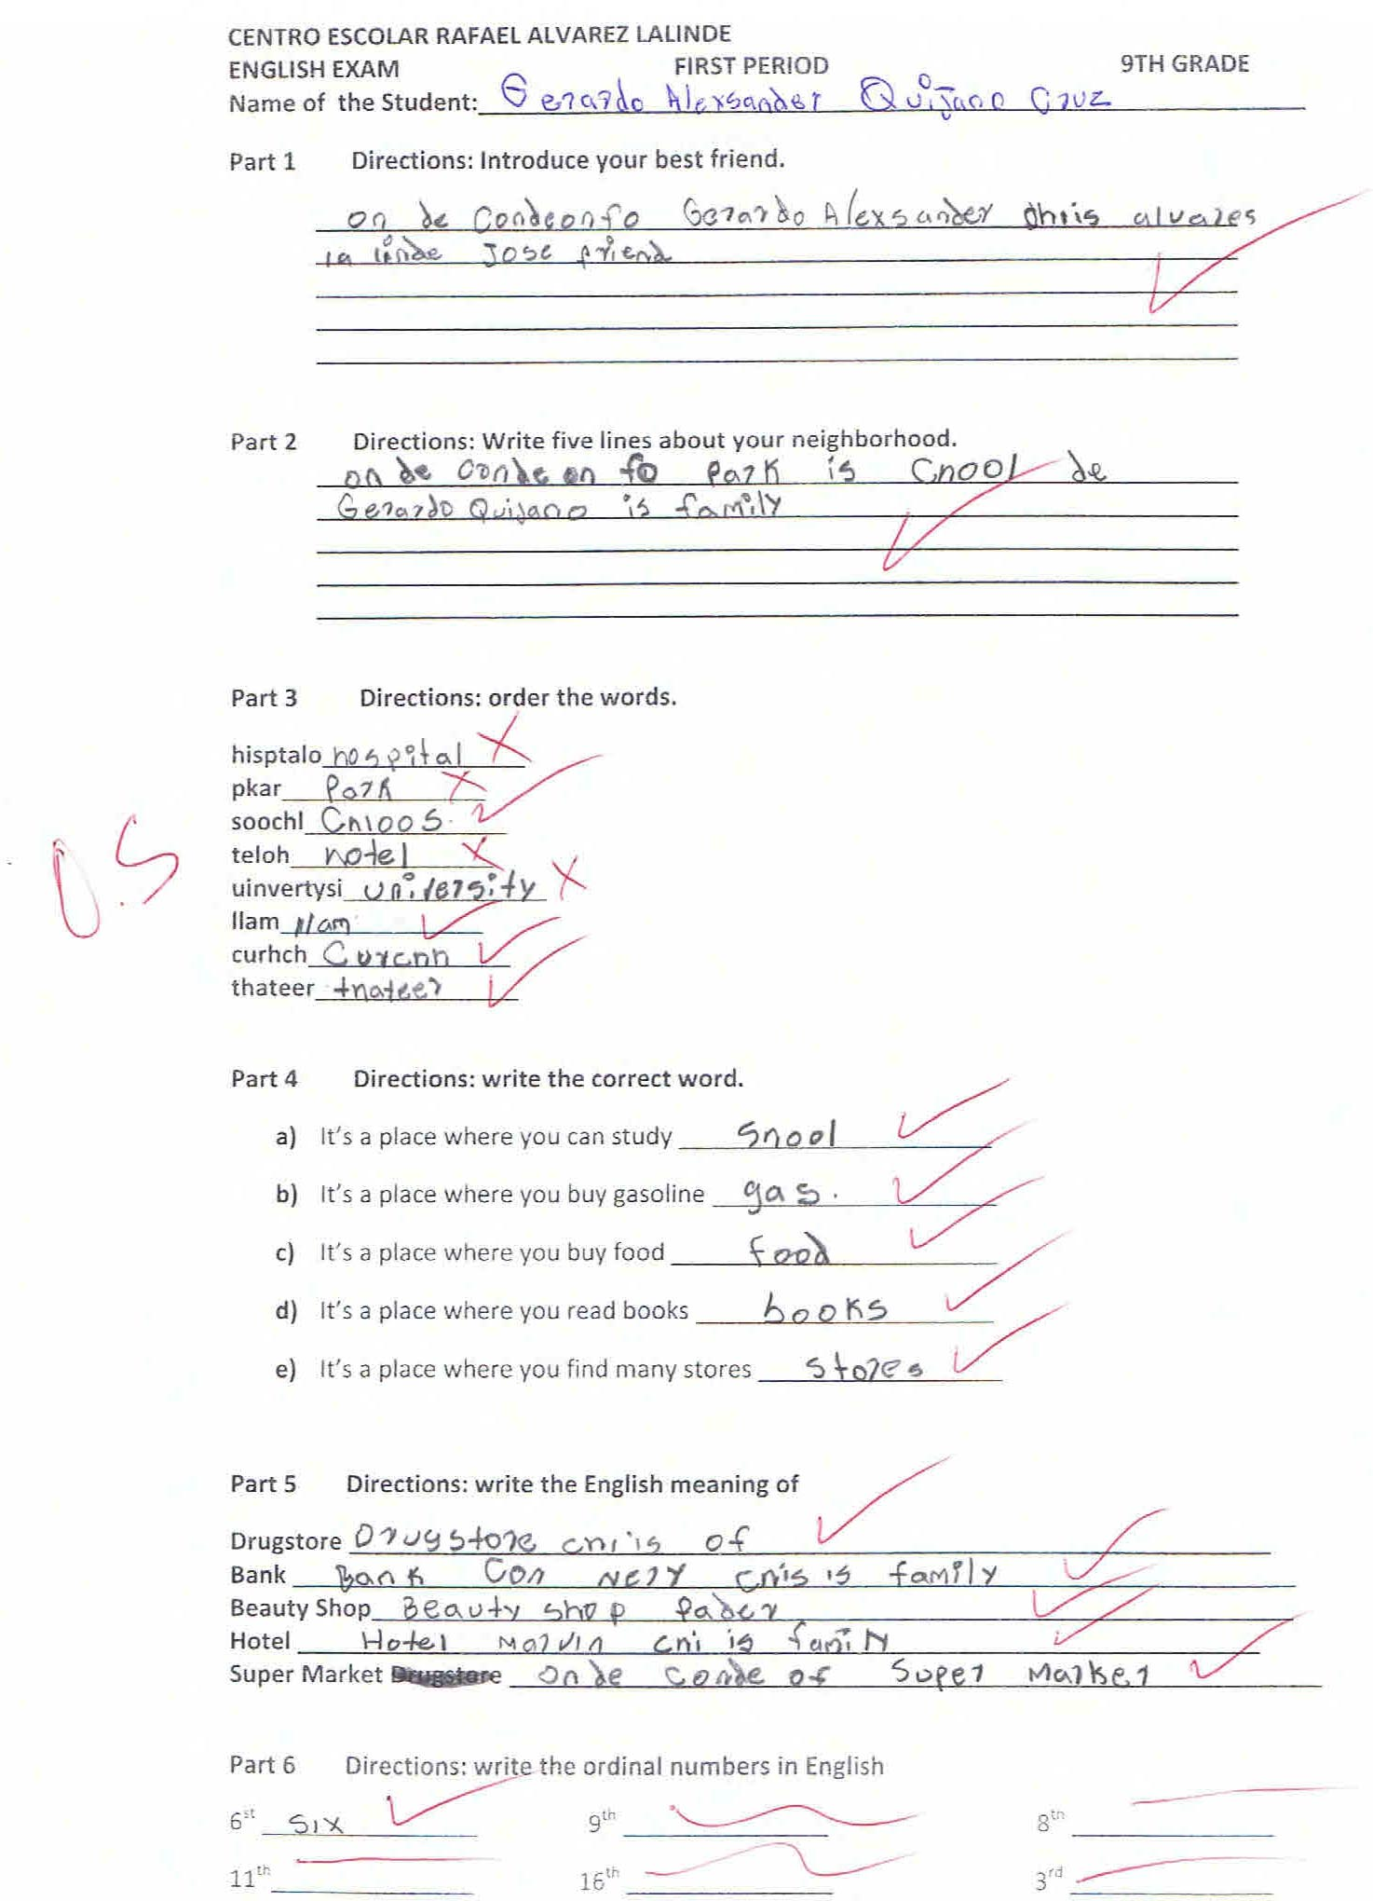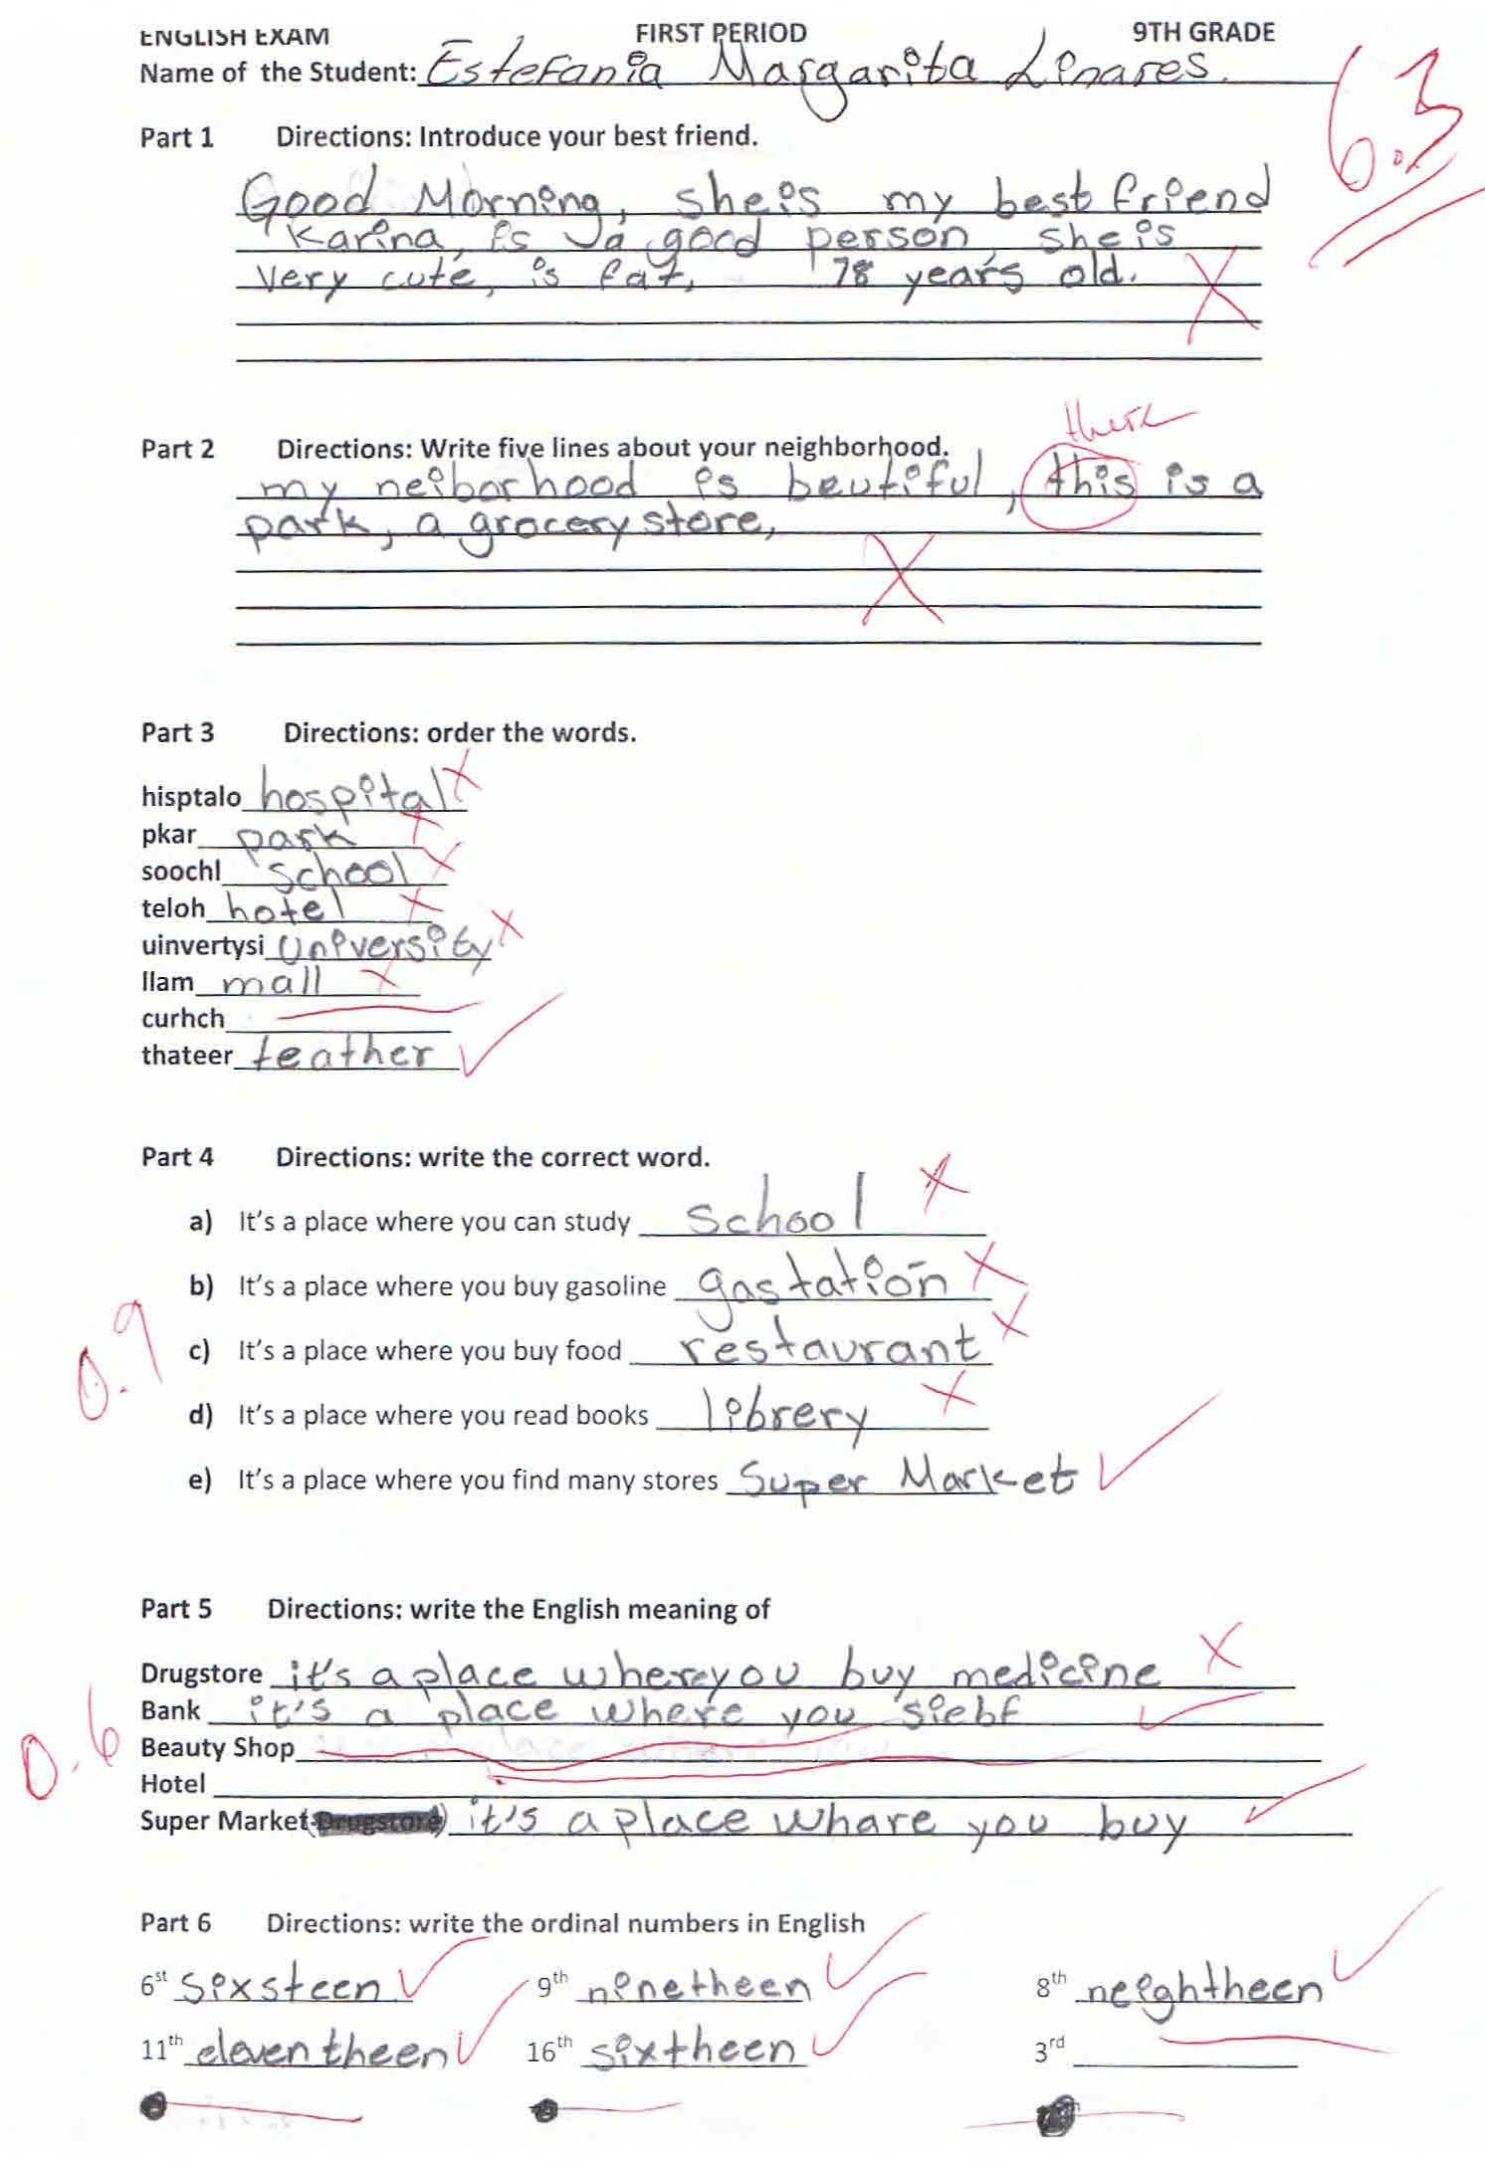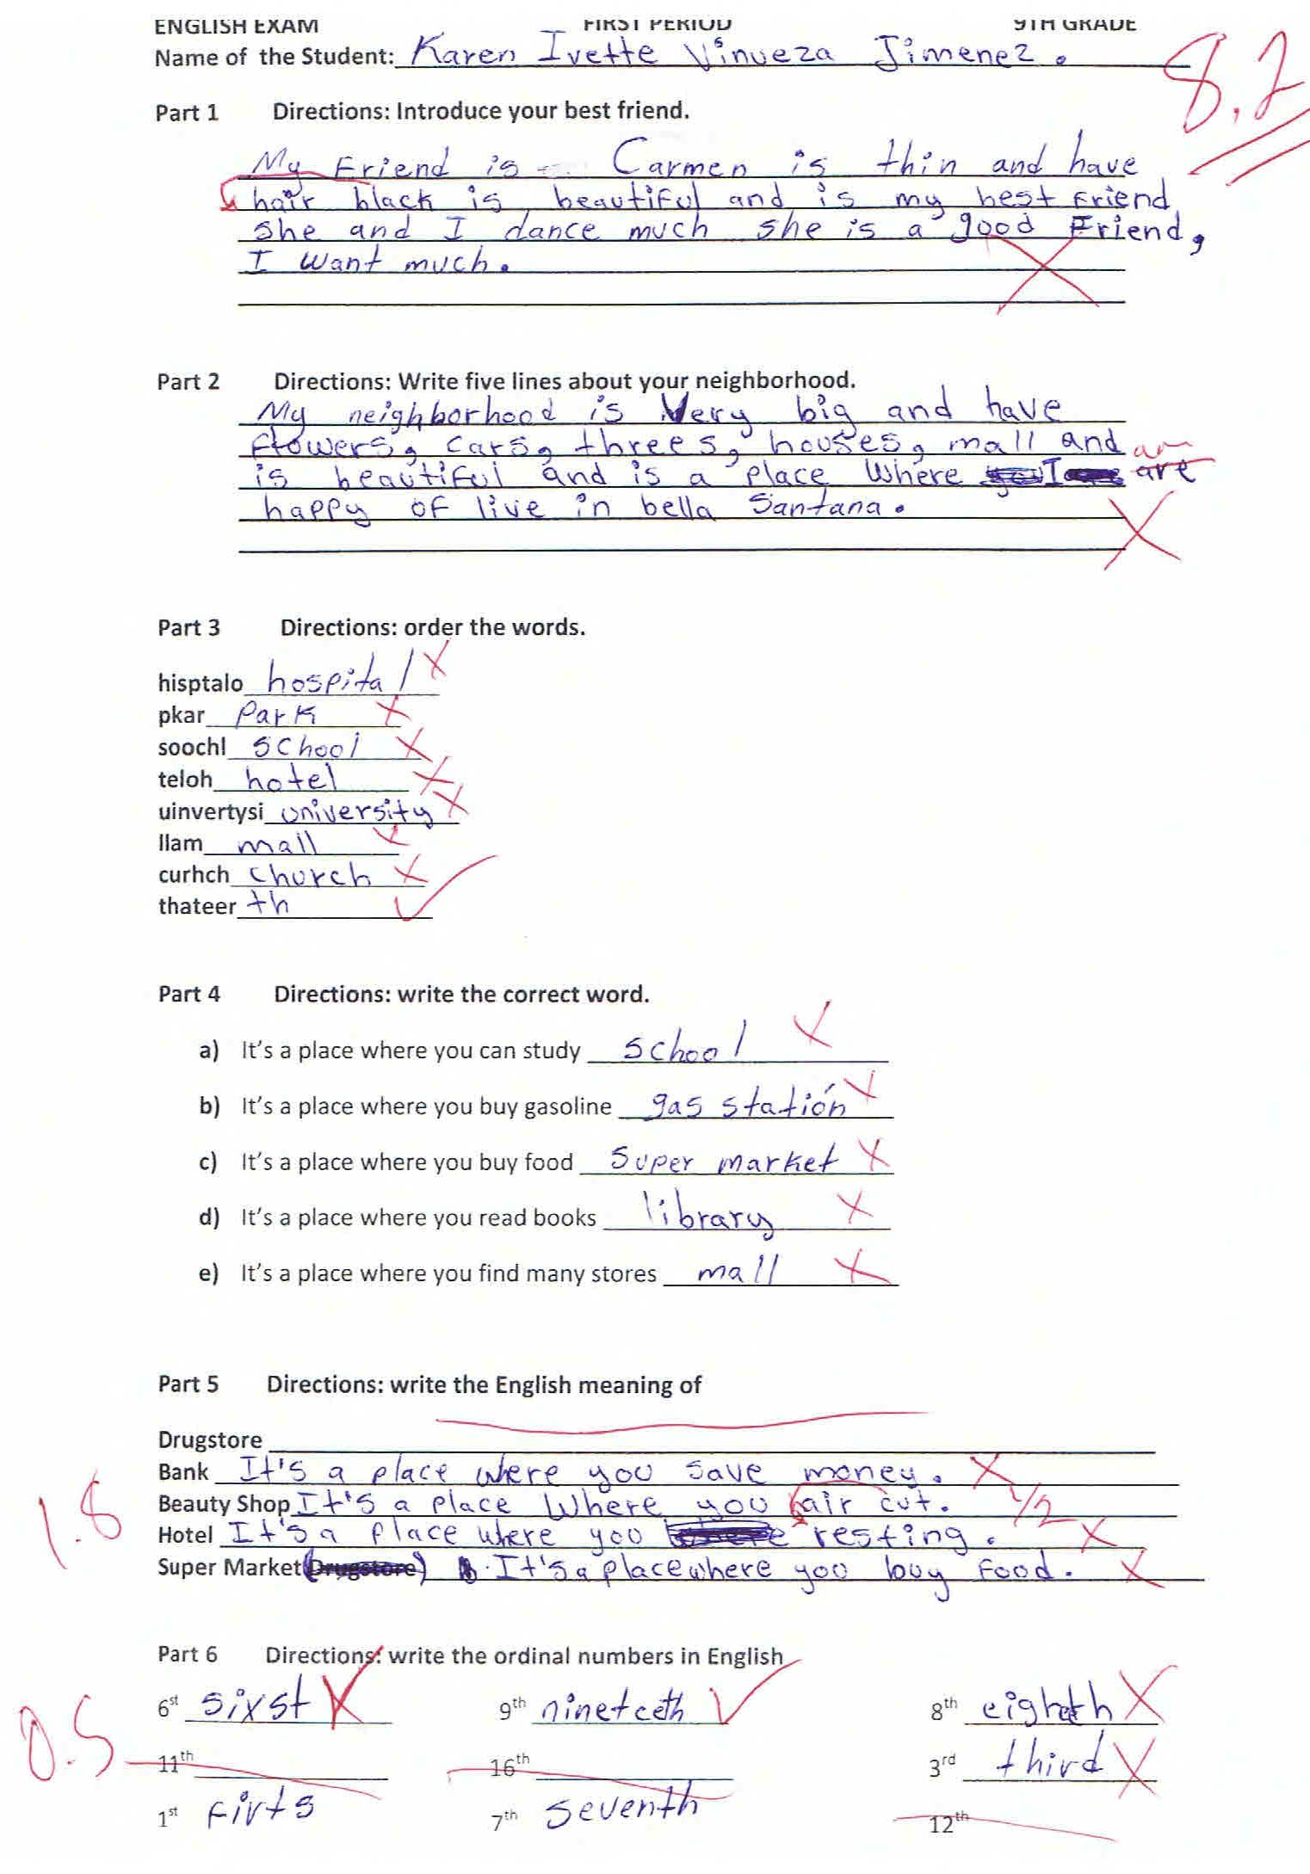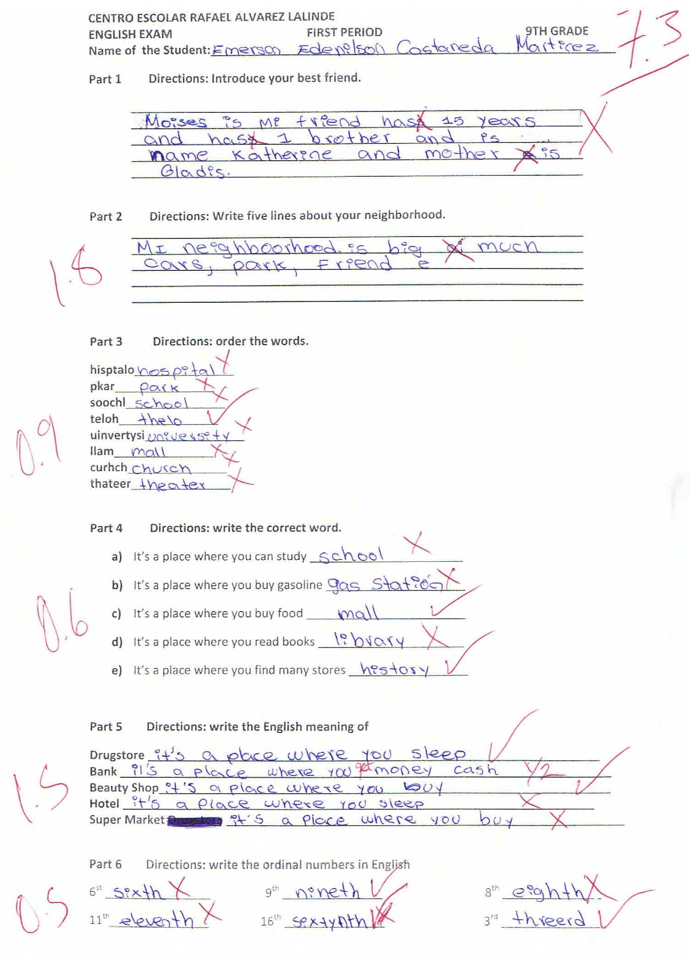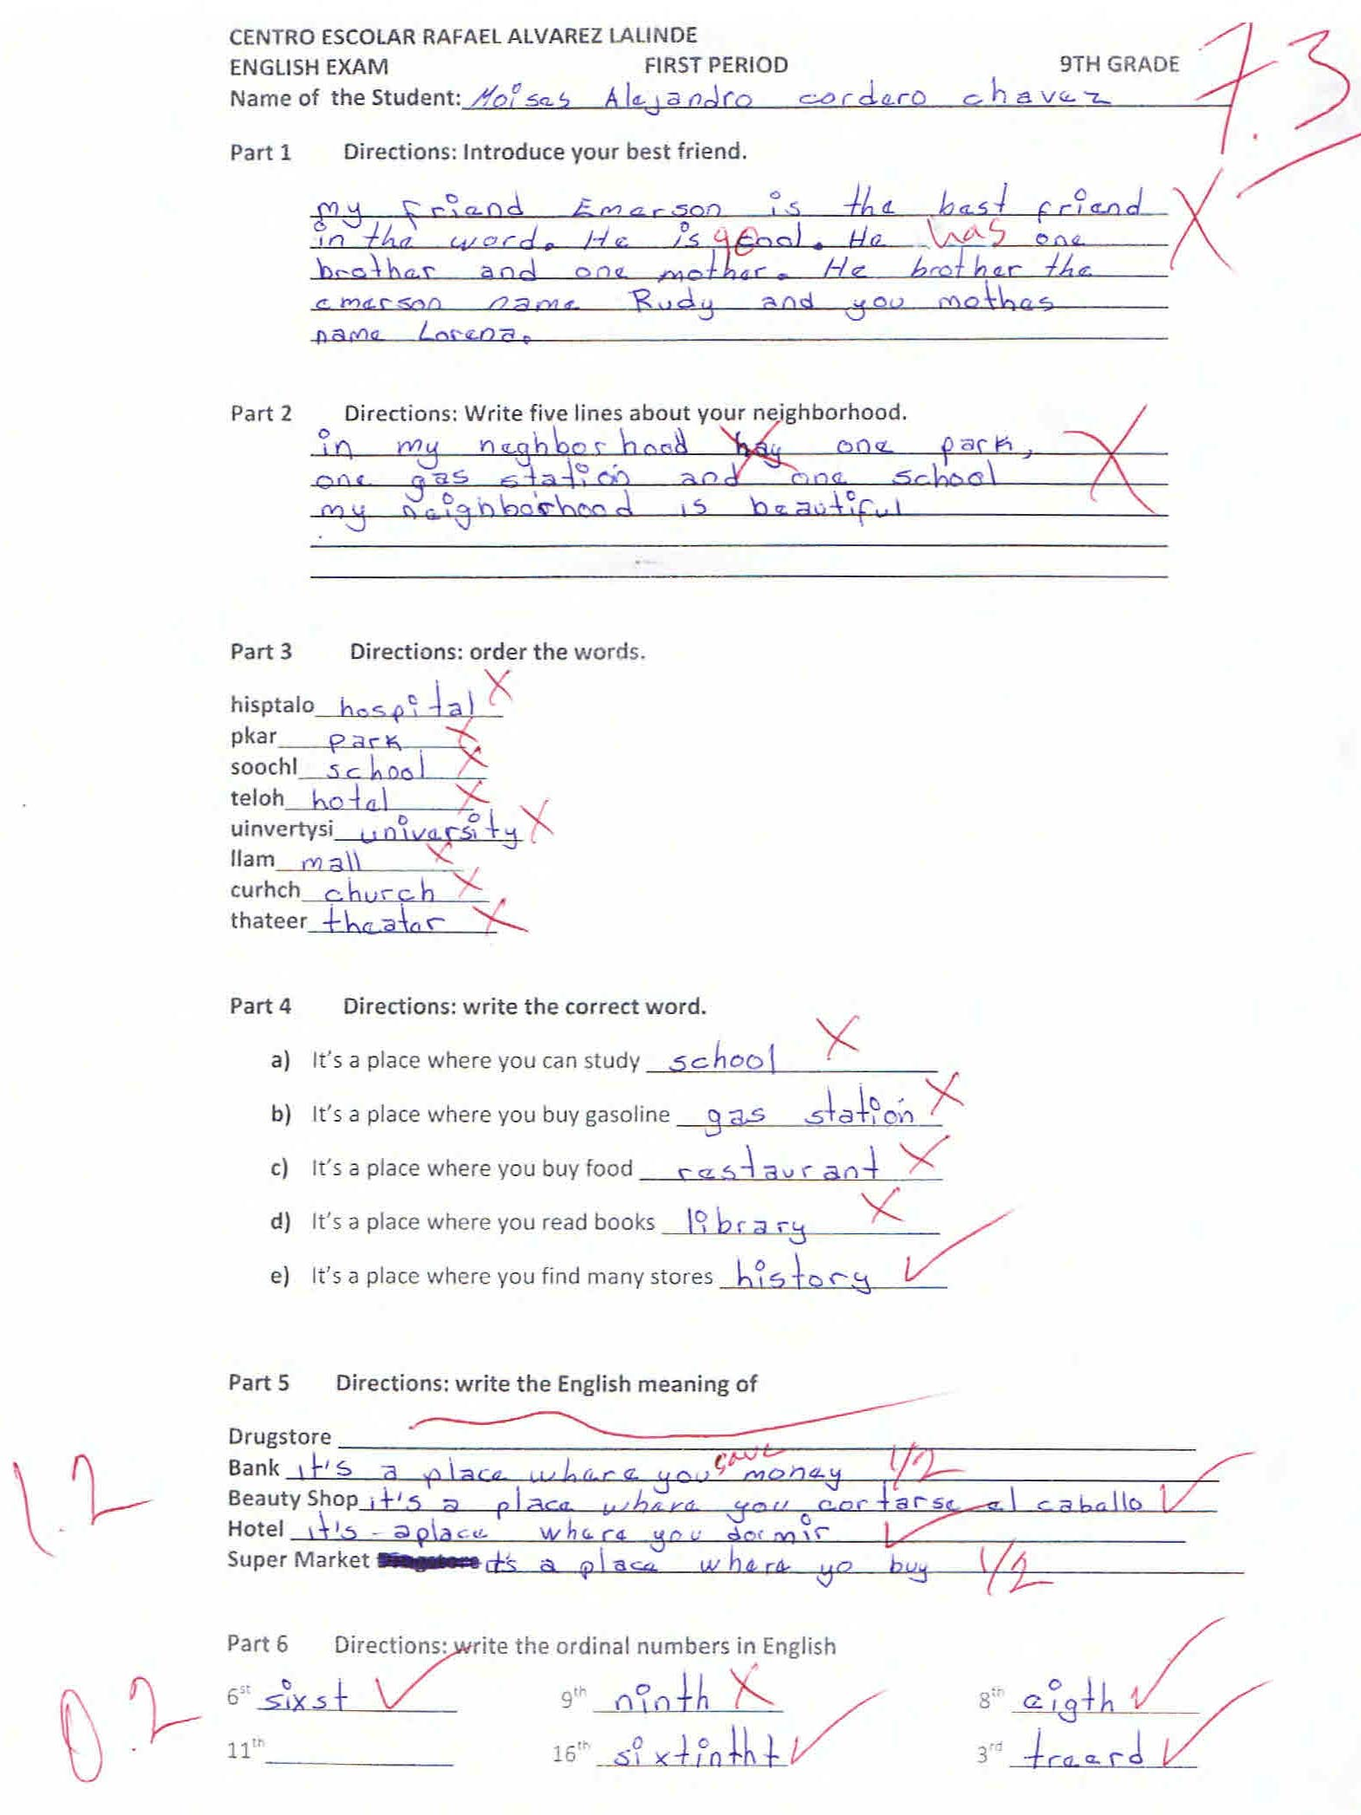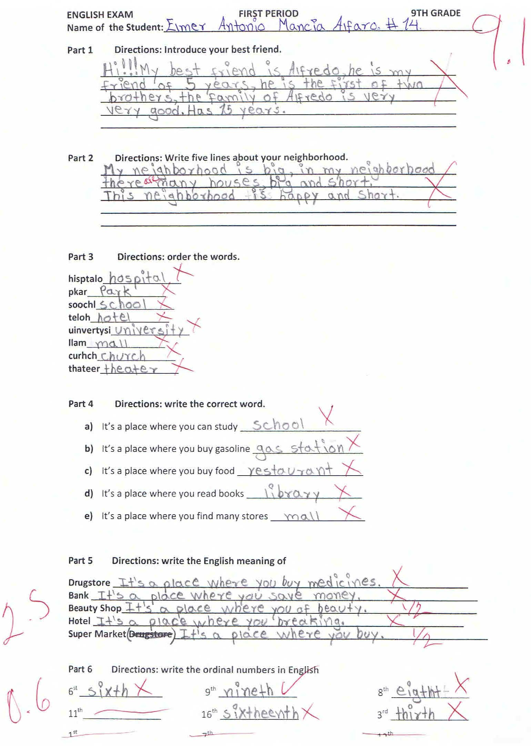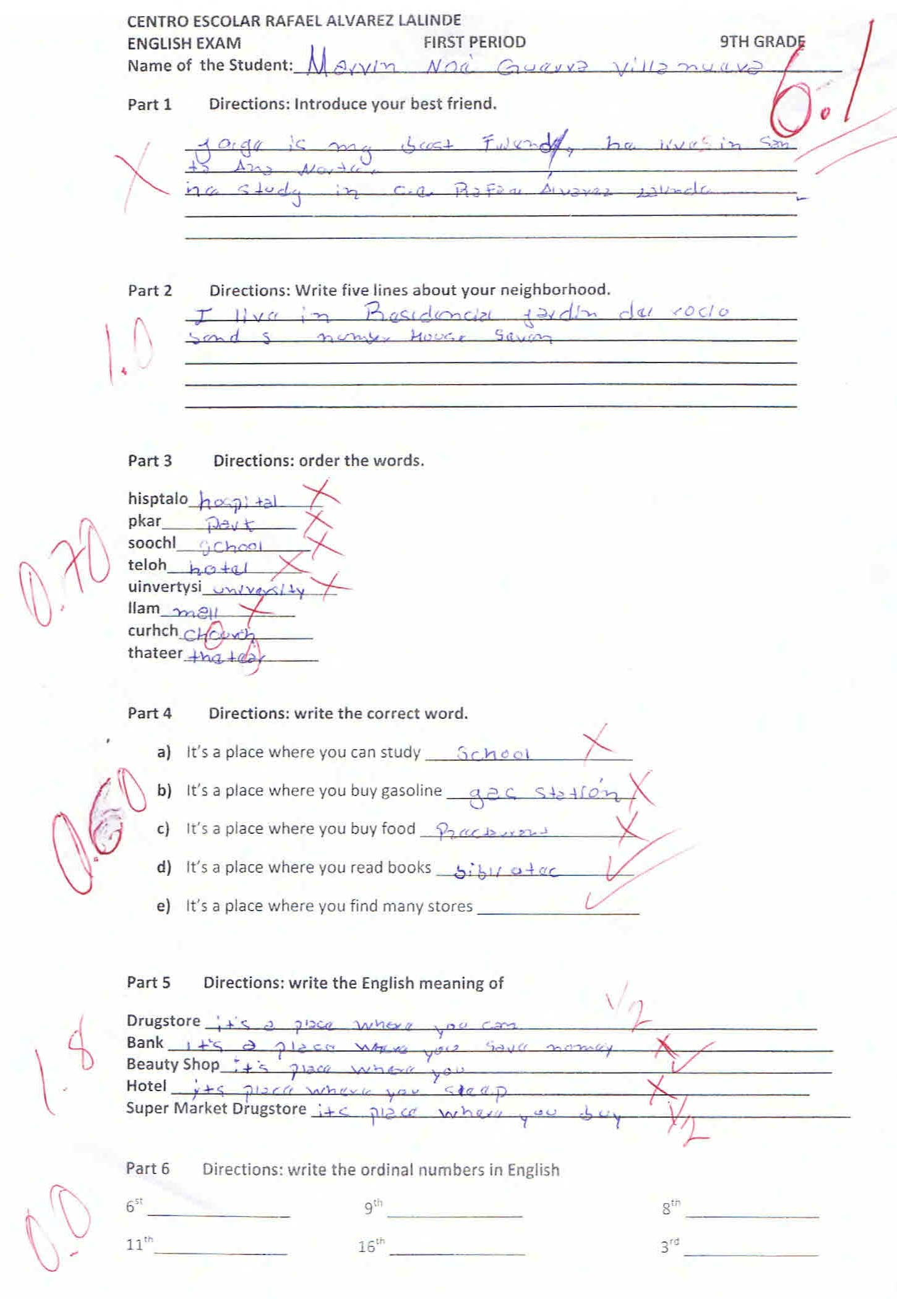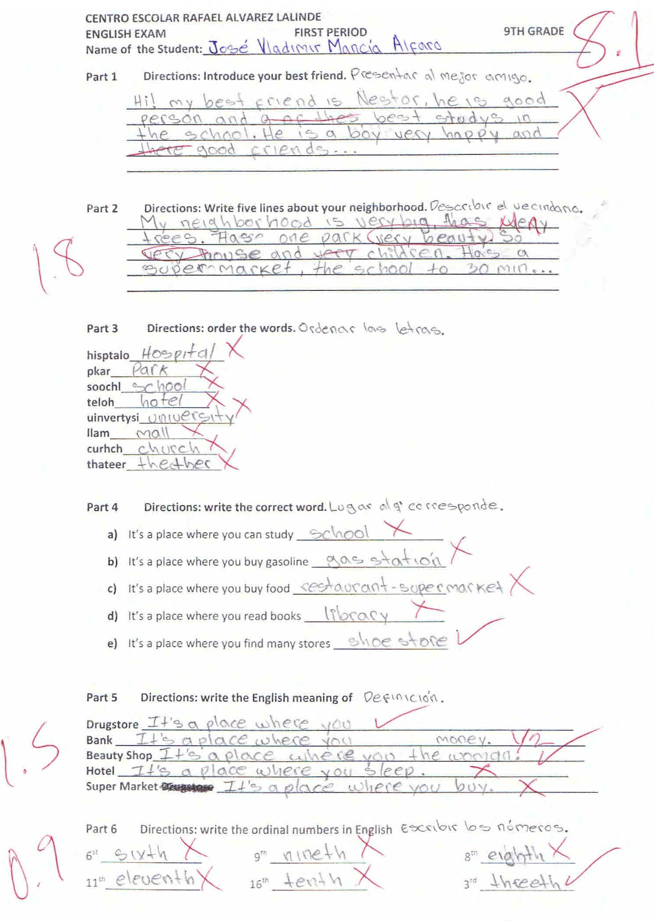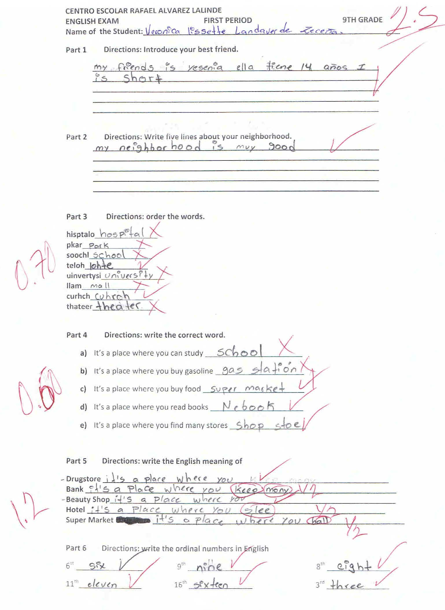

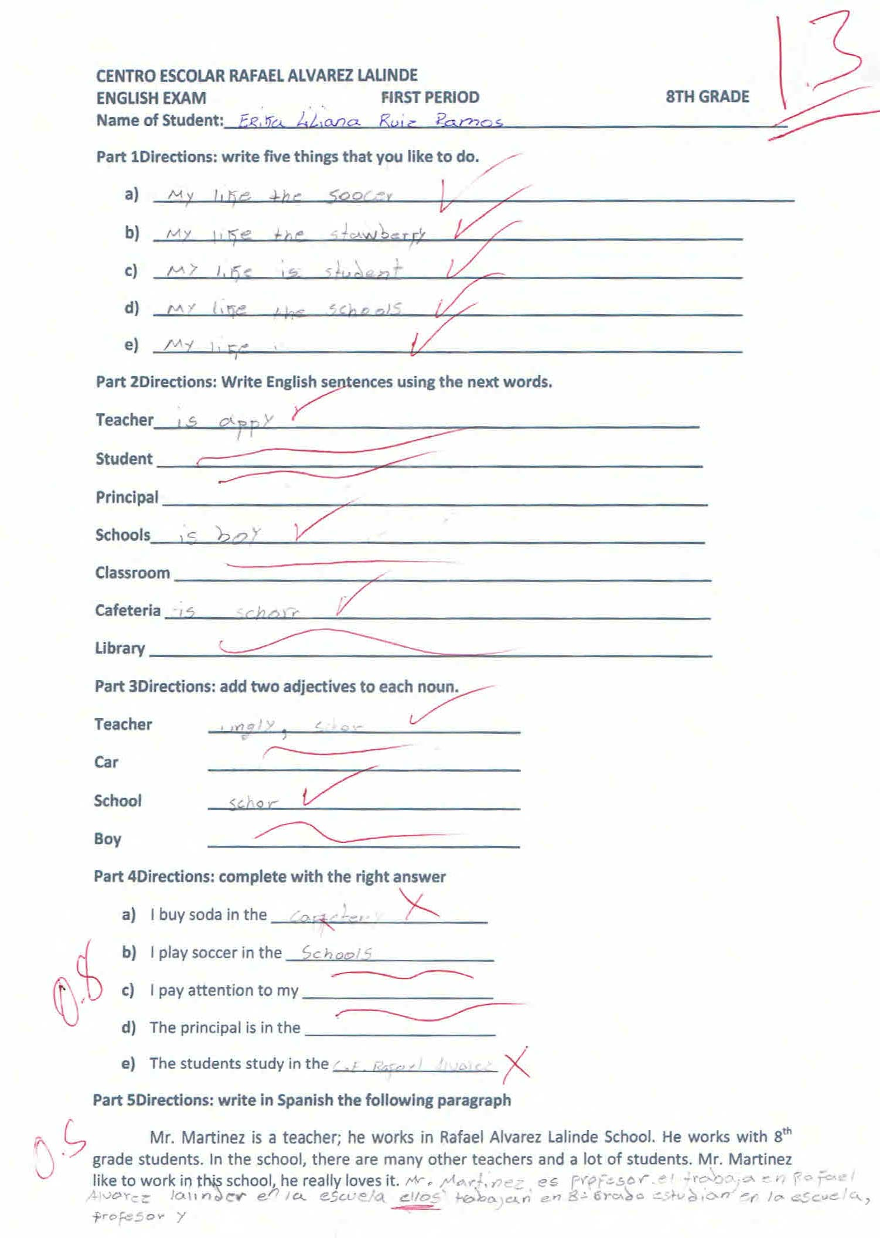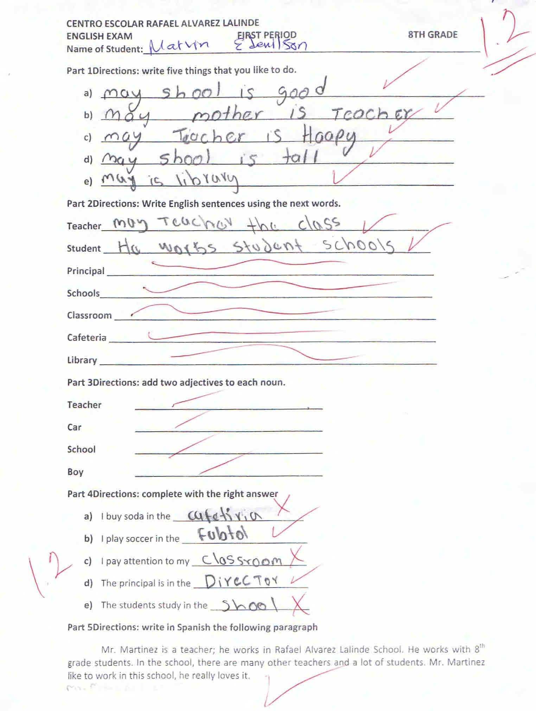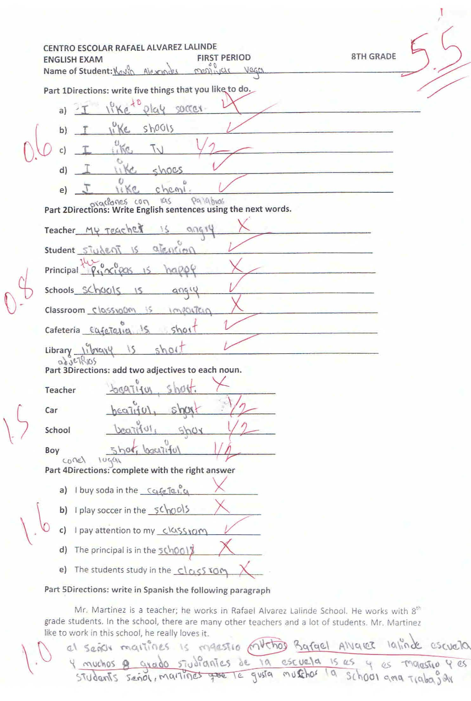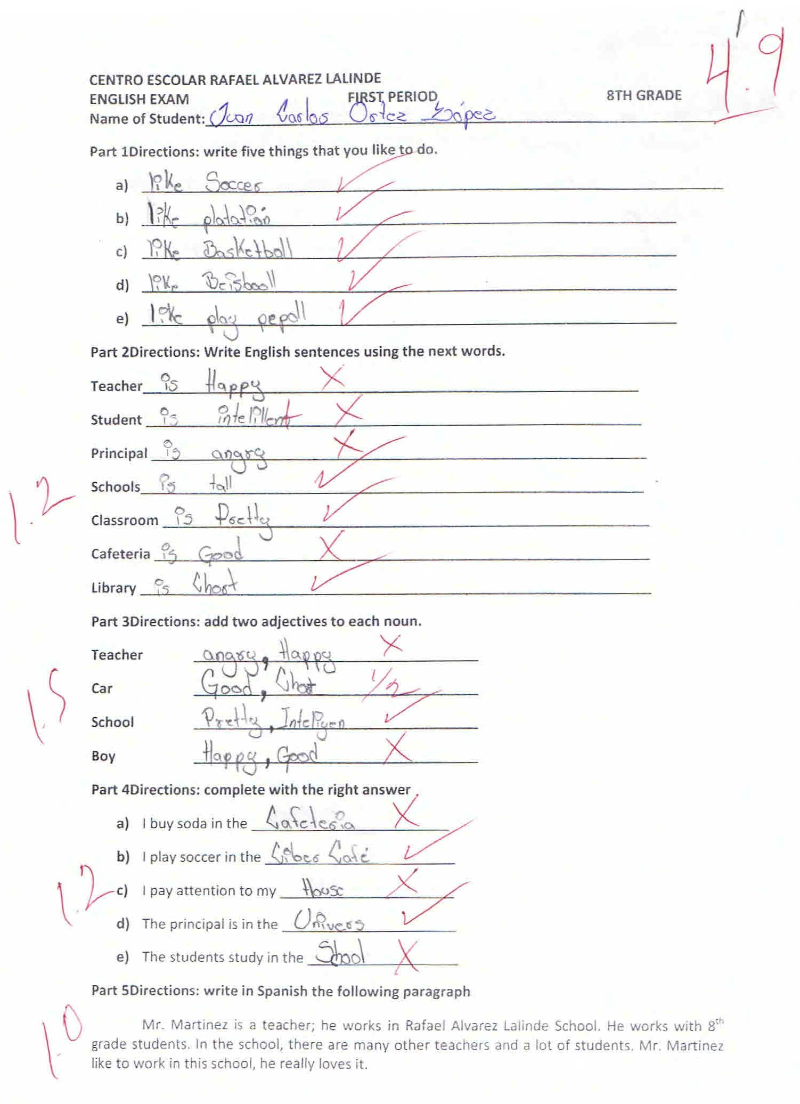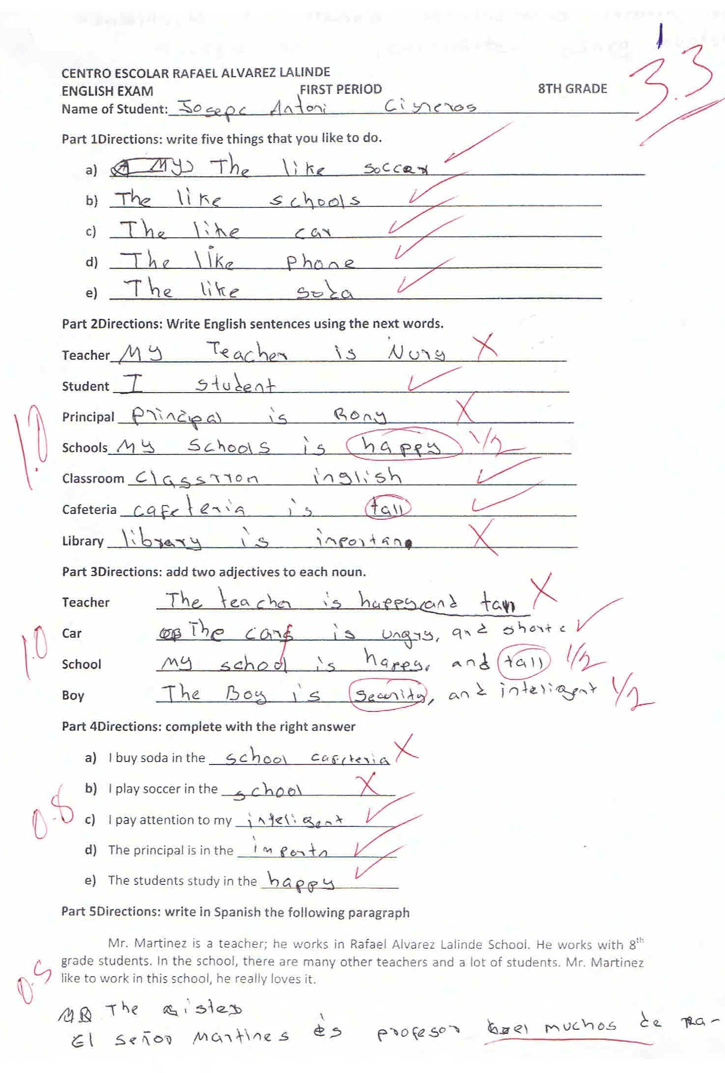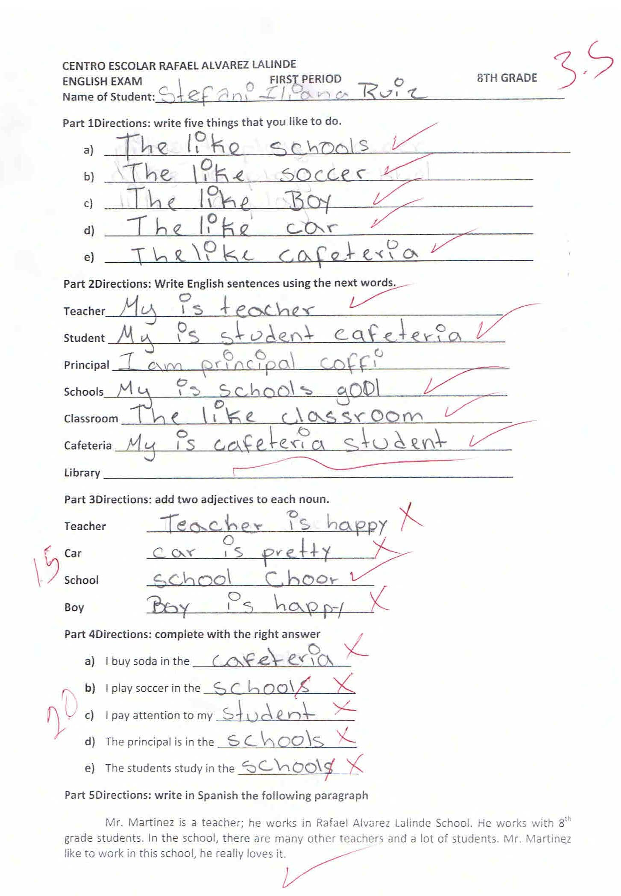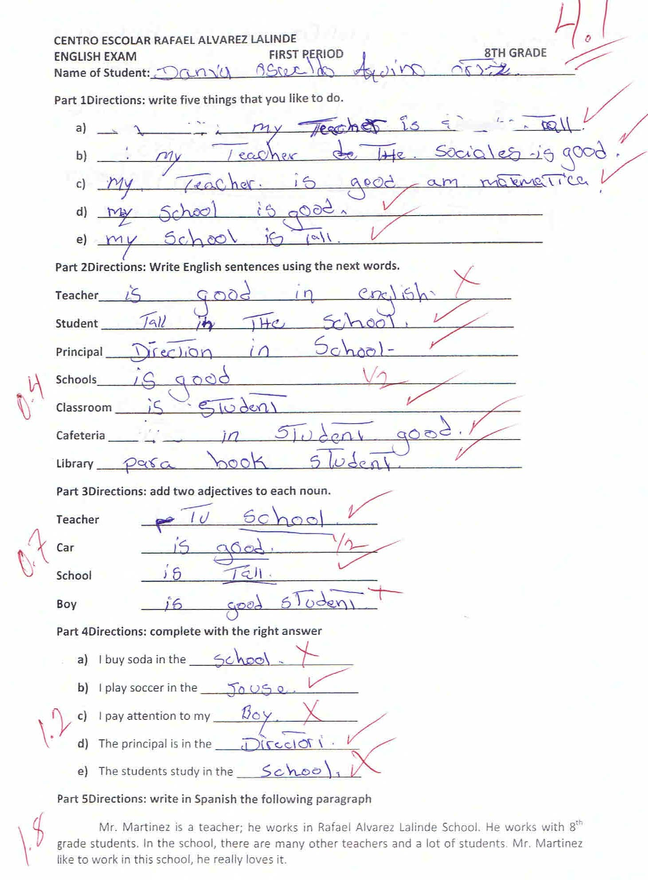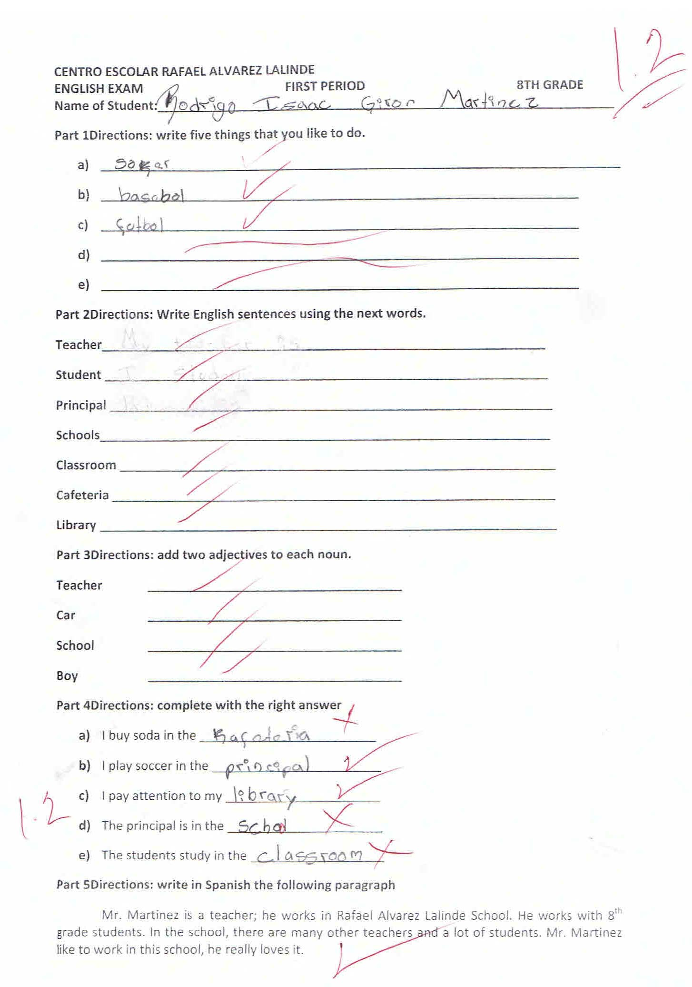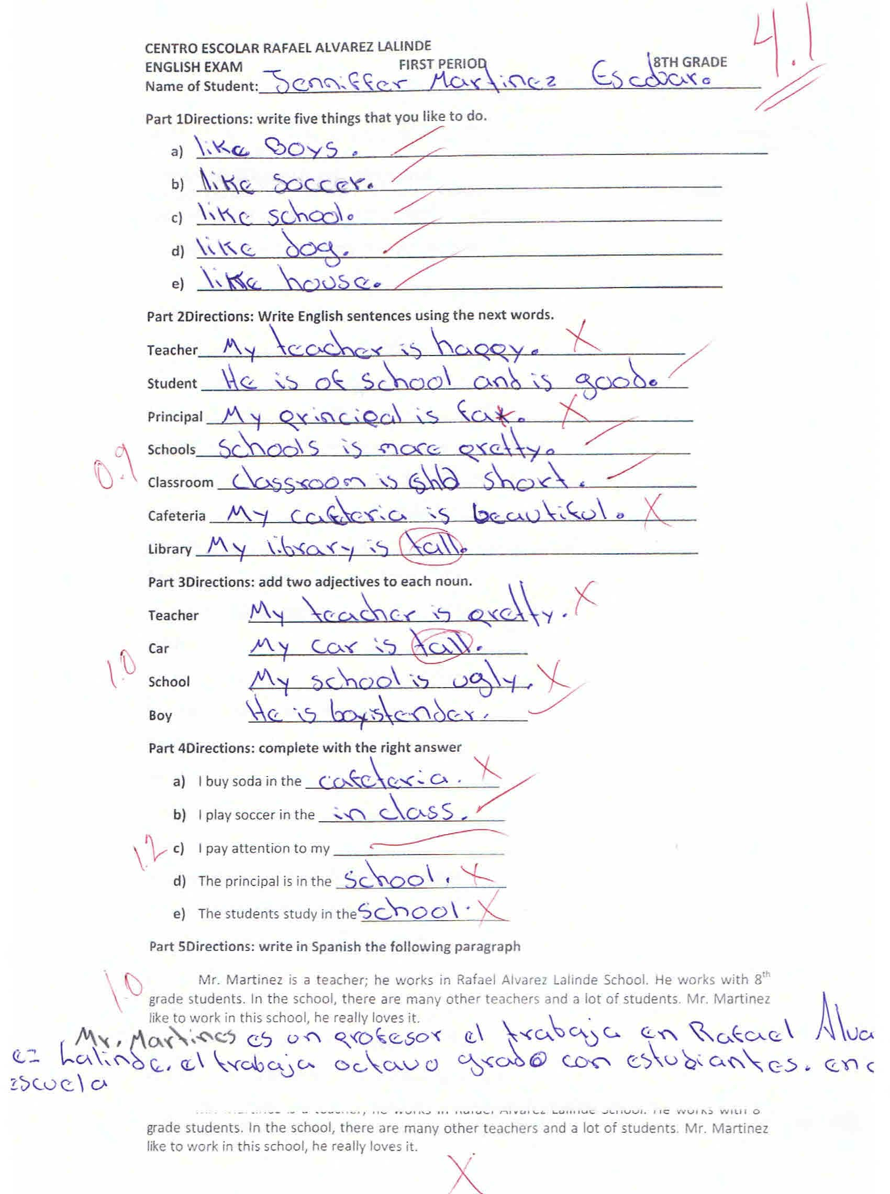

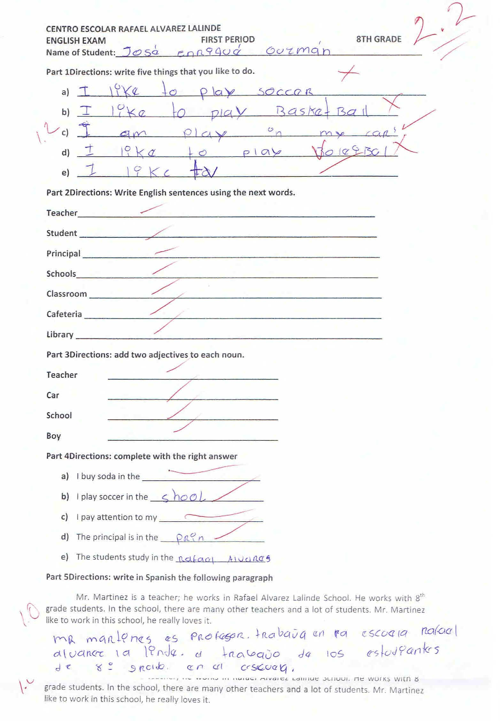
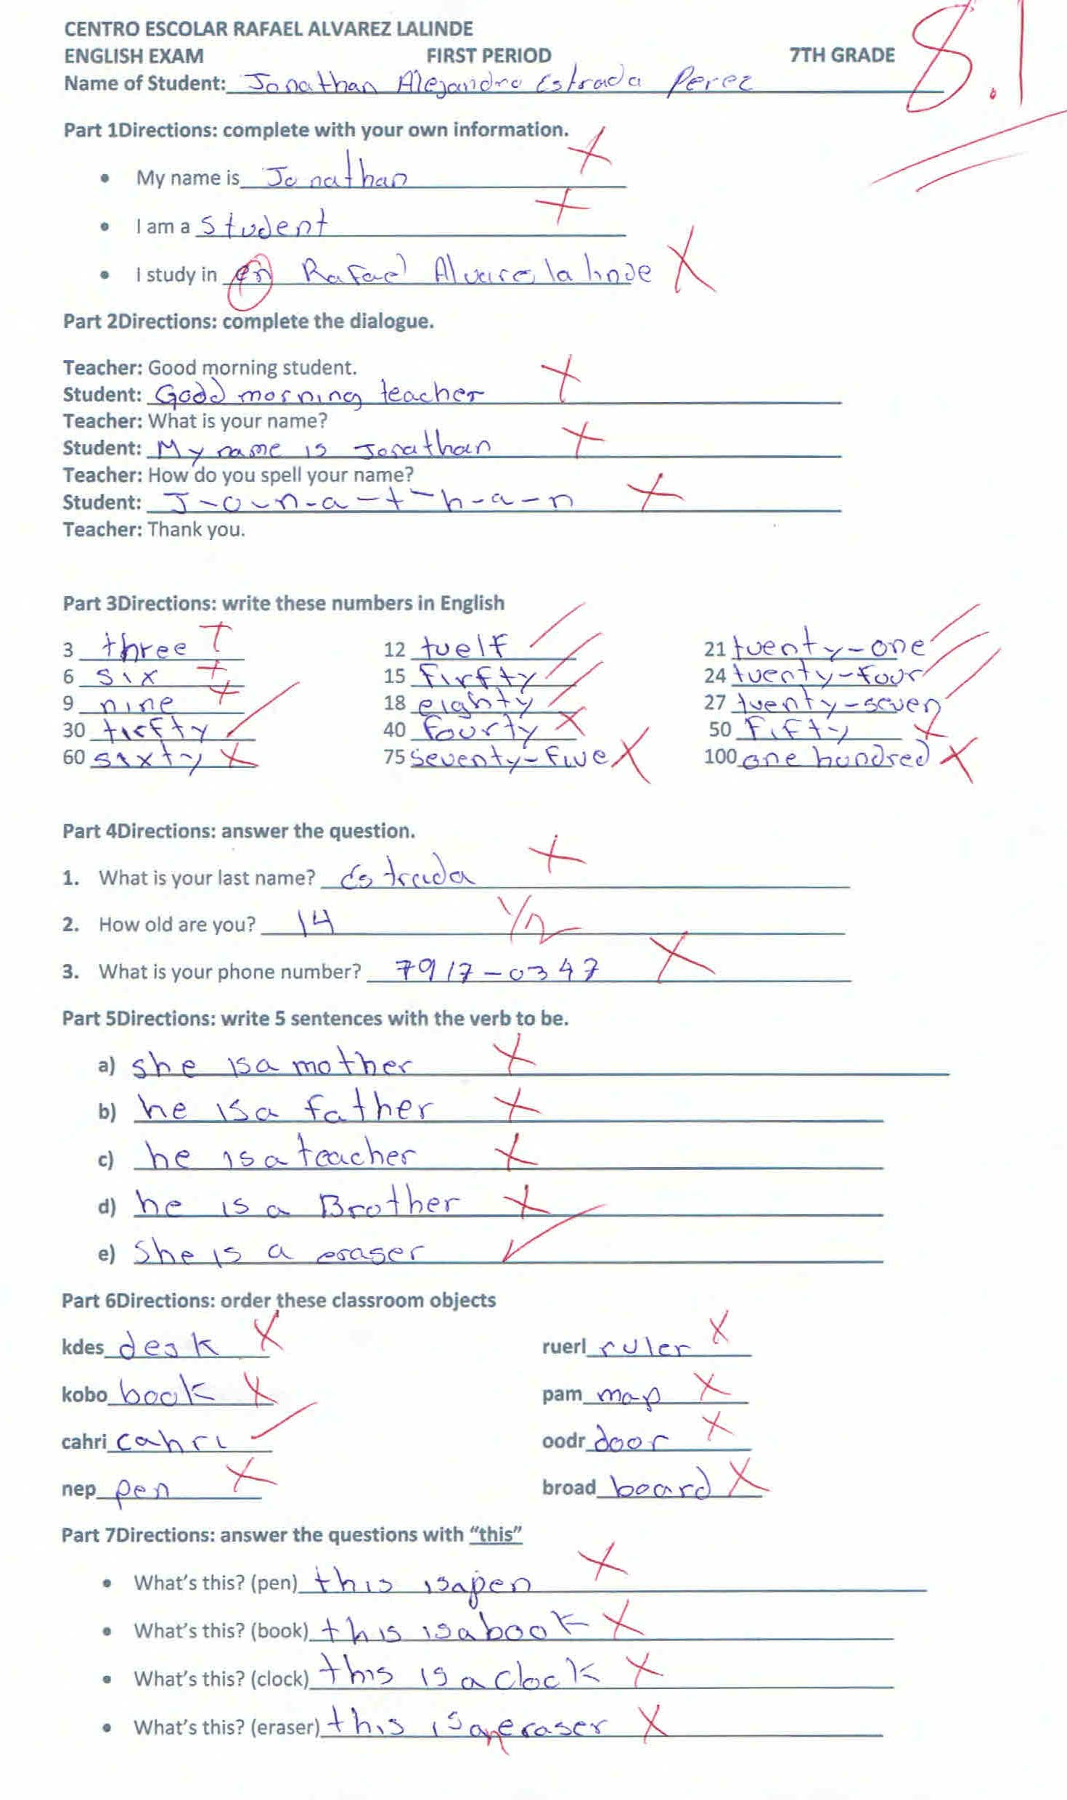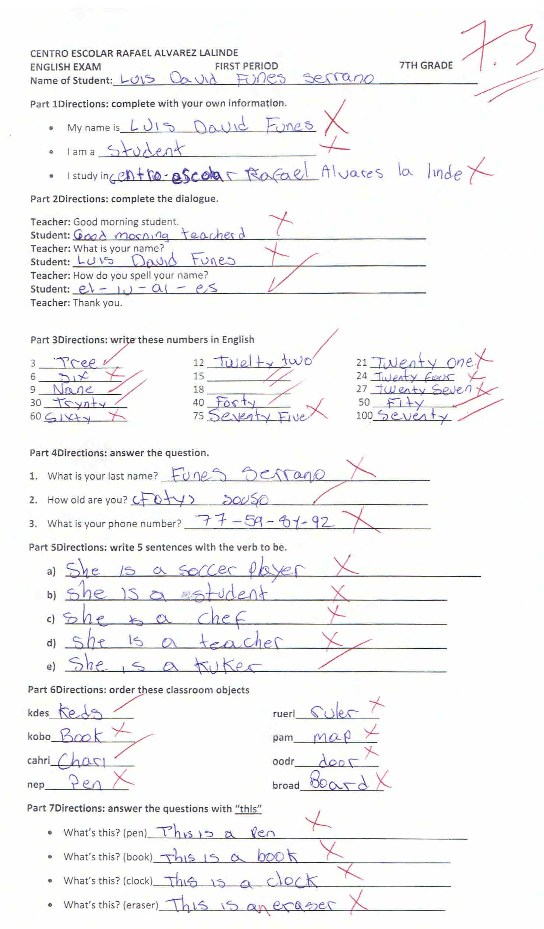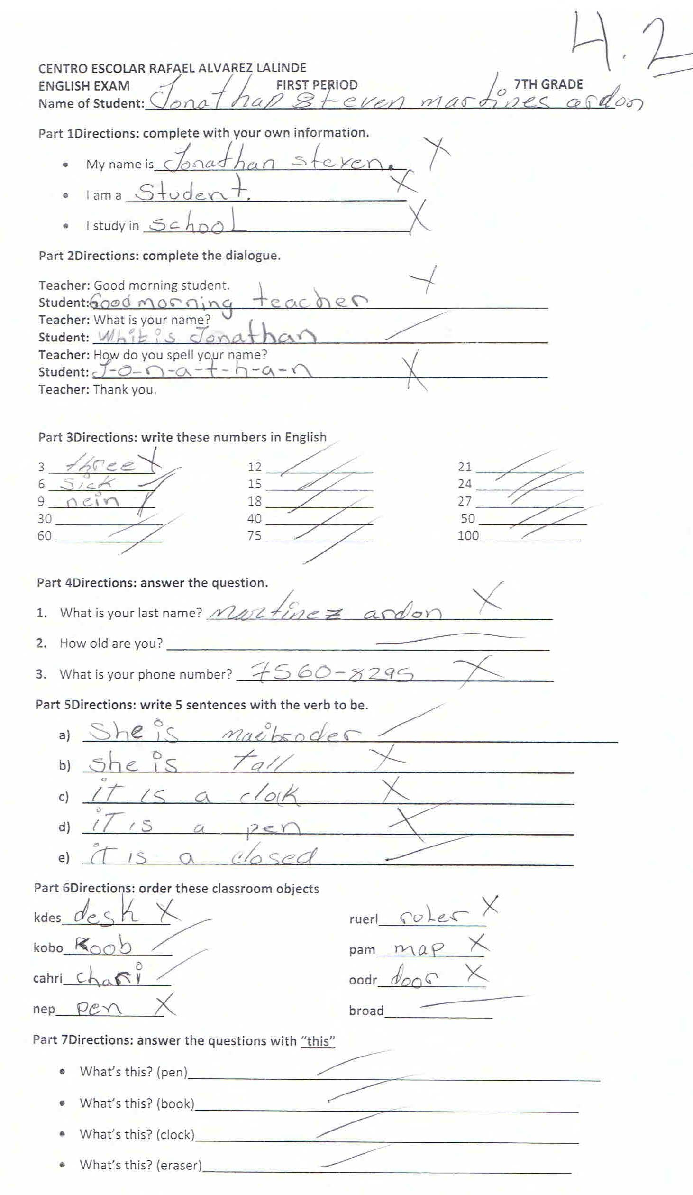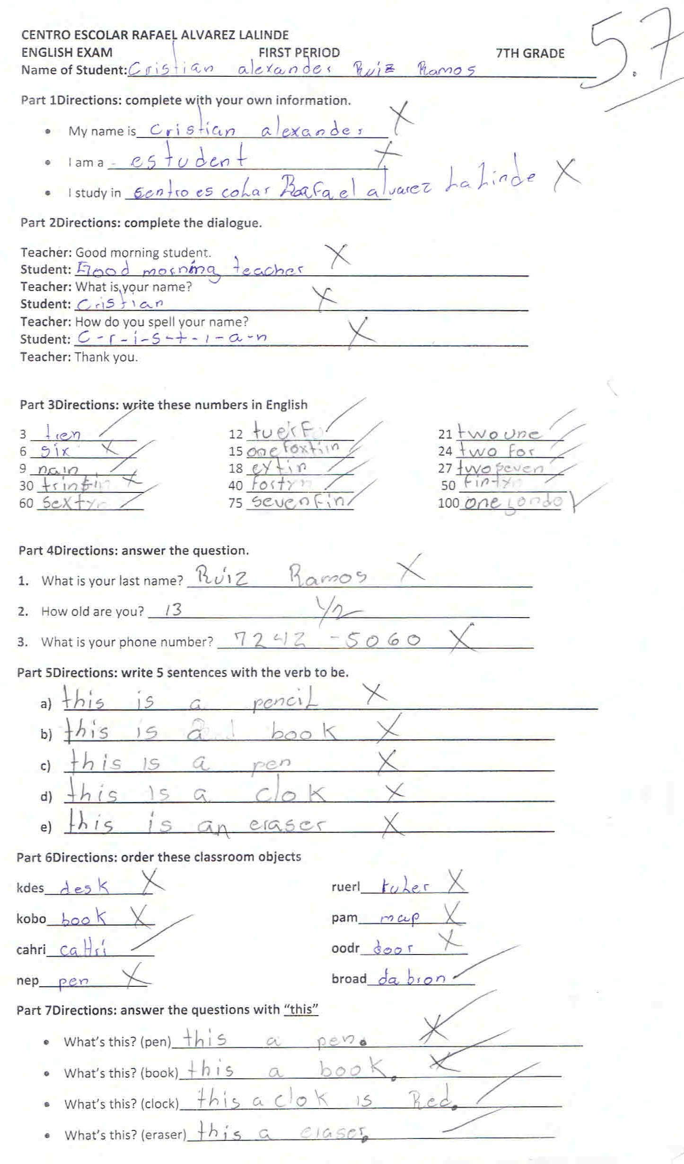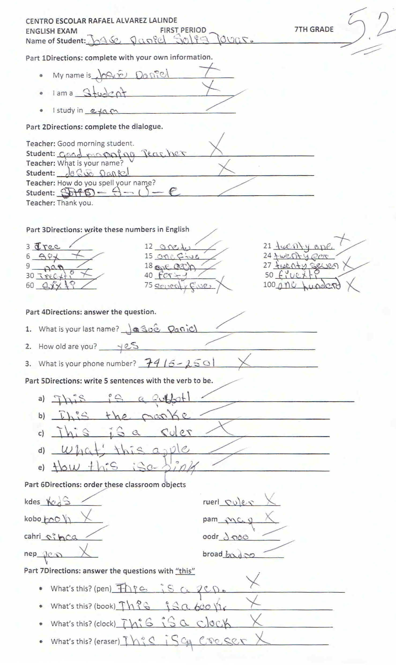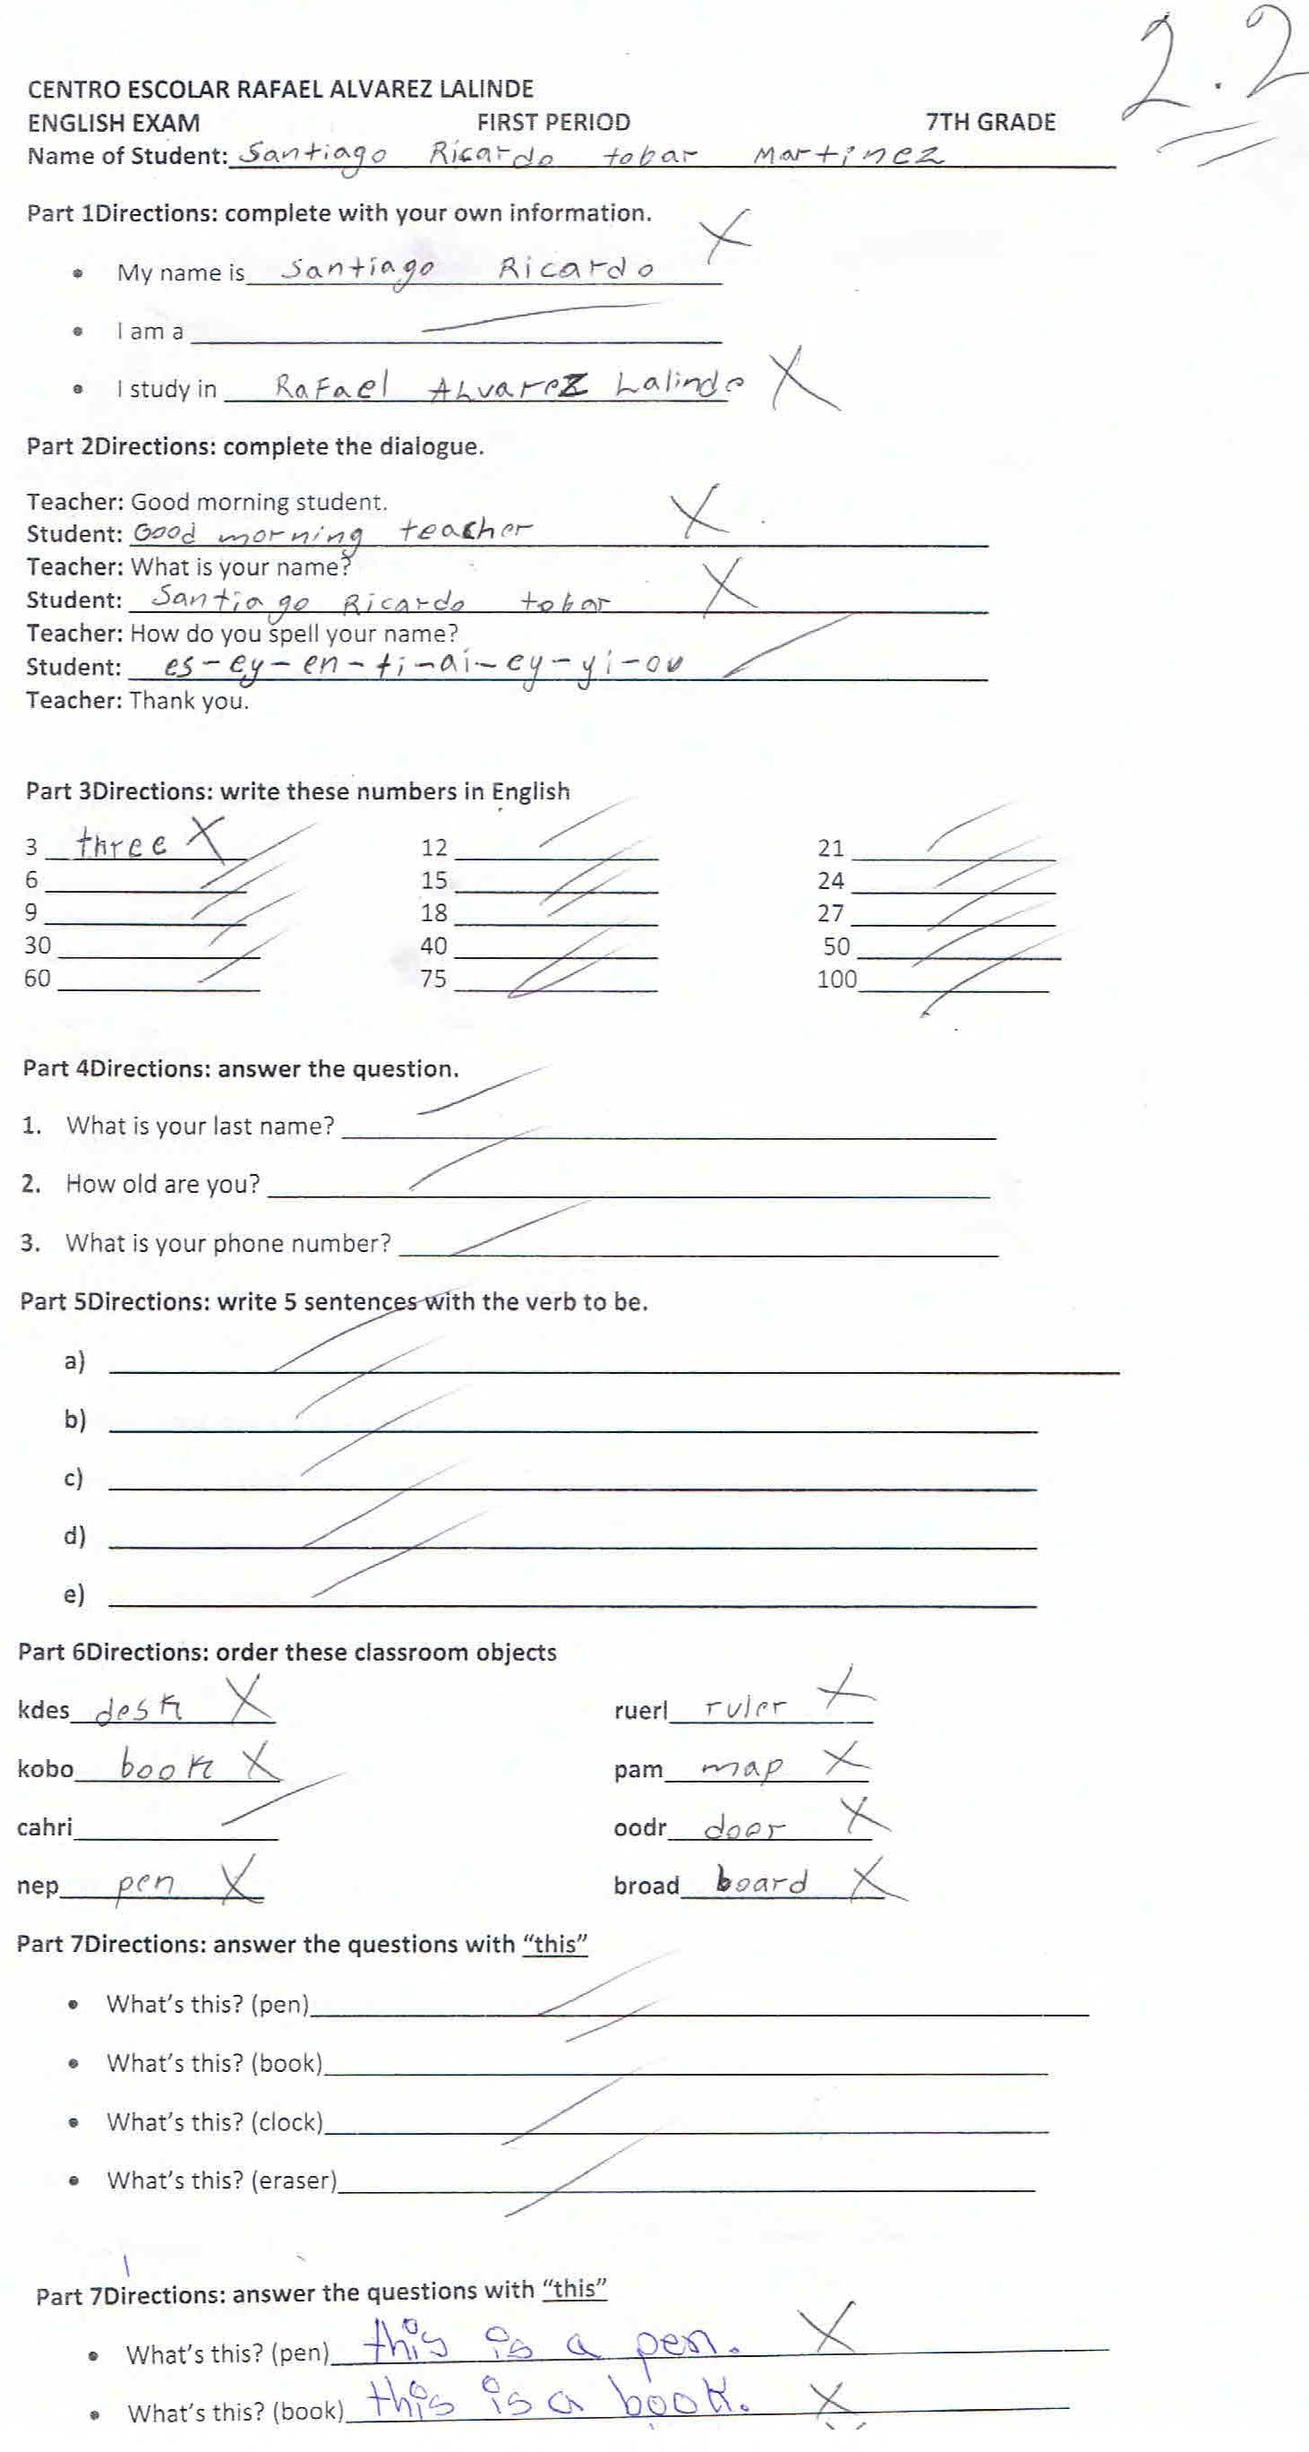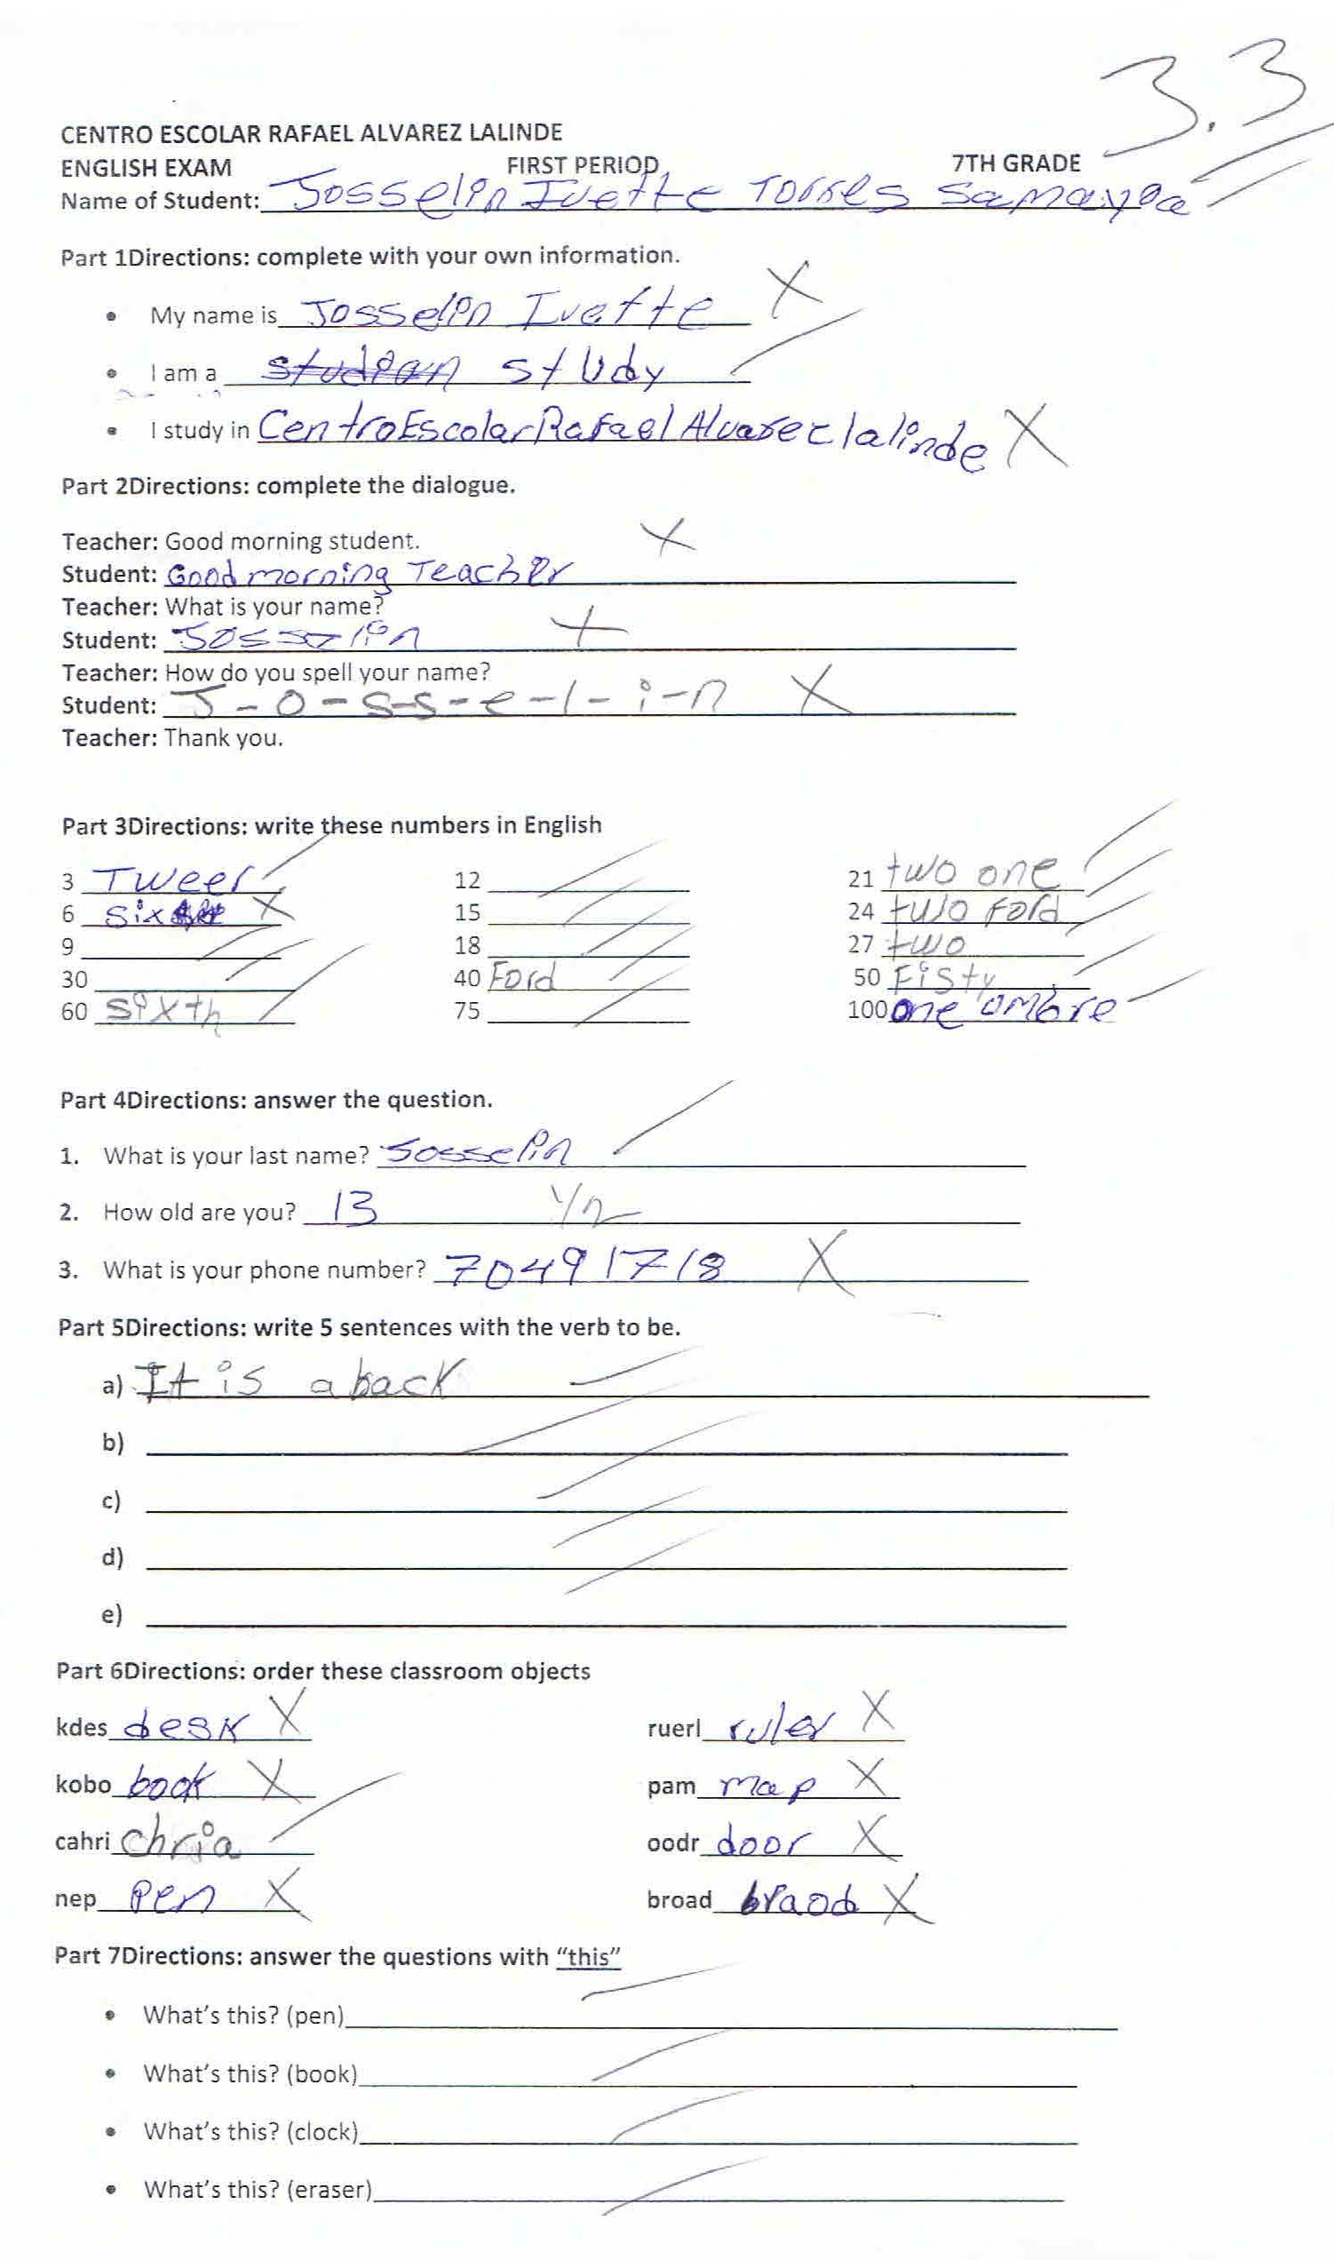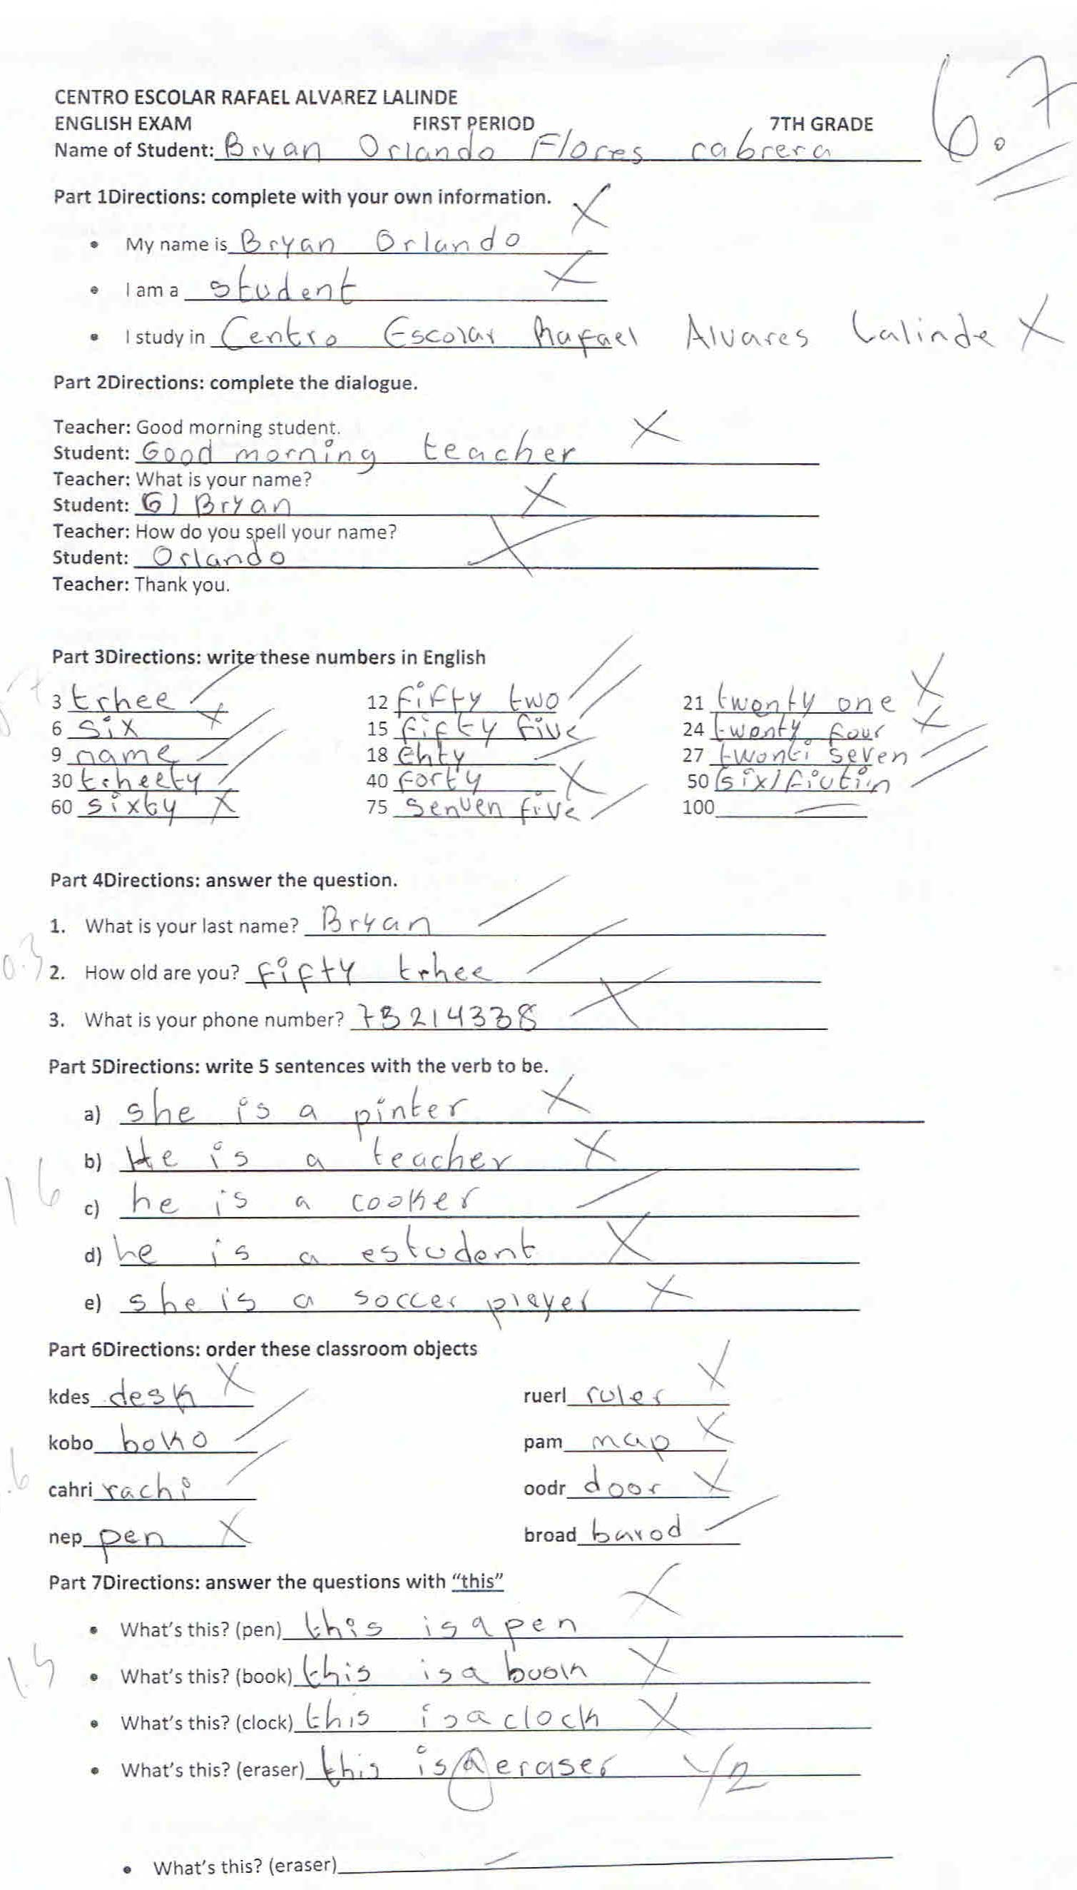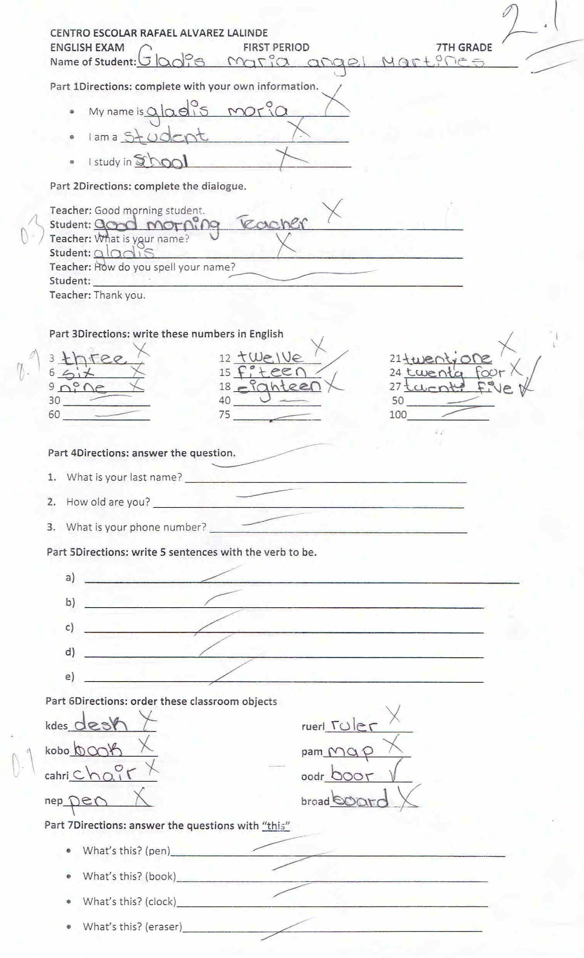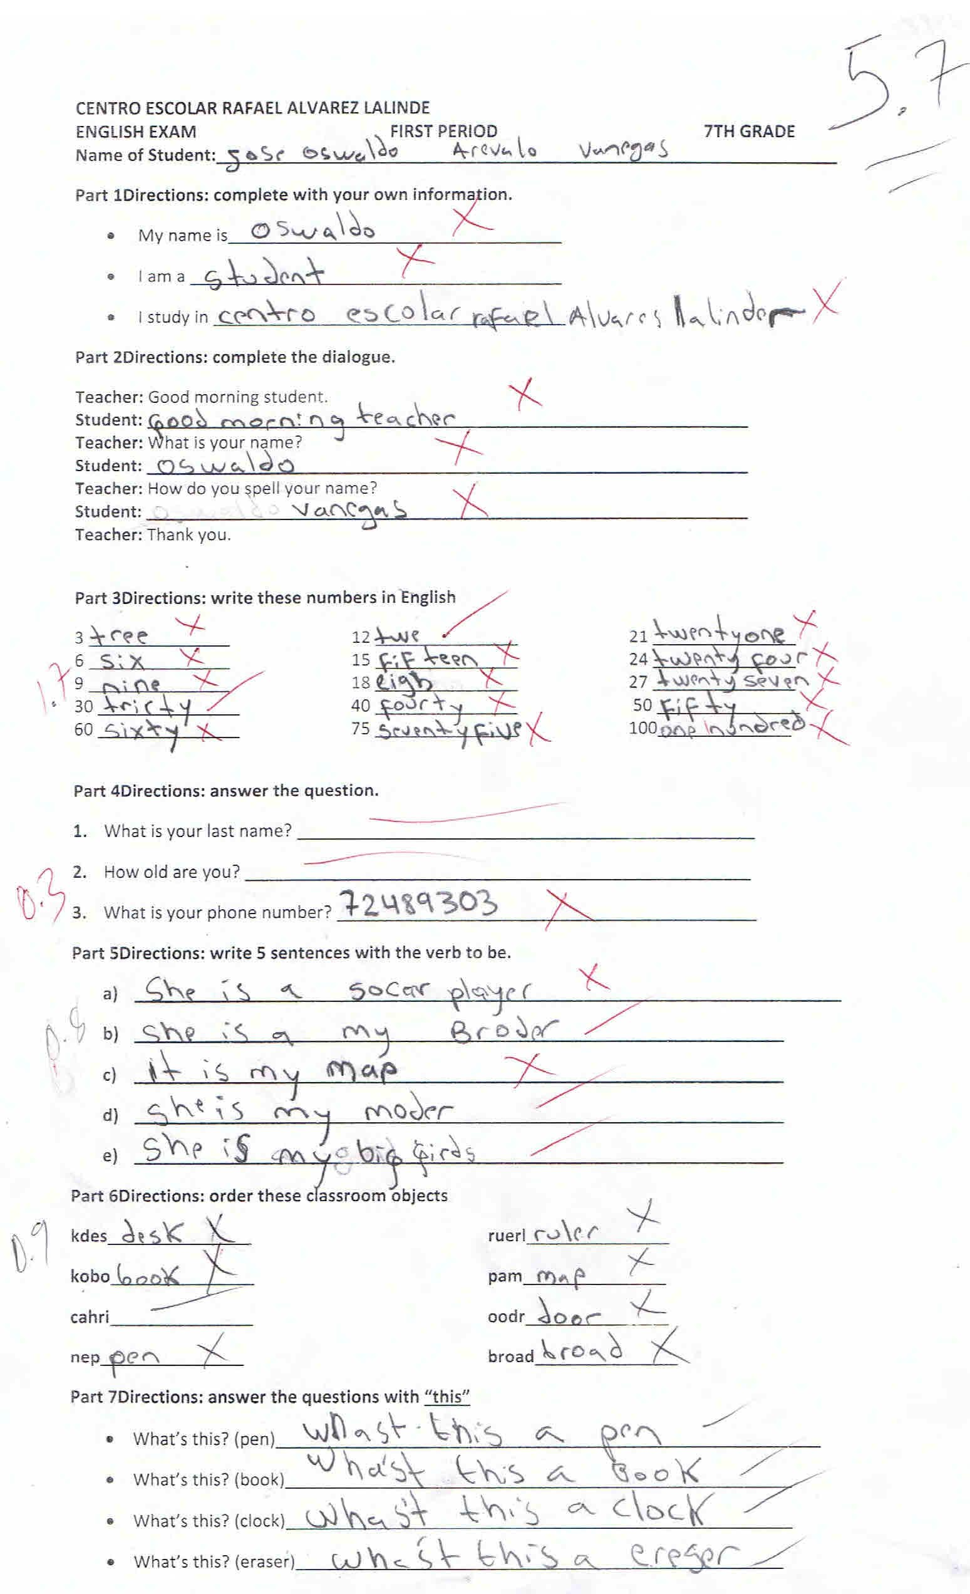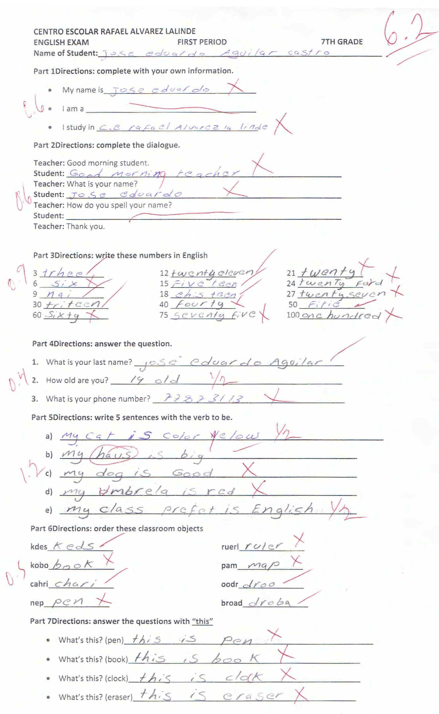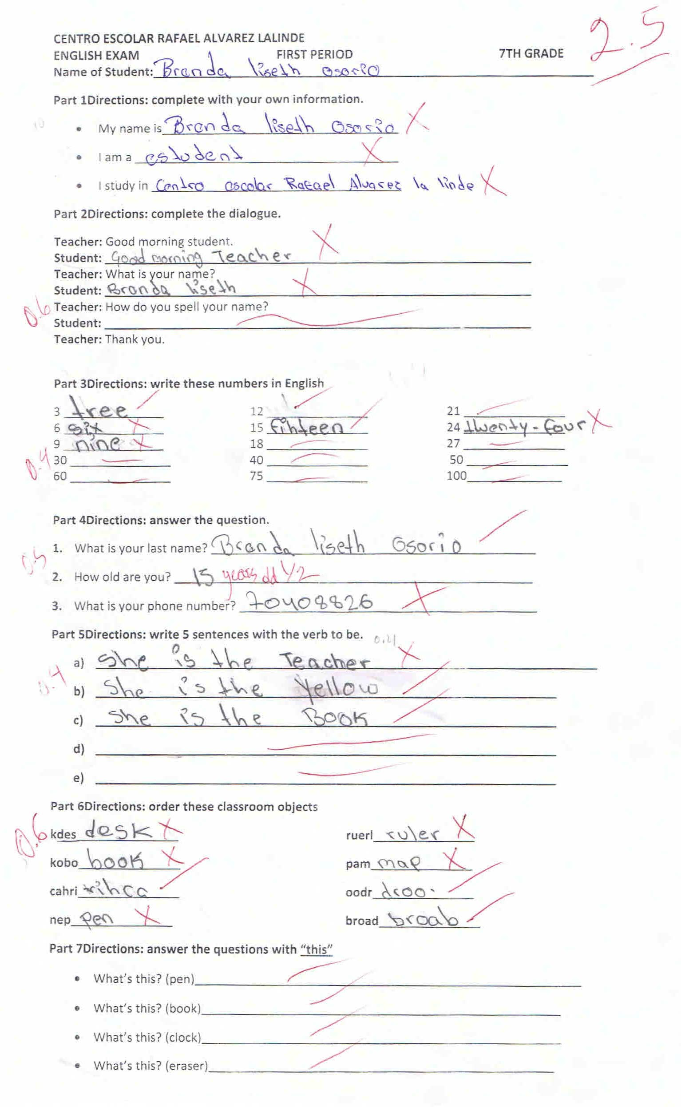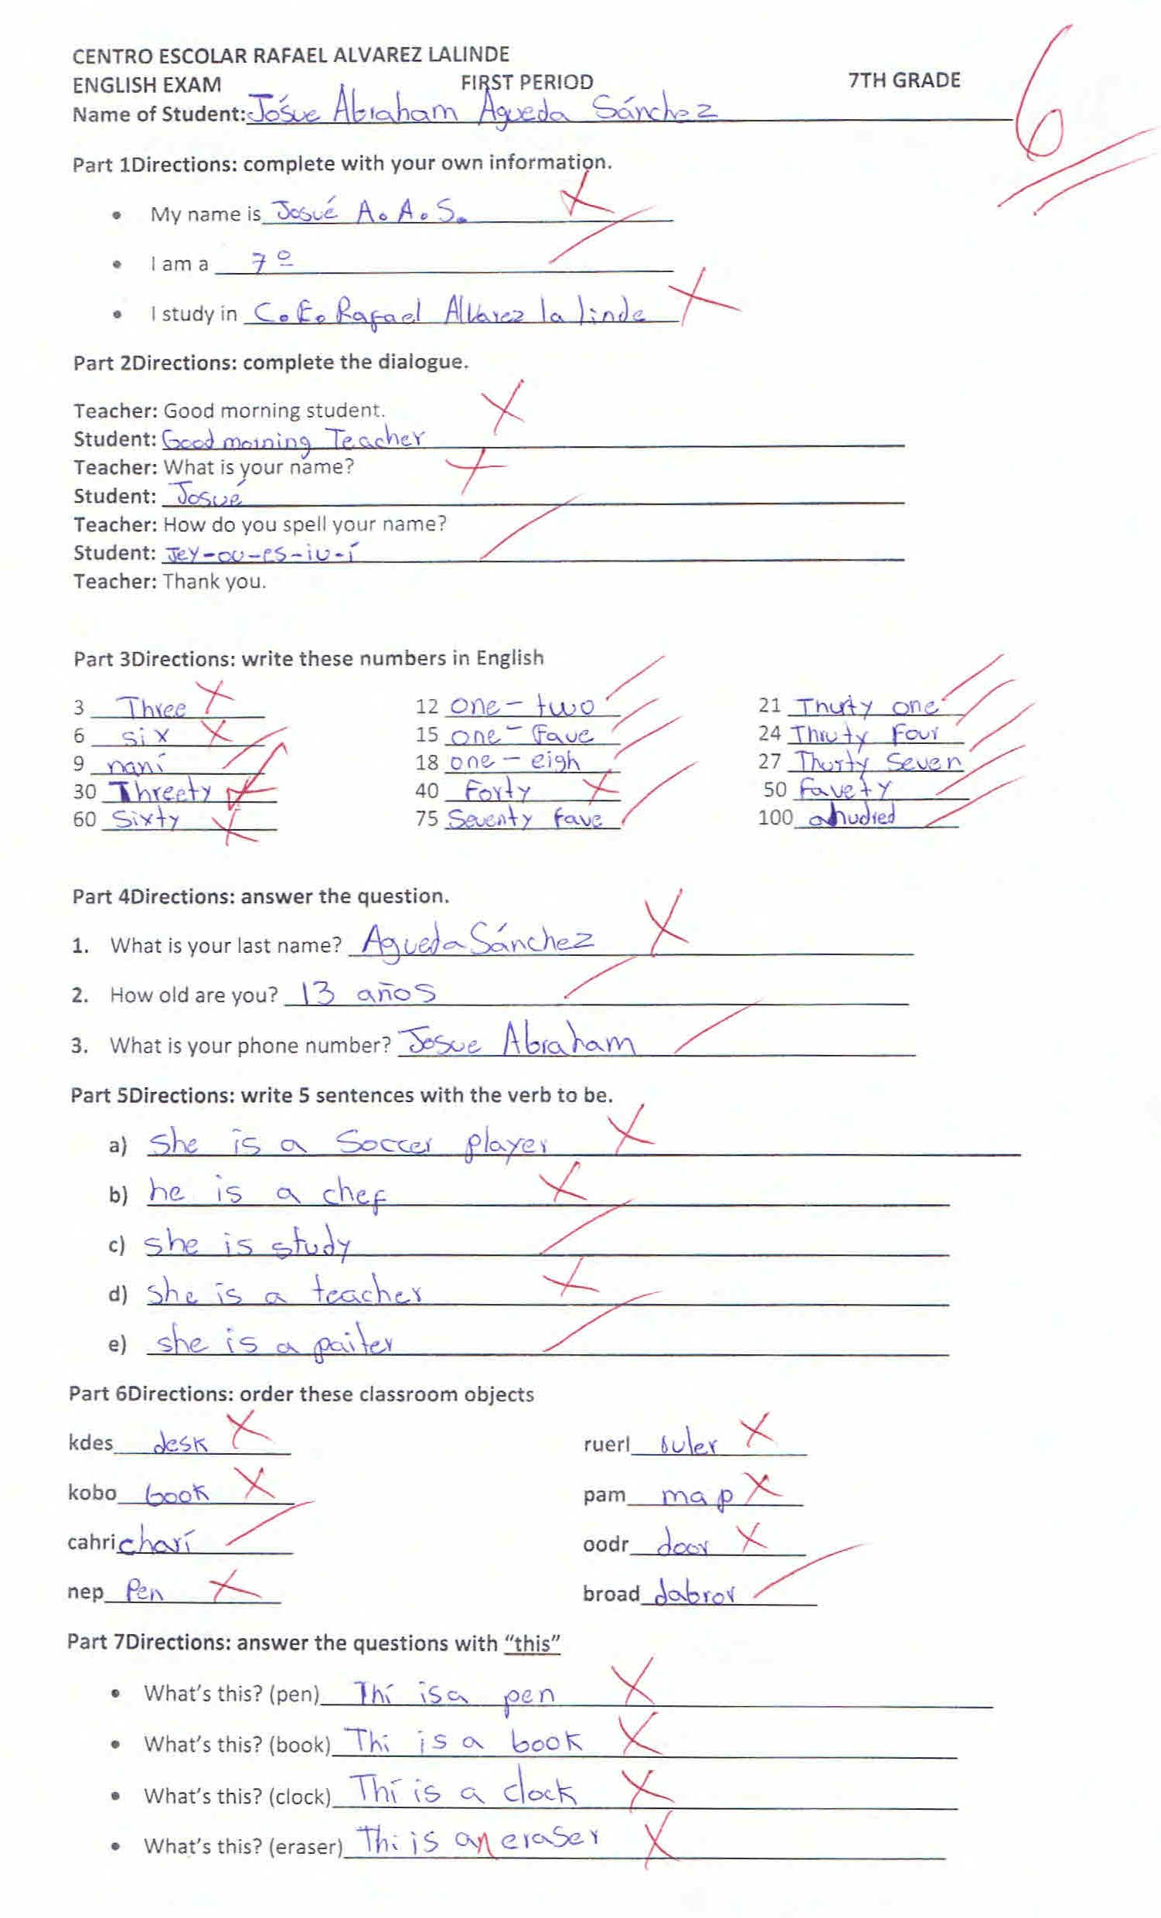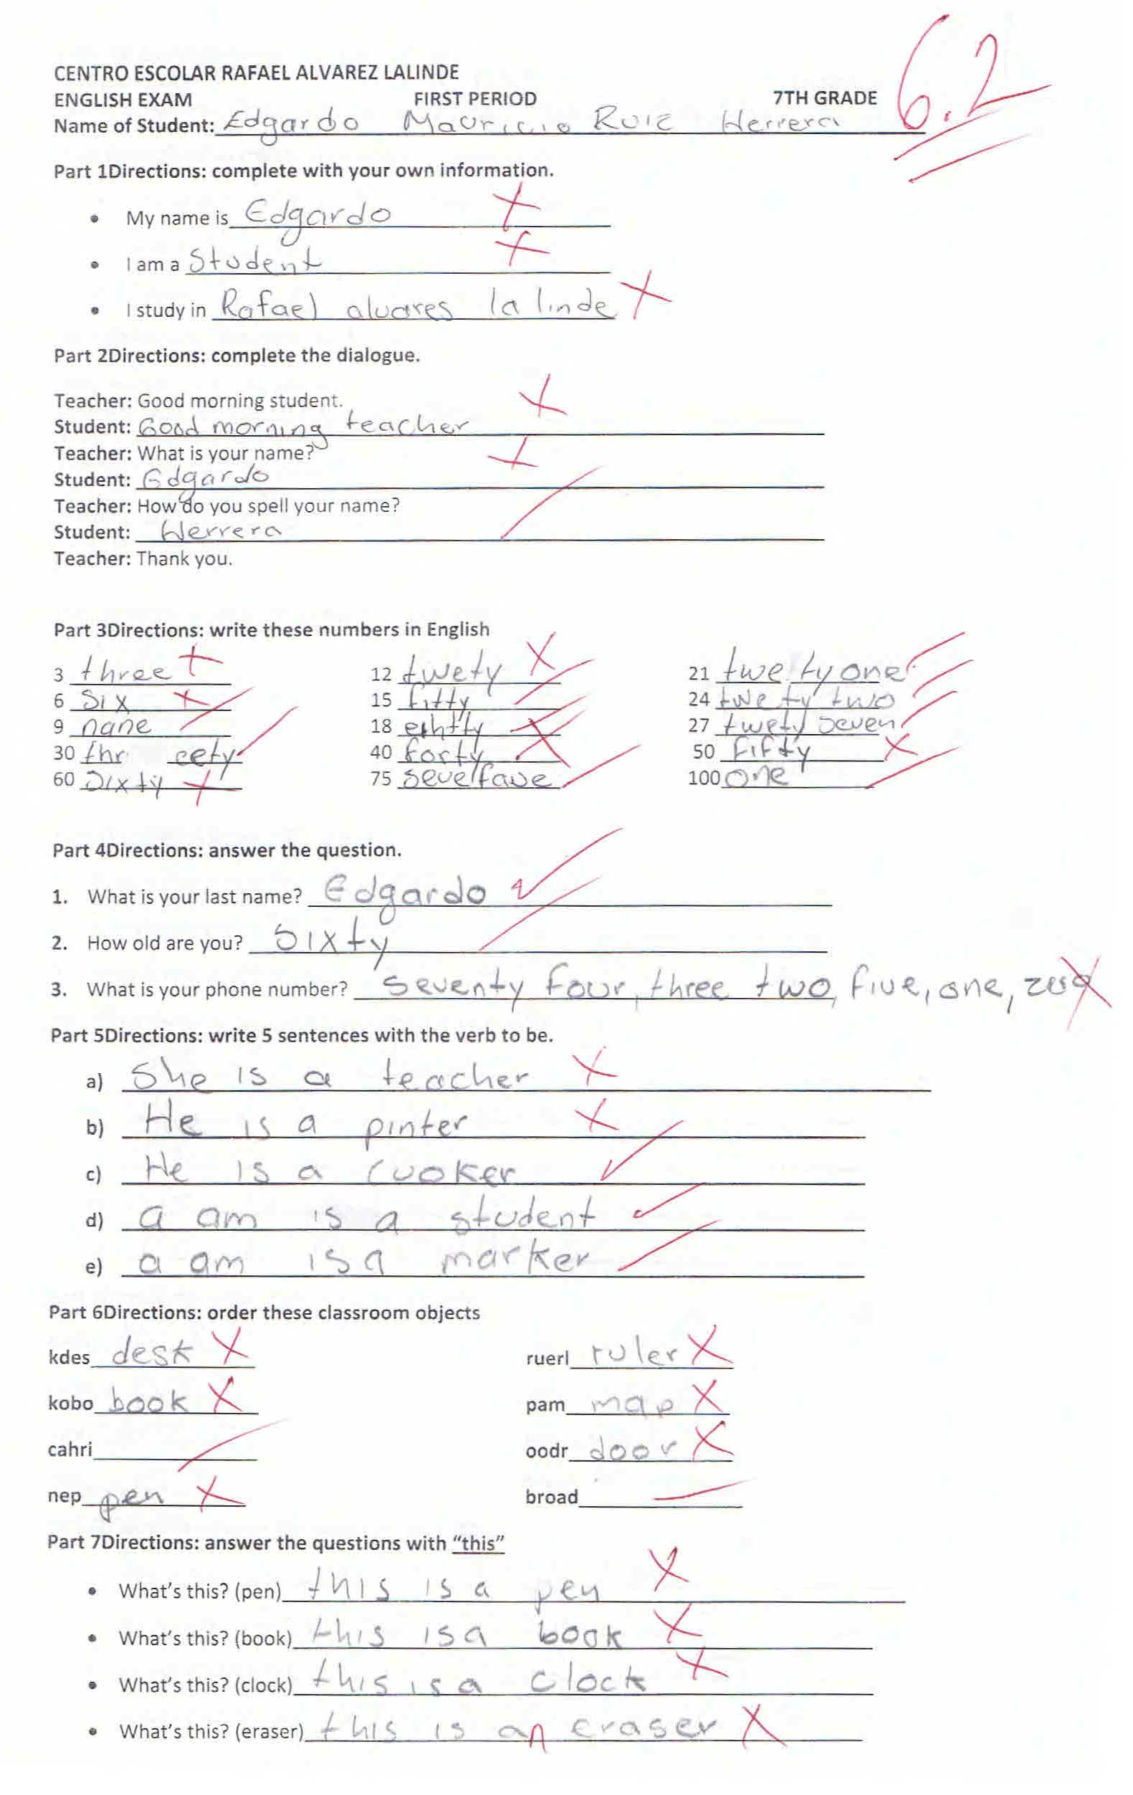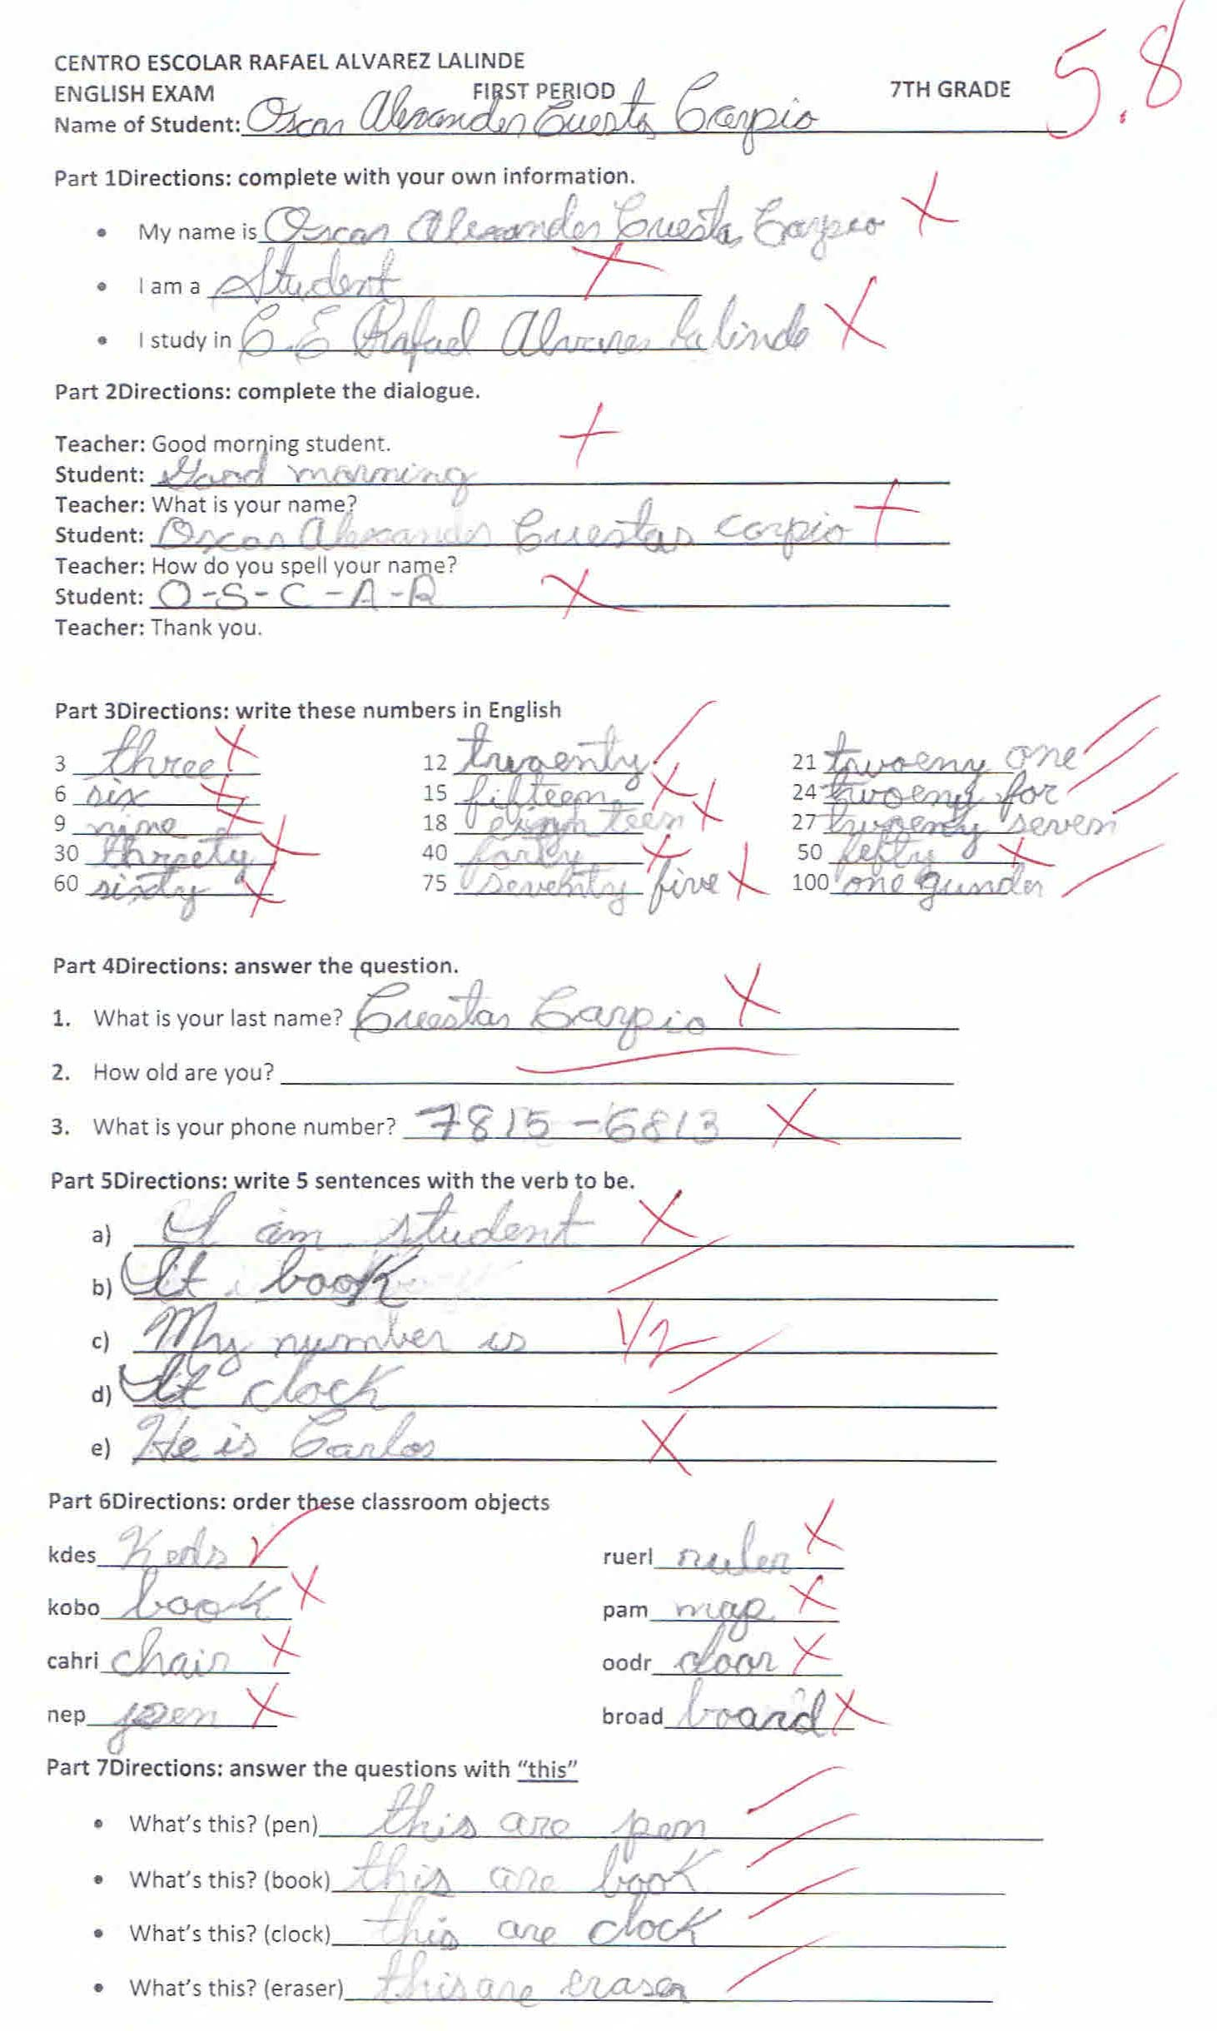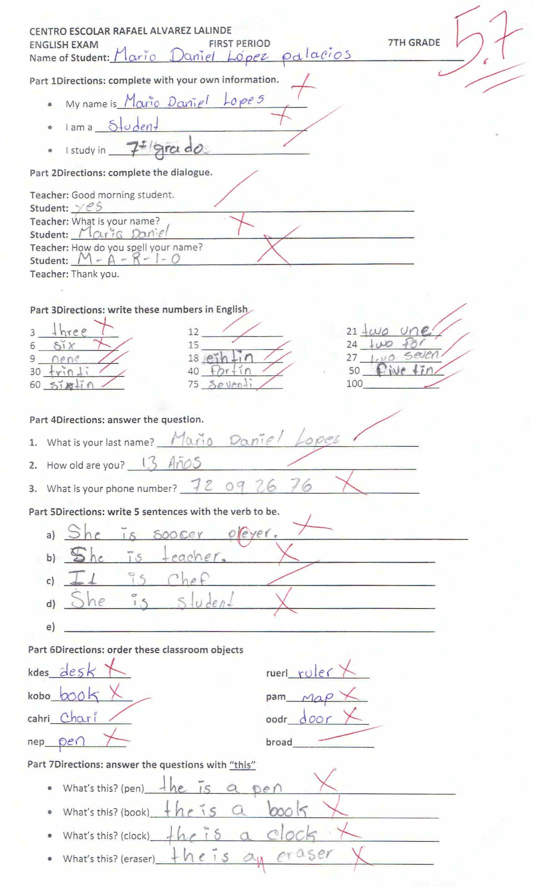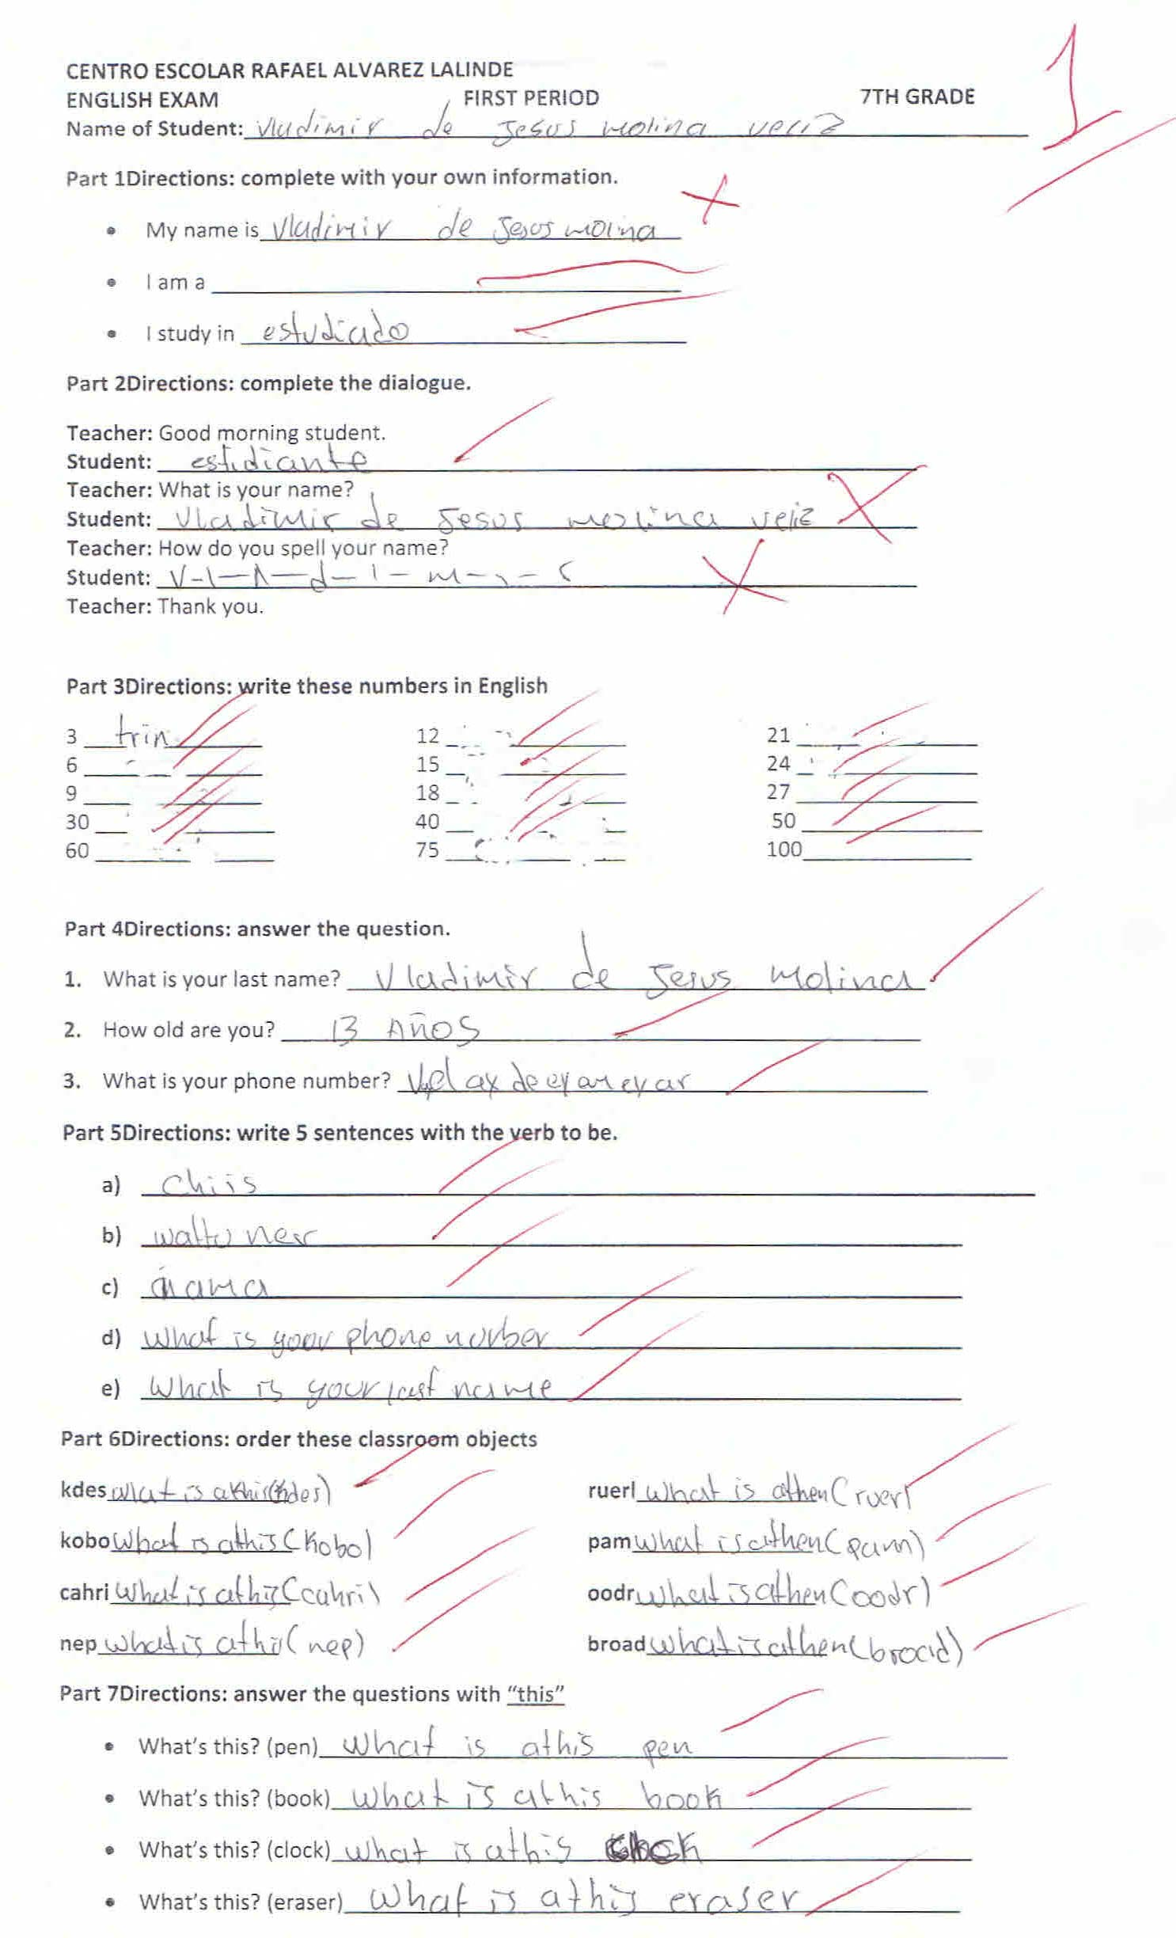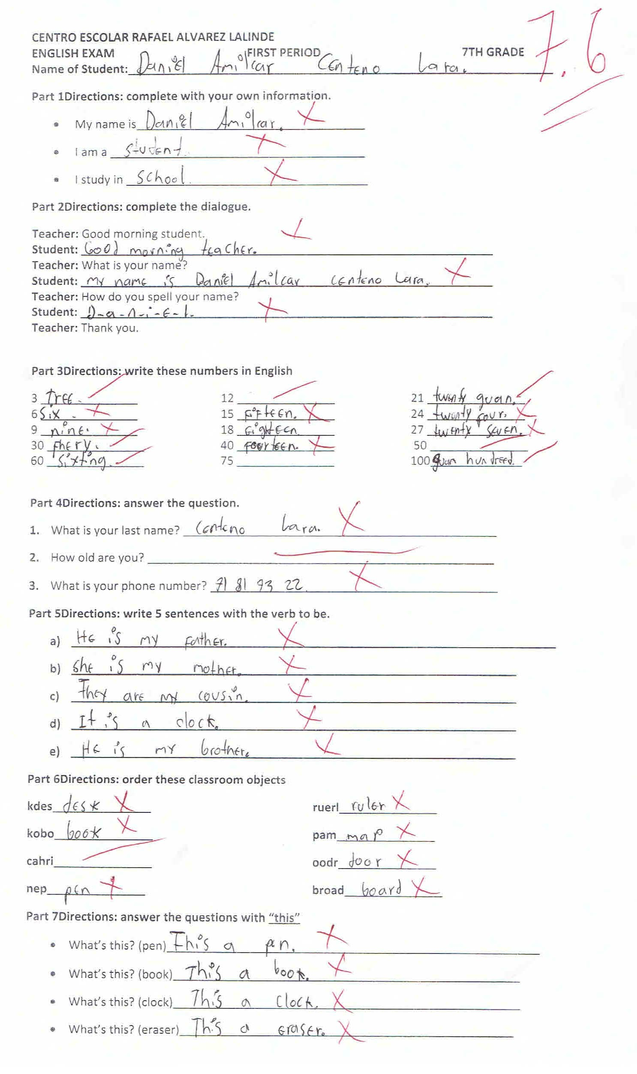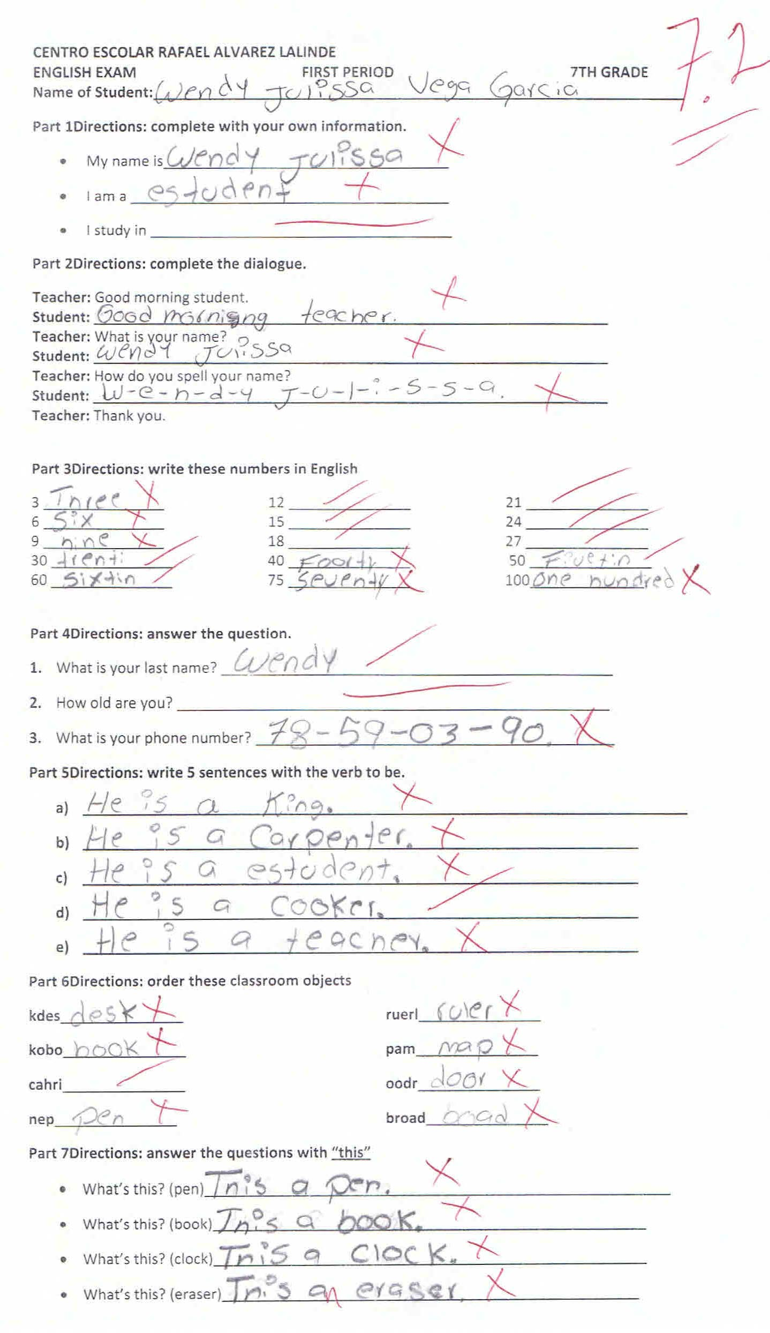
TERCER CICLO’S HOMEWORK ASSIGNMENTS
The alphabet
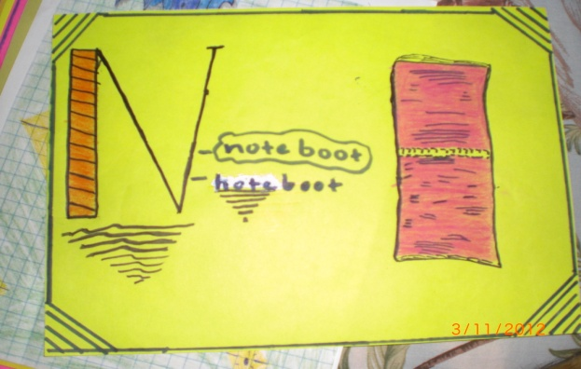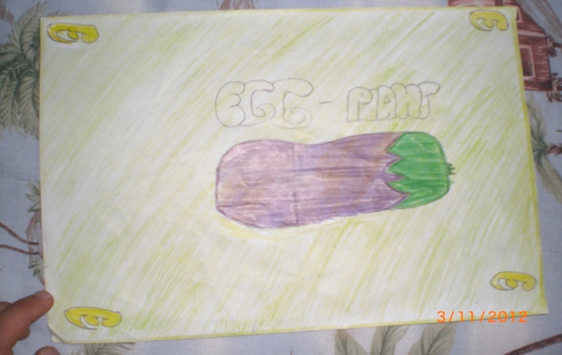
Prepositions of place
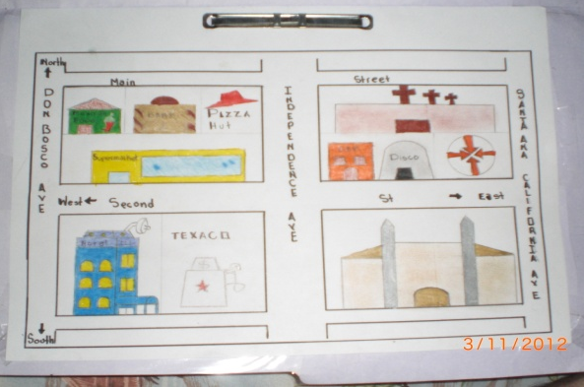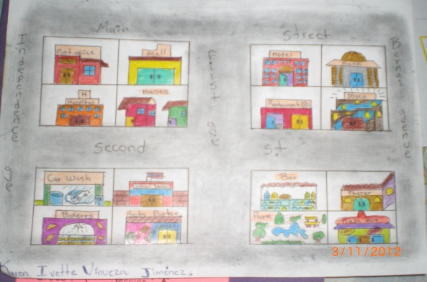
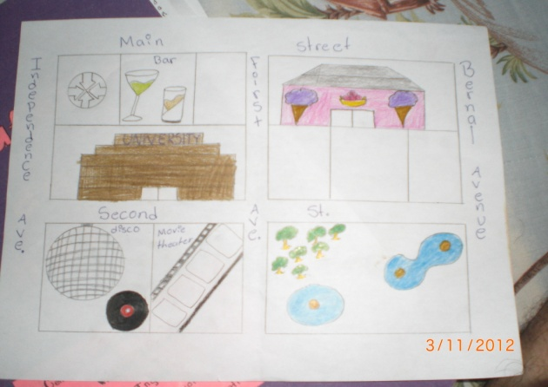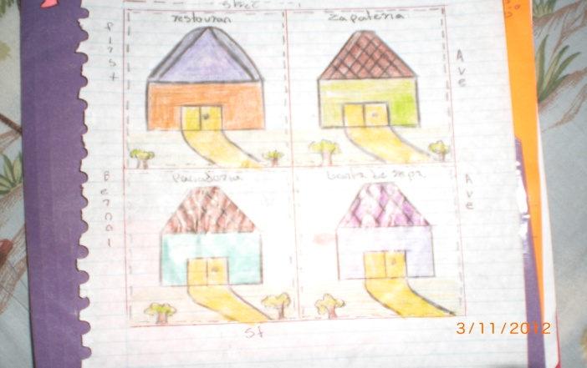
Simple homework assignments, but sadly presented by a few of the students only.

JOURNALS
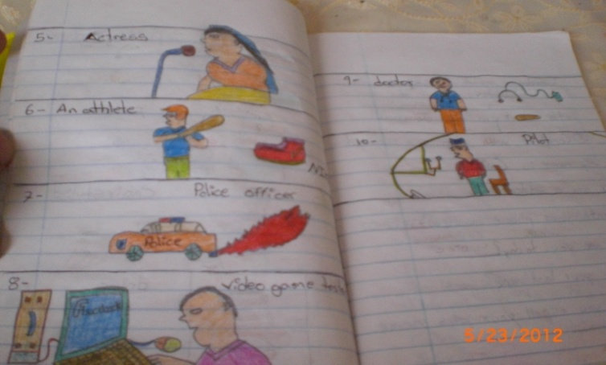

This is an entry of the journal related to the professions. The students have to write list of profession and draw something related to it.

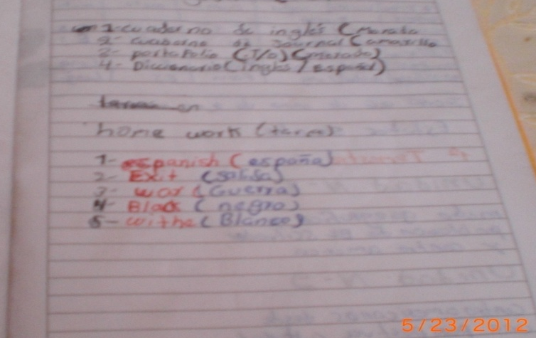

In this exercise, the teacher did not correct the student’s error. The student wrote España as meaning of Spanish.

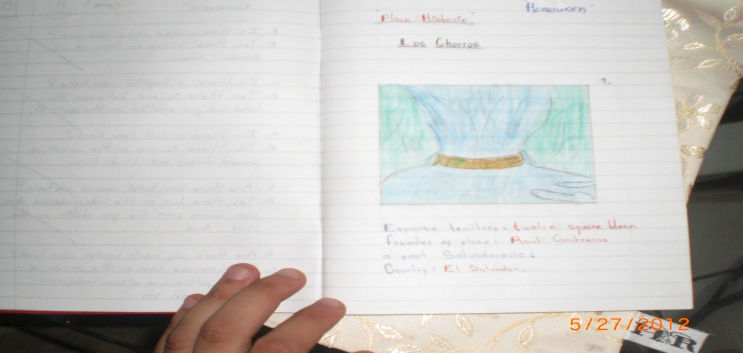

The teacher did not correct the writing mistake. The students wrote Place historic instead of Historic place.

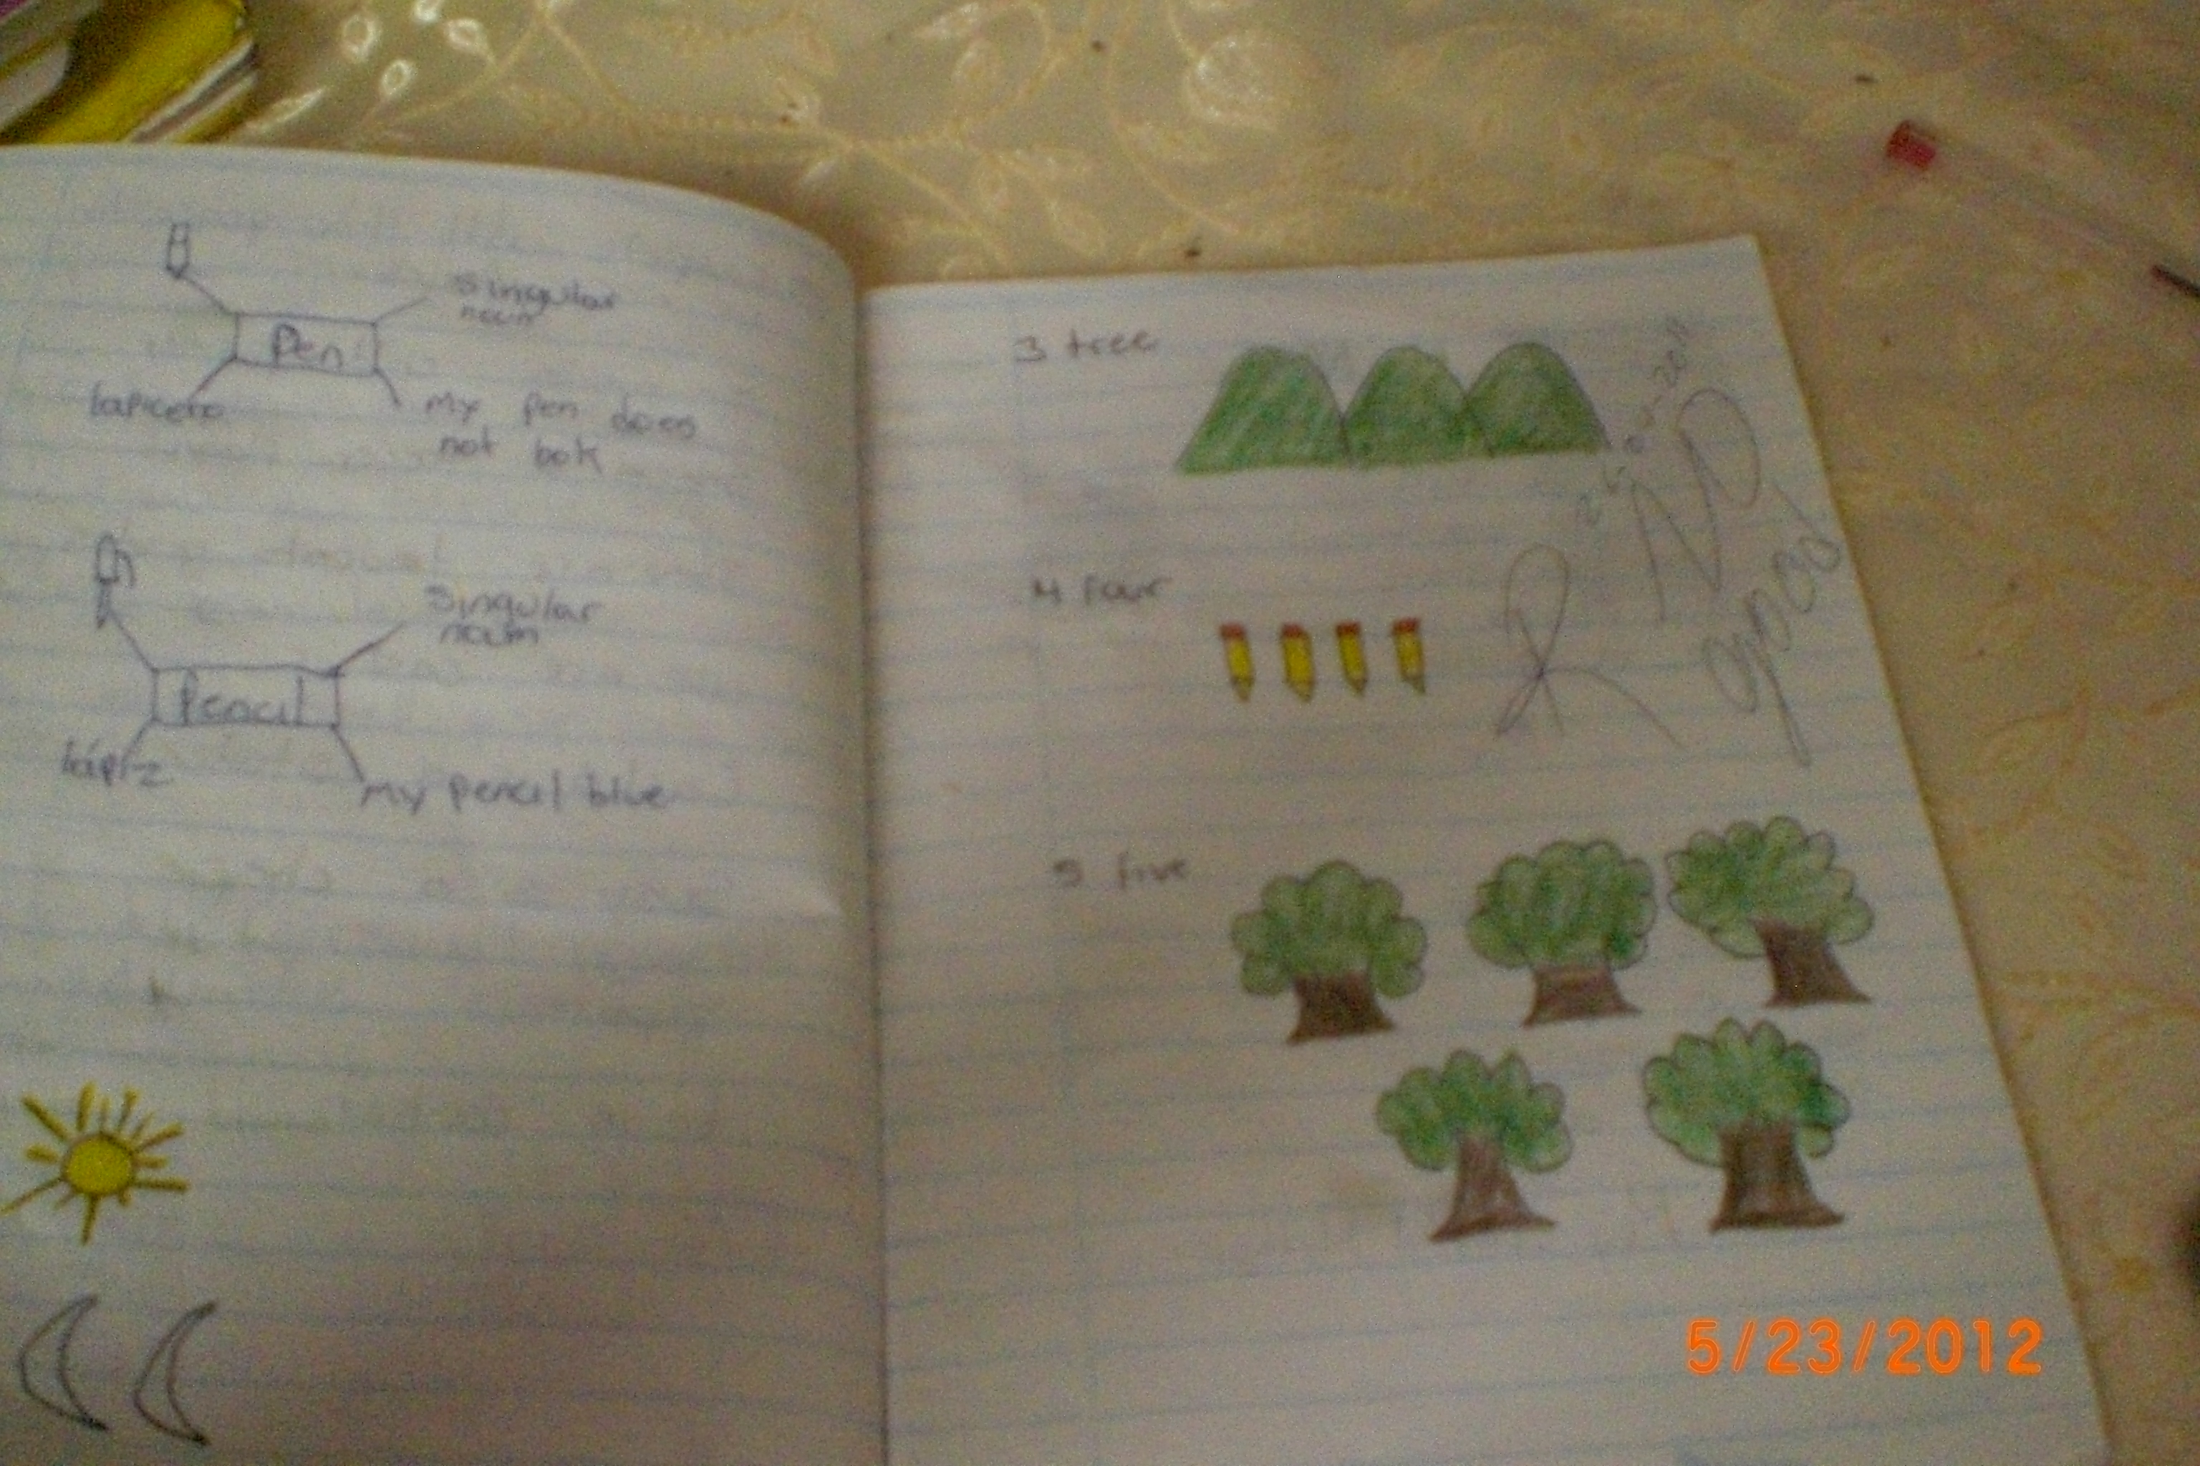
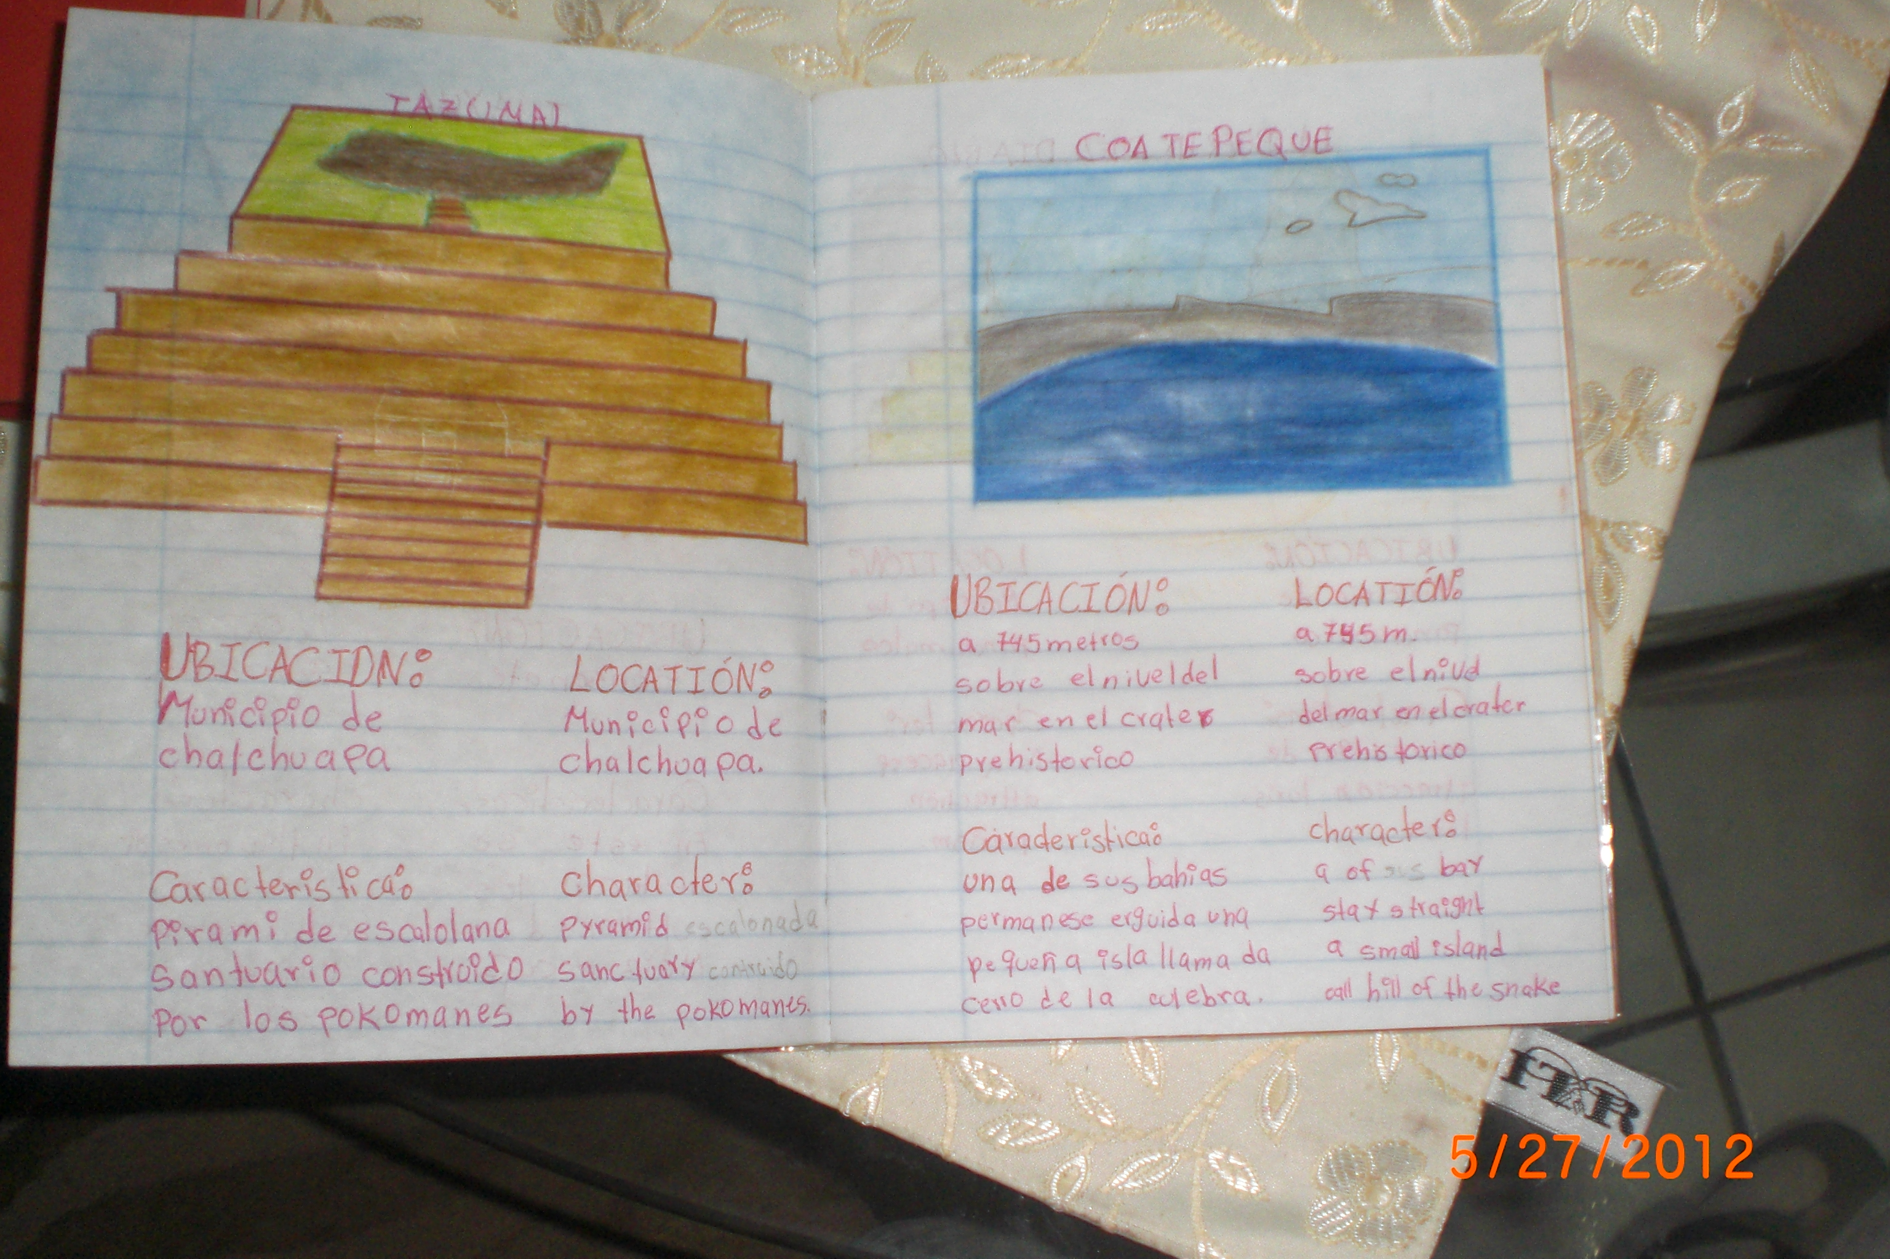
When students make an effort, they can do a good job!

NOMINA DE ALUMNOS Y ALUMNAS 9º GRADO, SECCION "A"
CENTRO ESCOLAR RAFAEL ALVAREZ LALINDE
AÑO: 2012

1 | Alvarado Alvarado, Carlos Ernesto
2 | Castaneda Martínez, Emerson Edenilson
3 | Castaneda Salazar, Néstor Vladimir
4 | Cordero Chávez, Moisés Alejandro
5 | Figueroa Pastora, Manuel Antonio
6 | Flores Escalón, Carlos Josué
7 | Guerra Villanueva, Marvin
8 | Guerra Villanueva, Nery Edgardo
9 | Hernández Sánchez, Eduardo Alfredo
10 | Jiménez Luna, Carmen Alejandra
11 | Landaverde Zeceña, Verónica Lissette
12 | Linares Guinea, Estefanía Margarita
13 | López, Kathya Johanna
14 | Mancía Alfaro, Elmer Antonio
15 | Mancía Alfaro, José Vladimir
16 | Mancía Alfaro, Yesenia Carolina
17 | Medina Alarcón, José Enrique
18 | Mezquita Alvarado, Diana Daniela
19 | Quijano Cruz, Gerardo Alexander
20 | Rivera Ruano, Ana Patricia
21 | Salguero Ramírez, Jorge Ernesto
22 | Valencia Guzmán, Zulma Lissette
23 | Valencia Zaldívar, Diego José
24 | Vega García, Jhoamy Marisol
25 | Vinueza Garcia, Karen Ivette

NOMINA DE ALUMNOS Y ALUMNAS 8º GRADO, SECCION "A"
CENTRO ESCOLAR RAFAEL ALVAREZ LALINDE
Año: 2012

1 | Álvarez Cisneros, José Antonio
2 | Aquino Ortiz, Daniel Oswaldo
3 | Dubón Mendoza, Jacquelinne Paola
4 | Escobar Valencia, William Alexander
5 | Escobar Vásquez, Josseline Dalila***
6 | Girón Martínez, Rodrigo Isaac
7 | González Rivera, Melvin Iván
8 | Guillen Mejía, Kevin Armando
9 | Guzmán Alvarado, José Enrique
10 | Hernández Cárcamo, Marvin Edenilson
11 | Maeda Gallardo, Susana Elizabeth ***
12 | Martínez Escobar, Jenniffer Guadalupe
13 | Martínez García, Vladimir Humberto
14 | Martínez Jaco, Katherinne Mariela
15 | Menjivar Vega, Kevin Alexander
16 | Ortez López, Juan Carlos
17 | Peña Escobar, Gerson Eliezer ***
18 | Peña Escobar, Tatiana Stephannie
19 | Quijano Cruz, Javier Antonio
20 | Rivera Ruano, Medarys Froylan
21 | Rodríguez Anaya, Cristian Humberto
22 | Rodríguez Ramírez, Ronald Oswaldo
23 | Ruiz Ramos, Erika Liliana
24 | Ruiz Zaldaña, Estefany Iliana
25 | Sánchez López, Mayra Guadalupe
26 | Tovar Salguero, Armando José
27 | Ventura Urrutia, Efraín Antonio
28 | Villalobos Valencia, Kevin Leonel

*** Students who quit

NOMINA DE ALUMNOS Y ALUMNAS 7º GRADO, SECCION "A"
CENTRO ESCOLAR RAFAEL ALVAREZ LALINDE
AÑO: 2012

1 | Ángel Martínez, Gladis María
2 | Águeda Sánchez, Josué Abrahán
3 | Aguilar Castro, José Eduardo
4 | Alfaro Guerra, María Victoria
5 | Arévalo Alfaro, Irving Armando
6 | Arteaga Ortiz, Kevin Fernando
7 | Centeno Lara, Daniel Amílcar
8 | Cuesta Carpio, Oscar Alexander
9 | Estrada Pérez, Jonathan Alejandro
10 | Flores Cabrera, Bryan Orlando
11 | Funes Serrano, Luis David
12 | Gallardo Ramírez, Raquel Nohemí
13 | Gutiérrez Alvarado, Nehemías Alberto
14 | Henríquez Rodríguez, Marlon Alexander
15 | Hernández Arita, Oscar Armando
16 | Jaco Jaco, Jeansy Stephannie
17 | López Ascencio, Edgardo Misael
18 | López Palacios, Mario Daniel
19 | Martínez Aragón, Jonathan Steven
20 | Matozo Peraza, Bryan Javier
21 | Osorio Alvarado, Brenda Lissette
22 | Reyes Guevara, Carlos Josué
23 | Rivas Martínez, Marisol Elizabeth
24 | Ruiz Herrera, Edgardo Mauricio
25 | Ruiz Ramos, Cristian Alexander
26 | Solís Mezquita, Jenniffer Carolina
27 | Solís Tovar, Josué Daniel
28 | Sorto Martínez, Douglas Alexander
29 | Tobar Martínez, Santiago Ricardo
30 | Torres Samayoa, Josseline Ivette
31 | Vanegas Arévalo, José Oswaldo
32 | Vanegas Ramírez, Erick Ernesto
33 | Vega Garcia, Wendy Julissa
34 | Vega Rivas, Josseline Vanessa***
35 | Velis Molina, Vladimir de Jesús

*** Students who quit

