UNIVERSITY OF EL SALVADOR
SCHOOL OF ARTS AND SCIENCES
FOREIGN LANGUAGES DEPARTMENT


UNDERGRADUATE RESEARCH:
THE RELATIONSHIP BETWEEN PERSONALITY AND THE ORAL FLUENCY OF STUDENTS ON THE SECOND SEMESTER OF 2012 AT THE FOREIGN LANGUAGES DEPARTMENT IN THE UNIVERSITY OF EL SALVADOR.
IN ORDER TO OBTAIN THE DEGREE OF:
LICENCIATURA EN IDIOMA INGLÉS OPCIÓN ENSEÑANZA

PRESENTED BY:
ELDA MELISSA MANCÍA FUENTES MF07004
KRISSIA MARIBEL MARTÍNEZ RODRÍGUEZ MR07069
SILVIA MARICELA RAMOS MANZANARES RM07049
NOHEMY ELIZABETH REYES LÓPEZ RL07019
ADVISOR
LIC. JOSÉ MATTHEW ALVARADO MORALES

SAN SALVADOR, EL SALVADOR, CENTRAL AMERICA, MAY 29th, 2013

AUTHORITIES OF THE UNIVERSITY OF EL SALVADOR

ING. MARIO ROBERTO NIETO LOVO
RECTOR

MTRA. ANA MARIA GLOWER DE ALVARADO
ACADEMIC VICE RECTOR

IN PROCESS TO BE ELECTED
ADMISTRATIVE VICE RECTOR

DRA. ANA LETICIA ZAVALETA DE AMAYA
SECRETARY GENERAL

AUTHORITIES OF SCHOOL OF ARTS AND SCIENCES

LIC. JOSÉ RAYMUNDO CALDERÓN MORÁN
DEAN

MTRA. NORMA CECILIA BLANDON DE CASTRO
VICE-DEAN

LIC. ALFONSO MEJÍA RIVERA
SECRETARY

AUTHORITIES OF THE FOREIGN LANGUAGE DEPARTMENT

MTRO. JOSÉ RICARDO GAMERO ORTÍZ
HEAD OF THE DEPARTMENT

RICARDO GARAY SALINAS, M Ed.
GENERAL COORDINATOR OF
THE DEGREE PROCESSES

LIC. JOSÉ MATTHEW ALVARADO MORALES

ADVISOR

Acknowledgement
At the end of our thesis we would like to express our gratitude to all those who made this thesis possible. First and foremost, we would like to thank Almighty God who gave us the wisdom, strength and enable us to complete this research.
Secondly, it is with immense gratitude that we acknowledge our Research Advisor Lic. José Matthew Alvarado Morales, who offered his continuous advice and encouragement throughout the course of this thesis. His stimulating suggestions and corrections for improvement helped us in all the time of research for and writing this thesis. We could not have imagined having a better advisor.
Our sincere thanks also go to Lic. Cecilia Reyes, Lic. Frank Rodríguez, and Lic. Juan Carlos Cruz for giving us the permission to work with their groups. We also acknowledge our gratitude to all the participants from these groups for helping us to gather the appropriate data.
Finally, we are indebted to our family and friends for their love, interest and continuous support- both spiritually and materially that enabled us to complete this work. This thesis would have remained a dream had it not been for their help and support.

It would not have been possible to write this thesis without the guidance and the help of all of these individuals who in one way or another contributed and extended their valuable assistance in the preparation and completion of this study.
We owe our deepest gratitude to all of them.
Elda Melissa Mancía Fuentes
Krissia Maribel Martínez Rodríguez
Silvia Maricela Ramos Manzanares
Nohemy Elizabeth Reyes López

TABLE OF CONTENTS
Abstract…………………………………………………………………………... i
Introduction…………………………………………………………………... ii
Chapter i ………………………………………………………………………….4

1. Problem 4
1.1. Statement of the Problem and Research Question 4

1.1.1. Subsidiary Questions 5

1.2. Objectives 5
1.3. Delimitations of the Research 6
1.4. Significance to the field 6
CHAPTER II………………………………………………………………………….7
2. Literature Review 7
2.1. Theoretical Framework 7
2.2. Definition of key terms 23
CHAPTER III……………………………………………………………………….27
3. Methodology 27
3.1. Sample 27
3.2. Data Collection Instruments and Analysis 28
3.3. Data Reliability Measures 30
3.4. Data Validity 31
3.5. Data Collection Process 32
CHAPTER IV………………………………………………………………………..36
4. Analysis of data 36
4.1. Data Results 36
4.2. Major Findings 57
CHAPTER V………………………………………………………………………...60
5. Conclusions and Recommendations 60
5.1. Conclusions of the study 60
5.2. Recommendations 61
BIBLIOGRAPHY 64
Bibliographical References 64
APPENDIX 67
Oral Interview Questions APPENDIX A
Fluency Rubric APPENDIX B
Personality Questionnaire APENNDIX C
Personality measurement APPENDIX D

Abstract

The purpose of this study was to find the possible relation between personality and oral fluency of the students from the Foreign Language Department of the University of El Salvador. It is believed that fluency is difficult to develop for different affecting factors that may interfere or stop students from being fluent. Among those affecting factors personality has a great significance. A quantitative methodology was utilised in this study. The quantitative research data consisted of an oral interview with 32 participants analysing the interviews with a rubric and getting a score to label students in a specific level of fluency. The second instrument was a questionnaire personality test that the same 32 students answered so the researchers could identify the personality type based on a score.
The results of the fluency interview revealed an unexpected result by finding introverts better positioned. Another unexpected result was that the majority of the sample was classified as ambivert in the personality test leaving just a small sample to compare complete extroverts with introverts. The researchers recommend for future research a correlational study with fluency and other sorts of affecting factor other than personality since it has been concluded that personality is not the only one that will determine the level of fluency a student may achieve.
Introduction
Globalization has led English language to turn into a necessity more than something desirable. Therefore, English language nowadays has gained a great importance in life. People all over the world use this language to communicate with others and it has become a tool for developing everyday activities. For instance, applying for a job or scholarships, travelling abroad, and even playing a video game are some of the examples in which people are required to learn English in order to succeed.
Learning English implies the development of many particular aspects such as the four macro skills (listening, reading, writing, and speaking) and the micro skills (punctuation, grammar, pronunciation, linguistics, etc.); however, speaking represents a challenge for students since it is a tool they use to communicate with the outside world. Moreover, in the oral performance of English, fluency, accuracy, pronunciation and grammar cannot be left aside. Within these micro skills, fluency is one of the most difficult to develop due to the fact that there are different factors that might interfere or prevent students from being fluent (Arevart, S. & Nation, P. 1991).
Some of the most common elements that are believed to interfere in the achievement of the oral fluency are motivation, age, gender, and personality. Grabiec (1998) has argued that the most determinant factor that influences students’ language fluency is personality. The main reason why some students persist and work hard to overcome the impact of their language difficulties while others give up depends on their individual personality. Thus, some findings have demonstrated the importance attached to the individual differences by classifying their characteristics into specific students personalities (Larsen-Freeman and Long, 1991).

CHAPTER I
- Problem
1.1 Statement of the problem
The impact of English has affected the educational system which has had to come up with some solutions for preparing more competitive professionals. For this reason, English has been incorporated to the syllabi of the majority of majors in the different higher educational institutions. The University of El Salvador (UES) is not the exception for this. The Foreign Languages Department (FLD) is the main source on English teaching inside the University of El Salvador. Hence, the different syllabi have English as either required or optional subject within the various majors at the Foreign Languages Department this prepares students to be able to apply for different type of jobs in which English is a main requirement such as English trainers, teachers, call center agents, translators, interpreters, etc. In contrast with the English that is taught in some academies, English program at the Foreign Languages Department does not focus only on developing communicative competences it also prepares students to be more competent in all the different English areas. The main purpose is to fulfill the individual characteristics of each student in the academic and working area. The focus of the current study is to find an answer to the following question: how does personality relate to the oral fluency of the students from the Foreign Languages Department?
1.1.1 Subsidiary Questions
- What personality types can be found in a student from the Foreign Languages Department?
- Which levels of fluency can be found in the students of the Foreign Languages Department?
- What are the characteristics of a fluent student?
- Which personality type is more fluent?

1.2 Objectives
The current research is a correlational study which is intended to accomplish the following objectives during the investigation:
- General objective
- To determine the possible relationship between the personality type and fluency level of students at the Foreign Languages Department.

- Specific objectives
- To investigate which personality type represents more disadvantages in the oral fluency development.
- To help students be aware of their personality type which might influence either positively or negatively on their English development.

1.3 Delimitations of the Research
The study involved a sample from the whole population of the Foreign Languages Department at the University of El Salvador. The participants were a group of 32 respondents (males and females). All these students are native Salvadoran speakers considered to have a specific level of oral fluency in English. The majority was taking English as a primary subject and is completely involved in the learning of English as a second language. These were Intermediate Intensive English, Advanced English, and Readings and Conversation I students. All of them were chosen randomly from both majors, Licenciatura en Idioma Inglés opción Enseñanza and Licenciatura en Lenguas Modernas, to validate the outcome of the research.
1.4 Significance to the field
This study is relevant to the Foreign Language Department of the University of El Salvador in three main aspects: First of all, it emphasizes how relevant is to develop oral fluency competence for the students of the Foreign Language Department. Second of all, this study remarks the necessity of motivating students despite their particular differences to develop oral fluency. Finally, this study can be used to help students to identify their personality types and use it positively in the development of their oral competence.

Chapter II
- Literature Review
2.1 Theoretical framework
Language teachers have always had an intuitive sense that some learners acquire the language faster and easier than others. Research has shown that several factors contribute to achievement in second language learning, including: language aptitude; cognitive style and memory, attitude, motivation, and personality (Grabiec, S 1998). One of the most important skills in a language is speaking since in that way ideas are communicated orally. Yet one of the most important speaking sub-skills is fluency, students can acquire it in different levels. What accounts for these individual differences? Various studies (Grabiec, S. 1998; Kezwer, P 1987) have linked psychological constructs of personality to oral performance. However, the relationship between personality type of learners and their fluency level has not been fully investigated. The research question for this study had three primary areas which integrate/involve psychological, linguistic and communicative constructs, these were: extroversion vs. introversion, personality and language connections; and, oral fluency development. The synopses of this study were provided in each of these areas.

- Personality researches looked at the relationship between the extraversion-introversion dimension of personality and different linguistic variables relating to oral performance.
Various studies have investigated the relation between personality variables and Second Language Acquisition (SLA). Personality has been described as a set of features that characterize an individual. It has been stated that this concept is difficult to define and measure because of its complicated nature. Studies which investigated personality traits are based on the belief that learners bring to the classroom not only their cognitive abilities but also affective states which influence the way they acquire a language (Grabiec,1998).Individual personality relates to extraversion and introversion, this notion stems from trait theories of personality developed in psychology (Zhang, 2009). Trait theorists try to identify this in a human being’s personality that is relatively stable, and it is believed, at least partly innate. To some extent, extrovertion-introvertion dimension of learners’ personality indeed affects the oral performance of their second language.
A typical extravert is someone who is sociable, likes parties, has many friends, needs to have many people to talk to, likes excitement, takes chances, acts on the spur of the moment, and is generally an impulsive individual. On the other hand, an introvert is described as someone who is a quiet, retiring sort of person, introspective, fond of books rather than people: he is reserved and distant except to intimate friends (Adamopoulos, 2004). An introvert tends to plan ahead, ‘‘looks before he leaps,’’ and distrusts the impulse of the moment, he does not like excitement. These characteristics of learners’ personality will accordingly affect their thoughts and lives, of course, including the learners’ activities for acquiring their second language (Gan, 2008).
In current psychological research, extroversion and introversion are considered the most stable personality traits that differentiate people from each other and that can be reliably measured. However, some individuals, on the other hand, seem to exhibit both traits simultaneously. Jung (1921) suggests it is possible to have an extraverted side and an introverted side, with one being more dominant than the other. He defines this as ambiversion. An ambivert can be introverted-extroverted or extroverted-introverted.
Many SLA theorists have claimed that extraverts are the better language learners. Extraverts, who tend to be sociable, are more likely to join groups, more inclined to engage in conversations both inside and outside the classroom (Sahin,B., Tezcan, B., Türkcan, E., & Savran, Z, 2010). As such they take full advantage of language-use opportunities. It has been suggested that extroverted learners will find it easier to make contact with other users of the target language and therefore will obtain more input. The classroom learner may also benefit from being extroverted by getting more practice in using the target language. Furthermore, extraverts are believed to be prone to risk-taking and are likely to try out a larger amount and variety of different word types and grammatical structures at a higher speech rate (Gan, 2008). In recent years, a more nuanced perspective on the relationship between extraversion and SLA has emerged. In reviewing the literature on effects of extraversion on second language acquisition, two major positions were identified. The first advocated that “extroverted learners will do better in acquiring basic interpersonal communication skills”. The second maintains that: “introverted learners will do better at developing cognitive academic language ability”.
Furnham (1990) quotes a study by Thorne in 1987 which examined the interaction between introverts and extroverts. The study mixed and matched partners of extroverts and introverts in conversational situations. When introverts were paired with introverts, the conversation they engaged in focused on “problem talk,” according to Thorne (1987). On the other hand, “extroverts with extroverts showed a wide range of topics and more claims of common ground.” Furnham concluded from this study and subsequent observations that extroverts that talk more are more impulsive and take more risks with speech than introverts. Introverts are more careful with speech and more focused on form: vocabulary, grammar and pronunciation.
- There are certain factors that may change the perspective that favors extroverts as better language learners.
According to Clement, R., Dornyei, Z., Macintyre, P., and Noels, K (1998), there is a “Willingness to Communicate” factor in English learning. Willingness to Communicate (WTC) refers to the idea that language learners who are “willing to communicate” in the target language actually look for chances to communicate. This article explained that WTC in our mother tongue does not necessarily transfer to our second language, “It is highly unlikely that WTC in the second language (L2) is a simple manifestation of WTC in the L1 (pag. 546).” There are some factors that influence WTC. There are six categories or variables which are referred as “layers.” They represent two basic structures, the first three layers represent situational influences on a given moment; and the other three layers represent stable enduring influences on the process.
Even though many researchers have promoted extroverts as better language learners, there are certain components that may readjust this position. These are: motivation to learn the language, self-confidence, and communicative competence. The attitude towards learning English itself may influence motivation; this influence may be either positive or negative. According to Harmer (2001), there are two areas in learners’ motivation: extrinsic and intrinsic. Extrinsic motivation is caused by external factors such as a financial award, travel, the need to pass an exam. On the contrary, intrinsic motivation comes from within the learner; they are motivated and enjoy the learning process itself. Enjoyment and satisfaction in learning may encourage a student to do their best in the learning process. An intrinsic motivated student may find the language enjoyable because the development of linguistic competence is perceived as interesting and challenging (Clement, R., Dornyei, Z., Macintyre, P., & Noels, K 1998). This intrinsic motivation may take the form of WTC.
A positive attitude caused by motivation in the learner may lead to self-confidence. It corresponds to the overall belief of being able to communicate in the language in an efficient manner. Also, it refers to the self-evaluation of the language skills, this is a judgment made by the learner about the degree of mastery achieved. One’s degree of English proficiency will have a significant effect on their WTC. Specifically, it will be a function on how learners perceive their competence, either real or perceived, also leads to changes in WTC (MacDonald, J, 2008). Despite of this fact, there are many incompetent English speakers who believe they are competent and show a high level in WTC. On the other hand, there are speakers who have a low achievement because they underestimate their competence.
As it was mentioned before, most of the research has been done on second language learners. There are indications in literature that foreign language learners also feel influenced by the foreign language learning process. According to Granger (2004), the experience of a change in personality/identity is not limited to language learners starting a new life in a new “ethnolinguistic community.” There are shy and introverted people who become more communicative in foreign language classes. Her explanation for this change is the assumption that “communication in a different language allows speakers to feel like a different person, one more open and spontaneous than their real self”
The learner struggles to become a participant in that ethnolinguistic community. That participation leads to the acquisition of not only linguistic but also social knowledge, such as “values, attitudes, roles, identities, and emotional stances,” precisely what is considered the basic inventory of personality (Medved, M. &Juraga, I, 2008). Researchers in the field of language and personality emphasize the specificity of language as not merely a body of knowledge to be adopted, but a medium as well. According to Granger (2004), language is a methodology, which serves among other things, “to create, re-create, communicate, interpret, present and represent the self, both the world and to the self”. Riley (1991, as cited in Granger 2004) defines language as “the main channel of sociocultural knowledge.” The introduction of a new cultural tool may lead to a reformation of one´s mental system, including one´s concept of the self.
Day (2002, as cited in Medved, M. &Juraga, I., 2008) explained that contemporary sociocultural theorists have seen language as a result of social processes. They spoke of language socialization instead of language acquisition/learning. That is a process through which learners acquire not only linguistic knowledge and skills but also social ones, such as values, beliefs and attitudes; with the aim to become members of a certain community of speakers. Language becomes a medium not only for the internalization of culture and development of identity, but for its transformation as well.
Any person who is communicatively competent in two or more languages is called bilingual. Grosjean (1982, as cited in Medved, M. &Juraga, I., 2008) noted that bilinguals change their behavior when they speak a different language. He emphasizes that bilingual people have two halves, one for each of their languages. Addler (1977, as cited in Medved, M. &Juraga, I., 2008) points out that bilinguals often have split minds, and split standards. He asserts that bilingualism can lead to a “split personality.” Bilingual people report that they feel their attitudes and behaviors change as they engage in communication in their respective languages.
Wilson (2005, as cited in Medved, M. &Juraga, I., 2008) reported an analysis of data for up to five languages gathered through an online questionnaire by Dewaele and Pavlenko between 2001 and 2003 from more than 1500 multilingual adults who were asked the question: “Do you feel like a different person sometimes when you use different languages?” After finding that the majority of respondents said they always or sometimes felt different when using different languages, and that the responses did not depend on the age, gender, educational background or profession, Wilson undertook to discover whether the responses did not depended on the personality traits (such as extroversion or emotional stability) of the respondents. The statistical findings of her study showed that feelings of difference were significantly correlated with a negative score in extraversion. Thus, it was introverts who feel different when speaking in a foreign language rather than extroverts.

- “Oral fluency development”
In this literature review, it has been talked about communicative competence; there is a relevant topic which needs to be linked here. During the 70´s foreign language learning was taught with traditional and structural methods with emphasis on meaningless pattern drills and repetition, such as the grammar/translation method. Nowadays, there is a new method which is the communicative approach. This is the theory that language is communication, thus, communicative competence is its aim. The communicative approach has as its main focus “language as a medium of communication.” Recognizes that all communication has a social purpose - learner has something to say or find out. Communication involve functions (e.g. seeking information/ apologizing/ expressing likes and dislikes, etc) and notions (e.g. apologizing for being late / asking where the nearest post office is).
Classroom activities maximize opportunities for learners to use target language in a communicative way for meaningful activities. Emphasis on meaning (messages they are creating or task they are completing) rather than form (correctness of language and language structure). Classroom should provide opportunities for rehearsal of real-life situations and provide opportunity for real communication. Emphasis on creative role-plays, simulations, surveys, and projects which all produce spontaneity and improvisation, not just repetition and drills. Contact time with language is all-important - paves way for more fluid command of the language / facility and ease of expression. Not just hearing teacher, but having personal contact with language, practicing sounds themselves, permutating sentence patterns and getting chance to make mistakes and learn from doing so. Learners trying their best to use the language creatively and spontaneously are bound to make mistakes. Constant correction is unnecessary and even counter-productive. Correction should be discreet / noted by teacher - let them talk and express themselves - form of language becomes secondary. Communicative approach involves the integration of all four skills. By using elements encountered in variety of ways (reading/ summarizing/ translating/ discussion/ debates) which make language more fluid and learners' manipulation of language more fluent (Brumfit, C &Johnson, K., 1979).
The last but not the least principle in communicative approach is that fluency is an important dimension of language. It needs not to be laboriously monotonous. It can be structured but also spontaneous and incidental. Language is never static. Life is not like that - we are caught unawared, unprepared, 'pounced upon!' learners need to practice improvising, talking off the cuff, in an unrehearsed but natural manner (Brumfit, C &Johnson, K., 1979). Spontaneous and improvised practice helps to make minds more flexible and inspire confidence in coping with unexpected/unanticipated situations.
Speaking English fluently is a goal for all English learners. A person is said to be a fluent speaker of a language when he can use its structures accurately while concentrating on content rather than form, using the units and patterns automatically at normal conversational speed when they are needed. Brumfit (1984, as cited in Al-Sibai, D 2004) feels that fluency is “to be regarded as natural language use.” Richard et al. (1985) maintain that fluency is “the features which give speech the qualities of being natural and normal including native-like use of pausing, rhythm, intonation, stress, rate of speaking, and use of interjections and interruptions.” Considering native speakers' oral production, Fillmore’s (1979) identifies four abilities that might be subsumed under the term fluency, the first of which is the ability to talk at length with few pauses. The three other abilities include the ability to talk in coherent, reasoned, and “semantically dense sentences”, the ability to have appropriate things to say in a wide range of contexts, and finally the ability to be creative and imaginative in language use (Al-Sibai, D, 2004).
It has often been assumed that the goal in fluency development consists in producing speech at the tempo of native speakers, unimpeded by silent pauses and hesitations, filled pauses.” Hence, fluency is not an absolute value that learners have or do not have. It is a degree based characteristic: all learners should achieve some degree of fluency. O’Malley and Valdez-Pierce (2005), classify fluency in 1 to 4 levels, this scale provides simple descriptions for vocabulary, grammar, pronunciation, fluency, and interaction.
According to Brown (2003, as cited in Al-Sibai, D., 2004), communicative language strategies can help learners communicate fluently with whatever proficiency they happen to have and at any given time, including the ability to use speed, pauses, and hesitations efficiently. According to the British Broadcasting Corporation [BBC] (2003), confidence is a very important element in learning to speak a language. They propose confidence- building fluency strategies. These are: practice often, relax and think about the message, and rehearse what learner wants to say. Students need to practice the target language. The more often you speak, the easier it becomes to master it. To try to think of people learners can talk to in English, or need to put them in a position where you need to speak. The key to relaxing when they are speaking is to talk about something which they find really interesting. Speaking is easier when learners have something to say, and they are enjoying the conversation. Learners must practice saying what they want to say to themselves a few times. Planning and rehearsal can make your speaking more confident. This strategy is very useful for introverted or shy learners since they practice in their minds and then when they get confidence, they speak fluently. However, learners need to think about the person who is listening to you – what are they likely to say in response?
Empirical research lends much support to the idea that speech rate is a sound indicator of fluency. In most studies, speech and articulation rates seem to rise with overall fluency. Schloff and Yudkin (1991, as cited in Al-Sibai, D., 2004) give some practical advice on speeding up one’s speaking pace. According to the authors, many non-fluent speakers take great pains with their speech because they believe that everything which comes out of their mouths should be perfectly worded. The researchers argue that it is admirable to care about what one says, but – in the long run – it is better to make a few mistakes along the way rather than to speak too slowly which may cause the speaker to be perceived as boring, tired, or less intelligent than he or she really is. Schloff & Yudkin (1991, as cited in Al-Sibai, D., 2004) advocate a ‘sixty-second strategy’. They advise slow speakers to choose about a 180-word passage from a magazine or a book, then to practice reading it aloud, seeing how close they can get to finishing it in one minute without sacrificing meaning or clarity.
Turk (1985, as cited in Al-Sibai, D., 2004) believes that fluency is often associated with speed, “the key is variety.” He believes that the pace of the human speaking voice – along the whole range from slow and deliberate emphasis to rapid enthusiasm – can be consciously varied. He notes varied-pace method adds to the attractiveness of the speaking voice; while monotonous regularity of speed increases the risks of boredom. Porter and Grant (1992, as cited in Al-Sibai, D., 2004)) also believe that it is important to vary one’s speech rate as situation warrants. Brown (2003) advocates that students should be trained to use speed wisely and not to blindly raise their speech rate at all cost. The author observes that untrained teachers may think of fluency as being about speed. But fast speech is not necessarily fluent speech. In fact, fluent native speakers vary their speed depending on the context in which they are speaking. Unfortunately, non-native speakers often think that they should speak fast to be more fluent. Hence, learners must realize that it is fine to speak slowly as long as it is done at a reasonable rate. Such rate is achieved when speakers, both native and non-native, have time to think as they talk.
According to Tam (1997, as cited in Al-Sibai, D., 2004), the speech of fluent speakers is often filled with reduced forms such as contraction, elision, assimilation, and reduction. These forms usually have a positive influence on speeding up one’s rate of speech because they often lead to: 1. disappearance of word boundaries, 2. omission of end vowels and consonants, and 3. substitutions of elements within words. Fluent speakers also produce sentences that appear in elliptical forms. As such, when the context is obvious, subjects, articles, verbs, pronouns, etc., are frequently deleted. Citing Brown, Tam observes that “Students whose education has been largely couched in slow and deliberate spoken English are often shocked to find, when they enter a context in which native speakers are talking to each other, that they have considerable difficulty in understanding what is being said,” as a remedy, Tam argues that speaking courses should include a half-hour weekly session on understanding reduced forms.
Brown (2003, p. 4) points out that reduced forms were defined by Brown & Hilferty (1989) as “connected speech replete with its contracted forms, elision, liaison, and reduction.” At this point, Brown (2003) adds several other subcategories including weak forms, linking, assimilation, and intrusion. To be sure, although reduced forms can play a positive role in speeding up the speech rate of learners, other speech-rate techniques hold even more promise. One of the well-researched activities for improving a learner’s speech rate is called the 4/3/2 technique. Devised and developed by Keith Maurice (1994, as cited in Al-Sibai, D., 2004), this technique is based on the principle of learners working in pairs, with one acting as speaker and the other as listener. The speaker talks for four minutes on a topic while his/her partner listens. The pairs are then changed, with each speaker giving the same information to a new partner in three minutes, followed by a further change of partners and a two-minute talk. Tam (1997, as cited in Al-Sibai, D., 2004) suggests that the 4/3/2 technique allows learners to perform at levels above their usual levels of oral performance.
“How would you react?” is another activity based on the speech rate principle developed by Voller & Widdows’ (1989, as cited in Al-Sibai, D., 2004). In this activity the teacher divides students in pairs. The he provides situational topics to the students. One given example says: your teacher suddenly slapped a student? After writing some other similar topics on the board the teacher asks students to choose one topic and to share their possible reactions with their respective pair. Then students will change partners two times and explain all their reactions with more fluency each time they change partner since they have restricted time. At the end of the activity students will go back to their first partners and they will share their experience when they changed partners and how they felt and became more fluent.
Tape recorders are a wonderful tool for helping students to improve their level of fluency. Schneider (1997, as cited in Al-Sibai, D., 2004) explains in an article how useful tape recorders are. For one suggested activity he lists several instructions that teachers can use as rules for activity. For instance, students will choose any topic they would like to talk; they will have a partner and change this partner in any moment of the activity. The purpose is to talk without pauses and they are not allowed for any reason to speak in their mother tongue. Students will develop this activity once a day during a week. At the end of the week the teacher will check all the tapes at some moment so he can provide feedback to students.
Another interesting activity that involves tape recorders is developed by Huges (1993, as cited in Al-Sibai, D., 2004). Students are assigned a spoken journal on cassette tape just as they are assigned a written journal in a writing class. Each student has to complete a fixed number of 5-minute entries during the course. Students should speak on a given topic for at least five minutes each week. At the end of the week students have to hand in their tape journals and the teacher checks them. Once the journals are returned students have to listen to their voices and to the teacher’s comments. Based on this activity the teacher then provides specific activities and topics for the students so they can improve in areas in which they are failing.
Previous research has suggested that an extrovert with an outgoing personality and more tolerance for risk would be a better language learner than an introverted who is more reserved and self-conscious. However, these researches did not study in depth the positive or negative effects of motivation, self confidence, and willingness to communicate in both introvert and extrovert students. Also previous research has been made on the relationship between personality and oral performance. Therefore, the aim of this study was to investigate the possible relationship between the personality type and fluency level of students in the Foreign Languages Department.

2.2 Definition of key terms
- Ambiversion: a personality trait including the qualities of both introversion and extroversion. An ambivert is moderately comfortable with groups and social interaction, but also can enjoy time alone, away from a crowd.
- Assimilation: Linguistics. The process by which a sound is modified so that it becomes similar or identical to an adjacent or nearby sound. For example, the prefix in- becomes im- in impossible by assimilation to the labial p of possible.
- Bilingual: using or able to use two languages, especially with equal or nearly equal fluency.
- Contraction: A word, as won't from will not, or phrase, as o'clock from of the clock, formed by omitting or combining some of the sounds of a longer phrase.
- Correlational: A causal, complementary, parallel, or reciprocal relationship, especially a structural, functional, or qualitative correspondence between two comparable entities.
- Elision: Omission of a final or initial sound in pronunciation. Omission of an unstressed vowel or syllable, as in scanning a verse.
- Ethno-linguistic: it is a field of linguistics which studies the relationship between language and culture, and the way different ethnic groups perceive the world. It is the combination between ethnology and linguistics.
- Extrinsic: Not forming an essential or inherent part of a thing; extraneous. Originating from the outside; external
- Extroversion: it is "the act, state, or habit of being predominantly concerned with and obtaining gratification from what is outside the self". Extraverts tend to enjoy human interactions and to be enthusiastic, talkative, assertive, and gregarious. They take pleasure in activities that involve large social gatherings, such as parties, community activities, public demonstrations, and business or political groups. Politics, teaching, sales, managing and brokering are fields that favor extraversion. An extraverted person is likely to enjoy time spent with people and find less reward in time spent alone. They tend to be energized when around other people, and they are more prone to boredom when they are by themselves.
- Fluency: Fillmore (1979) conceptualized fluency in four different ways. First, he defined fluency as the ability to talk at length with few pauses and to be able to fill the time with talk. Second, a fluent speaker is not only capable of talking without hesitations but of expressing his/her message in a coherent, reasoned and "semantically densed" manner. Third, a person is considered to be fluent if he/she knows what to say in a wide of range of contexts. Finally, Fillmore (1979) argued that fluent speakers are creative and imaginative in their language use and a maximally fluent speaker has all of the above mentioned abilities.
- Identity: the set of behavioral or personal characteristics by which an individual is recognizable as a member of a group.
- Introversion: it is "the state of or tendency toward being wholly or predominantly concerned with and interested in one's own mental life". Some popular writers have characterized introverts as people whose energy tends to expand through reflection and dwindle during interaction. This is similar to Jung's view, although he focused on psychic energy rather than physical energy.
- Linguistic: it is the scientific study of human language. Linguistics can be broadly broken into three categories or subfields of study: language form, language meaning, and language in context.
- Metalinguistic: it is the branch of linguistics that studies language and its relationship to other cultural behaviors. It is the study of dialogue relationships between units of speech communication as manifestations and enactments of co-existence
- Motivation: it is a psychological feature that arouses an organism to act towards a desired goal and elicits, controls, and sustains certain goal directed behaviors. It can be considered a driving force; a psychological drive that compels or reinforces an action toward a desired goal. For example, hunger is a motivation that elicits a desire to eat
- Personality: it is the particular combination of emotional, attitudinal, and behavioral response patterns of an individual. The differences in personalities among individuals is theorized to come from the differences of prior events and anticipated events for the individual.
- Self-confidence: confidence in oneself or one's own abilities
- Strategy: the science and art of using all the forces of a nation to execute approved plans as effectively as possible during peace or war.
- Trait theory: it is an approach to the study of human personality. Trait theorists are primarily interested in the measurement of traits, which can be defined as habitual patterns of behavior, thought, and emotion. According to this perspective, traits are relatively stable over time, differ across individuals (e.g. some people are outgoing whereas others are shy), and influence behavior.

CHAPTER III
- Methodology
This chapter introduces the methodological approach and research design best suited to develop this study. In order to answer the research question a quantitative method was employed by the researchers. Then a general outlook of the research design follows starting with a frame of the key method used; strictly speaking, a personal structured interview and a personality test. After that, the relevance, validity and reliability of the instruments are explained as well as the justification of the method. The succeeding section contains a description of the data collection process and next a review of methods used for data analysis is provided. The chapter culminates summing up the former sections.
One of the researchers’ responsibilities is choosing from a variety of research methods the ones that are the most appropriate for the situation and the study that is being carried out. Those methods should fit directly with the purpose of the study, the question that is being investigated, and the sources available as well. Due to the nature of the current study, a quantitative method was adopted to assure the success of the study design.
3.1 Sample
The participants were a group of 32 respondents at the University of El Salvador. All the groups consisted of native Salvadoran speakers considered to have a specific level of oral fluency in English. All of them were chosen randomly and they were studying the major Licenciatura en Idioma Inglés opción Enseñanza and Licenciatura en Lenguas Modernas. The researchers decided to divide the population within three groups. Below is a presentation of the groups.
Group 1 included students of the Intermediate Intensive English I course. They were in their first year in the major. They were taking English as a primary subject.
Group 2 consisted of second year students. These students were taking the Advanced Intensive English I course.
Group 3 included students from Readings and Conversation I. These students were majoring their third year and taking Readings and Conversation as a primary class.

The reason why these three groups were chosen and not the whole population from the Foreign Languages Department was that developing the study with the whole population would have meant to spend too much time and the study would have presented many disadvantages for the researchers. At the same time it would lack reliability because it would be impossible to cover all the students without leaving anybody aside.
3.1.1Finite formula
This formula was used was used to obtain the correct number of respondents the researchers needed to work with.

Where:

N = Size of the population
P = Possibilities of succeed
Q = Possibilities of failure
Z² = Trustiness
E² = Permisible error

Data gathered:
P = 0.5
Q = 0.5
Z² = (1.96) ²
E² = 0.05
N = 107

Replacing:

n = (1.96)² (107) (0.5) (0.5)
[(107 -1) (0.05)²] + [(1.96)² (0.5) (0.5)]

n = (3.8416) (107) (0.5) (0.5)
[(106) (0.0025)] + [(3.8416) (0.5) (0.5)]
n = 102.7628
[0.265 + 0.9604]

n = 102.7628
1.2254
n=83.860616941407
Sampling:
Ksh = n 83.860616941407 = 0.7837440835645 constant value
N 107

Nh*fh = nh 0.7837440835645 *41 = 32.133507426145

3.2 Data collection instruments and analysis
In Quantitative research interviews are more structured than in Qualitative research. In a structured interview, the researcher asks a standard set of questions and nothing more (Paltridge, B & Phakiti, A., 2010). Personal interviews with participants on a one-to-one basis were considered favorable for the study compared to group interviews, since they were more likely to lead to the true views of the respondents when certain levels of confidentiality and trust were required and established (Brown, 2001). The purpose of this interview was to discover the level of fluency of each of the participants.
Since oral fluency is not usually the only aspect evaluated on oral exams it was important to adapt a rubric that incorporates the main aspects of fluency. For convenience purposes the researchers decided to associate the 4 well known English competence levels: beginner, intermediate, upper-intermediate, advanced to the 1 to 4 fluency levels classified by O’Malley and Valdez (2005).
The Ohio State University College of Education School of Teaching and Learning developed a rubric for oral English language fluency in 2005 which is appropriate to measure the oral performance of learners of English. Pearson Education, Inc. also developed a rubric in 2005 with the purpose to evaluate students’ oral presentations on given topics. Aspects of both rubrics were suitable to the type of population that exists in the Foreign Languages Department.
In order to identify the participants’ introverted or extroverted personality, a combination of two personality tests was used. First of all, Taylor-Johnson Temperament Analysis is a personality test developed by Dr. Roswell H. Johnson in 1941. It was designed to measure personality variables or attitudes and behavioral tendencies that are claimed to influence personal, social, family, and vocational adjustment.
Secondly, a personality test based on Carl Jung’s and Isabel Briggs Myers’ typological approach to personality was also used. The Swiss psychiatrist Carl Gustav Jung had discovered based on some clinical experiments that apart from individual differences, there are also typical differences in daily situations. Some people are primarily oriented on the world outside themselves, and these are called extroverts, whereas others are focused on their inner life and are called introverts which he associated with the four classic temperaments.
3.3 Data reliability measures
A structured interview was used to determine the level of fluency that each participant had. The questions that were asked during the interview were carefully planned before the interview, and the same questions were asked to all the students. Each interview was recorded for further analysis, and the analysis was done by correlating the students’ oral performance to the features that characterize the definitions of each level of fluency in our rubric. All participants were classified within these levels beginner, intermediate, upper-intermediate and advanced.
The personality test was used to determine if participants were either introverted, extroverted or ambivert. It was important that the participants answered all the questions from the perspective of how they really behave in the particular situations given in the test. Also, it was necessary to explain to the participants that effectiveness as an individual is not based on any particular personality style but on how well they know themselves.
3.4 Data validity
Validity is an estimate of the extent to which a study or a set of instruments measures what it purports to measure (Paltridge, & Phakiti, A., 2010). Research participants should respond similarly to the same question or item under the same conditions at different times. A valid measure is one which measures what it is intended to measure. The rubric used to classify students fluency level was designed to measure fluency as a whole rather than an element of English competence. In the oral interview, the fluency aspect as well as the behavior with the interviewer was evaluated. For instance, engagement and hesitation were also criteria in the rubric to analyze the oral interview.
In the personality test some of the questions were the same but they were given a different perspective. In the personality test, introversion and extroversion were evaluated in terms of how an individual reacts to a given situation. Students answered the test in Spanish to avoid that any language barrier could invalidate the results. Students had only 30 seconds to answer each question in order to gather data that represented their first reaction under those situations presented on the test.

3.5 Data collection process
As it was mentioned previously, the data collection included a personality test and a structured face- to- face interview with thirty-two volunteer participants that were attending three specific groups: Intermediate I, Advanced I, and Readings and Conversation I from the Foreign Languages Department. The thirty-two students completed the personality test first and the face-to-face structured interview later.
To begin with, the participants completed a personality test of 26 questions. They were given a page with given situations enumerated from 1 to 26. They were asked to read each of the 26 items and answer it in the next 30 seconds. These items reflected different scenarios from daily life and a specific reaction to it. The participants analyzed if the situation was true or false to them and, depending on that, they had to write a yes or a no next to each situation. Each item reflected a personality trait, either introverted or extroverted. At the end, the participants’ answers were counted to identify their personality type.
Each question in the personality test determined the level of extroversion or introversion the participants had. All the situations that received an affirmative answer got a point. The score determined the personality type of each of the participants. Participants that got from 0- 9 points were introverts. Participants that got from 10-13 points were intro-ambiverts. Extro-ambiverts got from 14-16 points. Finally, extroverts got from 17- 25 points.
In the case of the oral interview, it lasted five minutes in order to give each participant the opportunity to express their ideas; however, some warm-up questions were asked before to ensure the interviewees felt comfortable and willing to share their views. All the interviews were recorded with the purpose of not only ensure the accuracy of the data collection but also the subsequent analysis of each interview. The use of tape recorder allowed the researcher to be more attentive to interviewees (Paltridge, B & Phakiti, A., 2010).
Each recording was listened to three times before giving any score and classify the participants into a specific fluency level. The rubric contained four objectives that each participant needed to accomplish:
- To express ideas orally with fluency and confidence.
This is a very important aspect when evaluating fluency. This part of the rubric included the following characteristics level of hesitation, nervousness, confidence and willingness to communicate. Participants had the opportunity to get a minimum of 2 points and a maximum of 4 points in this area.
- To use oral language to inform, explain, or compare/contrast ideas.
This aspect included quality of explanations, clear information, time adherence and creativity. In this area the participants could get from 2 to 4 points.
- To utilize eye contact, projection, pace, diction and appropriate grammar.
In this area researchers evaluated quality of pace, diction, grammar, and control of the conversation. Participants could get from 2 to 4 points.
- To engage in a natural conversation with the interviewer.
In this area the acknowledgment of the interviewer and tone were evaluated. Participants had the possibility to get 2 to 4 points.

After evaluating the participants in each of these aspects, researchers were able to calculate the score. Participants who got from 4 to 7 points were beginners. The ones that got from 8 to10 points were intermediate. Participants who got from 11 to 13 points were upper intermediate. Finally, participants who got from 14 to 16 points were advanced.
This chapter has outlined the research design and described the research procedure used in details. A quantitative approach was adopted with the purpose of filling a gap found in the literature review.

CHAPTER IV
- Analysis of data
4.1 Data results
With the purpose of giving an answer to the research question, a data collection phase was needed. Taking into consideration it would be difficult to collect the required data from every student it was necessary to select a sample from the whole population of the Foreign Languages Department. The participants were a group of 32 respondents (males and females) studying at the University of El Salvador. Therefore, all groups consisted of native Salvadorian speakers considered to have a specific level of oral fluency in English. All of them were chosen randomly and the majority of them were studying the major Licenciatura en Idioma Inglés opción Enseñanza while the others were studying Licenciatura en Lenguas Modernas.
In order to achieve the purpose of the study two different instruments were used; these were a personality test and an oral interview to determine whether there was a relation between the students’ personality type and their oral fluency level. After finishing the data collection phase, the results indicated that there was certain relation between personality and oral fluency; however, it is not direct enough to stop fluency development. Moreover, it cannot be generalized that extroverts are always more fluent than introverts because the results gathered show that both of them can develop the highest level of fluency at the end. However, the results of this study show that introvert students of the Foreign Languages Department do better in oral fluency.

The following answers were found after the research:
Subsidiary questions:

- What personality types can be found in a student from the Foreign Languages Department?
It is well-known that there are two personality types, two extremes or opposite poles: extroverted and introverted people. Moreover, there are two combinations of both personality types; these were described in the literature review above and they were classified as either being “extro-ambiverts” or “intro-ambiverts”.
In the personality test each answer determined the level of extroversion or introversion the participants had. All participants that answered affirmatively to a question received a point. At the end of the process participants that received from 0-9 points were introverts. Participants that got from 10-13 points were intro-ambiverts. Extro-ambiverts got from 14-16 points. Finally, extroverts got from 17- 25 points. In other words, the lower score they got the less level of extraversion they had.
Below there is a chart with the final results for this group.
Figure 4.1.1: Intro-ambiverts results
INTRO-AMBIVERTS
Code | Score | Description
I03 | 10 | An intro-ambivert person is able to socialize if required. However, they will prefer to be in a meeting with people they know that being in party forced to interact with strange people. If they are exposed to very stressful situations they are more likely to get anxious.
I06 | 10
A14 | 10
A05 | 10
R02 | 10
A04 | 11
A03 | 11
R07 | 11
I08 | 12
R08 | 12
R03 | 12
R06 | 12
I09 | 13
I07 | 13
A01 | 13
A06 | 13
A07 | 13
A11 | 13

It was found that 25% of the participants were extro-ambiverts. These participants showed a high level of extraversion combined with more analytical skills. Below there is a chart with the results for this group.

Figure 4.1.2: Extro-ambiverts results
EXTRO-AMBIVERTS
Code | Score | Description
A09 | 14 | Extro-ambiverts are usually sociable. They are not afraid of social events since they enjoy being in groups. They are able to survive alone without feeling abandoned. They can play many roles in a group work.
A08 | 14
R04 | 14
R05 | 14
A02 | 14
I04 | 15
I01 | 15
A13 | 15

In the results, 10% of the participants were found to be extroverts. They answered affirmatively to the majority of the questions that identify this type of personality. Below there is a chart showing the results for extroverts.
Figure 4.1.3: Extroverts results
EXTROVERTS
Code | Score | Description
I05 | 17 | A typical extravert is someone who is sociable, likes parties, has many friends, needs to have many people to talk to, likes excitement, takes chances, acts on the spur of the moment, and is generally an impulsive individual.
r02 | 17
I02 | 19

Finally, there was found that 9% of the participants were introverts. These participants got the lowest scores in the personality test. This means that they show the highest levels of introversion.
Figure 4.1.4: Introverts results
INTROVERTS
Code | Score | Description
A10 | 8 | A typical introvert is described as someone who is a quiet, retiring sort of person, introspective, fond of books rather than people: he is reserved and distant except to intimate friends. An introvert tends to plan ahead, ‘‘looks before he leaps,’’ and distrusts the impulse of the moment, he does not like excitement.
A12 | 8
R07 | 9

In the current study most of the participants had both personality traits extraversion and introversion; they have a predominant or strong tendency for one of the two types. Below there is a chart showing the personality types found in the participants.
Figure 4.1.5: Personality types found in the three groups
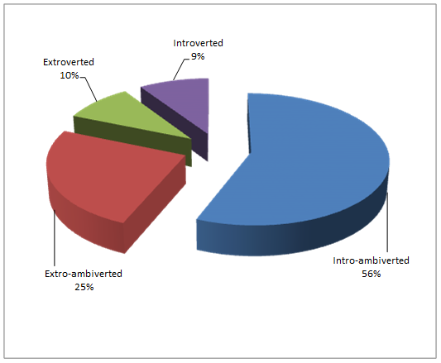
In the sample it was found out that 56% of the participants were intro-ambiverts. This means that their predominant tendency is introversion. Extro-ambiverts represent the 25% of the sample. Surprisingly, only 10% of the sample was classified as extrovert and 9% of the sample as introvert.
In the results, intro-ambiverts outnumbered the rest of the personality groups. In fact, 50% of participants were labelled in this category. This means that these students answered affirmatively in many of the questions that characterize an introvert person but at the same time their answers show that that they are more confident and sociable than typical introverts.
Since researchers worked with students from three different subjects and the majority of participants were classified as intro-ambiverted, it was important to find out if in each of the groups there was a variety of personality type. Below there is a chart with the results of the personality test from each of the three groups.
Figure 4.1.6: Personality types found in students from the Intermediate Intensive English subject

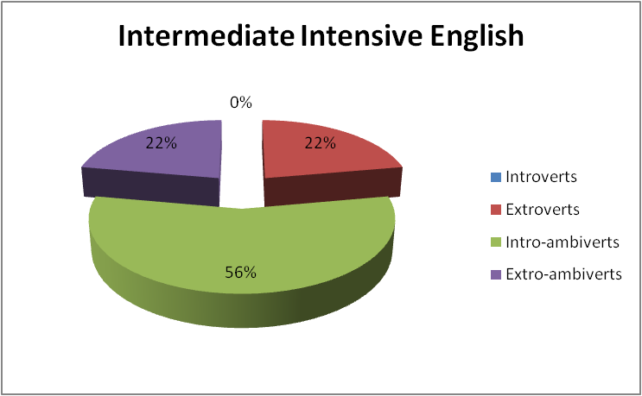
Researchers found out that the majority of students from Intermediate Intensive English were intro-ambiverts. Extroverts and extro-ambiverts shared the same percentage of 22%. An important fact is that there were no introverts participants in this group.
The second group is the group of the students from Intensive Advanced English. Below there is a chart with the description of their results.
Figure 4.1.7: Personality types found in students from the Intensive Advanced English subject

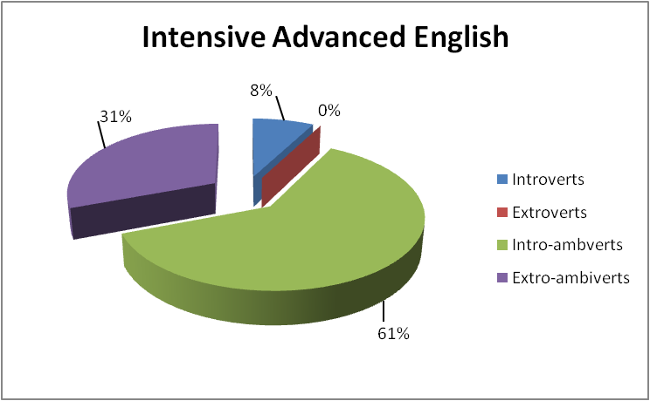
The majority of the students from the Intensive Advanced English were intro-ambiverts. Another important percentage was extro-ambiverted. And only 8% of them were introverted. It is important to emphasize that there were not extroverted participants in this group. One of the most interesting differences between this group and the group of the Intermediate Intensive English students is that this group has introverts but it does not have any extrovert.
The third group is the group of the Readings and Conversation students. Below there is a chart with their personality results.
Figure 4.1.8: Personality types found in students from the Readings and Conversations subject
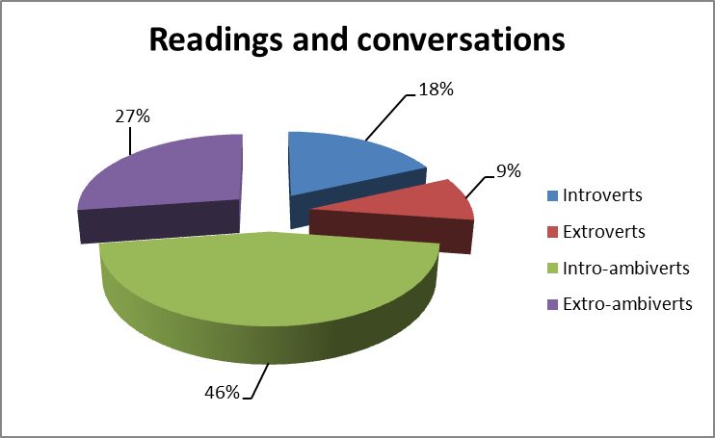
This was the only group in which there was found all of the personality types. However the majority of participants from Readings and Conversation were Intro-ambiverts. The second biggest percentage is for the extro-ambiverts. 18% of them were introverts and 9% were extroverts.

- Which levels of fluency can be found in the students of the Foreign Languages Department?
An oral interview was done to determine students’ fluency level. This interview was carried out using a rubric that contained a classification of the four different fluency levels (Beginner, Intermediate, Upper intermediate, and Advanced) with a description of certain characteristics that distinguish each of them. Each of the interviews was listened to three times. This allowed the researchers to score each participant correctly.
The rubric used helped the researchers to label students in the different levels of fluency. There were four areas that were evaluated. In each of them, students got from 2 to 4 points. The final score was used to place students in the specific level of fluency. The rubric contained four objectives that each participant needed to accomplish in each of the areas:
- To express ideas orally with fluency and confidence.
In this area the following characteristics were evaluated, level of hesitation, nervousness, confidence and willingness to communicate.
- To use oral language to inform, explain, or compare/contrast ideas.
This aspect included quality of explanations, clear information, time adherence and creativity. Students that were able to express ideas clearly and that did not take too much time to think the answer did better in this aspect.
- To utilize eye contact, projection, pace, diction and appropriate grammar. Some aspects of fluency that are never left aside are pace and diction. However, grammar accuracy was also evaluated in this area.
- To engage in a natural conversation with the interviewer.
Participants that acknowledged the presence of the interviewer and use a natural tone in the conversation did better in this area.

The lowest score a participant could have gotten with this type of rubric was four and the highest was ten.
Below there is chart with the results of the four levels of fluency gotten by the students from the Foreign Languages Department.
The purpose of this chart is to compare the results found during the oral interview in all of the fluency levels.

Figure 4.1.9: Fluency results

BEGINNERS
CODE |  | SCORE |  | DESCRIPTION
A01 |  | 5 |  | These participants show no confidence. They had significant grammatical mistakes. Diction was consistently sloppy and pace really uneven.
I03 |  | 6
INTERMEDIATE
CODE | SCORE |  | DESCRIPTION
I05 | 8 |  | These participants show some willingness to communicate but had some grammatical mistakes. Diction was unclear and pace uneven.
I08 | 8
R06 | 8
A13 | 8
A05 | 8
A04 | 9
I02 | 9
I06 | 9
R03 | 9
A12 | 9
I01 | 10
R08 | 10
A06 | 10
I09 | 10
A09 | 10
R05 | 10
A02 | 10
UPPER INTERMEDIATE
CODE | SCORE |  | DESCRIPTION
I06 | 11 |  | These participants show confidence and were able to express themselves clearly. Pace was mostly even and diction clear. Pronunciation and intonation were usually accurate.
A11 | 12
A03 | 12
R04 | 12
A07 | 13
R07 | 13
ADVANCED
CODE |  | SCORE |  | DESCRIPTION
I04 |  | 14 |  | These participants show self-confidence and express their ideas clearly. Pace was consistently appropriate and diction clear. There were minimal grammatical mistakes.
R01 |  | 14
R09 |  | 14
R02 |  | 14
R10 |  | 14
A08 |  | 15
A10 |  | 15
Below there is a graphic that describes levels of fluency found in the participants and the percentages in each of the fluency levels.
Figure 4.1.10: Fluency levels found in the sample
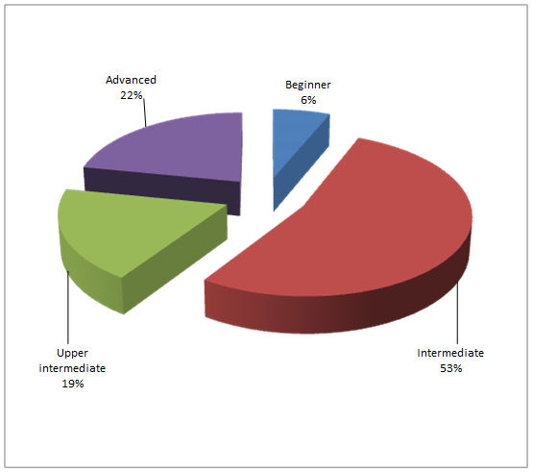
Participants were labeled in all of the levels of fluency. It is interesting that the majority of the participants reached the intermediate level. It is important to mention that highest levels of fluency were achieved by an important percentage.
The researchers worked with students from three subjects with the purpose of gathering data from the Foreign Languages Department. Even though it is expected that students from subjects such as Intensive Advanced English and Readings and Conversations do better in oral fluency the researchers found out that participants from Intermediate Intensive English were receiving positive results in the fluency interview.
Below there is a chart that describes the results found in the Intermediate Intensive English.
Figure 4.1.11: Fluency levels found in the students from Intermediate Intensive English
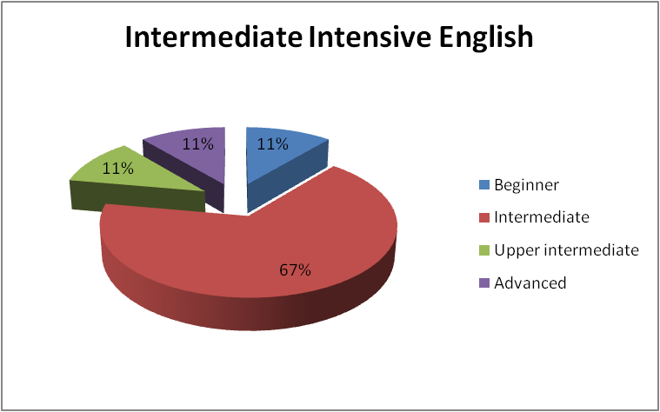
Most of these participants were intermediate fluent speakers. This is the most expected result any researcher may find; however, it is surprising that participants from this subject were able to reach upper intermediate fluency level and the advance fluency level.
The second group is the group of the students from Intensive Advanced English. Below there is a chart showing the fluency results found in this group.
Figure 4.1.12: Fluency levels found in the students from Intensive Advanced English
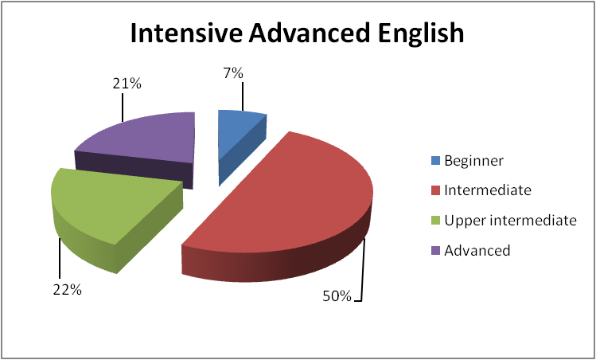

In this group, 50% of them were found to be intermediate fluent speakers. This was definitely an unexpected result. Another interesting fact is that 7% of them were still beginner fluent speakers when they are supposed to have a minimum level of fluency of upper intermediate. 21% were able to reach the advanced fluency level and 22% were in the upper intermediate fluency level.
Finally, the last group is the Readings and Conversation one. Below there is chart with the fluency results found by the researchers.
Figure 4.1.13: Fluency levels found in the students from Readings and Conversations
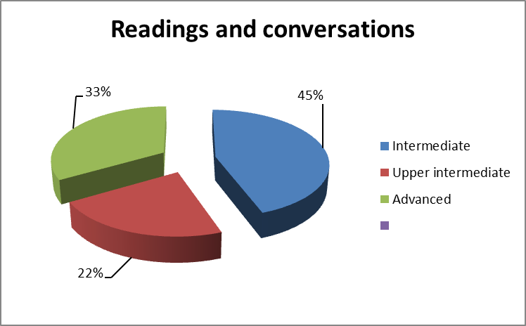
Readings and Conversation is the most fluent group, however, the highest level of fluency was reached only by the 33% percent. The majority of them were still intermediate fluent speaker. 45% percent of them were classified in the intermediate fluency level. And 22% were able to reach the upper intermediate fluency level.
- What are the characteristics of a fluent student?
Every student of English has a certain level of fluency from beginner to advanced level. There are some parameters that have to be used in order to classify a student into one specific category. A person is said to be a fluent speaker of a language when he can use its structures accurately while concentrating on content rather than form, using the units and patterns automatically at normal conversational speed when they are needed (Brumfit, 1984, as cited in Al-Sibai, D 2004). Fluency reflects the speaker’s ability to focus on the listener’s attention on his/her message by presenting a finished product rather than inviting the listener focus on the working of the production mechanisms.
After analyzing the data collected through the oral interviews, it was found that 22% of the participants (see figure 4.1.7) that were interviewed are completely fluent students; nevertheless, they have different personality types. Below there is a chart with the description of the levels of fluency found in the participants.

Figure 4.1.14: Descriptions of the fluency levels
BEGINNER | INTERMEDIATE | UPPER INTERMÉDIATE | ADVANCED
Beginner speakers are unable to express ideas. They have no confidence to participate in oral activities. Their pace can be too fast or too slow. They have many grammatical errors and frequent problems with pronunciation and intonation. | Intermediate speakers may display some nervousness when speaking in English. Their pace is uneven and they will have some diction problems. They have some grammatical errors and their pronunciation and intonation sometimes make it difficult to understand. | Upper intermediate speakers can express ideas with only minor hesitation. Pace is mostly even and diction is clear. They have minimal grammatical errors. Their pronunciation and intonation are usually clear with a few problem areas. | Advanced speakers can express ideas clearly and with confidence. Diction is clear and pace is consistently appropriate. They have no grammatical errors. Pronunciation and intonation are almost always very clear.

- Which personality type is more fluent?
Based on the results, introverted participants are more fluent; this can be seen in the highest fluency level: 67% of introverts reached advanced level opposed to the little percentage of 33% reached by extroverts. The upper-intermediate level was achieved by 33% of intro-ambivert students. In regards to the lowest level of fluency, beginner, 11% of introverts was placed in this level. An interesting fact in the results is that regardless the type of personality; most of the students were categorized in the intermediate level. As a matter of fact 53% of the participants were placed in this level (see figure 4.1.7).
Figure 4.1.15: Introverts results
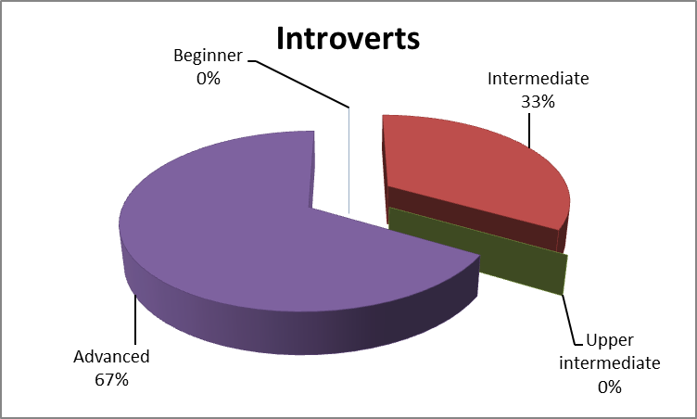

Introverts results show that the majority developed a high level of fluency and only 33% of them were placed in the intermediate level. It is relevant to mention that in the group of the introverts no participant was labeled as beginner.
Figure 4.1.16: Extroverts’ results
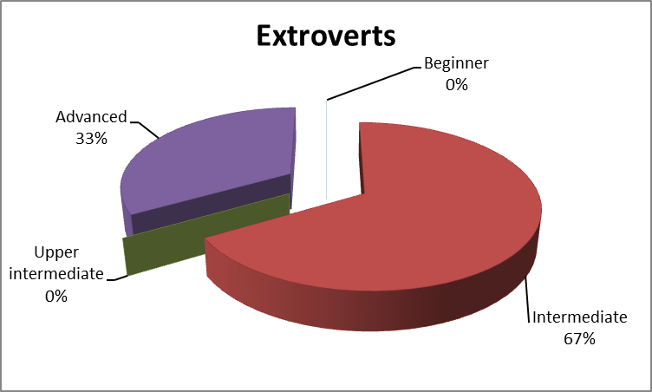

Extroverts are the second more fluent group. They reached the same level of fluency as introverts; however, the percentages are completely different. Below there is a chart showing the levels of fluency reached by extroverts
The majority of extroverts reached the intermediate level of fluency and only 33% percent of them were able to reach the advanced level. This is a proof that both introverts and extroverts developed the highest level of fluency nevertheless extroverts may need more time to do it.
Figure 4.1.17 Extro-ambiverts’ results
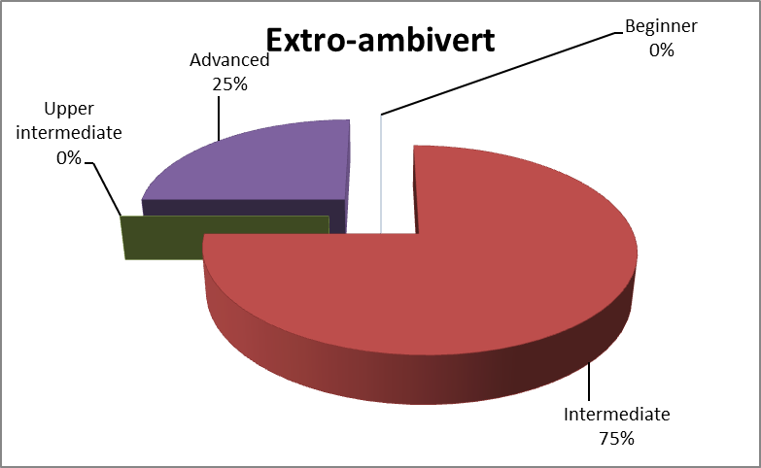

Extro-ambiverts results show that they were able to get the same levels of fluency than introverts and extroverts. These results also show that most of the extro-ambiverts reached the intermediate level of fluency and just 25% reached the advanced level. Extro-ambiverts results are very close to extroverts’. They reached the same levels of fluency in similar percentages.

Figure 4.1.18: Intro-ambiverts’ results
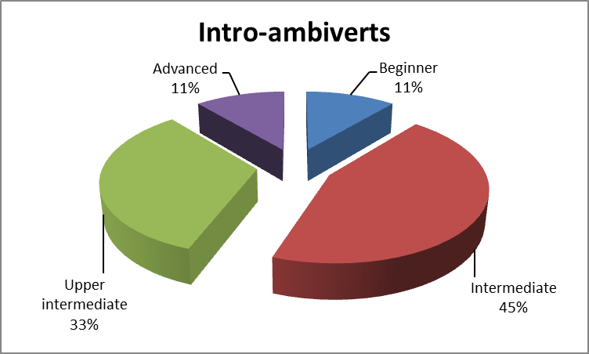
The group of the intro-ambiverts was the only one that was labeled in all of the levels of fluency. And even though this was the only group that was found to have beginner participants an important percentage of them reached the highest levels of fluency. With this result, the researchers concluded that intro-ambiverts showed more development in the fluency competence than extro-ambiverts considering that in this group 75% was found to be in the intermediate level opposed to 45% of introverts. In addition, 44% of intro-ambiverts participants reached the two highest level of fluency: upper intermediate and advanced.
Based on these results, introverts are the most fluent group. There was not found any introvert participant in the beginner level of fluency. This is an indicator that introverts develop fluency fast since the lowest level of fluency they got was the intermediate level. The fact that 67% of the introverts reached the advanced level of fluency is remarkable.
To conclude and give an answer to the research question proposed: How does personality relate to the oral fluency of the students from the Foreign Languages Department?, the findings of this study indicate that personality is not an element that stops or lets students develop a high level of fluency because both extroverts and introverts reach the highest level of fluency. Therefore, it is assumed that there are some other factors such as motivation (positive or negative), learning styles, learning strategies, and teaching methods that may have a direct relation with this and such elements may be studied in depth in further researches (Grabiec, S., 1998; Harmer, J., 2001)

4.2 Major findings
It has been said that extroversion and introversion are potentially important factors in the acquisition of a second language (Grabiec, S. 1998). Since personality causes an impact in all the areas in one individual´s life, the purpose of the study developed was mainly guided toward foreign language learning; specifically, on the development of fluency in English. It was necessary for the study to find out whether there was a relation between personality and the oral fluency achievement of the students from the Foreign Languages Department. For doing this, it was required to stick to a specific methodology so that necessary data could provide exactly the information needed.
The first step followed during this study was the selection of participants. In this step, 32 students from three specific subjects were chosen randomly. These students were all from Intermediate Intensive English, Advanced English, and Readings and Conversation.
After using the two instruments required for the data collection (a personality test and an interview), the next step was the analysis of the results gathered. The information collected showed that students with different personality types can reach the same levels of fluency.
It was found out that in the Foreign Languages Department extroversion cannot be considered a synonym of fluency in general, because the results showed that a group of both extroverts and introverts reached the same level of fluency, the only difference it was that introverts and intro-ambiverts outnumbered extroverts and extro-ambiverts.
Introverted participants who reached the highest levels of fluency (see figure 4.1.9), showed willingness to communicate with the researchers during the oral interview. Since introverts are more analytical and like to plan ahead and rehearse what they will talk about they definitely showed confidence during the interview. What can be deduced is that introverts who love learning a language and the major they were studying practice and look for perfection in their oral performance. According to Harmer (2001), this is called intrinsic motivation; this is why intro-ambivert have done their best in the learning process by overcoming or channeling some of their (negative) personality traits such as introspection and shyness which they could turn them positively into being self-taught.
An interesting fact is that extroverts and extro-ambiverts shared similarities in the results (see figures 4.1.10 and 4.1.11). Both groups reached the same levels of fluency and similar percentages. This is a concluding result. Based on this, the researchers assumed that it takes more time for an extrovert to become fluent in comparison with introverts.
What can be inferred about this in first place is that even though extroverts are mostly expected to achieve the highest levels of fluency (Gan, 2008), introverts potentiated more efficiently their personal skills enough to reach the highest levels of fluency.

Chapter V
- Conclusions and Recommendations
5.1 Conclusions of the study
- Many conclusions were reached based on the results of this study. One of the conclusions is that the majority of the respondents labeled as extroverts were classified as intermediate and advanced, sharing the same fluency levels as introverts. However, introverts outnumbered extroverts in the highest fluency level: advanced.
- It is assumed that introversion characteristics such as shyness and introspection may have influenced positively the students’ performance. It is believed that those personality characteristics represent a disadvantage in social-communicative fields. However, introverted participants channeled them to practice the language alone a few times, planning and rehearsing before they got self-confidence (BBC, 2003).
- Extraversion characteristics are useful and beneficial to the classroom since extroverted students are more participative, they enjoy being volunteers and it is well known that these students like to practice more with English speakers to obtain more input. Extroverts may speak at a higher rate but their speech may not be correct (Brown, 2003). Extroverted participants in this study were found to speak fast but their speech was not so accurate.
- The findings of this study indicated that the English oral fluency achieved among students from the Foreign Language Department could not be directly related to the personality types in such a way that these students could develop a different level of fluency even though they were labeled introvert or extrovert by the Personality Test.

5.2 Recommendations
- More research should be conducted in this area in order to more clearly define the effect of personality on oral fluency. Larger sample sizes, for example, may allow for more detailed and significant information. Expanding the definition of fluency may also lead to more in-depth information regarding the effects of personality. In addition to determining the effects of personality on fluency, research should be conducted to determine effective ways to counterbalance these possible effects.

- Future research could explore the factors that helped introverted students to take advantage and channel their personality traits positively in order to reach a high level of fluency. Based on this, a future research could take into consideration demographics factors such as age, gender, income level, etc. This research may lead to changes in the field, such as innovating classroom activities, raising awareness on students’ personality types, and taking into account learning strategies that match their types.

- Unlike the current study, further research could be carried out in a specific group such as Readings and Conversation II. This group would be more suitable to work with since the students have passed all of the levels of intensive English required in the major that makes them reach a higher level of fluency. It would be interesting as well to develop this research along the semester, so that researchers may be in the classroom observing students’ behaviors, comparing their academic achievement, taking notes, concluding, and analyzing. Assessing the relationship between students’ personality type and their fluency development could lead to valuable information for both students and teachers. It could help to raise awareness, which in turn could enhance the effectiveness fluency development.
- Evaluating fluency is not an easy task. It is very important to receive tutoring or to hire expert interviewers that can elaborate an appropriate set of questions based on the level of English the participants are supposed to have. Since researchers recommended for a follow up study to work with students from Readings and Conversations the interview should be done or at least designed by interviewers that are trained to pass instruments to evaluate English speaking competences. These experts can be found in embassies and in some high education institutions.

BIBLIOGRAPHY

  - Bibliographical References
- Adamopoulos, Robin (2004) “Personality and Second Language Acquisition”. Salisbury University. Retrieved from www.salisbury.edu/
- Al-Sibai, Dina (2004). “Promoting Oral Fluency of Second Language Learners”. Department of English. King Saud University.
- Boeree, George (2006) “Personality Theories”. Shippensburg University. Psychology Department.
- Borala Liyanage, Indika Jananda (2004). “An Exploration of Language
Learning Strategies and Learner Variables of Sri Lankan Learners of English as a Second Language with Special References to Their Personality Types”. Faculty of Education, Griffith University.
- Clement, Richard., Dornyei, Zoltan., Macintyre, Peter D., and Noels, Kimberly A., (1998) “Conceptualizing Willingness to Communicate in a L2: A Situational Model of L2 Confidence and Affiliation”. The Modern Language Journal. Volume 82. Pages 545–562.
- Dénes, Mariann and Kormos, Judit (2004). “Exploring Measures and Perceptions of Fluency in the Speech of Second Language Learners”. Eötvös Loránd University, Budapest. Retrieved from http://dx.doi.org/10.1016/j.system.2004.01.001
- Eby, Douglas (2011). “The Creative Personality: Both Extroverted and Introverted” Retrieved from http://blogs.psychcentral.com/creative-mind/2011/03/the-creative-personality-both-extroverted-and-introverted/
- Fillmore, Charles J. (1979). “Individual Differences in Language Ability and
Language Behavior.” New York: Academic Press.
- Gan, Zhengdong (2008). “Extroversion and Group Oral Performance: A
Mixed Quantitative and Discourse Analysis Approach”. The Hong Kong Institute of Education. Volume 23, N° 3.
- Grabiec, Sylwia (1998). “Learning Factors Affecting Second Language Acquisition”. Retrieved from http://www.publikacje.edu.pl/pdf/7970.pdf
- Jung, Carl Gustav (1921). “Psychological Types” Routledge, Taylor & Francis Group.
- Juraga, Ivana and Medved Krajnovic, Marta (2008). “Perception of Influence of Foreign Language Learning on Personality”. Faculty of Humanities and Social Sciences. University of Zagreb.
- Kasschau, Richard (1985) “Psychology: Exploring Behavior”. Chapter 11: personality theories. Prentice Hall School Group.
- Kezwer, Paula (1987). “The Extroverted Vs. the Introverted Personality and
Second Language Learning”. TESL Canada Journal/Revue TESL DUCANADA. VOL. 5, NO.1
- Oxford, Rebecca L (2003). “Language Learning Styles and Strategies: an overview”. GALA 2003.
- Paltridge, Brian and Phakiti, Aek (2010). “Continuum Companion to Research Methods in Applied Linguistics”. Continuum International Publishing Group. British Cataloging-in-Publication Data.
- Zhang,Yan (2008). “The Role of Personality in Second Language Acquisition”. Asian Social Science. Vol. 4, N° 5. Qingdao University of Science and Technology.

APPENDIX

APPENDIX A.
Oral interview questions

- Tell me about yourself.
- What major are you studying? Why?
- Do you feel like a different person when you speak in English?
- Tell me about the last movie you have watched.
- What type of activities do you prefer in the classroom?

OBJECTIVES | BEGINNER (1 pt) | INTERMEDIATE (2 pts) | UPPER INTERMEDIATE (3 pts) | ADVANCED (4 pts) | Total
Express ideas orally with fluency and confidence. | -Unable to verbally express ideas  -No confidence  -Apprehensive about participating in a interview | -Willing to participate in a interview  -Displays nervousness  -Expression of ideas uneven | -Comfortable with interviewer  -Can express ideas with only minor hesitation | -At home with the interviewer  -Ideas are clear  -Self confident
Use oral language to inform, explain, or compare/contrast ideas | -Information is unclear  -Explanations are too broad or too narrow  -Comparison/contrast is not clear | -Some evidence of clear information; explanations; and comparison/contrast | -Most information adjusts to fit time/interviewer  -Comparison/contrast is clear and effective | -Strong and effective communication of information  -Clear explanations  - Creates interest  - Persuasive comparison/contrast
Utilize eye contact, projection, pace and diction.  Use appropriate grammar. | -No eye contact  -Interviewer is unable to hear the participant  -Pace is consistently too fast or too slow  -Consistent sloppy diction  -Many grammatical errors  -Frequent problems with pronunciation and intonation | -Some eye contact  -Projection is uneven  -Pace is uneven  -Some diction problems with inappropriate slang  -Some grammatical errors  -Pronunciation and intonation errors sometimes make it difficult to understand | -Eye contact is mostly consistent  -Projection is good and isolated phrases/sentences lost  -Pace is mostly even  -Diction is clear  -Minimal grammatical errors  -Pronunciation and intonation are usually clear/accurate with a few problem areas | -Consistent eye contact  -Projection is uniform and clear  -Diction is clear, free from inappropriate slang and use of reduced forms  -Pace is consistently appropriate  -No grammatical errors  -Pronunciation and intonation are almost always very clear/accurate
Engage in a natural conversation with the interviewer | -Ignores the presence of the interviewer | -Fleeting recognition of the interviewer | -Acknowledges and addresses the interviewer  -Some attempts to involve the interviewer | -Establishes a tone conducive to building rapport with the interviewer  -Holds the interviewer’s attention
Score | 4-7 pts | 8-10 pts | 11-13 pts | 14-16 pts

APPENDIX B.
FLUENCY RUBRIC

Participant___________________________________ Comments: _________________________________________
Interviewer___________________________________ _______________________________________
Score__________________________________________ ________________________________________
APPENDIX C.
TEST DE PERSONALIDAD
Indicaciones: Lee cada pregunta y responde sí o no en el espacio.
- Cuando estás en un grupo y ha pasado una situación difícil, ¿tiendes a sentir que fue tu responsabilidad? ____
- ¿Tienes cambios bruscos de ánimo? ____
- ¿Eres organizado? ¿Tienes una agenda y escribes cada cosa que debes hacer?__
- ¿Entiendes la diferencia entre conocidos y amigos? ____
- ¿Te gusta analizar mucho a las personas o todo lo que pasa a tu alrededor? ___
- Cuando se te pide un favor, ¿te tomas tu tiempo para pensar si aceptar o no? __
- ¿Prometes cosas impulsivamente y luego no las puedes cumplir? ___
- En una reunión de amigos, ¿hablas mucho y cuentas muchos chistes? ___
- ¿Al final de una reunión te queda la sensación de haber querido continuar hablando? ___
- ¿Te queda la sensación de haber querido hablar más? ___
- ¿Tiendes a atreverte a hacer cosas que otros no? ___
- ¿Te atraen las actividades en grupo como por ejemplo, deportes en equipo, excursiones, o juegos? ___
- ¿Eres indeciso? ___
- ¿Eres hiriente con tus palabras? Dices cosas impulsivamente que luego hubieras querido no decir? ___
- ¿Eres autoritativo es decir que te gusta que las cosas se hagan como lo consideras mejor tú? ___
- ¿Te gusta que te busquen tus amigos para resolver dificultades? ___
- Cuando te enojas, ¿gritas y has llegado a golpear a alguien? ___
- ¿Eres tacaño? Te cuesta compartir tus cosas? ___
- ¿Emprendes proyectos grandes y planeas estrategias para lograr metas? ___
- ¿Prefieres que otros sean los que planifican eventos o proyectos? ___
- Cuando alguien pide ayuda, ¿no haces nada porque sabes que alguien más lo hará? ____
- ¿Tienes tendencias a ser pacificador y arbitro en peleas de amigos? ____
- ¿Es difícil hacerte perder la calma y por eso te admiran? ____
- Al salir de un lugar que estaba lleno de gente, ¿te sientes aliviado, con un peso menos? ____
- ¿Sientes el dolor de los demás, eres empático? ____
- Cuando alguien pasa una situación difícil, ¿te es fácil decir palabras indicadas?_

APPENDIX D.

Personality Measuring
The personality test reveals four scores:
- Score 0-9. It represents a high level of introversion.
- Score 10-12. It measures how much of an introvert a person is.
- Score 13-15. It measures how much of an extrovert a person is.
- Score 16-25. It represents a high level of extroversion.
To interpret the scores, it is necessary to plot on a graph the aspects that correspond to the personality type. Each of the questions represents an aspect for each personality type.

